Playdom

Game Services Training
Star Wars: Commander GSAT
Playdom Confidential

Purpose/Scope
This Module introduces basic handling procedures for Star Wars: Commander to new Game Services agents.

Training Objectives
- Introduce Game Services Agent Tools for Star Wars: Commander.
- Introduce basic steps for the most frequently encountered issues.



***ALL ACTIONS IN GSAT ARE LOGGED AND AUDITED***

What is GSAT?
The Game Service Admin Tool (GSAT) is used by Game Services to edit guest game information. This tool should only be used to address issues that require GSAT, such as lost items, accidental purchase reimbursements and issue investigations.

Access GSAT

Log into the VPN
You must connect to Playdom via VPN to access Game Services tools.
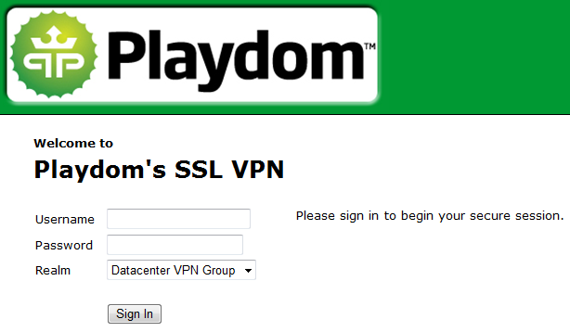
Step | Description
1 | Navigate to https://vpn.playdom.com
2 | Enter your LDAP Username and Password
3 | Select Datacenter VPN Group as your Realm
4 | Click ‘Sign In’

Log into GSAT
Once you are connected to Playdom via VPN, load and log into GSAT.

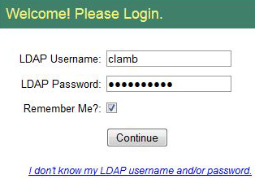 | Step | Description
 | 1 | Navigate to  http://n7-gsat-int-active.compliant.disney.private/
 | 2 | Enter your LDAP Username and Password
 | 3 | Select Datacenter VPN Group as your Realm
 | 4 | Click ‘Sign In’

Opening Star Wars: Commander GSAT
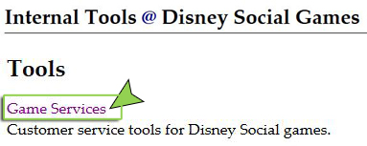  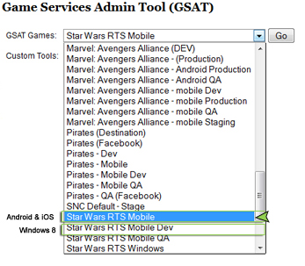 | Step | Description
 | 1 | Click Game Services to open the menu.
 | 2 | Click the arrow to open the drop-down menu
 | 3a | Select Star Wars RTS Mobile (iOS & Android)
 | 3b | If you are helping a guest on Windows 8, choose Star Wars RTS Windows

Loading a Guest Account
Step | Description | Example
1 | Enter the Guest’s ID in the box | 12345678-1234-1234-1234-123456789012  GS iPad
* | Include any Dashes  Players word processors sometimes auto-correct the dash into a different symbol. Delete and retype the dash manually to troubleshoot this.
* | ID is Case-Sensitive  Guests sometimes capitalize the first letter accidentally.
* | Remove any extra spaces before and after ID
* | Remove or replace any invalid characters | The ONLY Valid characters in a Player ID are:  0123456789  Abcdef  -

Making a Note on an Account
To make a note about a guest in GSAT, click the square comment box. Type your comment, and click the Checkmark to save it.

Make notes about important Guest information or investigations. Notes can include:
- Comments about player game preferences “Guest’s favorite character is the Hulk.”
- The guest’s preferred name, “Amber,” or, “Mr. Spencer.”
- Investigation into fraud, “Guest submits billing requests often. Review for potential fraud.”
- Guest’s game set-up “Plays game on Facebook and iOS usually. Has a very old computer.”

A note should NEVER include:
- Any rude or disparaging comments, “This player is really mean.”
  - Instead, say something like, “Player given warning for verbal abuse 01 Jan 2015”
- Personal information that is not related to assisting guest with the game.
- Billing information, such as credit card numbers, payment account names.

Past Notes will be shown in the Audit Log tab. See the Audit log tab in GSAT to see previous / overwritten warnings or issue notes.

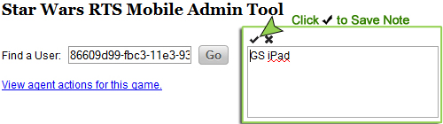

Tabs in Star Wars Commander GSAT
There are many tabs in Star Wars: Commander GSAT. This list will show you which tabs you will use, and how.

Tab Name | Notes | Items in this tab
Frequently Edited Tabs
Action Logs | Use this tab to write a note about your action in GSAT. Include the ticket ID #.  This is required. | Lists all actions taken by support, for this account.
Ban and Remove | Tier 3 and 4 ONLY. Do NOT edit this page.  (Unless specifically directed by a lead) | Ban a player  Delete a player game
Other Fields | MOST of your actions will be in this tab.  You can only ADD units on this tab.  AFTER editing the unit, refresh GSAT, then check the research tabs (below) to make sure the items added correctly. | See last played time  View and Edit player name  View and Edit Level  Add Troops, Heroes and rewards  Add Credits, Material (alloy) and Crystals  Add Special Attacks
Transaction History | This tab shows basic information about credited transactions.  If a player reports a transaction, and none is listed here, collect all billing information and escalate this report. | This tab contains information about player purchases, and can be used to investigate billing inquiries.  Refunds must be initiated by Guest through iTunes.
Research Tabs Only
Heroes | Research ONLY. Do NOT edit this page.  Use the “Other Fields” tab to Add Heroes. | Exception: You may use this tab to remove any Heroes you may have accidentally added.
Missions | Research Page.  Edit only if player is stuck on a quest. | Status Are:  Claimed  Default  Completed
Campaigns | Research ONLY. Do NOT edit this page. | See guest’s quests  See what rewards a player has not yet earned
Buildings | Research ONLY. Do NOT edit this page. | Research what buildings a guest owns  Research when they collected their materials
Special Attacks | Research ONLY. Do NOT edit this page.  Use the “Other Fields” tab to Add Special Attacks. | Exception: You may use this tab to remove any Special Attacks you may have accidentally added.
Squad History | Research | See Squad information  See Names  See Squad members  See Leadership Actions
Troops | Research ONLY. Do NOT edit this page.  Use the “Other Fields” tab to Add Troops. | Exception: You may use this tab to remove any Troops you may have accidentally added.
Unused Tabs
Campaign Inventory | Unused Tab
Multi Set: | - Any tab labelled “Multi Set” will affect a large number of players.  - Do not use these tabs unless specifically instructed by your team lead.  - Values entered in these tabs are comma delineated.

How to add items
There are two methods to add items, selecting an item from a drop down menu, and editing a value.
Method 1) Add Items in Other Fields Tab | Example: Adding items from drop-down menu
1. Select an item from the drop-down menu | 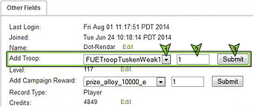
2. Type the number you wish to add in the box.
3. Check the number you entered, then click Submit
4. Edit notes in audit log

Method 2) Edit Amount | Example: Adding Currency in the “Other Fields” Tab
1. Click Edit next to the value you want to adjust | 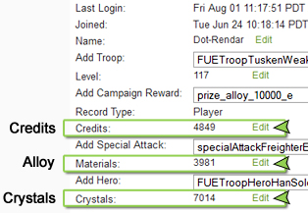
2. Type the word or number you wish to add
3. Click Submit
4. Edit notes in audit log
* Method 2 only works if the player has had at least one of the items in the past.
**If you cannot find the item to edit, you must ADD it using the steps in Method 1 instead.

Currencies in Star Wars: Commander
- Currency/Currencies are items in game that guests use to purchase, build or complete items. In example, players “purchase” buildings with Alloy.
- CRYSTALS: Hard Currencies are currencies that cost Real Money, and are often purchased with Credit Cards, Mobile Pay, special offers or Gift Cards. Only Hard Currencies can be refunded for real money.
- ALLOY & CREDITS: Soft Currencies are currencies in game that you can earn by playing the game.
- Some currencies are both earned in-game, and purchased with real money.
  - Crystals are awarded for some quests.

* Remember! Player will use their Hard Currency to buy items in the game. Here is a common occurrence:
“I bought Crystals. I used those Crystals to get Alloy, but my Alloy never showed up! I have lost my purchase!”
This may not be a billing issue, but it sure feels like it for the player. Remember to remove the billing tag from the ticket, and mark it as an accidental purchase.

 | 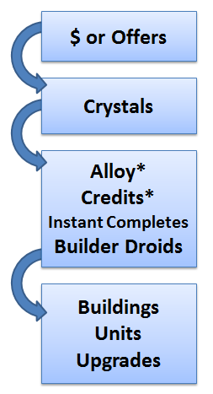
  $USD Value | Crystals
  $4.99 | 500
  $9.99 | 1,200
  $19.99 | 2,500
  $49.99 | 6,500
  $99.99 | 14,000

