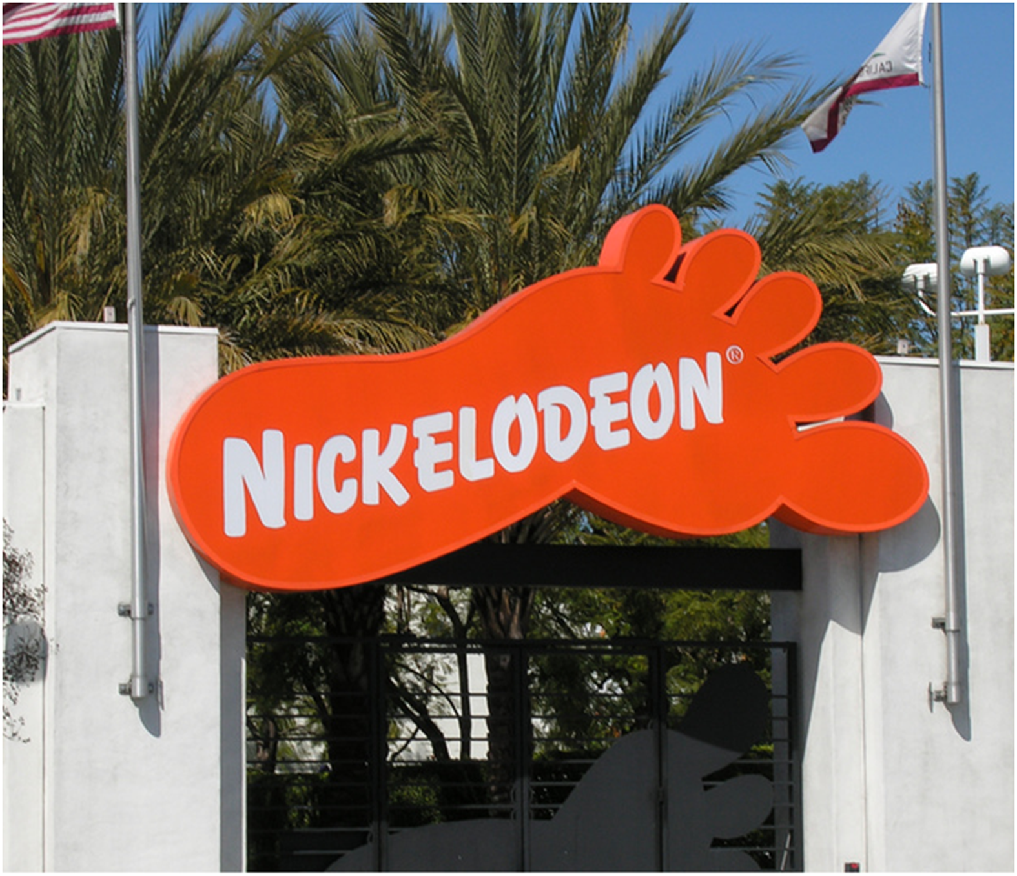
zdCharacter Rig Handbook
A guide to animating a Nickelodeon character rig.
Updated 12/20/2010

Table of Contents
Main Controls
Control Colors 2
Transform 3
Visibility_Ctrl 4
COG 7
Limb System
FK Systems 9
IK Limb Systems 11
The Green Mid Ctrl 14
Twist Control 17
Master Control 20
Hand/Foot System
Hand Control 21
Finger Controls 22
Foot Control 23
Face Systems
Eye Control 25
Eye Deformers 25
Blendshape Controls 26
Face Controls 27
Deformer Systems
Clothing Controls 28
Geo Display 29
Limb Deformers 30
Stomach and Sculpt Deformer 32
Character Specific Deformers 34
Automated Systems
Jiggle Systems 35

Main Controls

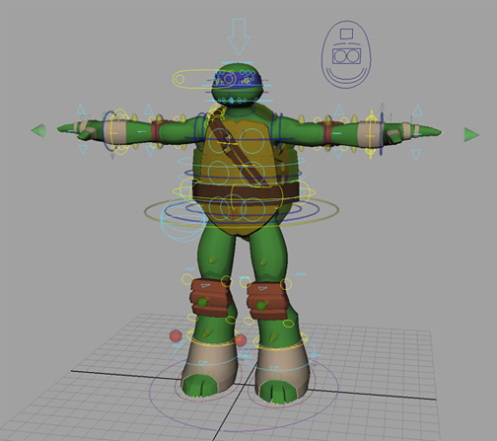
Control Colors
Each control's general purpose can be defined by its color.
A typical character in animation mode with all controls turned on.

control colors and what they mean in our rigs
blue | FK system
red | IK system
green | systems that are independent of IKFK switching
light blue | general deformers (mostly cluster-based)
yellow | limb and clothing deformers, COG, and eye controls
purple | transform
dark blue | visibility and blendshape controls

Transform
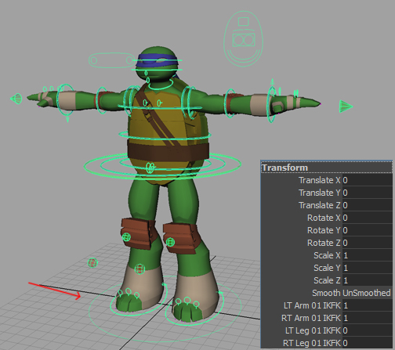
First and foremost the Transform of a character is meant to be used as a global control. This control will determine the placement and size of the character. The Transform is also used to set the smooth level of the character and switch between ik and fk controls for all body parts.
Attributes available on Transform.

Each IKFK switch attribute has a minimum and maximum of 0 and 1 respectively. When set to zero, the rig for the specified body part will be set to IK. When set to one, the rig will switch to an FK system. It is easy to tell which number, 0 or 1, will set the rig to IK or FK because of the name of the attribute. Since "IK" comes before "FK" in the attribute's name, the body part will switch to IK when set to 0 because 0 comes before 1.

Visibility Control
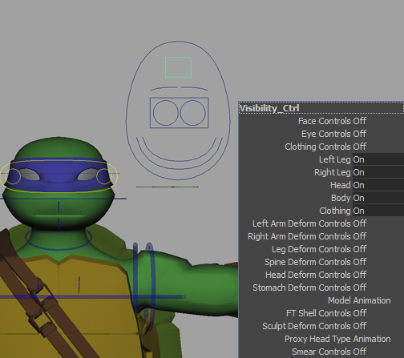
The Visibility_Ctrl is another sort of global control, but instead of movement and smooth settings, it is in charge of showing and hiding various rigging systems, geometry, and modes of the rig. It can be found as the square control within the face control system and follows the COG of the character:
Location of Visibility_Ctrl and attributes.

All of the attributes on the visibility control can be categorized into three groups; control visibility, geo visibility, and geo display modes. All attributes should be non-keyable except for the geometry visibility attributes because there is nothing gained from animating the visibility of controllers on the rig. However, each of the attributes made for showing and hiding control visibility is connected to the envelopes of any deformers that are related to the particular rigging system. This was done to increase real-time speed performance for easier playblasting and scene manipulation. The only attribute that is meant for switching between geo display modes is the "Model" attribute. This attribute can switch the geometry of the rig between proxy, animation, and render modes.

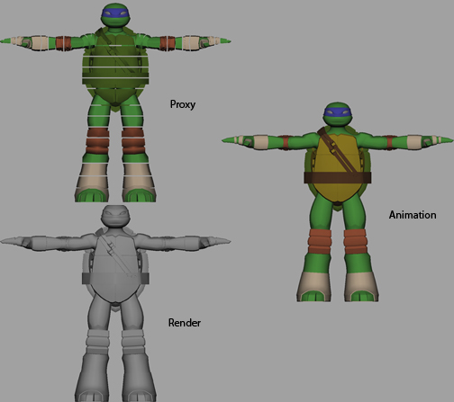
Comparison of proxy, animation, and render modes of character.

Versions of Character Geometry
Proxy | this mode is used for quickly interacting with the rig and blocking out rough animation
Animation | a mode of the character that shows estimated colors of body parts in the viewport without displaying the texture of a character
Render | the render geometry of the character
You might be asking yourself why the animation mode exists. It exists because the render geometry often shows up as grey or completely black in shaded mode. If the display mode of your viewport is set to show hardware texturing, the correct colors on the character may show, but interaction with the scene slows down considerably. This is especially problematic when animating eyes on a character because there may be no distinction between the color of the pupil and the whites of eyes in the render mode. In the animation mode, all of the colors are available to the animator without any hit to the performance of the scene.

COG
The COG is a yellow control that stands for “Center of Gravity” and controls the location of the base of the spine and the start of the hips.
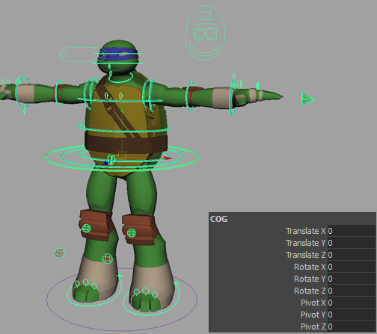
The COG and its attributes.

The COG can move the entire character just like the Transform if all limbs are set to FK, but unlike the Transform, which is used for placement, the COG is meant to be used to move and rotate the hips, spine, and head portions of the rig from the character’s center of gravity. If the limbs of the character are set to IK and the follow attributes on IK controls are set to anything other than COG or Master, the wrists and the ankles of the character will remain in place when the COG is moved or rotated. This is especially useful on legs when you don’t want the feet of the character to move with the spine of the character and want them to stick to the ground.
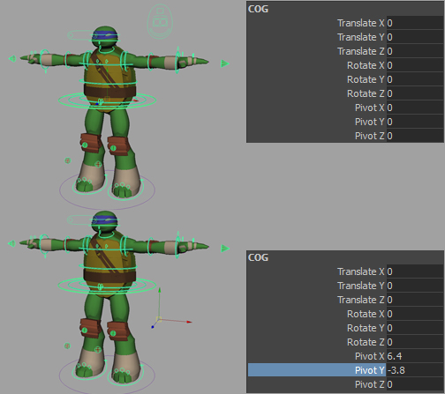
Moving the pivot point of the COG.

The COG also has the ability to change its rotate pivot by manipulating the Pivot X, Pivot Y, and Pivot Z attributes.

Limb Systems

FK Systems
It might be best to start with the FK systems of the rig because they are used the most in so many places. Our FK system is just like any other FK system with two differences: auto FK and follow attributes.
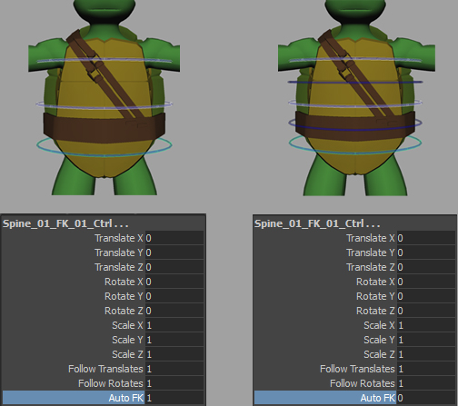
Setting the AutoFK attribute to 0 will reveal more detailed FK controls for finer animation.

The auto FK system was built to provide the animator with the most control over deformation without cluttering the scene with a lot of controls. If auto FK is set to 0, controls between the current FK control and the next FK control become available for detailed animation. If it is set to 1 the detailed FK controls will get hidden and will automatically translate, rotate, and scale accordingly. By default all auto FK attributes are set to 1, so that there are fewer controls to worry about.
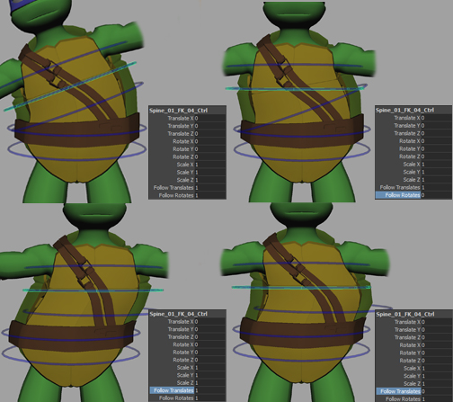
Comparison of various settings of the follow attributes

The follow system in our FK systems was designed to animate FK controls regardless of any animation on their parent FK controls. If FollowTranslate is set to 0, the current FK control will not move with its parent adn if FollowRotate is set to 0, the current FK control will ignore rotations above it. This is especially useful if the scene calls for a body part getting stuck and left behind or when you don't want your head FK control to point forward no matter how much the spine FK controls are rotated.

FK systems are used throughout the rig in the head, neck, spine, arms, legs, tails, ears, whiskers, tongue, uvula, fingers, toes, etc. As you can see, FK systems are the go to rig unless the body part requires additional rigging.

IK Limb Systems
The IK systems used in our arms and legs have all of the expected functionality of a normal IK system with a couple of additions to help the animator achieve a broader number of shapes.
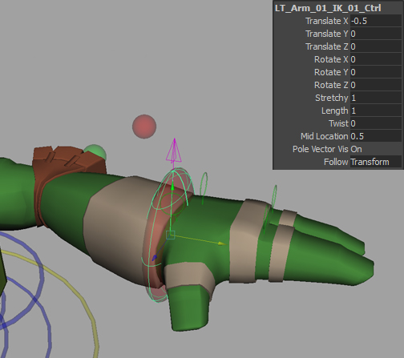
The attributes on a typical IK control.

As you can see there are attributes not typically found on a generic IK system. Let’s start at the top.
control colors and what they mean in our rigs
Stretchy | A 0 to 1 attribute that controls the limb’s ability to stretch when the IK control is manipulated past the default length of the limb.
Length | Controls the overall length of the limb. The default value of this attribute is 1 because it is one times the original length of the limb. If this value is increased the limb will grow longer regardless of where the IK control is placed.
Twist | An attribute featured on previous rigs that controls the twist orientation of the entire limb.
Mid Location | This attribute is used to move the elbow or the knee of the limb along the limb. By default it is set to .5 because the elbow/knee is not favoring the top or bottom of the limb. If the attribute is set to 1 the elbow/knee will move near the wrist/ankle of the limb and if it is set to 0 the elbow/knee will move near the shoulder/hip of the limb.
Pole Vector Vis | An attribute to control the visibility of the limb’s pole vector control.
Follow | On all of our rigs, the Follow attribute will always specify which part of the rig to follow for the current control. For limb IK controls, the options for the attribute are COG, Transform, World, and Master in that order. If the master option is selected, the limb IK control will follow the master control for that limb.
Twist | visibility and blendshape controls

Each IK limb system has a pole vector to control how the limb is rotated in the twist axis.
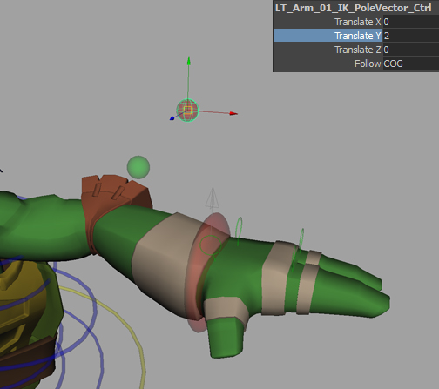
A typical pole vector control and its attributes.

As you can see, only translate and follow attributes are available on the pole vector control. This is because rotating or scaling the pole vector will not alter the look of any portion of the limb rig. This is because the elbow/knee aims at the rotate pivot of the pole vector control and rotating or scaling the pole vector control does nothing to change the location of its rotate pivot. The follow attribute is the same on this control as it is on the main IK control. Similarly, the options for this attribute are IK Control, COG, Transform, World, and Master. As you can see there is one more option available on this follow attribute: IK Control. This will allow the pole vector to move with the IK control so that the animator will not have to constantly match the pole vector’s position with the IK control to get proper deformation.

And finally, each IK limb system features a clavicle control.
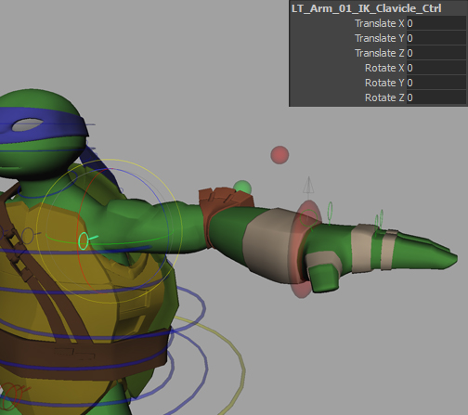
The clavicle control of an arm.

This control determines the start of any IK limb system. By manipulating this control the animator is able to change the start location of any IK limb system.

The Green Mid Ctrl
The mid control of any limb is a control used for secondary animation, to make the elbow or knee of a limb stick to a surface or location, and to control the bowing behavior of the limb.
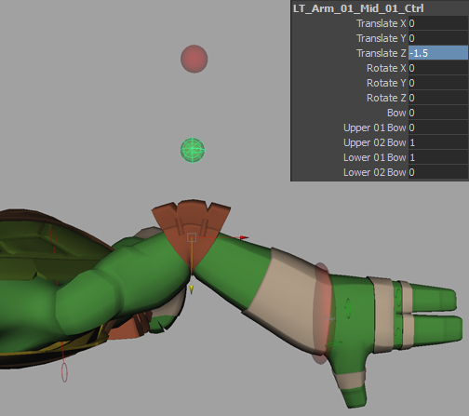
The mid control of an arm.

By translating the mid control, the location of the elbow/knee can be altered. If this control is constrained to another control or node, the elbow/knee will not follow the rest of the rig. This is useful for when the elbow/knee must get stuck to an object. The rotates on this control will rotate and twist the middle of the limb. In addition to these features, the mid control also has 5 bow attributes.
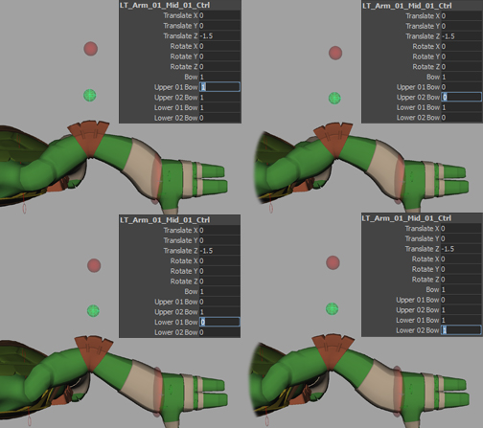
Various bow attribute settings and how they affect the look of the limb.

When the bow attribute is set to 1, the limb will try as hard as it can to smoothly curve the limb. The upper and lower bow attributes will change how the rig behaves only when the bow attribute is set to 1 as they modify the look of the bow.
Bow Attributes
Upper01Bow | controls the amount of bowing at the top of the limb.
Upper02Bow/Lower01Bow | controls the amount of bowing at the elbow or knee
Lower02Bow | controls the amount of bowing at the wrist/ankle
If all upper and lower bow attributes are set to 0, then no bowing will occur even when bowing is turned on. If all of these attributes are set to 1 however, the limb will bow with no falloff at the ends of the limb. It is for this reason that the Upper01Bow, Upper02Bow, Lower01Bow, and Lower02Bow are set to 0, 1, 1, and 0 respectively by default, so that there is a bow effect with falloff at the shoulder/hip and the wrist/ankle of the limb.

Twist Control
The twist control can be found on each limb as a grey arrow shape at the wrist or ankle of any limb rig.
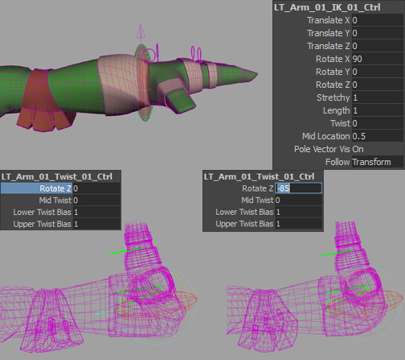
The twist control and an example of flip prevention when rotating the wrist/ankle back.

The twist control serves to control flipping in the twist of the forearms and calves. Whichever direction the twist control is pointing in determines the local orientation of the joints in charge of twisting the forearm or calf area.
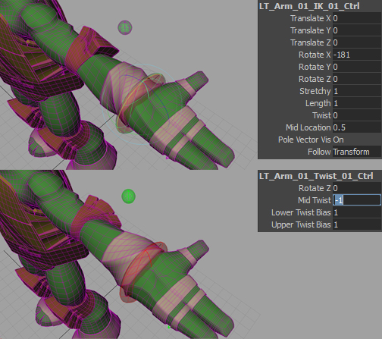
The mid twist attribute and its importance in preventing flipping after the wrist/ankle is rotated past 180 degrees.

The twist control also features a MidTwist attribute that controls the twisting of the elbow/knee area of the limb. This is included in the rig because it helps to prevent flipping in the forearm and calf area when the wrist or ankle is rotated along its twist axis, which in most cases will be X. If the wrist/ankle control is rotated more than 180 degrees difference from the elbow/knee, the forearm/calf area will flip. Therefore, if MidTwist is activated to lessen the difference in rotation between the elbow/knee and the wrist/ankle the flipping will not occur.
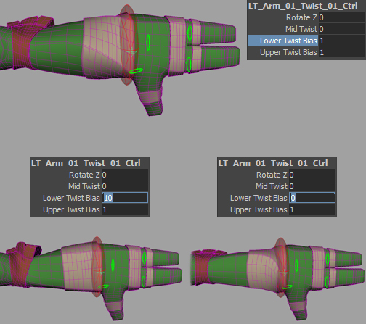
Bias attributes on the twist control

The upper and lower bias attributes control the falloff of the twisting that happens in the upper and lower parts of the limb. For example, if the LowerBias is set to 0 the forearm/calf joints follow the rotation of the elbow/knee, but if LowerBias is set to 1 however, the forearm/calf joints will favor the wrist/ankle rotation. By default this attribute is set to 1 so that the twist joints will evenly twist between the elbow/knee and the wrist/ankle.

Master Control
The master control is a global control for the specified limb.
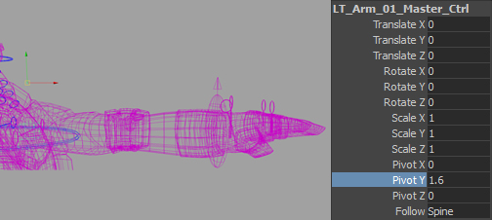
The master control is a purple cube at the base of each limb with a small sphere-like curve that shows where it pivots.

The master control is designed to move the limb as a whole when it is necessary to move the limb separately from the body like when an arm needs to fall off of the character. In addition to the default translate, rotate, and scale attributes, pivot and follow attributes are also available. The pivot attributes will change the location of the pivot for the master control and is shown to the user via a small sphere curve. This was implemented to avoid any confusion as to where the pivot of the control might be when manipulating pivot attributes. The follow attribute is much like any other follow attribute with the following options: Spine, COG, Transform, and World.

Hand/Foot Systems

Hand Control
The hand control serves to move, rotate, and scale the hand as a whole.
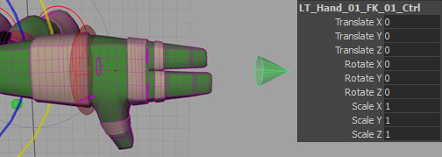
The hand control.

On characters whose hands can separate from the their wrists, this control is used to animate the hand separately from the arm.

Finger Controls
Finger controls are green and show the top most controls of each finger by default.
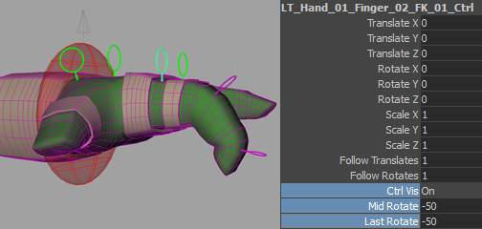
Top finger controls can curl fingers in one axis and show lower level controls.

Finger controls are similar to FK controls in that they also have follow translate and rotate attributes. The top most finger controls can rotate all digits in the fingers in their curl axis. This is a feature in the rig to get overall animation of the finger as quickly as possible. If further detail in animation is needed, the animator can show individual finger controls by setting the CtrlVis attribute to “On.”

Foot Control
The foot control is responsible for lifting the heel and rotating parts of the foot without rotating children and is only available in the IK mode of the legs.
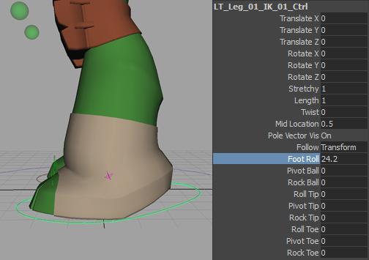
The IK foot control, its attributes, and areas of influence by part.

The most frequently used attribute will probably be the FootRoll attribute as it rotates the heel upwards without rotating the ball or the toes of the feet. The parts of the foot are organized and separated by the following terms:
Parts of Foot
Ball | section of foot from ball of foot to heel
Tip | entire foot rotated from the tip of foot
Toe | section of foot from ball to tip of foot
In front of these terms are the action that the attribute will perform like:
Actions Performed
Roll | rotates the part of the foot along the length of the foot
Pivot | rotates the part of the foot in the Y axis as if it is pivoting on the floor
Rock | rotates the part of the foot in the twist axis as if it is rocking left and right

Face Systems

Eye Control
The eye control of a character is used to specify which direction the eyes of the character should be pointing.
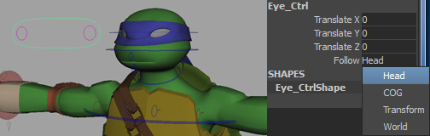
The eye control and its smaller individual controls.

Because the eyes are aimed at the pivot of this control, the rotates and the scales of this control are useless and therefore hidden. The control also features a follow attribute just like the IK controls of the rig. The options for the follow attribute on the eye control are Head, COG, Transform, and World.
In addition to the overall eye control, individual eye controls are available if further animation is necessary on a per eye basis or if one of the eyes starts to disappear into the eye cavity. By moving these individual eye controls around, the user can further tweak how each eye is rotated.

Eye Deformers
Eye controls serve to further deform the eyeballs. They are yellow and feature an overall control for moving the eyeballs and individual deformation control for the front, top, bottom, and sides of the eyeball. Some eye controls will even let you change the look of eyelashes and other character specific items.

Blendshape Controls
The blendshape controls are responsible for activating facial blendshapes on the character.
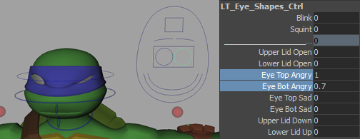
Blendshape controls can be found within the face control as brow, eye, and mouth shapes.

Each of these blendshape controls will control different areas of the face:
Blendshape Controls
Brow_Shapes_Ctrl | a control for brow emotions.
Eye_Shapes_Ctrl | a control for eye blinking and emoting.
Phoneme_Shapes_Ctrl | a control for phonetic sounds for the mouth
Mouth_Shapes_Ctrl | a control for emotional shapes for the mouth such as smiling and frowning

Face Controls
These controls can be turned on from the Visibilty_Ctrl, which is a square in the face control.
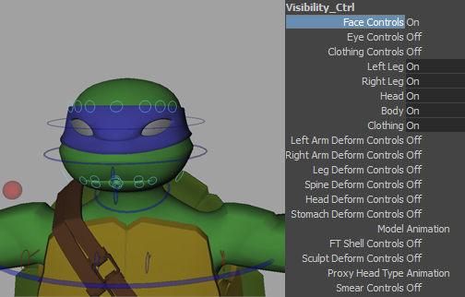
Typical face controls show up as light blue circles with world orientation.

Each of these controls will deform a different part of the face and are meant to be used when blendshapes have been used and further control is needed. Most face control setups will feature control for the brows, lips, and cheeks of a character.

Deformer Systems

Clothing Controls
The clothing controls will vary to accommodate the needs of each character
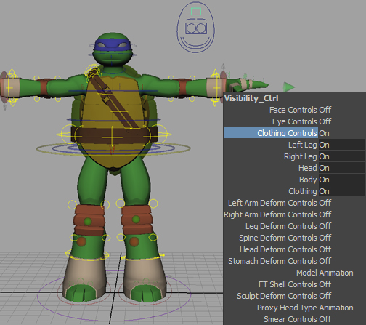
Clothing controls are yellow and are meant to manipulate accessories and cloth.

Typically, clothing controls are made for sleeves, bottom of shirt at waist, top of pants at waist, baggy pants, socks, bangles, straps, pockets, etc. All clothing deformers are clusters on the geometry by default. Before playblasting or rendering any animation the user must remember to set the deformer attributes to on because they control the envelopes of deformers in addition to their visibilities. This was done to speed up interaction with the character as turning on all deformers slows the speed of interaction down considerably.

Geo Display
The set of keyable attributes in the middle of the attribute list of the visibility control are geo visibility settings.
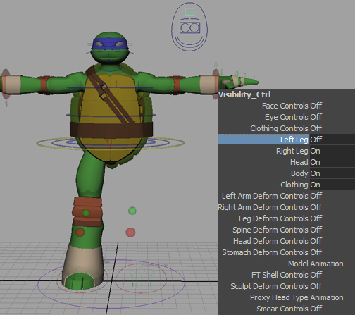
These attributes are in charge of showing or hiding different parts of the character in animation.

Typically, geo visibility attributes are made for the head, body, left arm, right arm, left leg, and right leg. If the character has more elements than the default amount, more will be added by the Character TD.

Limb Deformers
Limb deformers are meant to deform arms, legs, spine, and head in addition to any animation on those body parts.
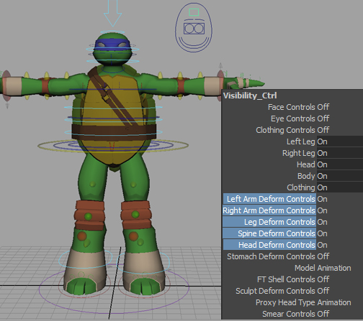
Limb deformers can be shown or hidden with the attributes underneath the geo display attributes.

These deformer controls will ride along the animation you’ve already created, so they can be used to further tweak animation and achieve cartoon like poses. When translating one of these controls, the geometry will try to angle the topology to accommodate the deformation. This angling of topology can be adjusted with the WireRotation attribute on the middle control of a limb deformer system.
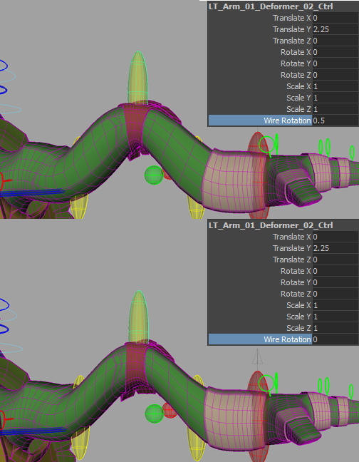
WireRotation attribute and its effect on topology.

Stomach and Sculpt Deformer
The stomach and sculpt deformers have become a standard on all characters going forward.
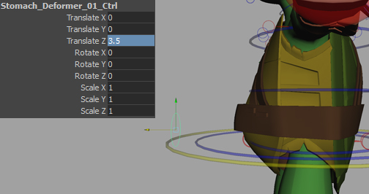
The stomach deformer is a cluster that deforms the stomach region
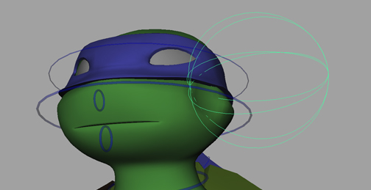
The sculpt deformer is meant to be used to deform geo whenever a punch has connected or the character is being hit by an object. It can also be used to blow up a specific part of the character depending on its positioning.

Character Specific Deformers
Many characters will need special deformers because of the way that they are designed.
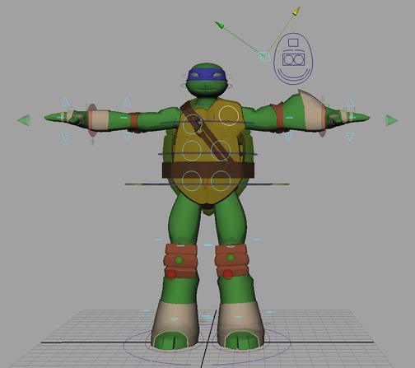
FTShellControls and SmearControls are additional deformer controls necessary for this character.

These deformers can be found at the bottom of the list of attributes on the visibility control.

Automated Systems

Jiggle Systems
Jiggle systems are rigged on parts of the character that need to flow and settle like cloth and hair like accessories.
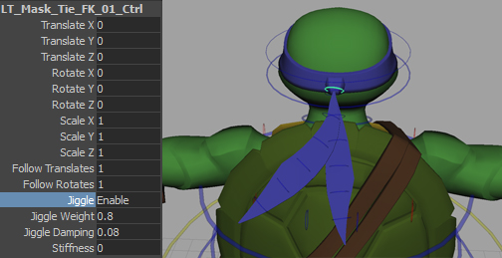
The jiggle system in action on a bandanna. Only jiggle has been enabled with no keys set.

You will know that a jiggle system is available for use if you select the first FK control in a system and examine its attributes. You should see the following for attributes:
versions of character geometry
Jiggle | the options for this attribute are Enable, Disable, and Enable Only After Object Stops. Enable and disable will turn jiggle on or off, should be off by default, and Enable Only After Object Stops will make the part jiggle only after all movement of its parent has stopped.
JiggleWeight | 0 to 1 attribute that controls the amount of jiggle derived from the motion of its parent. A value of 0 will have no jiggle and a value of 1 will have a large amount of jiggling.
JiggleDamping | 0 to 1 attribute that controls the halting of jiggle animation where a lower value will result in a loose jiggle and a higher value will result in very little jiggling.
Stiffness | 0 to 1 attribute that controls how elestic the jiggle animation behaves. A lower value will result in a more floating animation and a higher value will result in a more high energy jittery animation.

