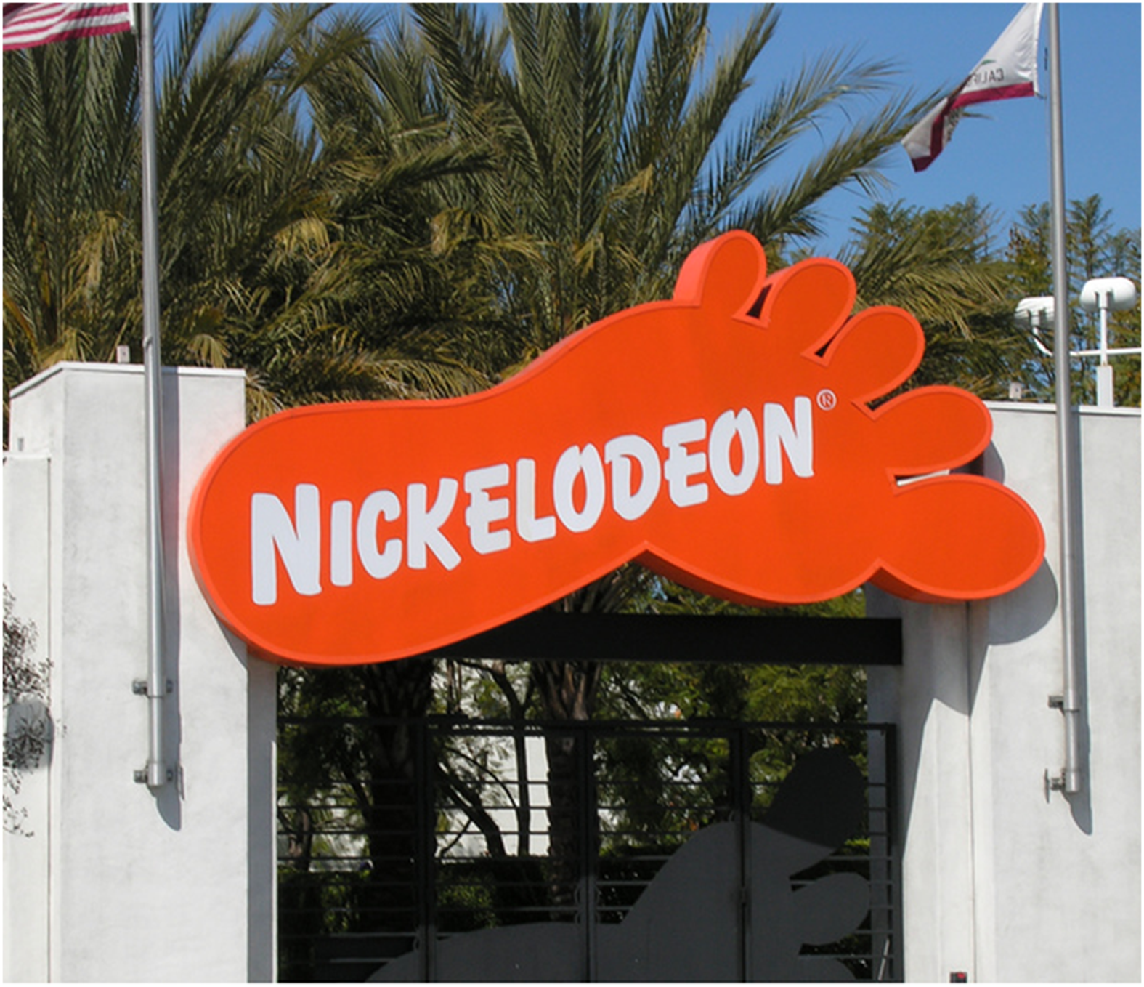
Blaze Rendering Process
Table of Contents
File Setup
Render settings 1
Additional Render PAsses
Shadow Pass 2
Creating the Ground Plane 2
Preparing the Shadow Lighting 2
Creating An Ambient Occlusion Pass 2

File Setup
File setup in Softimage is similar to the system used in Maya. The application uses a referencing system that pulls assets into the animation scene. You will be unable to make some adjustments to referenced objects while in the anim file.

- Navigate to your Animation scene path in an explorer window.

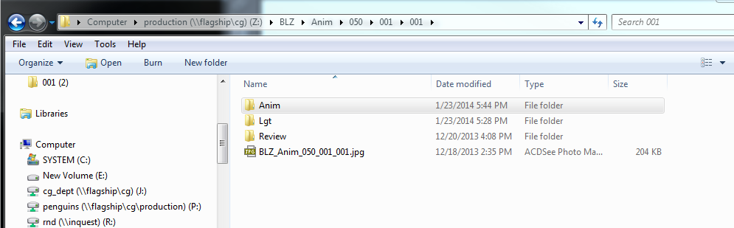

- Make a new folder in the scene folder and name it “Lgt”

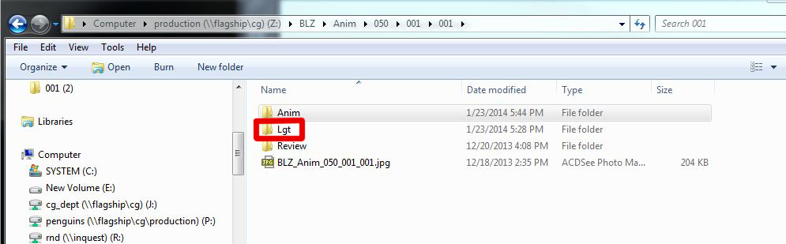

- Open a blank Softimage scene.
- Set your project.
- Open the latest Animation file
- Save your new scene in the “Lgt” folder you created in step 2. Name the file with the “Lgt_v001” extension.

Render settings
- Check to see if the pull down menu on the left side is on the Render tab. By default the tab may be set to the anim mode.
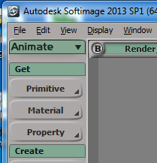

- Select the RENDER menu from the pull down menu on the left side. This will change the tool options below it so you can access the render buttons.

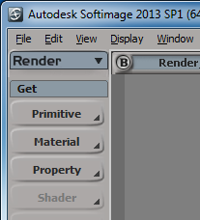

- Select the RENDER MANAGER from the RENDER menu.

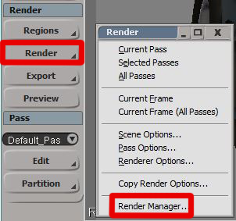

- The RENDER MANAGER is where you will set all the controls for the different render passes.

- Rename Pass Name from “Default Pass” to “Color Pass”

- Change the Pass Renderer from “Use Scene Render Option” to “Mental Ray”

- Edit the Render Channels Output to change the output format from “.pic” to “.tiff”. Selecting [Pass]_[Framebuffer] will allow you to click on the edit button to change the output format.

- Change Pass Frames from “Use Scene Render Options” to “Frame Range”

- Change Pass Camera from “Camera” to “Render_Cam”

- Under Pass Output Resolution, turn on “Override Scene Render Options” and then click on “Update from Camera”, this will update your Width, Height, Aspect Ratio and Pixel Ratio to match the camera.

- Change the Primary Rays to “Raytracing”

- Change the Aliasing levels to “Min 0” and “Max 2”

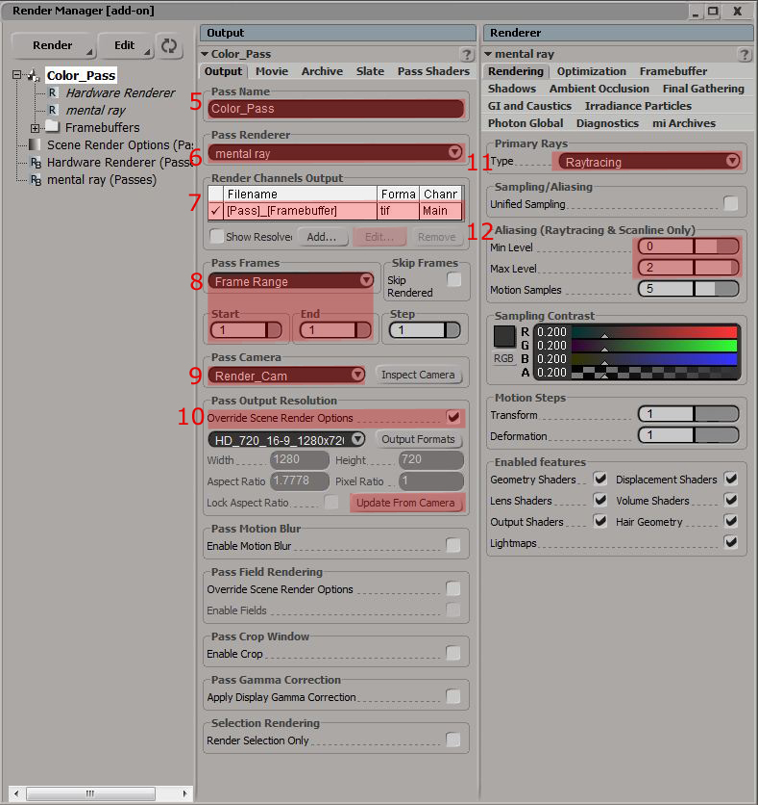

Before you render your color pass, change the output directory.

In the 1st column of the Render Manager , highlight “Scene Render Options(Passes)” this will allow you to change the “Scene Globals”

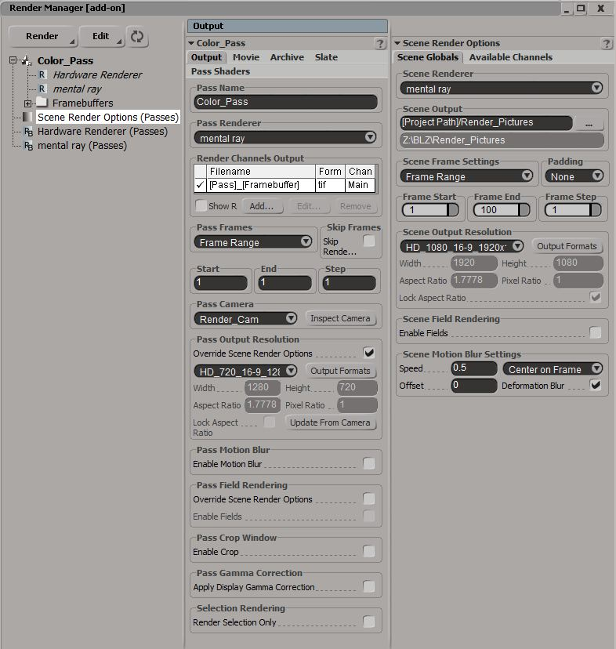

- Under Scene Output, click on the button and navigate to the correct directory. You can follow the normal directory structure Z:\BLZ\Comp\050\001\001\Nuke\_Footage
- Change Padding from” None” to “####” if you want 4 digit padding, you can leave it at None if your rendering a single NCR pose.
- Change the “Frame Start” and “Frame End”.
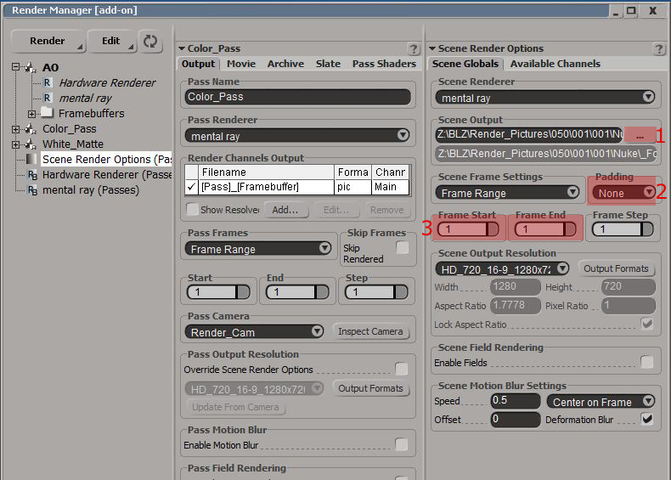

At this point you should be able to render your color pass. On the left side go down to the Render tab, select “Render -> Current Pass”. This will render the shot and save the image in the directory specified above.

Shader and Lighting Adjustments

The default shaders on some of the character bodies have lighting baked in. This means that they are entirely non-reactive to light. Remake the shaders using the process below to prep them for lighting, then add any necessary lights for maximum control. This process is done in the character model file so it will propagate into all anim files.

Shader Reconstruction
** Replacing lightmaps to a blinn (Current lightmaps work as surface shader)
1. Open the latest clean file under character folder.
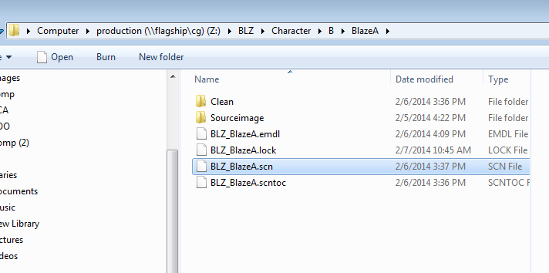
It’s handy to have render_region tool on as you change the shaders. But keep the quality low, otherwise it will take forever to render or can crash softimage.
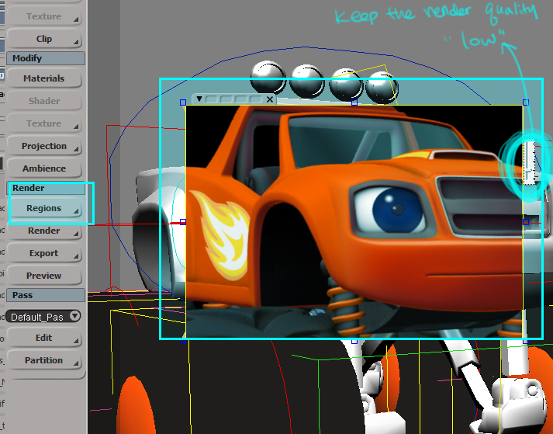

2.Hit Ctrl+7(if you are using maya interaction mode, 7 in softimage mode) to open up Material Manager.
3.Find the body shader you want to modify.
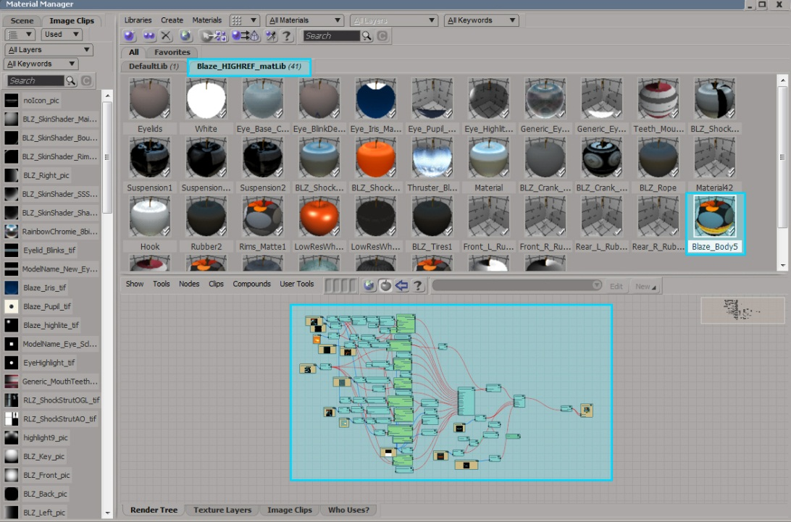
4.Go under the shader tree and find the main body shader you want to change and click “e” icon to expand.
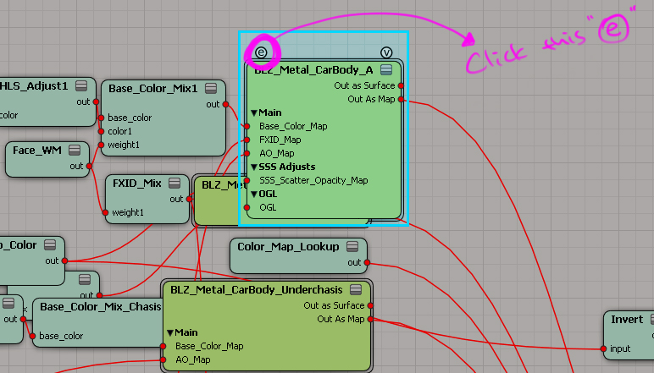
5. Find the light maps plugged into Shader_Mix weight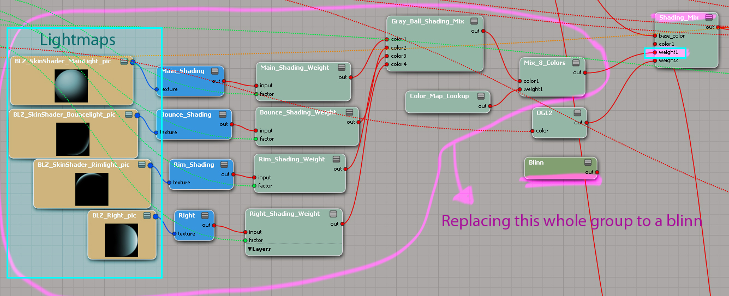
6.Open Render tree (shift+7). Under illumination, create a Blinn Shader then drag it into Material manager. Double click to open blinn attribute, then change diffuse value to 0.3, 0.3, 0.3 and disable specular.
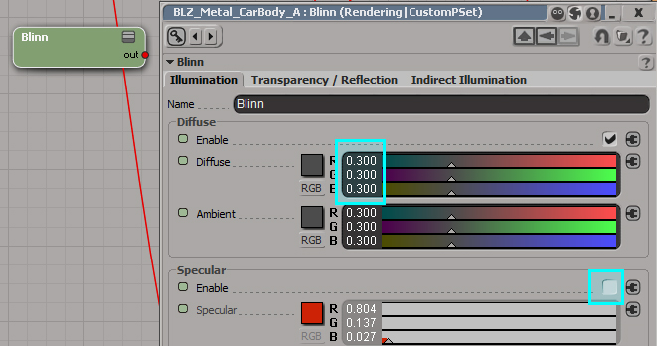

7.Connect the blinn to Shader_Mix weight 1 to replace the light maps. (drag the red dot on the right side of blinn node)
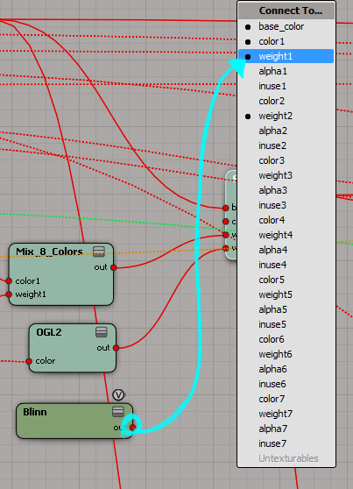

** Changing SSS value
In BlazeA, there was a weird red artifact around the mouth along the crease, and had to change sss value to fix it. If you don’t have a such issue, then skip this process.
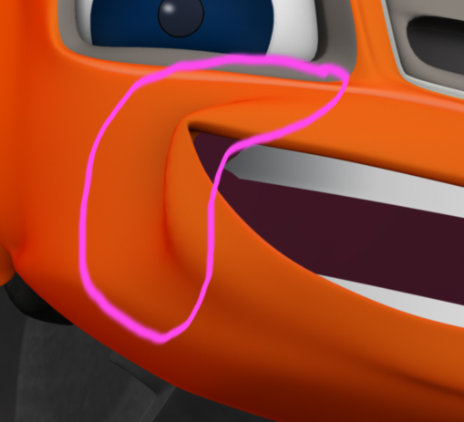
1.Find SSS map. 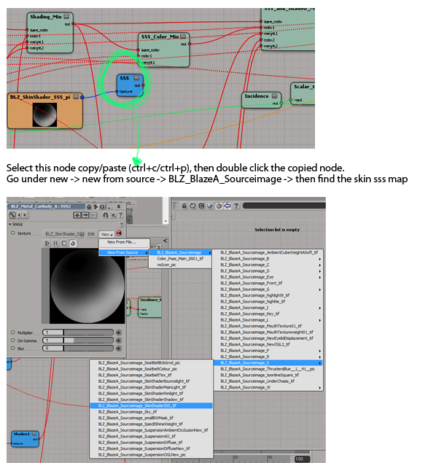
2.After you load the source file, double click the file. Go under Adjust tab then enable the effects. Lower the gain down to 20. 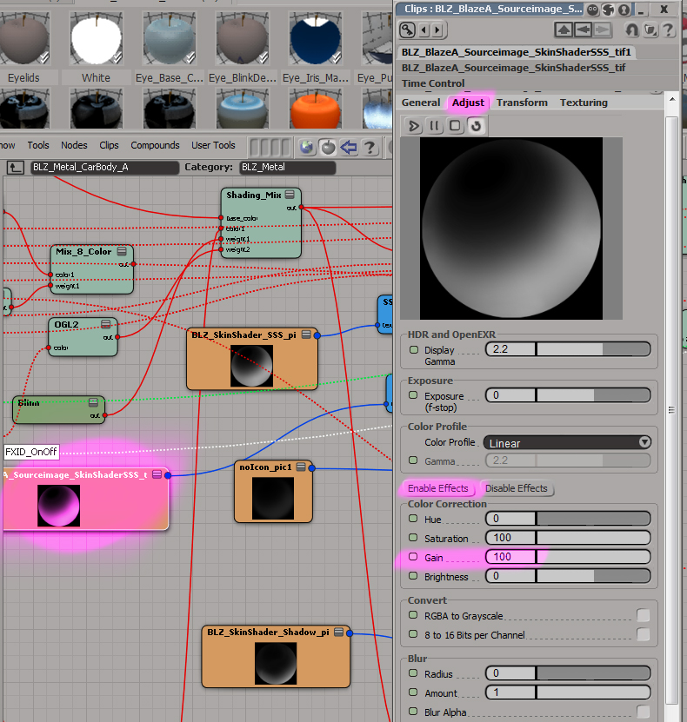

3.Connect the copied sss map to SSS_and_Shadow_Mix Weight1 to replace the original one. (Do not delete the original shader map)
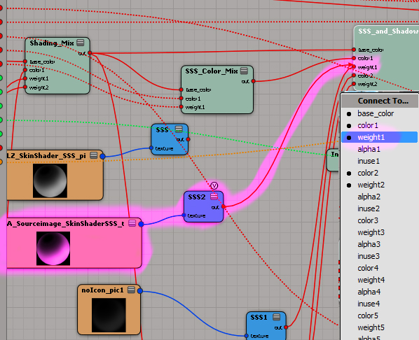

**Reducing the shadow map value (This reduces overall darkness around the undercarriage, bottom of body area)
1.Go back to the main body shader tree and double click the CarBody shader. And change the incidence Y value down to 0.478.
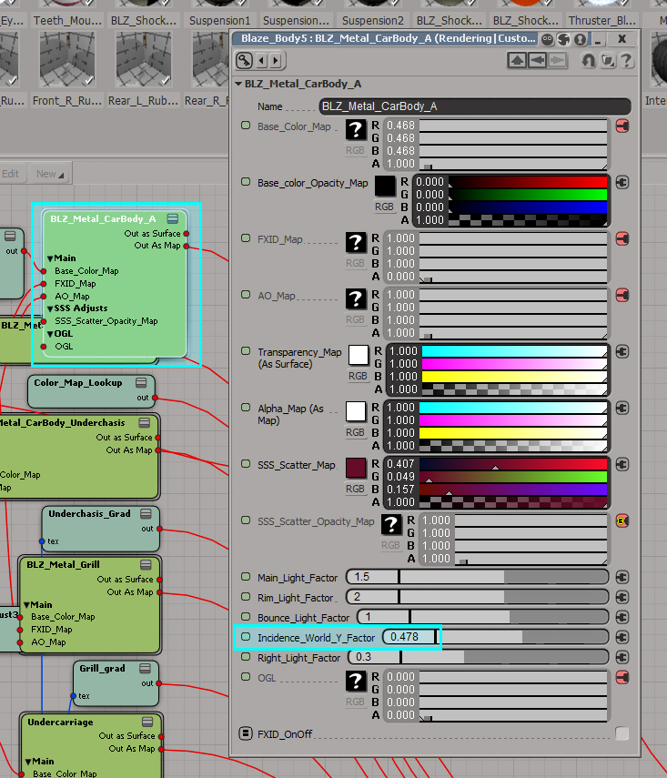

**Changing Mouth_fix_weight map (only If there is mouth_fix node connected to the main body shader, some characters don’t have it.)
1.Go back to the main body shader, then find Mouth_Fix shader. You can see Mouth_OGL map is replacing the base mouth color and you want to change the weight map of it to get rid of the shadow part since the OGL map has the shadow baked in. If you click “V” icon of the Scalar_to_Color3, then you can view the current weight map.
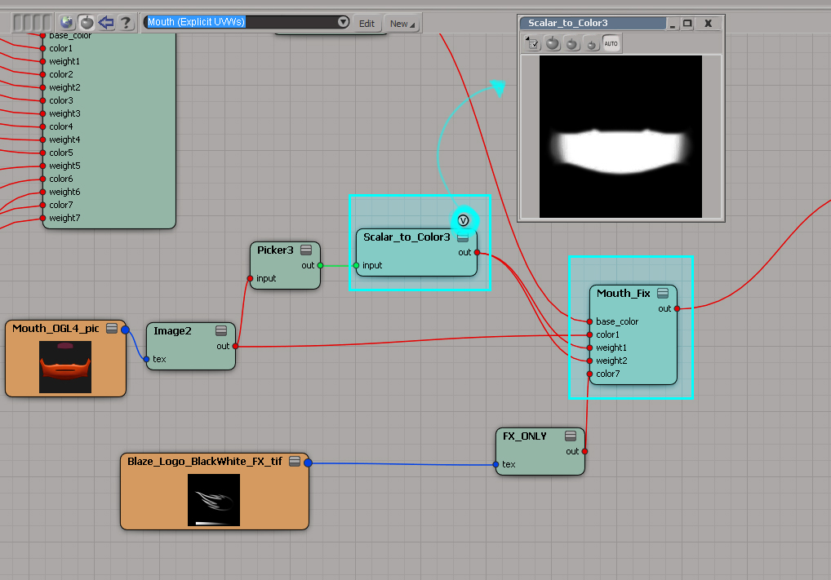
13.Change the weightmap in Photoshop. (I got rid of the shadow area but kept the high light area)
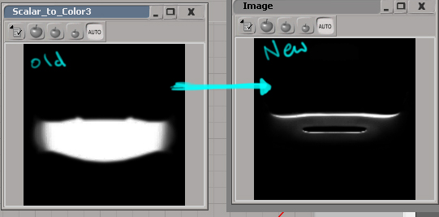

14.Load the new weight map you just created and plug that into weight1,2 to replace the old one. (make sure you are using the same UVs for the mouth piece- double click image node -> texture projection -> mouth)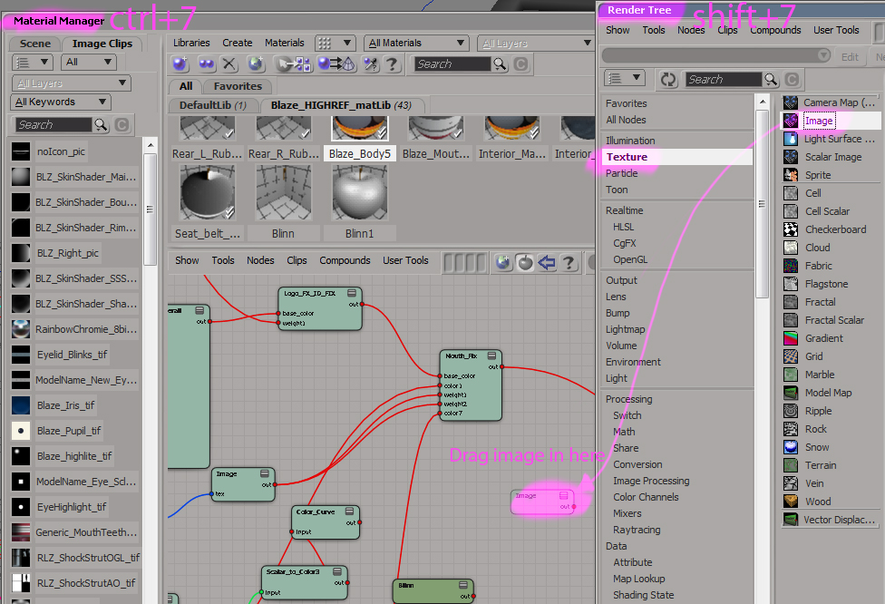e)
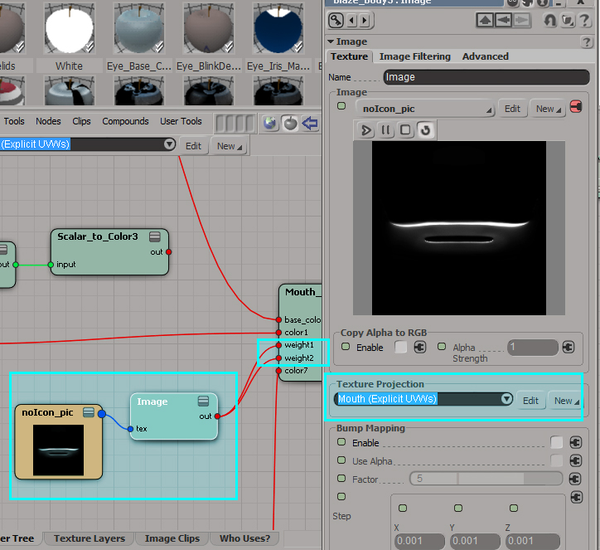

**Saving and Exporting
1.Version up the clean file. Open up Explorer (Ctrl+8) select the geo group, go to file->export->model, then save as emdl.
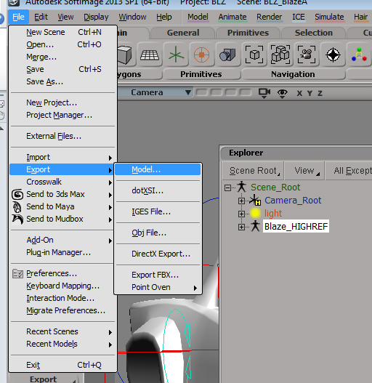
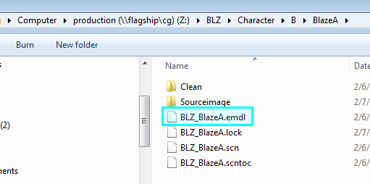

Adding Custom Lighting
Open up your lighting file, create a spot light, position it how you want. Enable the shadow, turn Umbra value to 0, add softness and sample rate if you want soft ray traced shadow.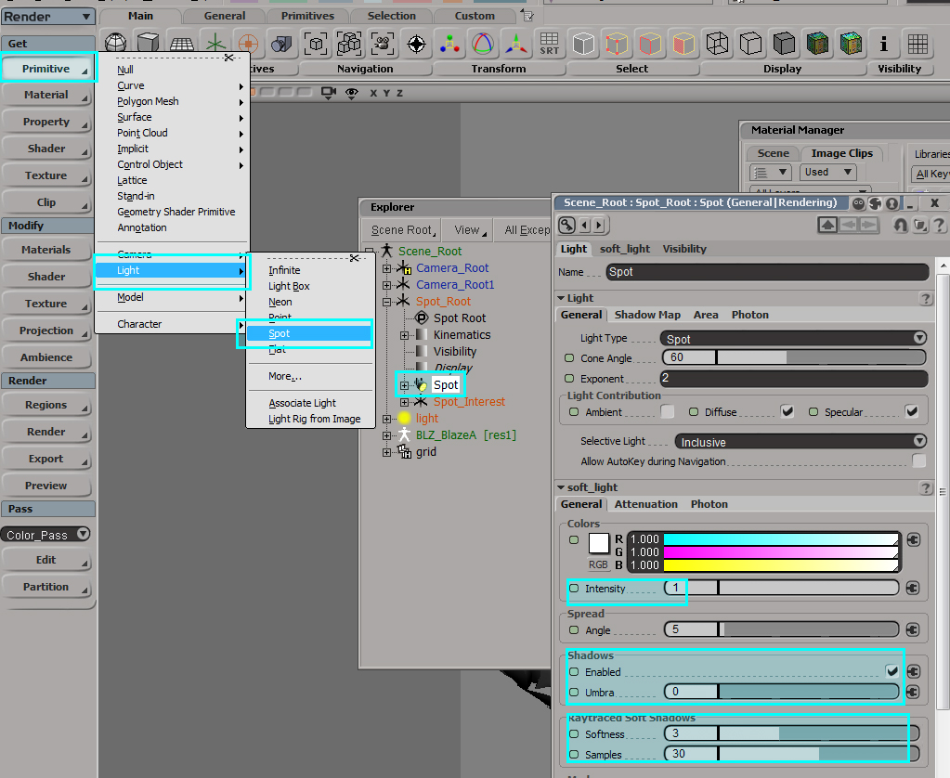
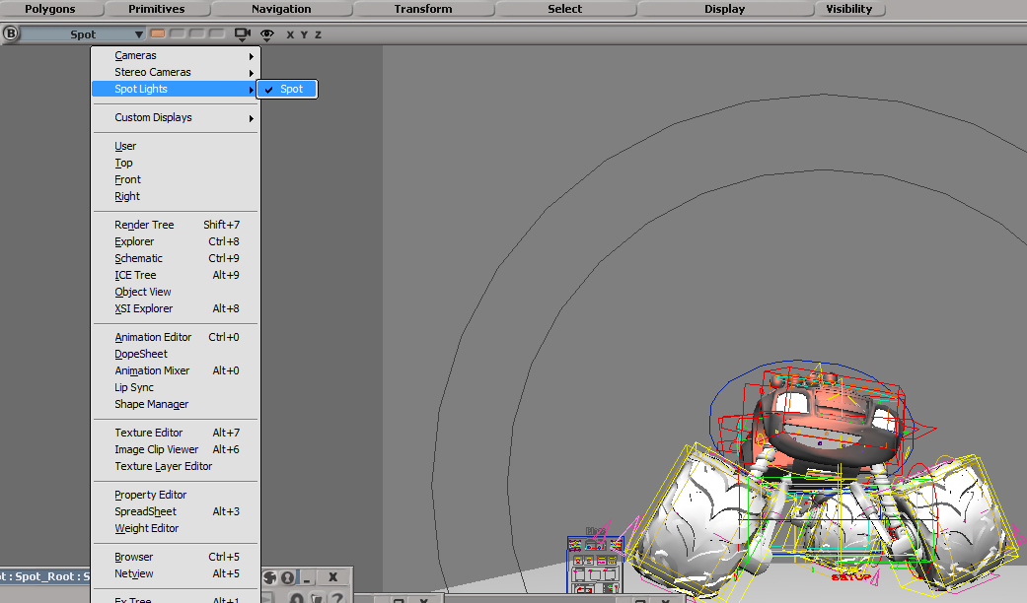
Looking thru the spot light camera will make it easier to position the light.

If you add more lights then it will change the ground shadow color. If you want only default light to cast shadow, use light link in shadow pass.
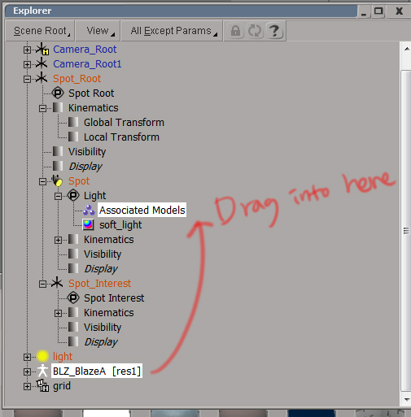

Paint Fixes

The car body will start reacting to lights after modifying the shaders. BlazeA had some issues with wrinkly geo around the mouth corner but painted out in photohop.

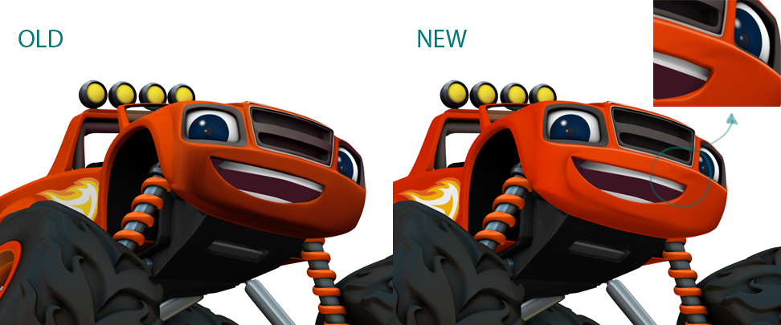

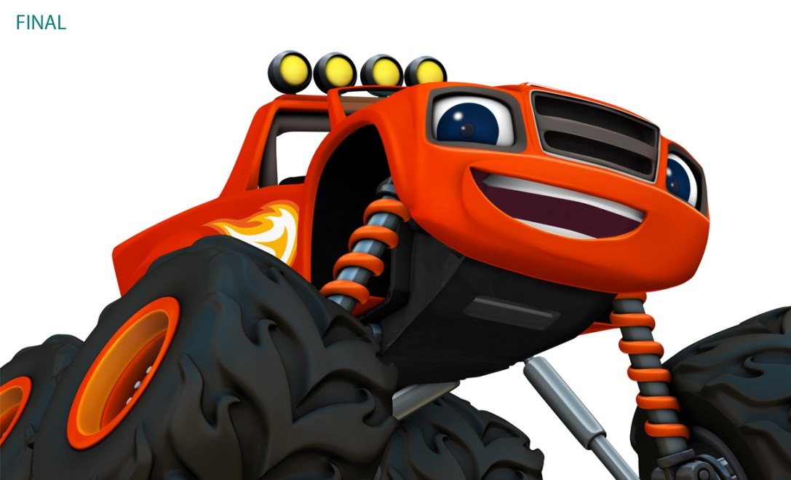

Additional Render PAsses
Your scene may require you to create shadow, AO or matte passes to complete the image.

- To create a pass, select your object or partitions you want to be in the pass from the explorer window. In this example we will select all the geometry in the scene by selecting the default “background_objects” partition. Think of a partition as a pass-specific group that can hold overrides for the objects inside it. The background objects partition is under the “default pass” hierarchy in the explorer window, so if you do not see it, expand the default pass hierarchy. The geometry in the viewport should now be selected.

- With the object or objects selected, click the Edit New Pass buttons, then select the pass you need to create. The first pass you will need to create is the shadow pass.

Shadow Pass
That shadow pass will create a black background with a white shadow. This is the opposite of what you need for compositing, so the output image will need to be inverted in comp. The shadow pass should be composed of the key shadow on the ground only – the character geometry needs to be invisible in this render.

- Create the shadow Pass by selecting Edit New Pass Shadow from the Pass tab on the left side of the display. This will automatically set up the materials and other settings for the shadow layer. These changes will apply to the shadow pass only and will have no effect on the color pass.

Creating the Ground Plane

- Create a ground plane by selecting Get Primitive Polygon Mesh Grid. Scale the grid to be large enough to catch the shadows.

- Select the grid and create a new partition called “Ground.” This will remove the grid from the Background Objects partition and allow you to override the grid and other objects independently.

- Select the Background Objects partition and select Get Property Override. This will bring up the override dialogue box.

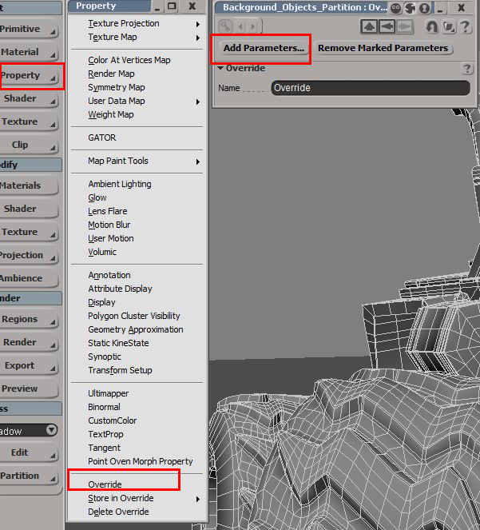

- Select “Add Parameters to open a list of the objects in the partition. This will open a window with a list of all the objects in the partition. By default they will all be selected, so making changes to one will affect all the others.

- Click on the plus sign next to the first object on the list to expand its hierarchy. Click on the VISIBILITY attribute to expand its hierarchy as well.

- The menu will now list a huge number of visibility attributes that can be overridden. Select SHADOW RECIEVER and click outside the window to accept the selection.

- The SHADOW RECIEVER attribute will now be listed in the override window with a checkbox. Uncheck the box to prevent the objects from catching shadows. Doing this will make the shadow pass record the ground shadows ONLY.
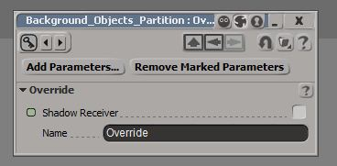

- Select the ADD PARAMETERS button again and repeat the process. This time, select the PRIMARY RAYS attribute. Uncheck the box as you did for the shadow recievers attribute.

- Next you will need to turn off the grid’s render visibility in the color pass. Switch to the Color Pass mode by selecting it from the drop down menu under the Pass tab on the lower left side of the screen.

- Select the grid in the explorer and create a new partition. The new partition will appear in the explorer window within the color pass hierarchy. Rename the new partition “Ground.” With the new partition selected, go to “Get -> Property -> Override”. Click the Add Parameters button to open a pop-up explorer window. Select Render Visibility and click outside of the pop-up explorer window to accept the selection. The render visibility option will now appear in the overrides window. Uncheck it to make the grid invisible in the color pass.

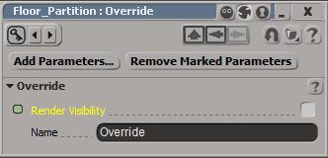
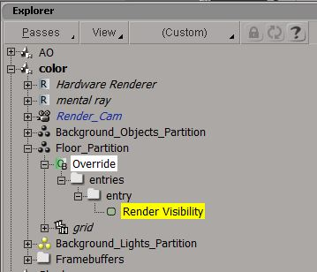

The grid will now be invisible in the color pass but will still catch key shadows in the shadow pass. The rest of the geometry will be visible in the color pass and invisible in the shadow pass.

Preparing the Shadow Lighting
The default light will provide you with the necessary character illumination, but in most cases you will need to create a separate light to cast the shadows.

- Create an infinite light to cast the shadows by selecting the Primitive Light Infinite under the Get menu on the left side of the display.

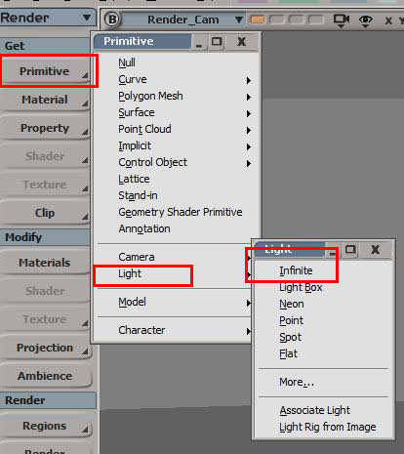

The options for the light will pop up immediately when you create the light. You will need to make some adjustments to the default options.

- Set the light intensity to 1.
- Enable Shadows.
- The umbra is the shadow darkness. Set this to 0.

- Rotate the shadow light as needed to adjust the time of day. Blurring and opacity changes can be made to the shadows in comp.

Render the Shadow Pass. It should be black with white shadows on the ground.

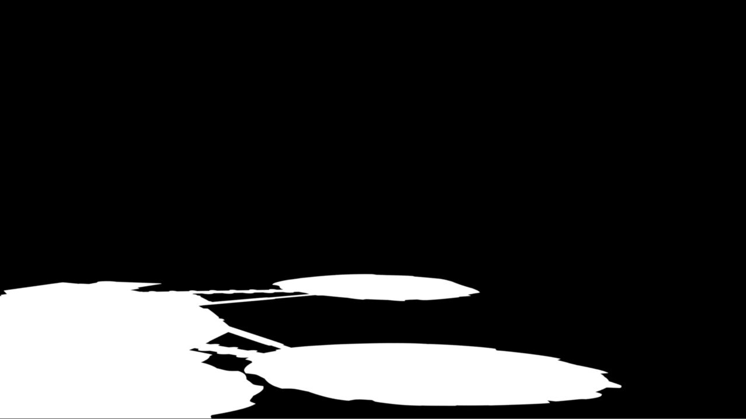

Creating An Ambient Occlusion Pass
Blaze characters have AO built into the shaders, but there may be cases in which an additional AO layer is needed. To make an Ambient Occlusion Pass, select the object or objects and create an Empty Pass.
- With the object selected, go to “Pass -> Edit -> New Pass -> Empty”. Rename the “Empty Pass” to “AO”. Next you’ll need to make a new partition, with the object still selected go to “AO-> Partition -> New Partition”. Rename the new partition “AO_Obj.”
To see the partition open up your Explorer window: “View -> General -> Explorer” or use the hotkey “8”. The explorer window is a rough equivalent to Maya’s outliner.

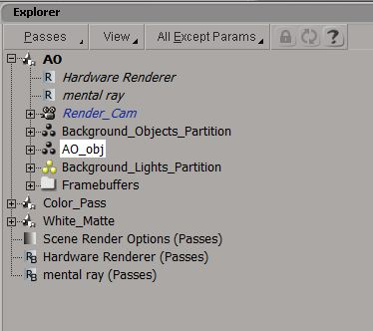

- Select the partition and go to “Get -> Materials -> Constant”. This will apply a constant shader to all the objects in that partition.

- With the partition still selected, open up the Render Tree window: “View -> Rendering/Texturing -> Render Tree.”

- Next you will need to add and then connect the Ambient Occlusion shader. In the Render Tree window, go to “Nodes-> Illumination ->Ambient Occlusion”. Click the red dot on the Ambient Occlusion node and drag the connection to the Material node. Shift select the Surface, Shadow and Photon ports to replace the connections.
.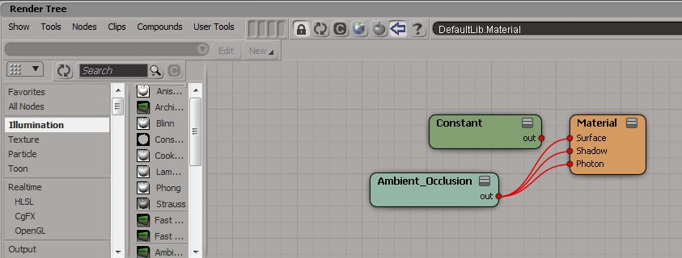
To make adjustments to the “Ambient Occlusion” shader, double click on the “Ambient Occlusion” node in the “Render Tree” window. Make sure you click on the AO partition in the Explorer window before you open up the Render Tree window or you won’t see the shader nodes. You will be able to change the number of Samples, Color, Spread and Maximum Distance from the Material menu.

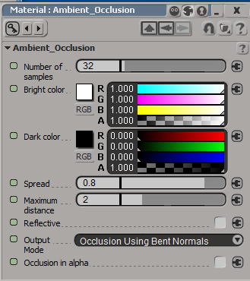

To enable the “Ambient Occlusion” and/or change the number of “Rays” open the “Render Manger -> AO -> Global Renderer -> Ambient Occlusion”.

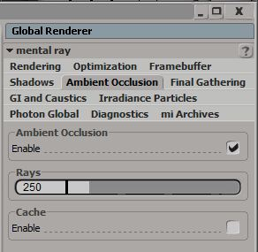

Approved Look
