McFarland, USA

ADVERTISING REQUIREMENTS & RESTRICTIONS

The marketing materials (the “Materials”) provided are intended for your use in promoting the exhibition of the above-mentioned title (the “Picture”). Your use of all Materials must include the copyrights, trademarks, logos, and credits intact, as provided below, wherever and whenever such Materials are used. Materials may not be altered inconsistent with the requirements below.

1. Approved Materials: Only the Materials provided by Disney ABC Home Entertainment and TV Distribution are approved for use, subject to the requirements and restrictions contained herein. Materials may not be used for any purpose other than the promotion of the Picture during the period of time you are authorized to promote the Picture.

2. Requirements and Restrictions: The requirements and restrictions set forth in the attached Paid Advertising Summary (the “Paid Ad Summary”) shall apply to any and all advertising, marketing and/or promotion activities of any kind related to the Picture (the “Campaign(s)”).

In addition, you are required to comply with the following provisions:

- Copyright:

i. The following copyright must appear in all Campaigns: © Disney Enterprises, Inc. All Rights Reserved.

ii. The year the Campaigns are created shall be added immediately following “©” in the copyright line. Do NOT alter the copyright on the original film and/or trailer.

- MPAA Rating: PG

The MPAA rating must appear in all Campaigns.

- Marketing Restrictions:

- THE FOLLOWING ARE NOT CLEARED TO USE IN ANY MARKETING MATERIALS:

  - The book PRE: the Story of America’s Greatest Running Legend, Steve Prefontaine by Tom Jordan, used as a prop (see below).

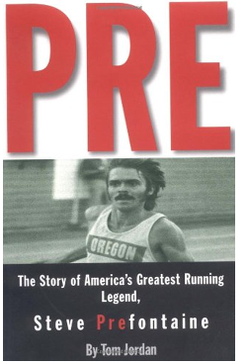

- Exterior McFarland High School dedication wall with cross-country runners’ names.

- Two photos of Johnny Samaniego (see below).

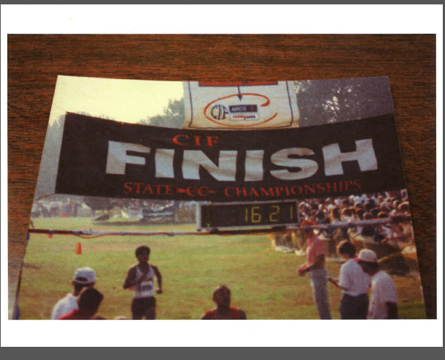

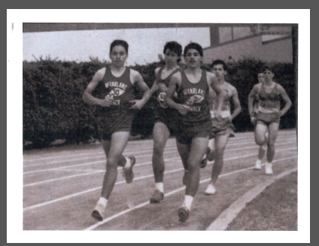

- Dialogue: “I hear they don’t run without a cop behind them or a Taco Bell in front of them”.

- A student’s poem in dialogue: “We fly like blackbirds through the orange groves, floating on a warm wind. When we run, we own the earth. The land is ours. We speak the birds’ language. Not immigrants no more. No stupid Mexicans. When we run, our spirits fly. We speak to the gods. When we run, we are the gods.”

- Footage from the TV show “CHiPS” playing on a television set in a Mexican restaurant.

- A girl’s pink “BARBIE” bicycle (ridden by Coach Jim White).

- In addition, the following restrictions apply:

Please use the following messaging on marketing materials if you wish to communicate that the film McFARLAND is based on a true story:

BASED ON A TRUE STORY

Please do not use the following messaging:

A TRUE STORY
INSPIRED BY A TRUE STORY

- Use of the song “Where the Streets Have No Name” by U2 is strictly prohibited in all Campaigns without clearing through Disney ABC Home Entertainment and TV Distribution.

- The song “Watermelon Man” is not clear for use in any context-marketing, including free previews.

- Commercial Tie-ins: No commercial tie-ins are permitted without the prior written approval of Disney ABC Domestic Television. Without limiting the foregoing, any Campaign that promotes not only the Picture, but also a product or service (including, without limitation, promoting the service or services that are telecasting the Picture), shall be considered a commercial tie-in for purposes hereof. For clarity, if a Campaign promotes your service as much as or more than it promotes the telecast of the Picture on your service, that Campaign would be considered a commercial tie-in and would require Disney ABC Domestic Television’s prior written approval.

- Use of Likeness: Use of an actor’s likeness in any and all Campaigns shall only occur in connection with the promotion of the Picture on the service to which it is licensed. Campaigns that endorse/promote/sell additional services (such as the Internet, telephone, computers, etc.) may not contain any actor’s likeness without prior written approval, pursuant to section 2(C) above.

- Guild Requirements:

- This is a DGA film. Credit to the director, whether in the billing block or otherwise, is required for advertising: (i) of one or more minutes; (ii) less than one minute if persons other than the two starring actors are credited (excluding congratulatory and/or award ads for that individual); (iii) where three or more actors are credited; (iv) “paid” trade ads. If an outdoor ad contains five (5) or more personal credits, or if the name of the writer(s) or producer(s) also appear in a “presentation” credit, the “Directed by” credit must be boxed.

- This is a WGA film. The credited writer(s) must be included in all publicity if the director or producer is included.

- Billing Block:

- Billing block credits are required in connection with the following: (a) in newspapers ads; (b) in magazine and other periodical ads that are twelve (12) inches or less IF the name of a person other than the two (2) starring actors (excluding only the names of reviewers) is mentioned; (c) if likenesses or photographs of more than three (3) starring actors appear; (d) in radio ads in excess of one (1) minute; (e) in television ads in excess of one (1) minute. Note: If any person or entity other than the actors is credited, the billing block will be required.

- Group advertisements, teasers, and trailers (unless film/camera process or producer and/or writer is mentioned) do not require billing block credits.

- Please refer to the Paid Ad Summary for billing block credits and size requirements.

- Special “Disney Pictures” Provisions: This Picture is distributed under the “Disney Pictures” banner. The following additional provisions apply to any and all Campaigns related to this Picture:

- The Picture shall not be exhibited or promoted adjacent to any R-rated video or print materials;

- the Disney name and/or logo shall not be used in such a way as to constitute an endorsement of any kind;

- the Disney name and/or logo shall not be used in connection with any non-Disney entity; and

- all Campaigns for the Picture must be pre-approved by Disney ABC Domestic Television in writing.

PRINT ADVERTISING BILLING BLOCK -
ONE SHEET/OUTDOOR, HALF- PAGE AND LARGER

DISNEY presents
kevin costner
”MCFARLAND, USA”
A MAYHEM PICTURES Production

A NIKI CARO Film

MARIA BELLO

MORGAN SAYLOR
Music by ANTONIO PINTO
Costume Designer SOPHIE de RAKOFF
Film Editor DAVID COULSON
Production Designer RICHARD HOOVER
Director of Photography adam arkapaw
Executive Producers mario iscovich mary martin
Produced by GORDON GRAY, p.g.a. and MARK CIARDI, p.g.a.
Story by CHRISTOPHER CLEVELAND & BETTINA GILOIS
Screenplay by CHRISTOPHER CLEVELAND & BETTINA GILOIS and GRANT THOMPSON Directed by NIKI CARO
© 2014 DISNEY ENTERPRISES, INC.
Distributed by WALT DISNEY STUDIOS MOTION PICTURES
Soundtrack available on WALT DISNEY RECORDS (logo)
DISNEY (logo)
disney.com/mcfarland
This film is rated PG for thematic material, some violence and language.

NOTE: Credits in the billing block must be not less than 20% of the average size (height, width and thickness) of the artwork title.
Billing block credits in outdoor advertising must be not less than 35% of the average size (height, width and thickness) of the artwork title.

PRINT ADVERTISING BILLING BLOCK
LESS THAN HALF PAGE

DISNEY presents
kevin costner
”MCFARLAND, USA”
A MAYHEM PICTURES Production

A NIKI CARO Film

MARIA BELLO
Executive Producers mario iscovich mary martin
Produced by GORDON GRAY, p.g.a. and MARK CIARDI, p.g.a.
Story by CHRISTOPHER CLEVELAND & BETTINA GILOIS
Screenplay by CHRISTOPHER CLEVELAND & BETTINA GILOIS and GRANT THOMPSON Directed by NIKI CARO
© 2014 DISNEY ENTERPRISES, INC.
Distributed by WALT DISNEY STUDIOS MOTION PICTURES
Soundtrack available on WALT DISNEY RECORDS (logo)
DISNEY (logo)
disney.com/mcfarland
This film is rated PG for thematic material, some violence and language.

NOTE: Credits in the billing block must be not less than 20% of the average size (height, width and thickness) of the artwork title.

TRAILER/TELEVISION AD BILLING BLOCK

DISNEY presents
kevin costner
”MCFARLAND, USA”
A MAYHEM PICTURES Production

A NIKI CARO Film

MARIA BELLO
Executive Producers mario iscovich mary martin
Produced by GORDON GRAY, p.g.a. and MARK CIARDI, p.g.a.
Story by CHRISTOPHER CLEVELAND & BETTINA GILOIS
Screenplay by CHRISTOPHER CLEVELAND & BETTINA GILOIS and GRANT THOMPSON Directed by NIKI CARO
© 2014 DISNEY ENTERPRISES, INC.
Distributed by WALT DISNEY STUDIOS MOTION PICTURES
Soundtrack available on WALT DISNEY RECORDS (logo)
DISNEY (logo)
disney.com/mcfarland
This film is rated PG for thematic material, some violence and language.

NOTE: Credits in the billing block must be not less than 20% of the average size (height, width and thickness) of the artwork title.

 |  |  |  | APPROVAL
ARTIST | ABOVE ARTWORK  TITLE CREDIT | LIKENESS TIE | AUDIO  MENTION | STILLS | LIKE-  NESS | KEY ART RESUB | CONSULT
KEVIN COSTNER | No | Yes - if the recognizable likeness of any other cast member appears; same or similar ad | Yes - if the name of any other individual cast member is mentioned in any radio ad or in the audio portion of any teaser, trailer or television ad; first position of cast mentioned audibly | Yes | Yes | Yes | No
MARIA BELLO | No | No | No | Yes | Yes | No | No
MORGAN SAYLOR | No | No | No | Yes | Yes | No | No
JOHNNY ORTIZ | No | No | No | Yes | Yes | No | No
CARLOS PRATTS | No | No | No | Yes | Yes | No | No
MICHAEL AGUERO | No | No | No | No | No | No | No
SERGIO AVELAR | No | No | No | No | No | No | No
HECTOR DURAN | No | No | No | No | No | No | No
RAFAEL MARTINEZ | No | No | No | No | No | No | No
RAMIRO RODRIGUEZ | No | No | No | No | No | No | No

ARTIST | ARTWORK TITLE | AUDIO  MENTION | AD CAMPAIGN CONSULTATION

NIKI CARO  Director | No | Yes, if anyone other than cast is mentioned in audio (DGA requirement). | - Initial U.S. theatrical advertising campaign  - Initial U.S. theatrical release pattern of the Picture.

GORDON GRANT/MARK CIARDI  Producers | No | No | - Initial U.S. theatrical advertising campaign  - Initial US theatrical release pattern

