By Paul Moncrieffe
Pipeline Studios Inc.
_{Script Coordinating 101}
The Gateway to Screenwriting

TABLE OF CONTENTS

THE NEEDS………………………………… PAGE 1

THE DRAFT STAGES.……………………. PAGE 1

SCHEDULEING.…………………………… PAGE 2

SCRIPT PREPPING……………………… PAGE 6

ASSUMPTIONS…………………………… PAGE 17

DISTRIBUTION……………………………. PAGE 19

NOTE TRACKING……………………….. PAGE 23

THE IMPORTANT MISCELLANEOUS... PAGE 30

CONGRATUALATIONS…………………. PAGE 36

- THE NEEDS

A. SOFTWARE: Every script coordinator will need to become a master at the following softwares…

FINAL DRAFT (or scriptwriting software of the productions choosing)

MICROSOFT WORD

GOOGLE SHEETS

GOOGLE CALENDAR

BANZAI

B. EMAILS: A script coordinator works very closely with the Story Editor and the Client, as you will be sending out drafts and draft notes daily to the team. You will be glued to your email, and need to make sure your email etiquette is pristine.

2. THE DRAFT STAGES

Before you become a great script coordinator, first you must understand the stages to making a great script for television. Although every show is different most productions follow these draft stages…

PREMISE

OUTLINE

FIRST DRAFT

SECOND DRAFT

POLISH DRAFT

RECORD DRAFT

Each stage helps the writer make the story the best it can be. Your job as a script coordinator is to keep the writer on track in order to hit their deadlines for the production. In order to track all these stages you’ll need to be an expert at …
3. SCHEDULING

A. SCRIPT SCHEDULE: Every production will provide you with a script schedule, that will look something like this…

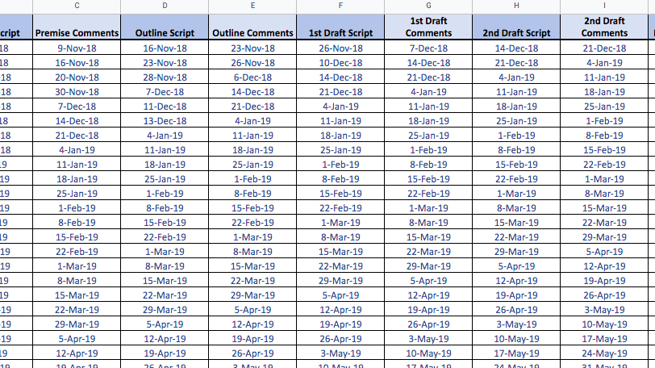
This provides you with the deadlines for each draft to follow. A full script, from Premise to Record Draft takes approximately 2 months. Below are the DAYS PER STAGE a WRITER gets (not including the noting process). These are meant to be guidelines, as you’ll find yourself shifting deadlines quite a bit, but it’s important you hit your RECORD DRAFT deadline, no questions asked.

PREMISE: Received
OUTLINE - 10 days
FIRST DRAFT - 8 days
SECOND DRAFT - 7 days
POLISH DRAFT - 5 days
RECORD DRAFT - 2 days

NOTING PROCESS: Each draft gets sent out to the team where they get approximately 2 business days to complete their notes.

From there you make your very own…

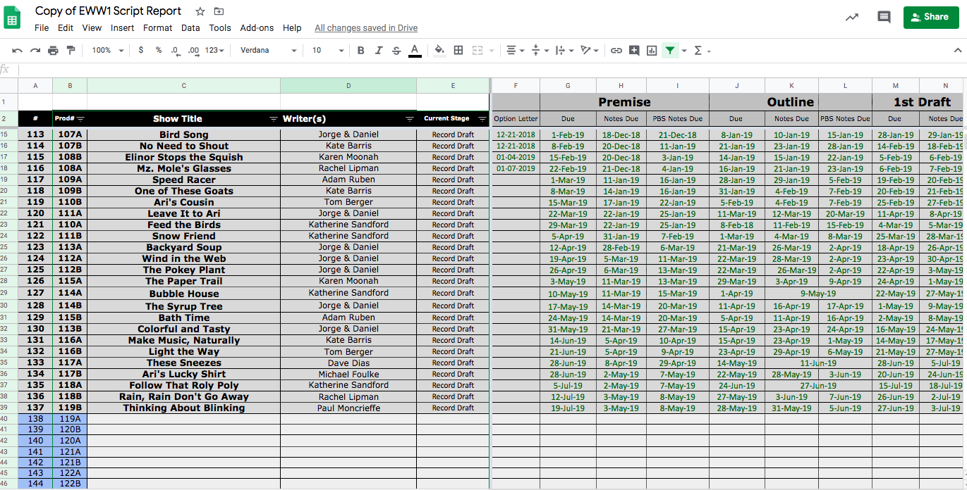
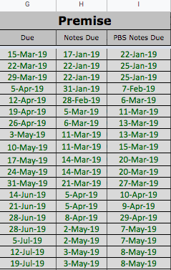
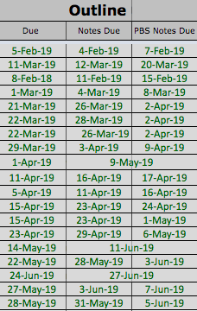
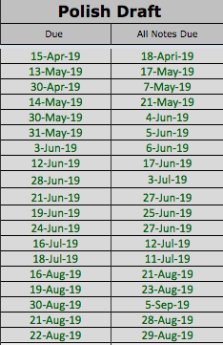
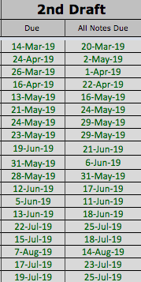
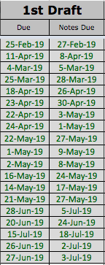
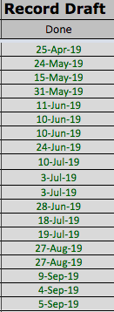
B. SCRIPT REPORT: A script report is every script coordinators holy bible. It’s made in Google Sheets. This is the number one document you will be working from daily. It tracks each script stage with draft deadlines and note deadlines.

C. SCRIPT NUMBERING: It’s important on your Script Report you have a script number and production number. The script number allows for easy maneuvering while pairing each 11 minute episode. You always refer to the Script # up until you create the RECORD DRAFT.

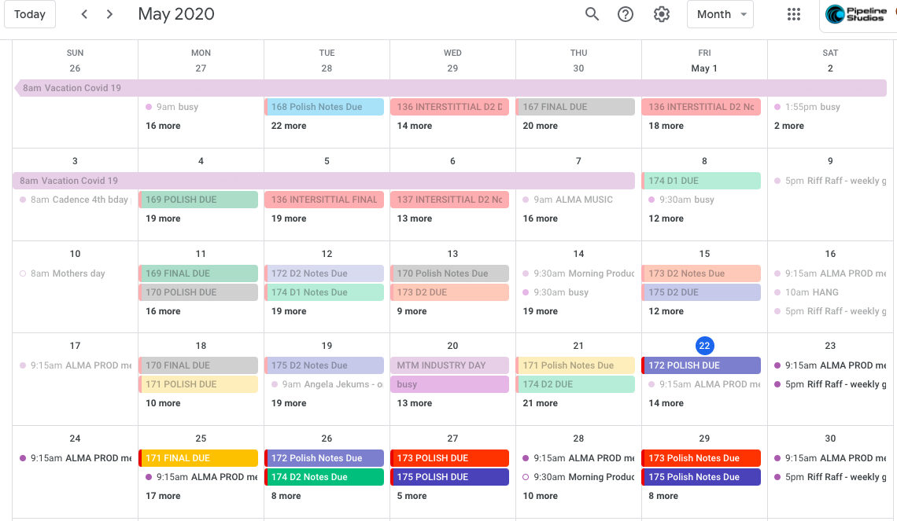
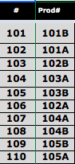

D. GOOGLE CALENDAR: To help keep track of your weekly deadlines, it’s a must to track each draft and notes on your google calendar, this helps you keep a birds eye view on your week, as well as makes it easy to maneuver deadlines.

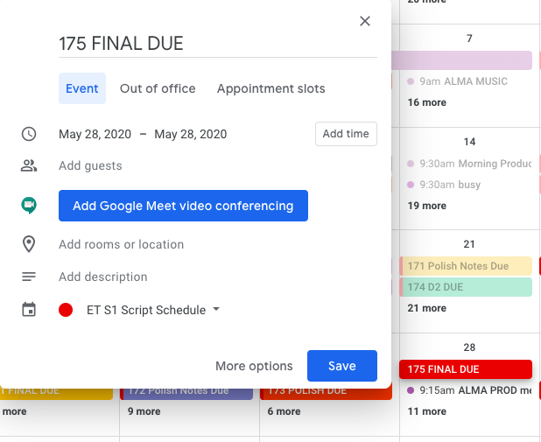
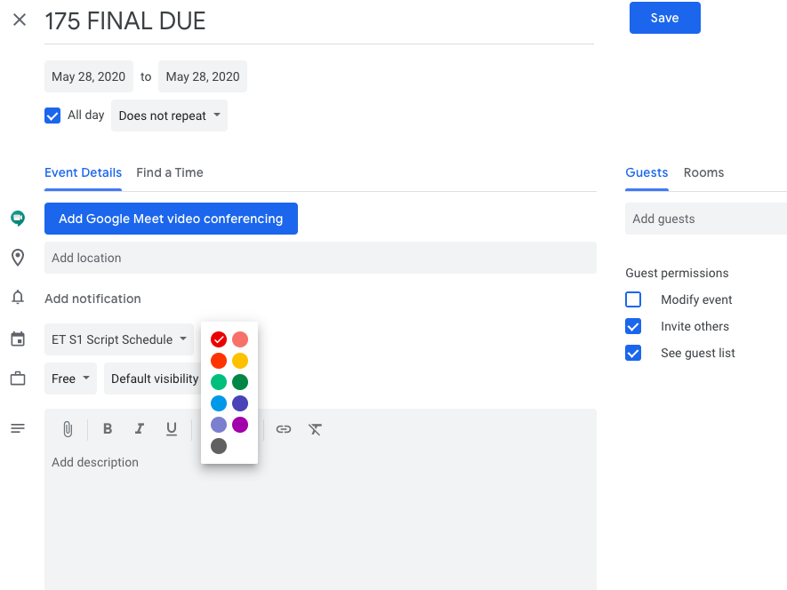
To enter a date on your Google Calendar, simply click on that date with your curser and fill out your deadline…

Make sure to colour code each script…

E. THE WEEKLY SCRIPT SCHEDULE: At the end of each week you send out a weekly schedule for the upcoming week to the team. The email will look something like this…
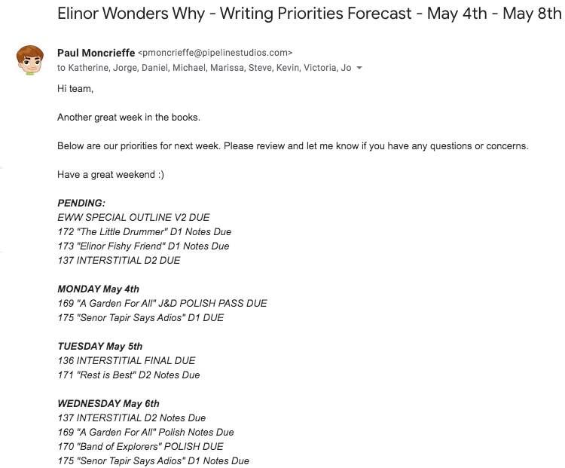

This weekly schedule is very important to you and your Story Editor. It’s an easy way to keep track of Deadlines that week. You should print it out and keep it on your desk for easy cross-out action, or if you need to add any priorities.

This leads to the next exciting thing about script coordinating…

4. SCRIPT PREPPING

You will receive each draft (hopefully on time) from your Story Editor. Before sending the draft out to the team to be commented on, every script coordinator has to make sure the script is properly prepped and ready to be distributed.

Each draft stage gets prepped differently…

A. PREMISE: You will receive a Premise as a Word Document (.doc). It’s important every premise is formatted properly. Every premise is 1 - 1 1/2 pages long. The story is written in full paragraphs. It must have the title, date and writers name centred at the top of the document because Premises don’t have title pages.

Although every production is different, “Elinor Wonders Why” asks for Elinor’s Question, Logline and the Curriculum to be present on every Premise.

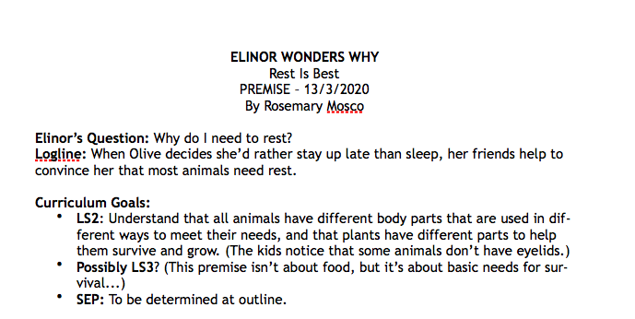
***PROOF READING: It’s not only important to proof read every draft for spelling and grammar mistakes, but it also important to proof read to make sure the story makes sense. I.E. character names, locations, act structure, songs, props, etc.

***Also notice this script isn’t assigned a script number yet, that’s because a Premise still needs to get approved by a broadcaster before being assigned a script number.

***All Premise documents should follow the same naming convention and should be saved as…

EWW_Rest is Best_PREMISE_13March2020

B. OUTLINE: You will receive an Outline as a Word Document (.doc). The document is much like a Premise but longer and more detailed. It’s must be around 4-5 pages long. The title must be formatted properly with Script #. It must have the Logline, Elinor’s Question and Curriculum present. It also must have scene headers numbered and bolded.

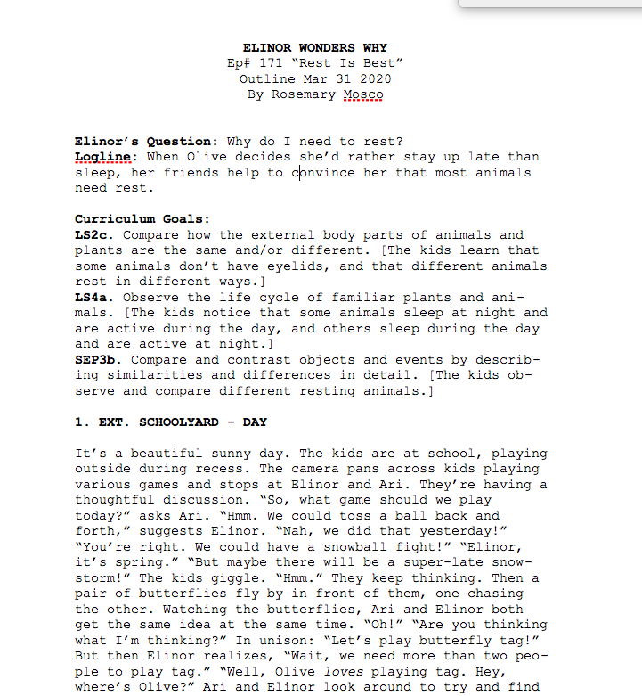
***Every production is different but “Elinor Wonders Why” asks for the episode ditty to be written on this draft.***

OUTLINE NAMING CONVENTION: EWW171_Rest is Best_OUTLINE_31March20

C. FIRST DRAFT - POLISH DRAFT: You will receive the First Draft - Polish Draft as a Final Draft Document (.fdx). The story is now in SCRIPT FORMAT. Each script should be around 12-14 pages long and have no more than 120 character lines.

Please follow the following steps in order to prep a script using Final Draft:

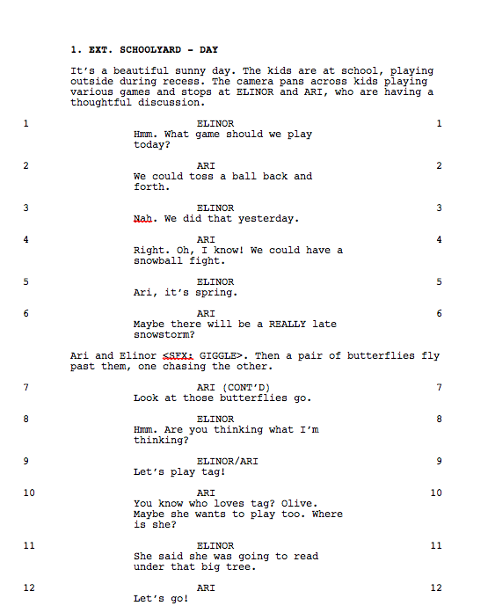
- Proof Read/Script Format - Spelling/Grammar mistakes. Make sure Scene Headings are numbered and bolded. Make sure all the <SFX> are similar. Check that all Characters, Locations, Props, and Ditties make sense.

2. Line Numbers - Make sure to reset the line numbers. Go to “Production” and click on “Scene Numbers”

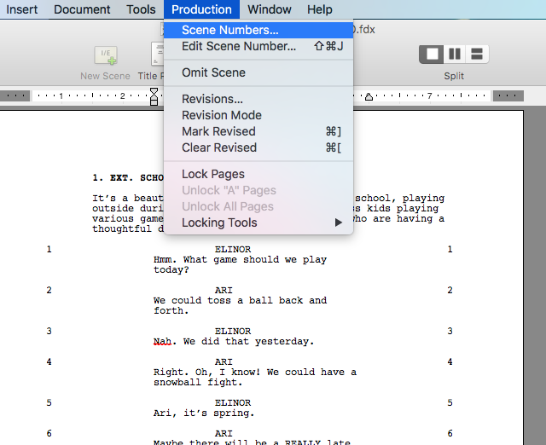

Then click on “Remove Numbers” and Scroll down to “Character” Then click “Okay”
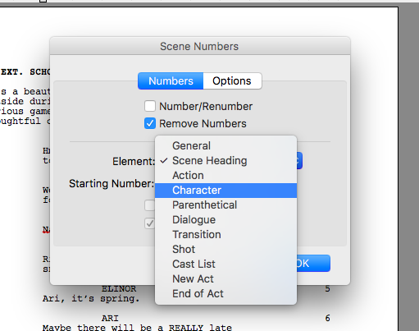

This removes all Line Numbers….

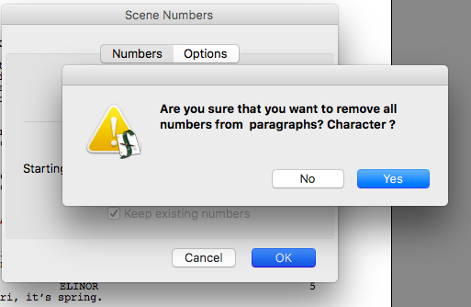

Then simply go back into “Production” “Scene Numbers” and click on “Number/Renumber” and choose “Character” and click “Okay.” This will renumber your line numbers for you.
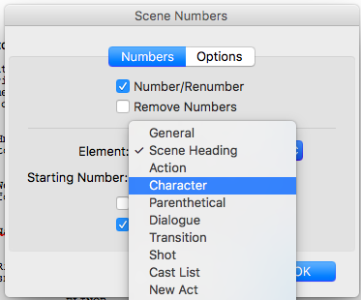

3. Header - Check to see the header of the script is up to date. This should match the title page and the naming convention of the document.

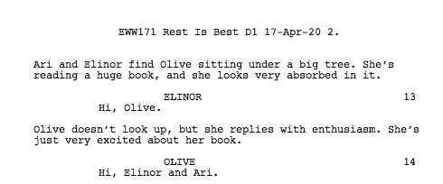
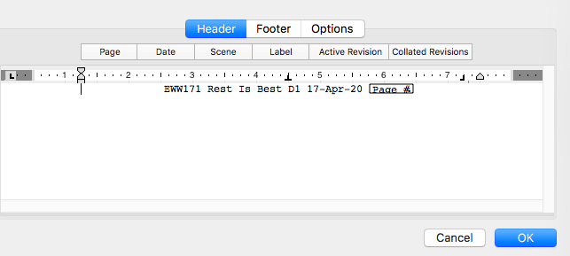
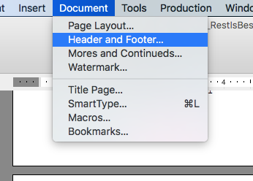
To edit the Header - simply click on “Document” then “Header and Footer”

Make sure your header has correct script number, title, stage and date.

4. Title Page - Find the title page by simply clicking the Title Page button at the top.

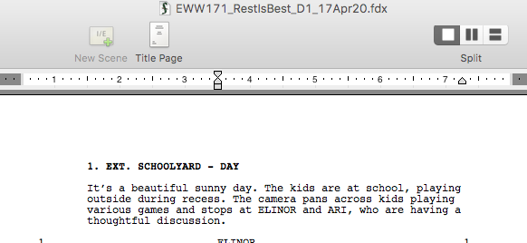
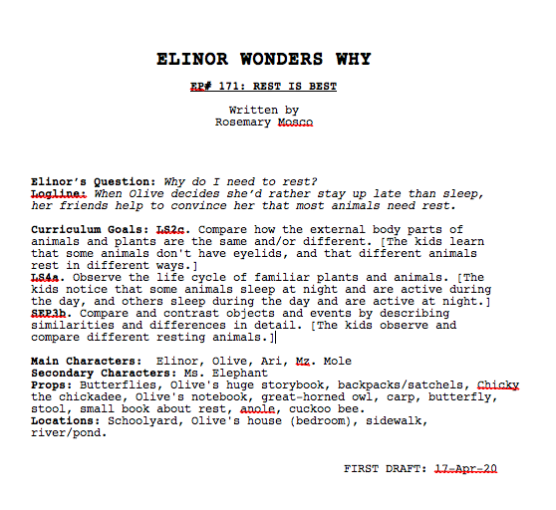
All Title Pages should be similar. They must have the title, script number, written by, Elinor’s Question, Logline, Curriculum, Characters, Props, Locations and Draft Date.

5. Saving Files - Each draft stage should be saved as a .FDX and a .PDF while following these naming conventions…

FIRST DRAFT: EWW171_Rest is Best_D1_17April20
SECOND DRAFT: EWW171_Rest is Best_D2_29April20
POLISH DRAFT: EWW171_Rest is Best_POLISH_08May20

D. THE RECORD DRAFT: You receive the Record Draft much like the other .FDX drafts. It will usually be called a FINAL. You'll follow the same steps through 1-5. But the main idea for the Record Draft is prepping it for the talent, which means you have to follow these extra steps…

6. Edit the Ditty - Every “Elinor Wonders Why” script has a ditty. The composers will have LOCKED this ditty by then. It’s your job to make sure the .MP3 (you receive from he composers) matches the ditty on the script for the talent.

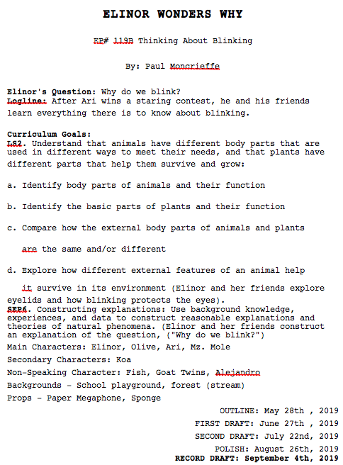
7. Title Page - The Title Page is just a little bit different than a normal draft. You will give the script its PRODUCTION NUMBER and always bold the Record Draft Date at the bottom.

8. Naming Convention - A Record Draft has a slightly different naming convention as you’ll have the Production Number present.

RECORD DRAFT: EWW136B_Rest is Best_RECORD DRAFT_15May20

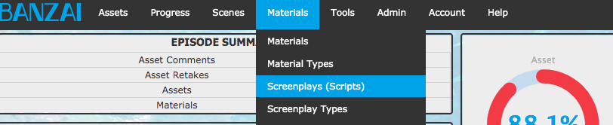
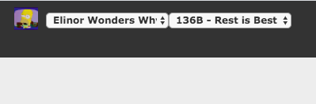
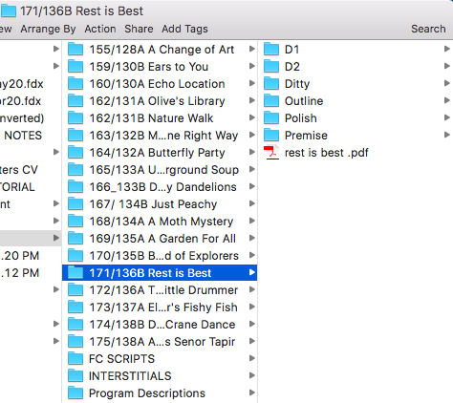
E. STORING YOUR DRAFTS: Each Draft Stage will be stored on Pipelines Server…

And on Banzai…

Simply choose the episode.

Click on “Materials” “Screenplays”

Drag and drop the .PDF of your script and select the correct Draft Stage.

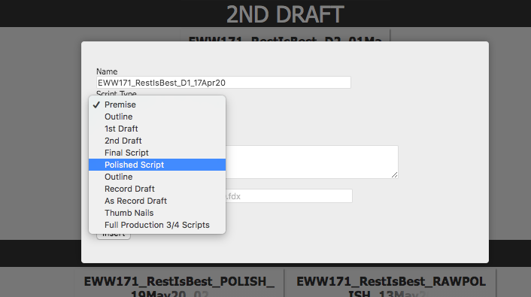
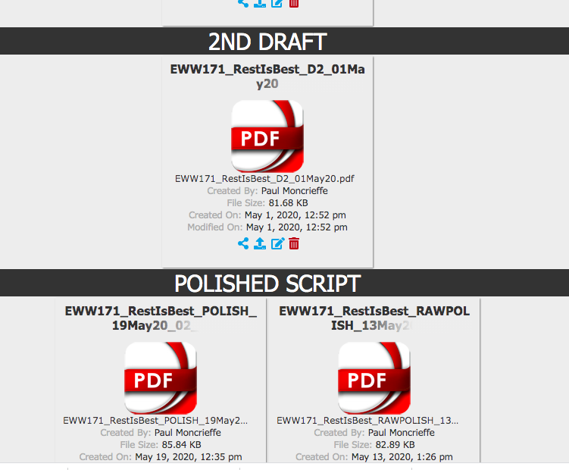

And your draft is successfully stored on Banzai.

6. ASSUMPTIONS

Every Production has different assumptions. The assumptions are put in place as guidelines for the creative to follow in order to help the rest of the production team. It’s your responsibility to work with your Story Editor to make sure you’re staying within them.

A director will give notes in regards to assumptions but it’s always a good thing to help him/her by…

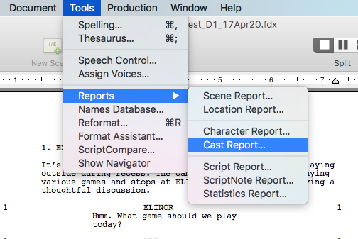
Making sure a story isn't too crazy with assets, it’s always a good thing to keep track of props, locations/backgrounds. You can also help the production by making sure you’re within the assumptions for Characters and Speaking Roles.

For “Elinor Wonders Why” we cannot have over 6 Principal Roles and 4 Actor Roles per a 22-minute episode, which means an A and B script.

A Principal Role is a character with over 5 speaking lines. An Actor Role is a character under 5 speaking lines.

Each 11-minute script is only allowed to have 120 speaking lines.

To keep track of these numbers you can follow these easy steps in Final Draft…

Go to “Tools” “Reports” and click on “Cast Report…”

Click “Okay”

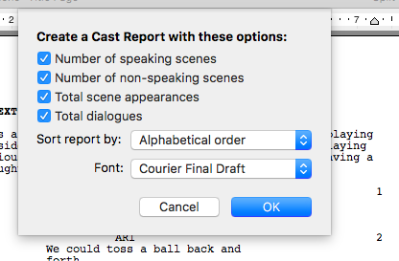
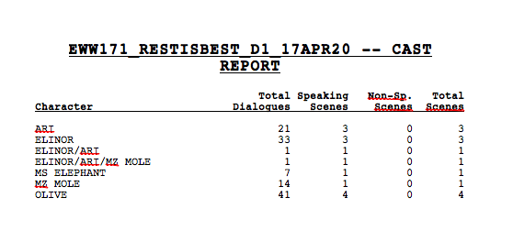
This will provide you with a list of all the speaking roles (Total Dialogues) in the script. You can simply add them up to see if you are within assumptions.

6. DISTRIBUTION

A. The Team - Now that your draft is prepped and within assumptions, it’s ready for the world to see, and it’s time to distribute to the team. Every production is different but a draft will usually go to these key team members:

CREATOR/CLIENT

BROADCASTER/CLIENT

DIRECTOR (S)

CONSULTANT (S)

PRODUCTION TEAM

It’s your job to work it out with your Producer and Story Editor on which key team members see what draft stage.

Elinor Wonders Why follows this process:

PREMISE - Sent to CREATOR, CONSULTANT AND BROADCASTER

OUTLINE - Sent to CREATOR, CONSULTANT, DIRECTOR and BROADCASTER

FIRST DRAFT - Sent to CREATOR, DIRECTOR and CONSULTANT

SECOND DRAFT - Sent to CREATOR, CONSULTANT and BROADCASTER

POLISH DRAFT - Sent to CREATOR, CONSULTANT, DIRECTOR and BROADCASTER

RECORD DRAFT - Sent to PRODUCTION TEAM (Pipeline Studios) to distribute to talent and rest of productions staff.

***After sending each draft, your key team members have approximately 2 business days to return their notes/comments.

B. THE DRAFT DISTRIBUTION LIST - Make it easier for yourself and make a Draft Distribution List. This will keep track of who you have to email with each draft. I have mine, as a TAB on my SCRIPT REPORT….

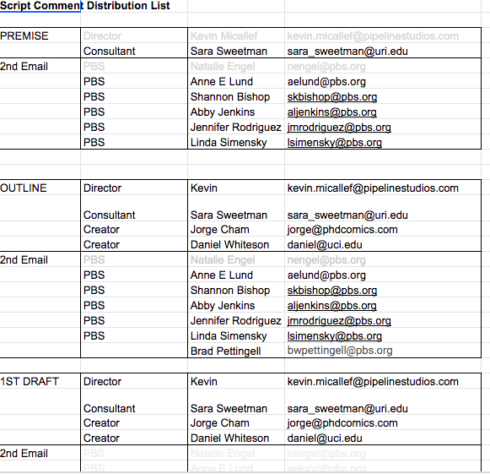

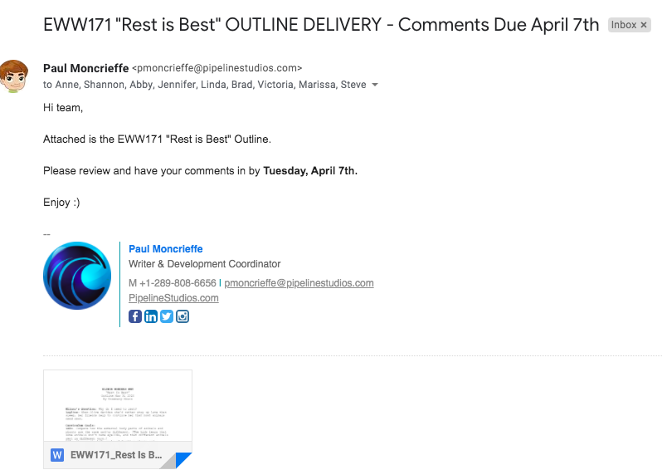
C. The Email - The email to the key team members should be short and concise and have a cleat DUE DATE. The Premise and Outline email will have a .doc attached.

While the First Draft - Polish Draft will have a .fdx and .pdf attached. As well as a link to the Note Tracker.

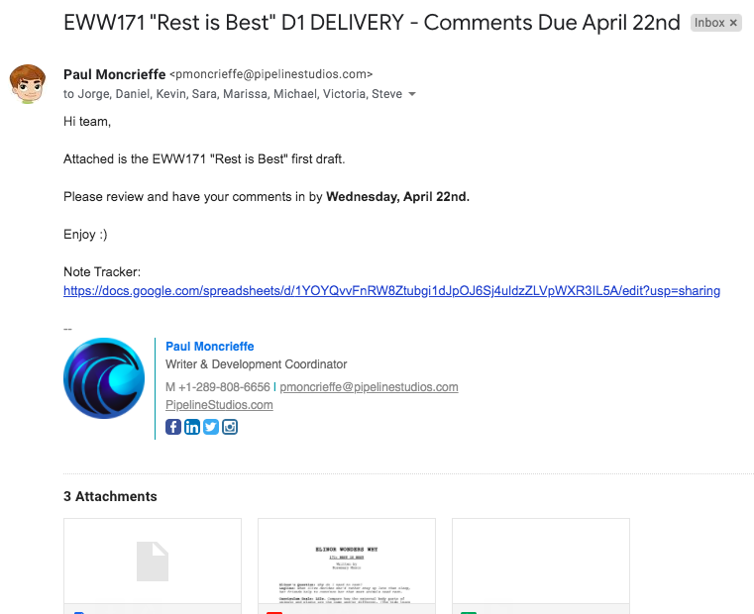
D. The Note Tracker - The Note Tracker is an easy way to track notes from your key team members per First Draft - Polish Draft.

You create it in Google Sheets. Each of the key team members have a column where they note on the script by the line numbers provided in the document. You provide the different drafts on the bottom TABS for easy access.

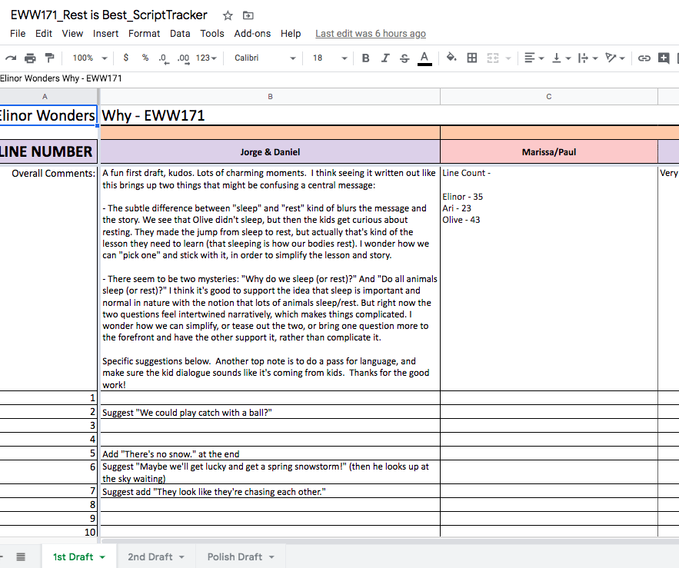

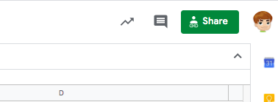
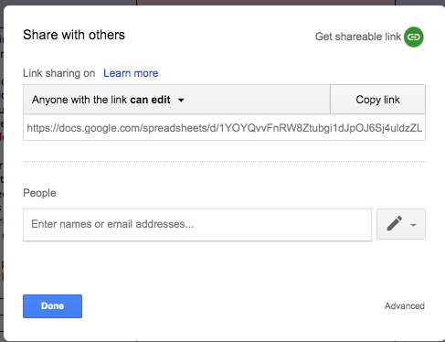
To create a link for this document, you simply click the “Share” button on the top right of the screen.

Then you click the “Copy Link” button and paste it into your email.

Which leads to the next very important task for every script coordinator…

7. NOTE TRACKING

You will receive the notes on each draft (hopefully on time) from your key team members. Now, it’s your job to consolidate all those notes and make them easy to read for the Story Editor and Writer.

You track each draft stage notes differently…

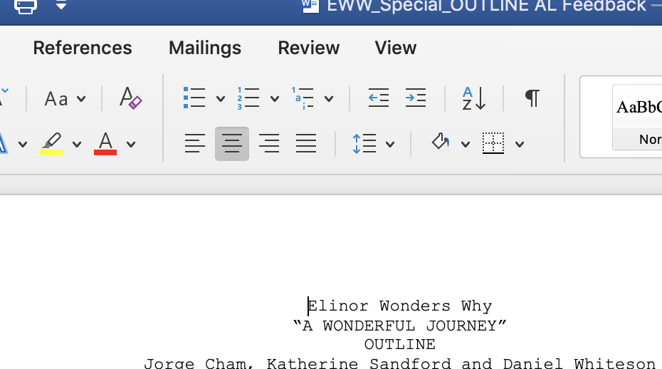
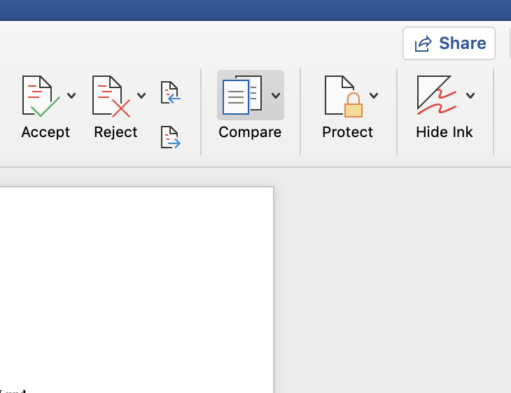
- PREMISE - OUTLINE: You’ll receive the Premise and Outline notes embedded into the Word Document (.doc) you distributed.

Each key team member will send you their notes separately. It’s your duty to combine all the notes into one document. Please follow these easy steps…

1. Open up one of the note documents in Microsoft Word and click on the “Review” button.

2. Then scroll over and click on “Compare”

3. Then you’ll click on “Combine Documents”

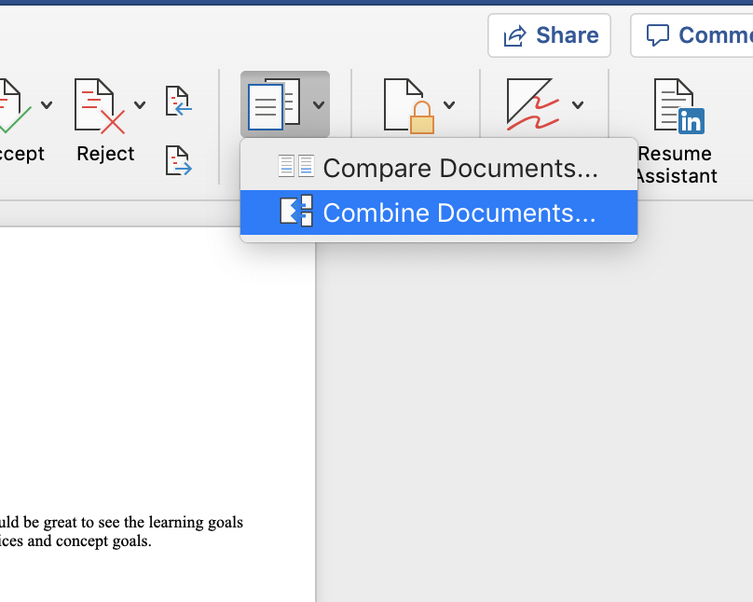
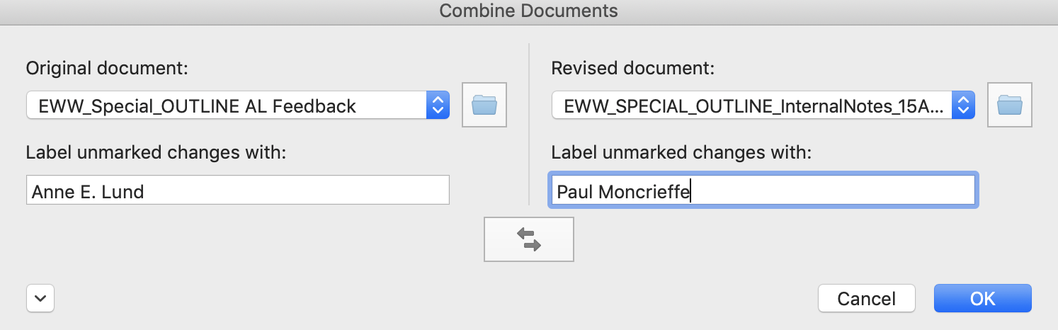
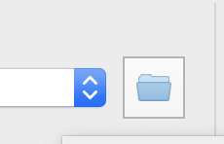
4. Using the blue “arrows” simply find the two documents you want

to combine. Then click “OK”

5. This MERGES the TWO documents showing both sets of NOTES. Simply SAVE the document.

NAMING CONVENTIONS:

EWW171_Rest is Best_Premise_AllNotes_18Feb20
EWW171_Rest is Best_Outline_AllNotes_05March20

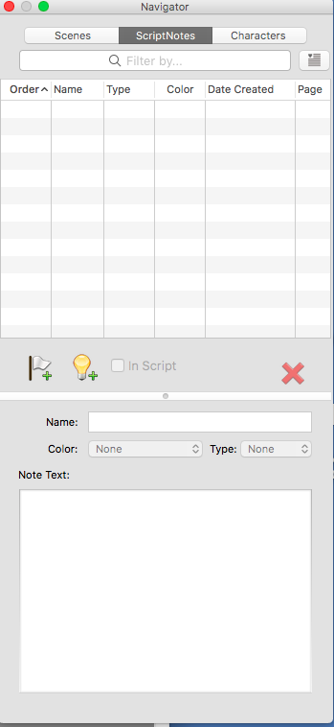
B. FIRST DRAFT - POLISH DRAFT: You’ll receive these notes in your trusty NOTE TRACKER (6.D.) It’s your job to embed them into the Final Draft script (.fdx) for the Story Editor and Writer. Please follow these easy steps…

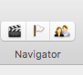
1. Open up the corresponding script in Final Draft and at the top right of the document click on the “Flag” button.

2. This will open up your “Navigator” tool.

3. Click on which line in the script you’d like to leave a comment. i.e. LINE 2.


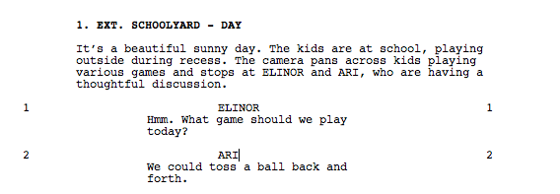
4. Then click on the in your navigator to add a note.

5. You should see a little BLACK FLAG show up.

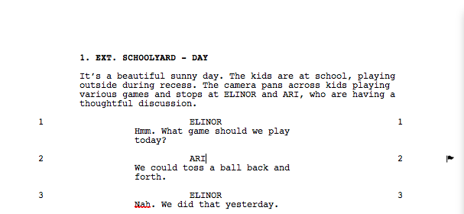

6. Open up your corresponding NOTE TRACKER (6.D.) and Copy the corresponding NOTE…

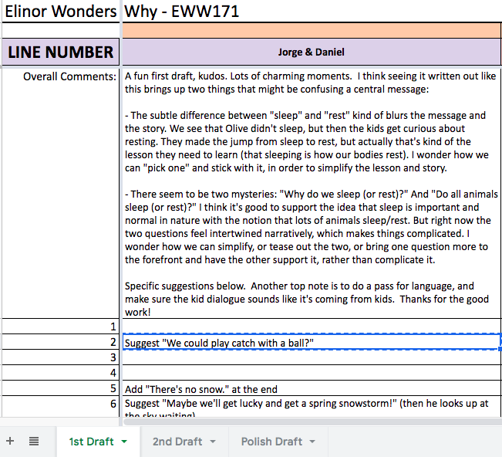
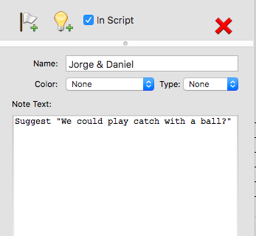
7. Paste the NOTE into the Navigator’s “Note Text:” and “Name:” who gave the note.

8. Then give each NOTER a colour code.

9. Repeat these steps until every NOTE is embedded into the script. Then SAVE.

NAMING CONVENTIONS:

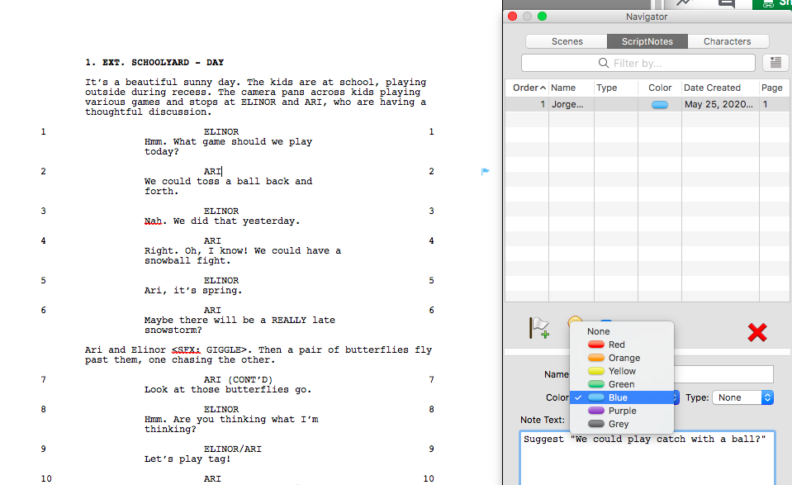
EWW171_Rest is Best_D1AllNotes_22March20
EWW171_Rest is Best_D2AllNotes_01May20
EWW171_Rest is Best_PolishAllNotes_12May20

C. STORING NOTES: Make sure to save your note docs on Pipeline’s Server.
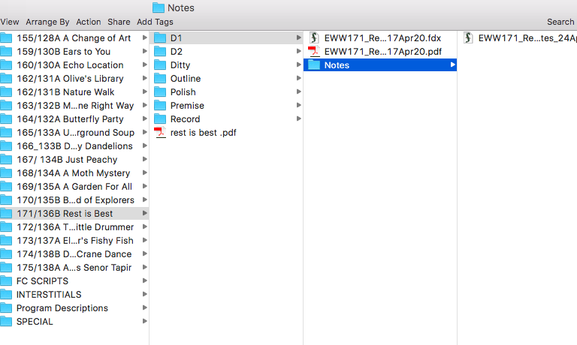

D. THE EMAIL: After all the notes are combined and stored properly. You email the notes to your Story Editor and issue the next DRAFT DUE DATE. Make sure this email is concise and the DUE DATE is clear.

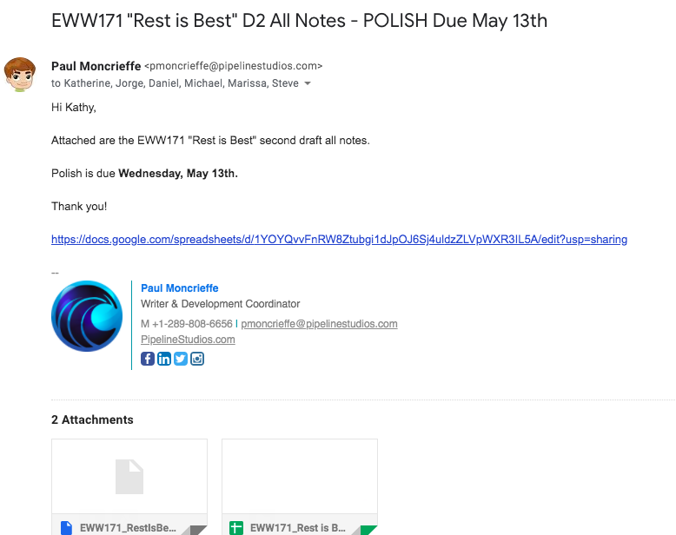
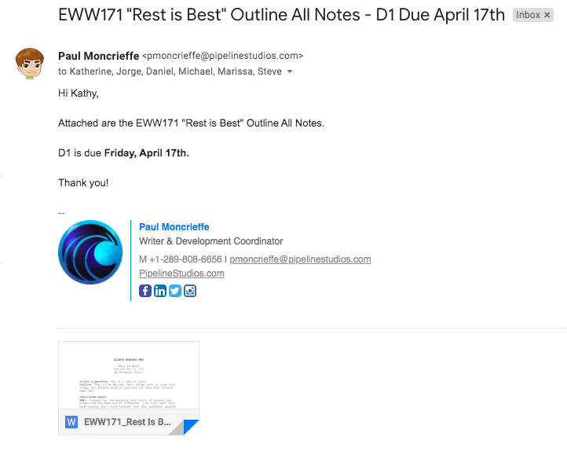
- PREMISE - OUTLINES: You attach the document (.doc) with combined embedded notes…

2. FIRST DRAFT - POLISH DRAFT: You attach the script (.fdx) with embedded notes and the Note Tracker…

7. THE IMPORTANT MISCELLANEOUS

Every great script coordinator helps out the Story Editor and Production team as much as humanly possible. This leads to all sorts of important miscellaneous tasks…

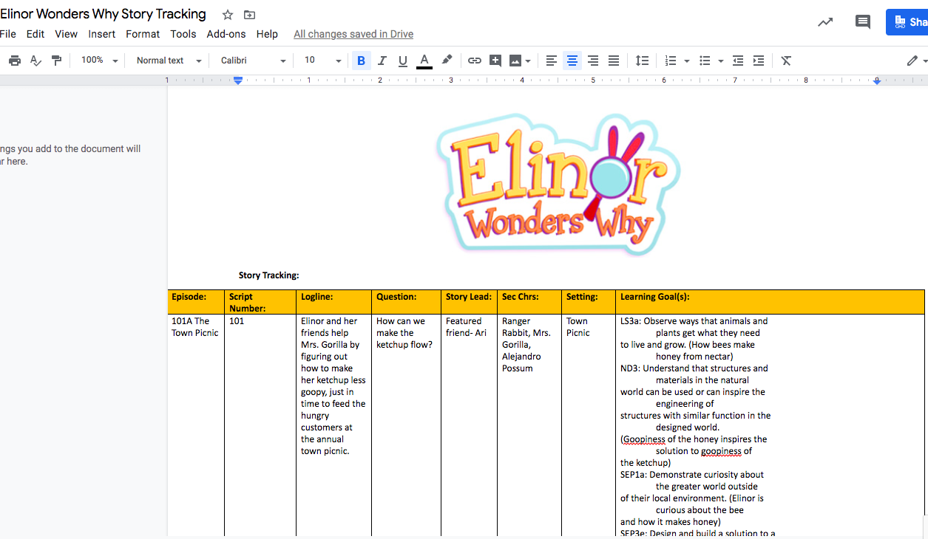
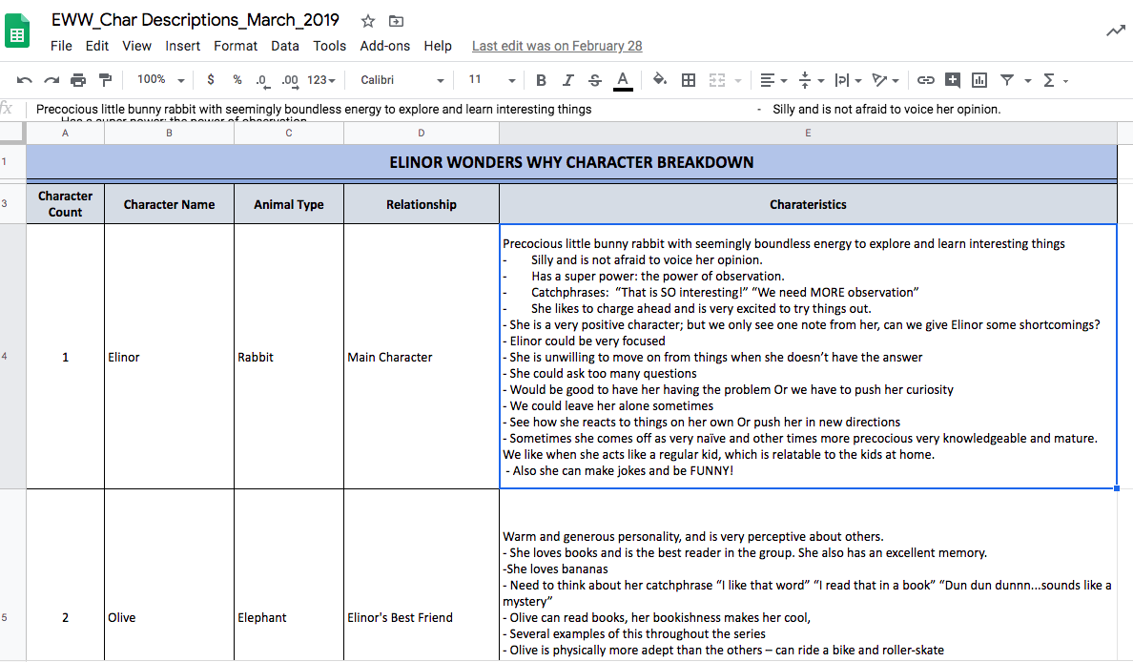
- STORY TRACKING: You must track all the stories in order for the team to tell new fresh stories. This includes tracking; titles, loglines, characters, curriculum, locations and every now and then main props. The best way to do this is in Google Sheets so it’s available for the whole team to review…

B. CHARACTER LIST AND DESCRIPTIONS: A great document for any writer to pick which character to write about. The best way to track this is on Google Sheets so everyone can be up to date.

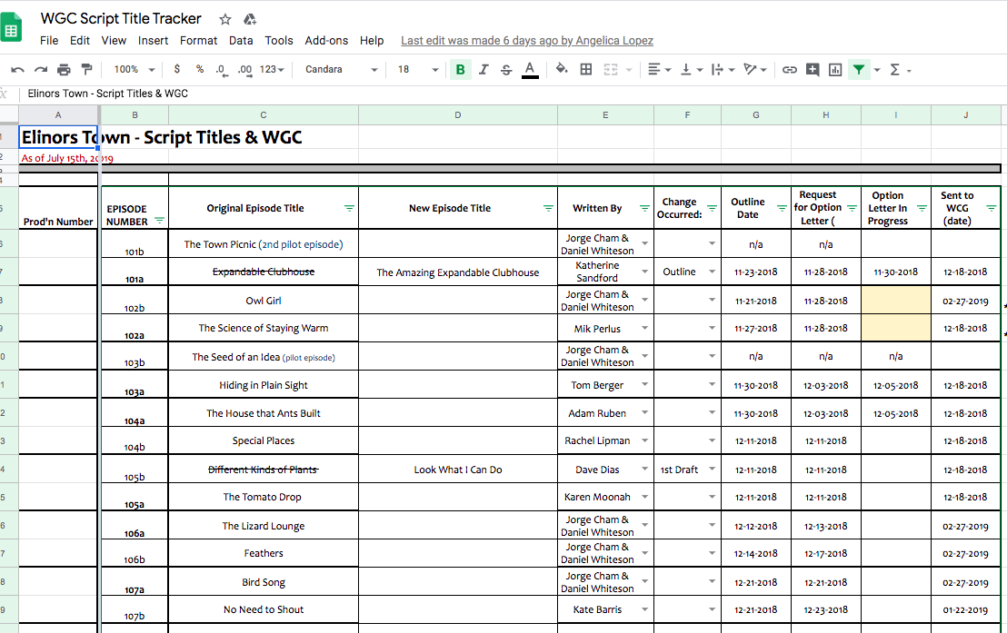
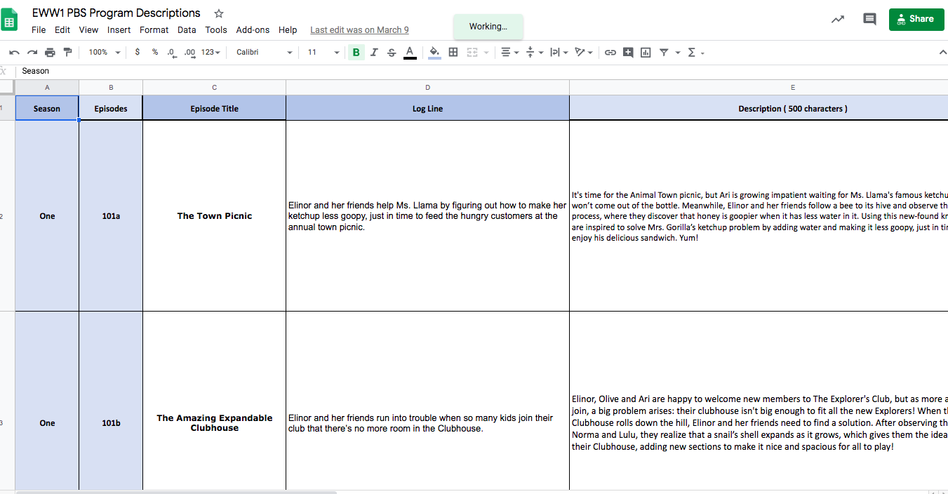
C. PROGRAM DESCRIPTIONS: This document has the Titles, loglines, summaries (500 characters) and curriculum of each episode. It’s mainly used by the broadcasters to track episodes and for marketing. The best way to make this available is on Google Sheets.

D. WGC TITLE TRACKER: You update this document every time a PREMISE gets GREENLIT by the Broadcaster and is ready to go to the OUTLINE STAGE. This document helps the WGC and Producers make contracts for the writers.

E. FINE CUT SCRIPTS: This is the FINAL script stage to any production. It’s made after the picture is LOCKED and is for the editor to create the Closed Captions. To complete this task you follow these simple steps…

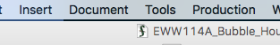
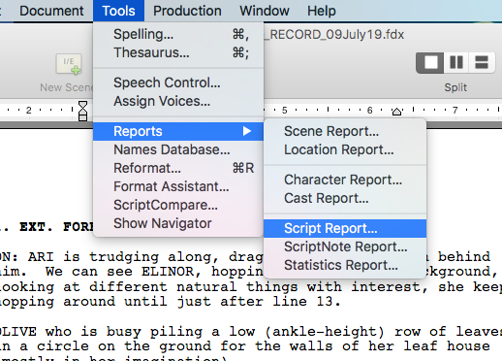
- You should receive the FINAL MIX VIDEO FILE of the episode via email from your production staff or editor. It’s a video file. You need this in order to HEAR the final dialogue recorded and picked for the episode.

2. You open the corresponding script’s RECORD DRAFT to the episode in Final Draft (.fdx).

3. Click on “Tools”

4. Go to “Reports” and click on “Script Report…”

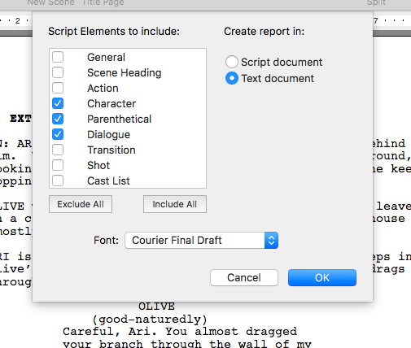
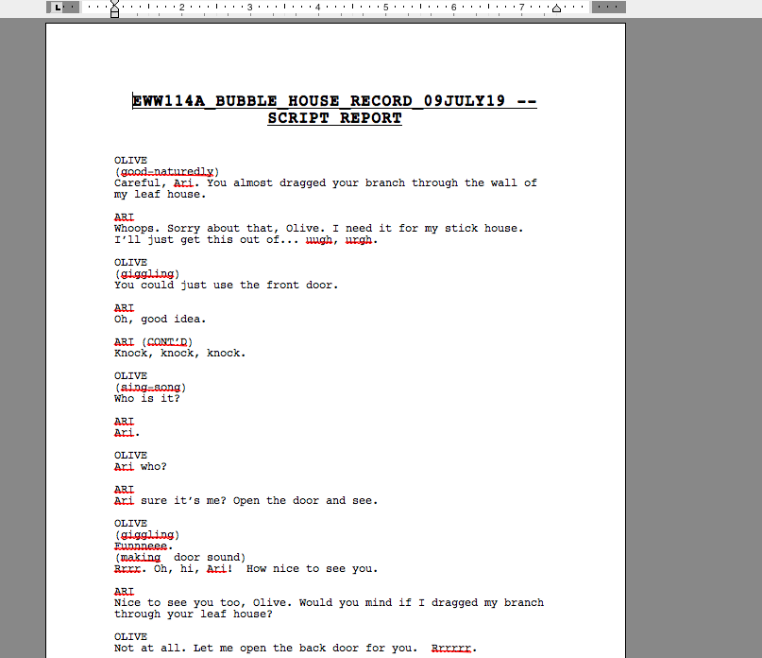
5. Make sure “Character” “Parenthetical” and “Dialogue” are checked and Create Report In: is checked “Text Document. The click “OK”

6. The script will look something like this:

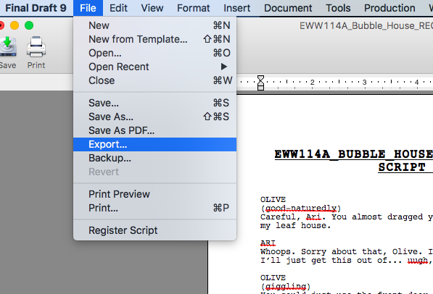
7. Then click on “File” “Export…”

8. Name the Document with below Naming Convention and make sure you save it as a “Rich Text Format (.rtf) and click “Save”
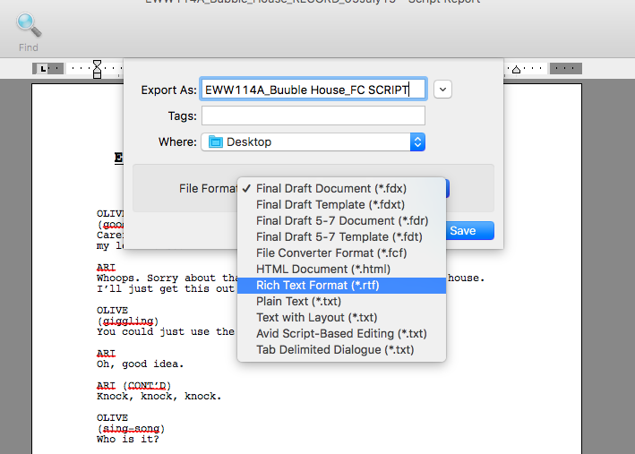

9. The document should look something like this.

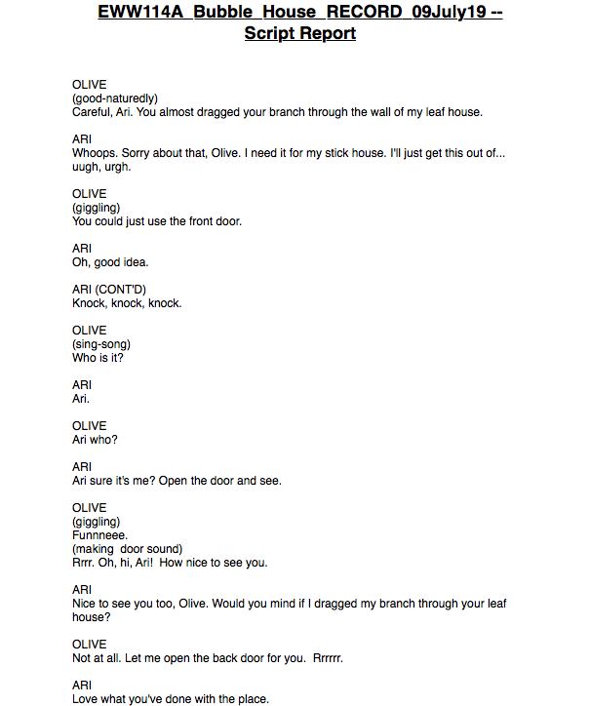
10. It’s your duty to follow the Video File given by the Production Staff or Editor and make sure the document matches the DIALOGUE exactly and in the same order. You must make are to put any sound effects in square brackets, i.e. [giggles]. The final FC SCRIPT document should look something like this….

11. When finished simply SAVE and store on Pipeline’s server as well as Banzai, and send it to your Production Team and Editor.

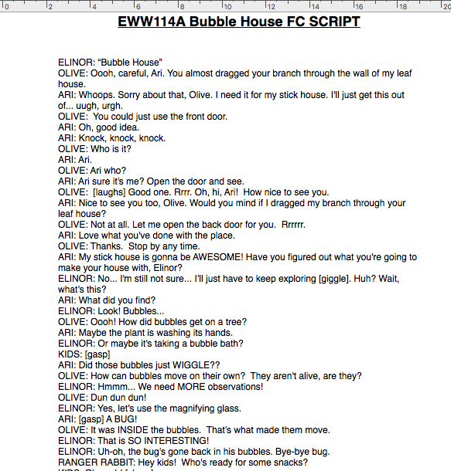
NAMING CONVENTION: EWW114A_Bubble House_FC SCRIPT

8. CONGRATUALTIONS

If you’ve successfully completed ALL these steps, you can now call yourself a great Script Coordinator. Happy Coordinating :)

