EWW 115
Senor Tapir Musical Moment:
Cai Lun, inventor of paper

Follows: the “Paper Trail” in which kids learn how paper is made.

Curriculum: the kids learn about how paper was invented by Cai Lun 2000 years ago, inspired by watching how paper wasps build their nests.

ND3. (RTL Crosscutting concept ‘Structure and Function’): Understand that structures and materials in the natural world can be used or can inspire the engineering of structures with similar function in the designed world.

- Intro scene in which the kids are making a project with paper. Sr Tapir asks them if they knew who invented paper and they are amazed to learn that paper was INVENTED.

- Senor Tapir sings a song about Cai Lun, who is credited with inventing the modern paper process after being inspired by watching how paper wasps build their nests.

The song begins as Cai Lun is trying to write on a rough surface (papyrus, though we likely won’t use the word) and is wondering if there’s a better way to make flat things to write on. He goes for a walk and sees wasps chewing up a plant and mixing it with saliva to build their paper nest. He copies the idea and makes smooth flat paper from mulberry plant fibers. The focus is on how he was inspired by an idea from nature.

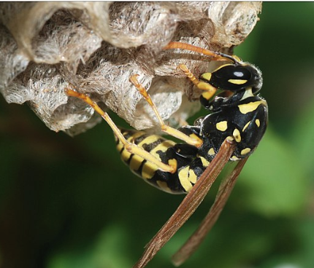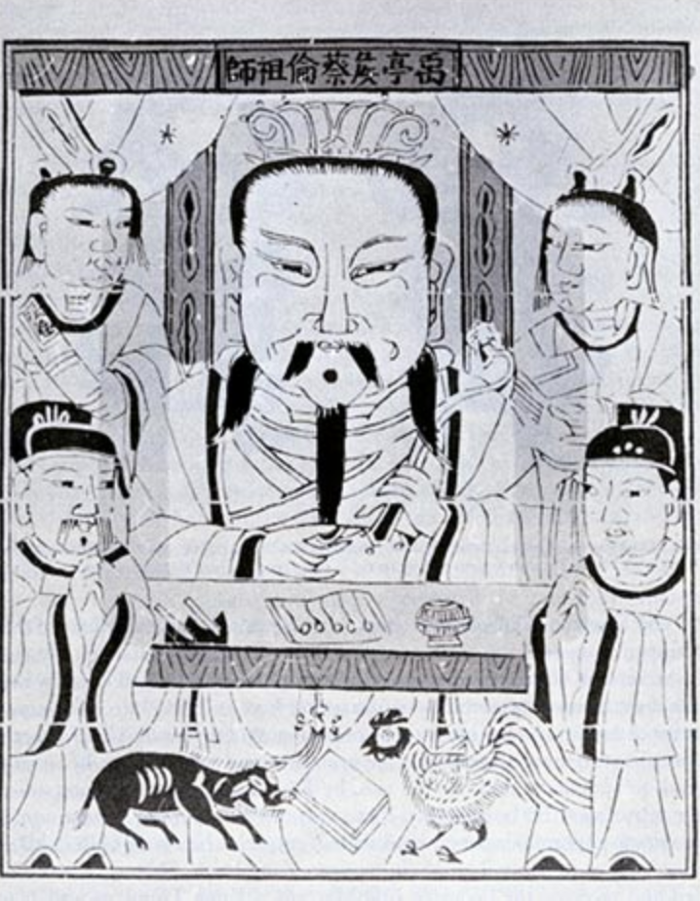

- The end scene shows the kids have made a folded paper (origami) wasp. A paper wasp!

