ELINOR WONDERS WHY
EWW127 Bubble House
(formerly Bubble Stuff)
Beat Sheet – April 18, 2019
By: Katherine Sandford

Elinor’s Question: How can we make a bubble house like the spittle bug does?
Logline: Inspired by a spittle-bug Elinor, Olive and Ari decide to make a bubble house.

Curriculum Goals:
- LS5. Begin to understand that animals and plants depend on other living things and nonliving things in the environment to meet some of their needs:
a. Distinguish between living and nonliving things based on background knowledge and
b. Identify the habitats of familiar animals and plants in the environment
c. Recognize that each kind of living things has a habitat that has resources to meet its unique needs (Elinor and her friends observe the spittle-bug’s bubble house, notice how he makes it (by blowing bubbles) and learn why (to hide inside.)
ND3. (RTL Crosscutting concept ‘Structure and Function’): Understand that structures and materials in the natural world can be used or can inspire the engineering of structures with similar function in the designed world. [Elinor and her friends are inspired by the spittle bug’s sticky bubbles to make a bubble house of their own).
SEP1. Asking questions (science) and defining problems (engineering)
b. Ask more complex questions about observable phenomena
c. Ask and/or identify cause and effect questions that can be answered by an investigation
d. Identify a problem that can be solved by the design of a new or improved object or tool
(Elinor and her friends ask questions about the nature of bubble house and how it is made, then they replicate the method the spittle bug uses (blow lots of small bubbles) to make a bubble house of their own).
SEP6. Constructing explanations (science) and Designing Solutions (engineering)
a. Use background knowledge experiences, and data to construct reasonable explanations and
theories of natural phenomena (science)
b. Look for and describe patterns and relationships in natural phenomena (science)
c. Use and apply productive science discourse to support an explanation
d. Use evidence to support a theory or solution to a problem (engineering)
(Elinor and her friends observe the spittle bug, then design their own bubble house).

BEAT SHEET

- Elinor and her friends are playing in the forest near Elinor’s place making a “houses” for themselves. Ari is making himself a little house out of twigs, and Olive is making herself a little house using leafy branches (or something).
- Elinor, while looking for things to make her house out of, comes across a spittle-bug. Whoa! What is that!? The other two kids come over.
- Amazing curiosity moment: At first they think the bubbles are moving on their own, then they observe there’s a little spittle bug living INSIDE the bubbles – it has its own BUBBLE HOUSE. That is SO INTERESTING! Elinor has an idea: she wants to make herself a bubble house!
- The kids run over to Elinor’s place. They tell Elinor’s mom about the bug they saw with the bubble house. Mom tells them it’s a spittle bug, and that it makes a little house out of bubbles to hide inside to protect itself and to stay nice and wet.
- The kids decide THEY definitely want to make a bubble house too, like the spittle bug.
- Mom sets them up with dish soap, some water, and wands outside. She also gets them some refreshments, which have straws in them. Ari loves the refreshments and loves drinking out of a straw! Ok, back to making their bubble house, they get to it. One of the kids is not very knowledgeable about bubble making, so Elinor explains how they make bubbles using the loops or bubble wands. You first mix the goopy soap liquid with some water, stir it, then dip the loop/wand in the soapy solution and then you blow. Out pops a bubble. Cool!
- At first they try to blow a bubble big enough to get inside. That doesn’t work. They try stacking bubbles, but they are hard to catch and pop when you try to handle them. Nothing seems to work.
- Elinor is disappointed. They haven’t figured out how to make a Bubble House.
- At that moment, Mom comes back out and asks them what’s wrong. The kids recap what they wanted to do and how what they tried didn’t work.
- Mom asks them, “Well, how did the spittle bug do it?” Hmm, they didn’t think about that before! Mom explains that to learn from things in Nature, sometimes it’s important to observe How they do things, and not just What they do.
- Elinor is energized. They need MORE Observations!
- The kids go back to the spittle bug and observe it more closely. This time, they observe the spittle bug as it’s making its bubble home. They notice, using a magnifying glass (or just looking closely), that the spittle bug doesn’t use a loop or a wand. It just seems to blow air into the goopy liquid. That’s it! Let’s try that!
- The kids go back to their bubble making area. How do we blow air into the soapy liquid? Hmmm…
- At that moment, Ari finishes his drink: “Sluuuuurrrrp… Ahhh… What?” Elinor borrows the straw and uses it to blow air into the liquid, just like the spittle bug. A few bubbles froth up. Yes!
- [This part is optional: But the froth isn’t that significant. The kids think back to the spittle bug. The liquid the bug used was suuuper goopy. They try adding more soap goop and mix it in. They blow again and… yes, the bubbles foam up and make a structure!]
- Elinor realizes that what they needed was to blow air into the liquid and make a bunch of SMALL bubbles, not big ones, just like the spittle bug.
- This is where she sings the song, about making small bubbles and getting the idea while observing closer.
- Finally, she makes a big mountain of suds and they get inside.
- Their own Bubble house! All three kids enjoy being inside the bubble mound and giggle away.
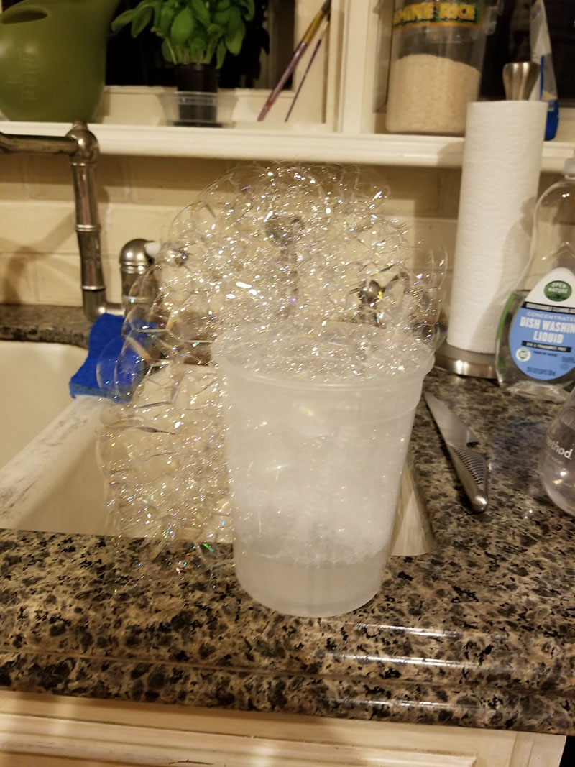
Actual bubbles in Jorge’s kitchen, blown with a straw – it works!

