ELINOR’S TOWN
Bird Song
PREMISE– V2 – December 17, 2018

Elinor’s Question: Why do birds sing?
Logline: The kids learn that birds sing to communicate with each other.
Curriculum Goals:
LS3: a. Observe ways that animals and plants get what they need to live and grow. Elinor will observe the ways the birds use songs to communicate in order to get what they need.
ND2. (RTL Crosscutting concept ‘Systems’): Begin to understand that systems
developed in our world often work in similar ways to systems found in the natural world. Elinor will use the system of bird calls to design a communication system for herself and her friends.
SEP1: To be determined at Outline

It’s morning in Elinor’s Town. The Rabbit family is happily sleeping in their beds. Suddenly, a bird lands on the tree outside Mr. Rabbit’s window and starting singing. This wakes him up, who tries to ignore it and go back to sleep. After a beat, the bird starts to sing again, waking him up again. He walks down to breakfast, looking a little sleepy. Elinor comes bounding in, telling her parents about the cool bird singing outside their window. She asks her parents why birds sing? Her mom isn’t sure what the answer is, but together they all have fun coming up and considering several ideas:
- Maybe birds just like music… but they haven’t ever seen a bird attracted to their music, or dancing to music
- Maybe birds like to wake up bunnies? But birds sing lots of other times.
- Maybe birds are practicing for a big performance, that's why they do the same song over and over…. But has anyone seen a bird performance?

They turn to ask Mr. Rabbit for his opinion, but he’s fallen asleep! This all makes Elinor very curious to know. Her mom gives her a pair of binoculars and encourages her to observe the birds to try to find out.
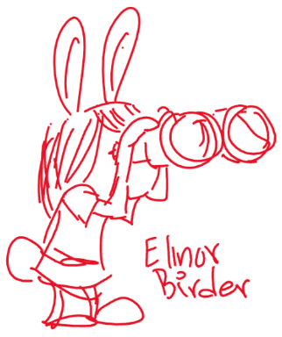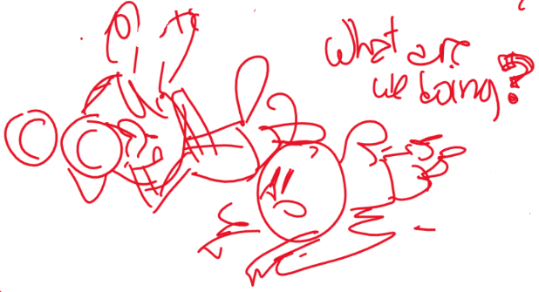

As she’s walking and looking for birds, Ari and Hazel join her, and they decide to help Elinor observe birds. They all crouch down in the same spot to listen for birds. When they realize there are lots of birds in the area, they decide to split up.

Now that they are in separate parts of the forest, they have to shout to communicate: to identify themselves (It’s me! Hazel!!), find each other (Where are you!?), warn each other (Watch out for this rock!), claim territory (This is my spot!). Each time, Elinor notices that birds seem to be doing similar things (identifying themselves, finding each other, warning and claiming spots), but that the kids’ shouting scares the birds away. Elinor realizes the birds sing to communicate and figures out a way to communicate with her friends without shouting: they whistle to each other, like the birds! After the kids are done in the forest, they come back to Ranger Rabbit, who confirms that birds use song for all kinds of reasons to communicate. This gives Elinor an idea…

The next morning, just as the bird is about to wake up her dad, Elinor uses a whistle or something (her own whistling?) to call the bird away and into the nearby woods, where she plays happily singing with the bird.

