ELINOR’S TOWN
The Owl
PREMISE P040 – V2 – November 12, 2018
Jorge Cham and Daniel Whiteson

Elinor’s Question: Why do owls sleep during the day?
Logline: Elinor learns that some animals have a different schedule.
Curriculum Goals:
- LS3 Observe ways that animals and plants get what they need to live and grow
- ND 2. (RTL Crosscutting concept ‘Systems’): Begin to understand that systems developed in our world often work in similar ways to systems found in the natural world.
- SEP: TBD

Elinor and her friends are on a walk after school with Gee raff and Joe Mouse. The kids are discussing what they are going to dress up as for class costume day. Hazel and Ari have lots of ideas but Elinor doesn’t know yet. Gee raff suggests a giraffe. Joe Mouse has no patience for things like costumes. While they argue, Elinor spots an owl in a tree in the forest, sitting calmly with its eyes closed. She thinks it’s beautiful and wants to see what it looks like with its wings open and flying, but it looks like it’s asleep. Gee and Mouse want to help her understand without just telling her. Gee is tall enough to look more closely and says it’s probably napping. Mouse seems nervous around the owl and wants to leave. Elinor and her friends wait for a while to see if it’ll wake up, but it doesn’t. So, they walk on.
[ Note: we want to use Gee and Joe but we’re not sure if it feels too shoe-horned in.]

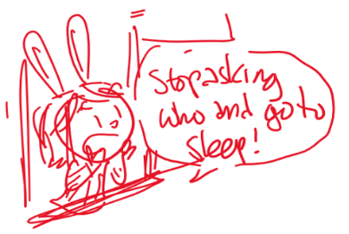That night, Elinor is awakened by strange sound coming from outside. Someone seems to be yelling “Whooo!” Elinor tries to respond: “Who what?” The voice answers back, “Whoo!” Elinor gets a little annoyed: “Yes, I know you said who! Do you mean me? I’m Elinor!” She goes back to sleep.
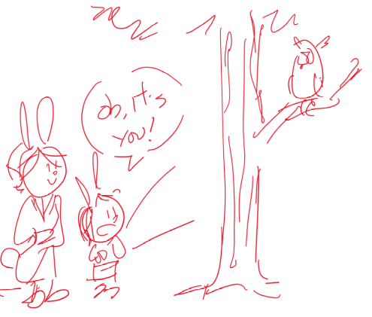The next day, the kids are walking to school and they see the owl again. They are amazed at how much it sleeps. They wonder: Do they sleep ALL the time? That night, she hears the same sound again, “Whoo!” After trying to talk to it again, she decides to wake her mom up and asks her to get more observations with her. They go outside to find it, but bump into Mr Racoon. They ask him if he is also wondering about the owl but he says that he’s on his way to work at the bakery. Elinor asks why now, in the middle of the night and he explains that some jobs are best done at night, so that the bakery treats are fresh for breakfast.

Mr Racoon rushes off and Elinor and her mom find the source of the sound: it’s the owl! Elinor’s mom explains that owls sleep all day and stay up all night because that’s when they can catch more bugs. Just like Ronny!

At school the next day, it’s costume day and everyone is dressed as something they find cool. Hazel is dressed like a self-reading book (the trunk turns the pages), while Ari is dressed like Super Ninja Bat, his favorite superhero. Elinor surprises everyone by appearing in an owl costume! She says she had to stay up late making the costume, but she’s really happy because owls are so graceful. When it’s time for each kid to stand up and talk about their costume, and it’s Elinor’s turn, Ari stands up instead. He explains that, like the owl, Elinor was awake too much at night, and is now taking a nap.

