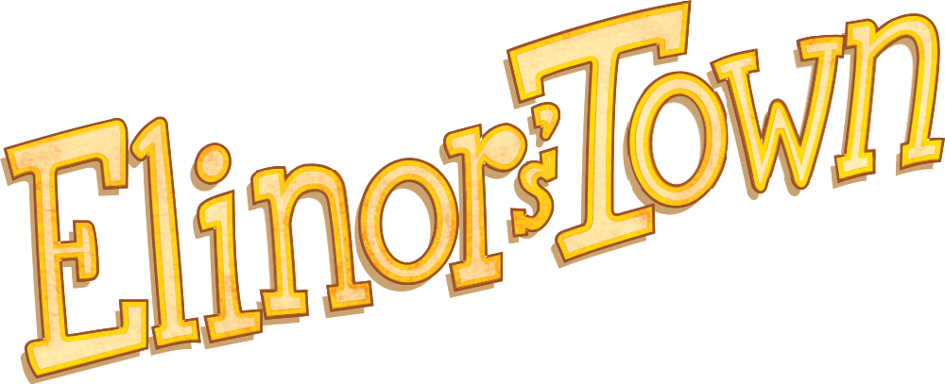
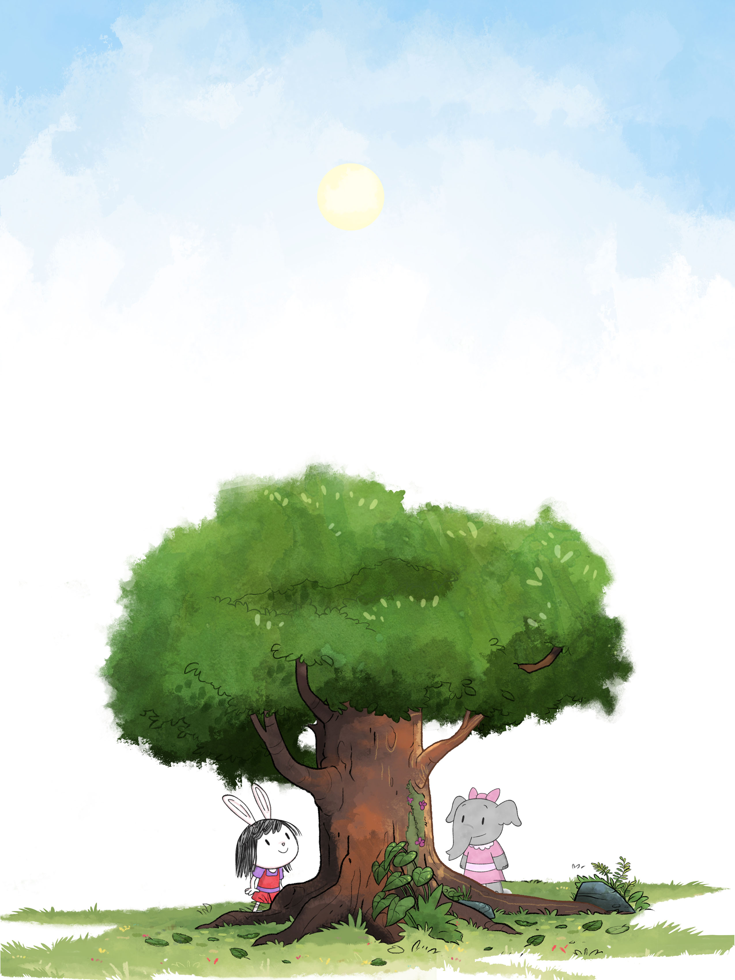

Curriculum Overview
Jorge Cham and Daniel Whiteson
SHOE Ink - business@shoe-ink.com
October 2018
Introduction
ELINOR’S TOWN aims to inspire young children’s wonder and curiosity about how the world works, highlighting the incredible ingenuity of life, and to teach them foundational science and engineering skills to help them answer their own questions.
In each episode and interactive digital experience, Elinor models for children her amazing powers of observation, her willingness to investigate, and her positive attitude (the basic tools of science and engineering) which help her understand and discover something new about life in the world around her. When she sees something that she doesn’t understand – how birds can soar without flapping, or how fish can breathe underwater, or how Velcro can stick without feeling sticky – she just can’t let it go until she understands it. Elinor encourages children and parents at home to ask their own questions and experience the joy of discovery and understanding.
The broad educational goals of ELINOR’S TOWN are learner-centered and measurable:
- Children will learn foundational science and engineering practices and display greater confidence to discover science knowledge themselves through play, investigation, imaginative exploration and inquiry-based learning.
- Children will learn and be able to describe core knowledge about life sciences, such as plant and animal life cycles, parts, adaptation and interaction.
- Children will learn and be able to describe how ideas from nature can connect to our designed world and influence our design process.
Foundational Science and Engineering Practices and Inquiry-based learning
Being curious is an essential, joyful part of being human. The world around us presents a constant stream of puzzles that tickle our curiosity, and this leads young children to generate a nearly endless set of questions about the world: Why can birds fly but we can’t? Why do plants stay in the same place? Why are leaves all green? We want to encourage children’s questions and give them the basic tools (scientific and engineering practices) to begin answering these questions themselves. Science is one of humanity’s most useful tools; we want children to see it as a method of building knowledge about the world, not just a list of accumulated facts. Science and engineering does not need to be limited to the lab and strict research environments, it can guide the way children think and explore. If you teach a child a fact, you have answered one question; if you teach them to do science, they can answer questions for a lifetime.
While the adults in Elinor’s Town are helpful and responsive, they are not repositories of facts. They often don’t know the answer to a question, but rather reflect the children’s question in a way that inspires further exploration: “I’m not sure, how can we figure that out?”
Core Knowledge about Life Science
Children are fascinated by life in our natural world: flowers, birds, animals of all kind trigger joy and wonder in their faces. Over billions of years, life has developed an incredible diversity and an amazing range of solutions to the challenge of adapting to Earth’s wide spectrum of habitats. We want to encourage children’s enjoyment of Nature’s living bounty and teach them core elements of what science has discovered.

Natural Design and Connections
Natural engineering and design are everywhere in a child’s world. It can be found in the slipperiness of snail slime, the color of flowers, the shape of a cat’s ears, and the arrangement of leaves. Each of these amazing ingenuities of Nature reveals how plants and animals adapt to their environments or find food and shelter. They can be used as sources of inspiration for solutions to related problems in our designed world. We want to show children these connections between the natural world and the designed world.

Structure and Content of this Document
The next section describes in detail the learning goals for the Elinor’s Town project, including episodes for broadcast as well as interactive digital elements and at-home activities. This is followed by a discussion of how these goals should be approached in each element of the project, and a list of examples. Finally, we discuss the educational theory that guides the approach to meeting the learning goals as well as considerations for universal design for learning and assessment strategies.

Learning Goals for Elinor’s Town
The learning goals for Elinor’s town encompass three broad areas:

- Foundational science and engineering practices for inquiry-based learning
- Core knowledge about life sciences
- Connections between nature and our designed world

Each of these areas are comprised of many, much more specific subtopics. These subtopics will be addressed by individual episodes or learning experiences, and are described below. The specific curricular topics below are selected (with minor adaptations) directly from the PBS Kids Ready To Learn Science Learning Framework (Revision 6.7.18) in the PreK-K age range.

Science and Engineering Practices

We view science and engineering as a set of tools for helping build knowledge about the world, and an essential goal of Elinor’s Town is to teach children how to use those tools to answer their own questions. These tools can be abstract (such as using simple models, see SEP2 below), or concrete (such as using magnifying glasses or notebooks, see SEP3a and SEP4b).

In each broadcast episode, the characters of Elinor’s Town will model several of these science and engineering practices for the children at home to follow. Elinor and her friends can’t let go of a puzzle or mystery until they have unraveled it and they feel satisfied with their understanding. By using good science and engineering practices in an intuitive and age-appropriate way, they provide a model for children at home to emulate. Specific examples are given in the following section.

In the interactive learning experiences (digital games and at-home activities), the learners will have a chance to engage with and use these practices. For example, using a particular science and engineering practice may be the key to solving a puzzle or advancing in a game.

SEP1. Asking questions
a. Demonstrate curiosity about the greater world outside of their local environment
b. Ask more complex questions about observable phenomena
c. Ask and/or identify cause and effect questions that can be answered by an investigation
d. Identify a problem that can be solved by the design a new or improved object or tool

SEP2. Developing and using models
a. Represent observable, concrete objects, events, and findings in many different ways
b. Distinguish between a model and the actual object, process, and/or events it represents
c. Use simple models to support explanations

SEP3. Planning and carrying out investigations
a. Identify and use a greater variety of tools to extend the senses for observing, measuring, and recording data about objects and events
b. Compare and contrast objects and events by describing similarities and differences in detail
c. Demonstrate an ability to make and test predictions based on background knowledge and experiences
d. With guidance, plan and conduct simple investigations using simple tools
e. Design and build a solution to a simple problem

SEP4. Analyzing and interpreting data
a. Collect, describe, and record observations in greater detail and in various ways
b. Use the 5 senses and simple tools to gather and record data
c. Record observations to describe patterns and/or relationships in the natural and designed world(s) in order to answer scientific questions and solve problems.
d. Talk about and reflect on what happened during an investigation or when solving a problem, and why it might have happened

SEP5. Using mathematics and computational thinking
a. Using counting and numbers to describe and compare quantitative attributes of objects
b. Sort and categorize observable phenomena based on attributes
c. Use mathematical language and vocabulary to describe attributes
d. Use measurement tools to measure and quantify properties of observable phenomena and objects
e. Create a simple graph to show data

SEP6. Constructing explanations
a. Use background knowledge experiences, and data to construct reasonable explanations and theories of natural phenomena
b. Look for and describe patterns and relationships in natural phenomena
c. Use and apply productive science discourse to support an explanation
d. Use evidence to support a theory or solution to a problem

SEP7. Engaging in argument from evidence
a. Engage in discussions before, during, and after investigations
b. Support thinking and argue ideas with evidence

SEP8. Obtaining, evaluating and communicating information
a. Obtain information through discussing prior knowledge and observations with experts including teachers or knowledgeable adults
b. Obtain information using various age-appropriate texts, text features, and other media to help answer a question and/or support an explanation
c. Describe observable phenomena using adjectives and labels
d. Use basic science and engineering practice vocabulary when engaged in investigations
e. Use basic science and engineering content vocabulary when investigating and describing observable phenomena
f. Share findings and explanations (correct or incorrect) through a variety of methods

Disciplinary Core Ideas: Life Science

Elinor’s Town episodes and interactive experiences will help children learn essential ideas in the Life Sciences so they can answer questions about the natural world around them.

Each episode or experience will focus on one topic, as described in the examples in the following section. The season as a whole will cover a significant portion of these topics.

LS1. Understand that all living things have external parts
a. Identify and describe the physical characteristics of a variety of animals and plants
b. Record observations about an animal’s or plant’s physical appearance
c. Categorize a variety of animals and plants based on their physical characteristics

LS2. Understand that animals have different body parts that are used in different ways to meet their needs, and that plants have different parts that help them survive and grow:
a. Identify body parts of animals and their function
b. Identify the basic parts of plants and their function
c. Compare how the external body parts of animals and plants are the same and/or different
d. Explore how different external features of an animal help it survive in its environment

LS3. Understand that all animals need food in order to live and grow, that they get their food from plants or from other animals, and that plants need water and light to live and grow:
a. Observe ways that animals and plants get what they need to live and grow
b. Describe patterns of the basic needs of plants and animals to understand what they need to survive
c. Help care for living things at home or in the classroom

LS4. Understand that all animals and plants have a life cycle, can reproduce, and change and grow over time:
a. Observe the life cycle of familiar plants and animals
b. Observe the growth in animals and plants
c. Understand that living things grow and change over time
d. Explore parts of different kinds of life cycles of plants and animals

LS5. Begin to understand that animals and plants depend on other living things and nonliving things in the environment to meet some of their needs:
a. Distinguish between living and nonliving things based on background knowledge and
b. Identify the habitats of familiar animals and plants in the environment
c. Recognize that each kind of living things has a habitat that has resources to meet its unique needs
d. Identify and observe the consequences of how plants and animals impact the environment

LS6. Understand that individuals of the same kind of plant or animal are recognizable as similar but can also vary in many ways:
a. Contrast individuals of the same kinds of plant and animal
b. Observe and recognize how we are the same and different from others

LS7. Understand that young animals and young plants are very much, but not exactly like their parents:
a. Understand that the young of a species are the same kind of animal or plant as the parents
b. Arrange and compare illustrations of humans and other animals in developmental sequence from infancy to adult

LS8. Begin to understand that there are many different kinds of living things and how they may be the same or different:
a. Observe and describe similarities and differences across different types of plants and animals
c. Group different kinds of living things into categories based on basic similarities and differences
d. Identify seasonal adaptations in physical characteristics or behaviors of animals

Natural Design Connections

In addition to showing how plants and animals meet their needs and adapt to their environments, we intend for children to discover the multiple connections that exist between natural habitats and the engineered solutions of the designed world that surrounds them.

Most episodes or experiences will underscore one of the natural design concepts below, which are closely connected to the science “crosscutting concepts” in the RTL framework as well as being inspired by the original RFP for a new RTL Science property. These cross-cutting concepts serve to bridge the natural and designed world by identifying similar patterns, systems, structure and function, flows, cycles, and conservation in the two worlds.

An overarching goal is to support one of the core concepts from the RTL Engineering and Technology curriculum: Understand that every human-made product is designed by applying some knowledge of the natural world and is built using materials derived from the natural world.

The specific natural design curriculum goals are described below, and examples are given in the next section.

ND1. (RTL Crosscutting concept ‘Patterns’): Understand that modes of life in the natural world and engineered solutions in the designed world have common patterns, and engineers often look to natural patterns for inspiration.

ND2. (RTL Crosscutting concept ‘Systems’): Begin to understand that systems developed in our world often work in similar ways to systems found in the natural world.

ND3. (RTL Crosscutting concept ‘Structure and Function’): Understand that structures and materials in the natural world can be used or can inspire the engineering of structures with similar function in the designed world.

ND4. (RTL Crosscutting concept ‘Flows, Cycles, and Conservation’): Appreciate the way that elements in the natural world change, interact and are re-used, and how we can organize our designed world to better fit and care for the environment.

ND5. (RTL Crosscutting concept ‘Cause and Effect’): Appreciate that events are connected to each other via cause and effect, and that similar links can be found in the natural and designed worlds.

Application and Examples of Learning Goals
The learning goals described in the previous section apply to the entire project, encompassing at least one season of broadcast episodes as well as several transmedia elements: the website, games, comic strip, and downloadable at-home activities.

In this section, we describe how individual episodes and learning experiences can focus on selected learning goals and give several examples.

Broadcast and Online Episodes

Each episode will focus on one core topic in life science. In order to keep the message clear and understandable, the same concept will be emphasized in several ways, using a variety of examples and contexts to allow children to absorb it. The target audience may have a wide range of language comprehension skills; using a variety of different phrases and repeated exposure will effectively include a broader audience, including children with developmental delays and dual language learners.

Many episodes will also feature one lesson about a connection between the natural world and the designed world. The goal is for children to connect the lesson they’ve learned about the life sciences to something they might encounter in their everyday life.

In addition, every episode will demonstrate several lessons in science practices, as the characters use them to better understand the science phenomena they are investigating.

Examples are given below for how each of the life science (LS) learning goals are taught in episodes. In each episode, we will attempt to introduce the learning goals several times at various levels, some simple lessons appropriate for the younger end of the age range and others for the group that is ready for a fuller description.

Learning Goal | Episode Example 1 | Episode Example 2
LS1. All living things have external parts | The kids wonder why different animals have different tails. | The kids wonder why snakes stick out their tongues
LS2. Living things have different body parts to suit their needs | The kids wonder why birds have feathers instead of fur. | The kids wonder why birds have different beaks and learn that they use them to find different foods
LS3. All living things need food to grow | The kids wonder why plants are green and learn about how they drink sunlight | The kids wonder why bees like flowers, and learn how they drink their nectar.
LS4. All living things have a life cycle | Elinor wonders how snails grow with their shells. | The kids wonder why there are no trash cans in the forest: where is Nature’s trash? They learn about the cycle of compost.
LS5. All living things depend on other things | The kids wonder why flowers are colorful, and learn that they do it to attract bees. | The kids wonder why sunflowers turn with the sun, and learn about how they want to drink as much light as they can.
LS6. Individuals can be similar or different | The kids are curious about the different sounds they can each make, and learn that they are all different, even if the same species. | Hazel’s African Elephant cousins come for a visit, and she learns how they are similar and different.
LS7. Young living things are similar to their parents | Elinor wonders why birds lay eggs, and watches a nest outside her window to learn about baby birds. | The kids wonder if baby plants have parents like them, and they learn about how plants grow up.
LS8. There are many different kinds of living things | The kids discover that they are all different sizes and have different strengths | Hazel doesn’t want to wear a jacket because Elinor isn’t, and learns that elephants don’t have fur because they come from a hotter place.

Examples for episodes teaching natural design (ND) learning goals are given below.

Learning Goal | Episode Example 1 | Episode Example 2
ND1. Patterns | The kids wonder why different birds have different beaks, then figure out they use them to pull their food out of holes; They realize that they can use similar ideas to fish a toy out of the lake. | Elinor wonders how the different rabbits in her family have different spots and patterns.
ND2. Systems | The kids learn about how crickets and other insects have natural springs in their legs, use them to design a jump-assist for Hazel. | The kids wonder how birds can soar without flapping their wings, learn about hot air balloons.
ND3. Structure and Function | The kids discover that Velcro was inspired by the hooks on some seeds | The kids wonder why mosquitos bite, learn about how their mouths work like straws.
ND4. Flows, Cycles, Conservation | The kids learn how the forest recycles leaves, and build a compost bin for their school. | The kids wonder why lizards sit on rocks in the morning, and learn about their cycles of heating themselves.
ND5. Cause and Effect | The kids see that worms come out after a rainstorm. | The kinds understand that seeds travel when the wind blows.

To demonstrate how multiple science practices feature in each episode, we give a description of the general application and specific examples of how each appears in two episodes: Velcro and Goopiness,

Learning Goal | General application | Example in Velcro | Example in Goopiness
SEP1. Asking questions | Every episode features a moment where Elinor sees something she doesn’t understand, says “That’s so INTERESTING” and asks a question about it. | Elinor notices that Velcro sticks together but isn’t sticky and asks herself “why?” | Elinor notices that honey is much thicker than flower nectar and asks “why?”
SEP2. Developing models | Every episode, the kids try to understand the puzzle by explaining it in terms of things they understand. | In the Velcro episode, the kids use their fingers as a model for the hook and loop | The kids use their time in the kitchen as a model for bees preparing honey: mixing and stirring
SEP3. Planning investigations | Every episode, the gang is excited to plan an investigation, and to make and test predictions. Elinor says “We need MORE observations”. | The kids wonder what else the Velcro will stick to. | The kids go around looking for fluids that are thick and thin
SEP4. Mathematics and Computational thinking | The kids will be investigating their world to help unravel the puzzle, which will often involve collecting quantitative data | In the Velcro episode, Hazel uses a table to keep track of their data. They also reference the number of things Velcro sticks to. | The kids compare the thickness of various liquids.
SEP5. Analyzing and Interpreting data | After they do their investigation, the kids collect their observations and describe patterns they notice. | The kids look at the chart they made of what the Velcro sticks to and try to notice a pattern. | The kids think about how adding water to the honey made it thinner
SEP6. Constructing explanations | In most episodes, the kids will study the patterns and come up with ideas. | The kids try to explain why the seeds stick to Ari and why the watch strap only sticks to some things. | The kids think about how the bees flapping their wings can dry the honey
SEP7. Arguing from evidence | The kids will test their ideas against their observations. | When the kids discover the hooks and loops, they think about whether it explains why the watch strap sticks to fuzzy things like the sweater and the carpet but not smooth things. | The kids suggest that if watering down the honey worked to clean off Ari, watering down the ketchup would make it easier to serve.
SEP8. Obtaining information | The kids often consult a reference or ask a grown-up for ideas | Hazel looks for a book about the seed but doesn’t find one. Later, Ms. Mole shows them a pop-up book with the story of Mistral’s discovery | Hazel looks for a book about bees, learns about flower nectar.

Interactive Digital Experiences

Digital games and other experiences are an opportunity to teach a specific skill and build children’s confidence. In this way, they are very well suited for teaching scientific and engineering practices.

We aim to teach children how to begin to answer their own questions. While Elinor and friends serve as models in the episodes for children watching at home, the interactive experiences can be a bridge to the children’s own exploration by teaching them how to take these practices with them into their everyday lives. We envision a series of games and experiences, each focusing on one or two science practices. Even though these experiences will be in the context of the characters and scenes from the show, and will serve as fun reminders of the life science lessons, the focus will be on teaching the science and engineering practices. The games will offer several levels of engagement, starting with a fun playable premise to draw the kids in and continuing to deeper levels that require more planning and strategy and demonstrate the science practices we wish to teach. We illustrate this concept with two categories of examples: a goal-oriented running game and an open-ended musical game.

Goal-oriented example

In a preschool-friendly role-playing game (RPG), players are encouraged to explore their environment while also observing and collecting evidence.

At the most basic level, players will move freely through an open environment, having fun just by playing the game. As they play, they will also observe and collect data in the form of seeking specific objects to collect along the way, which forms a second and deeper level of engagement. At various points in the game, the data collected will be used to solve a puzzle of some sort that will require the player to further engage with the science practices such as developing models, analyzing and interpreting data, and constructing explanations, but will do so in a playful way driven by visuals (no text). Players will be rewarded for the curiosity and exploration with fun surprises to add an additional level of delight on top of the core game mechanic.

Open-ended example

At Hazel’s concert hall, the user will be able to play Nature’s Orchestra, an interactive musical sandbox. In the game, a variety of animal characters and natural elements will be available for the user to select and drag onto the stage. Once on the stage area, the character or element will begin making its typical sound on a loop. Birds sing a chirp melody, a beaver hits the ground with her tail to give a thumping beat, Hazel the elephant plays trumpet sounds, a toad makes a low croaking sound, bees make a musical buzzing sound, etc. Some elements join the stage but only make a sound when tapped. For example, Elinor can join the stage and will sing “La la la!” when tapped. The user will get to select who or what goes on his or her own orchestra, and each combination will result in a unique sound.
After a round of free play, players can choose to enter a challenge mode (a playful investigation) where they will be given puzzle challenges such as completing patterns, comparing and contrasting different parts of the music/patterns, making predictions about what will happen when there is a change in the music/patterns, and recording their observations. These will to be connected to specific SEP learning goals, depending on the specific context.

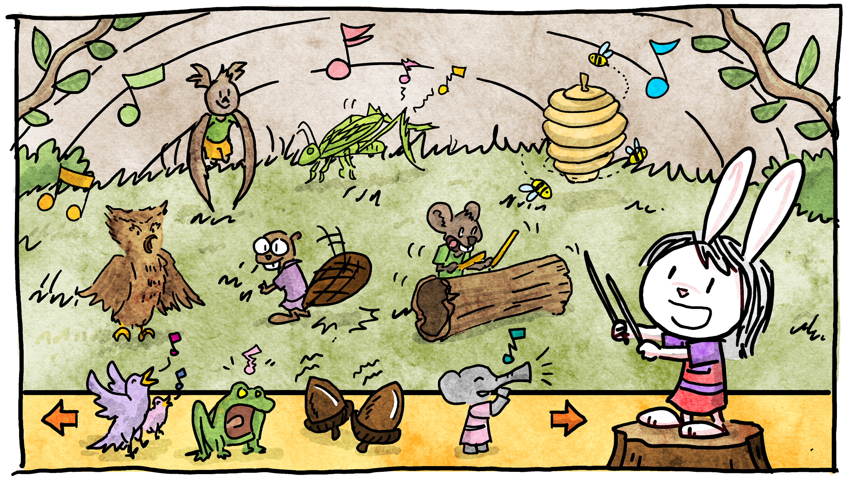
“Nature’s Orchestra” interactive musical sandbox game.

Online comic strips

Building on Jorge’s experience as a comic artist, we plan to produce a series of comic strips based on the stories in each episode. These will have the same learning goals as the episode, and will be written in a form and distributed in a medium that is engaging to the parent or teacher and encourages them to share the comics with children in their care.

At-Home and Educator Outreach Activities

An essential goal of the project is to equip children with the tools they need to explore their world and find reliable answers to their questions. We aim to teach children that science and engineering practices are useful outside of laboratory or academic settings, and can be applied to build knowledge about nearly anything that tickles their curiosity. The episodes allow them to observe characters modeling this behavior, and the digital experiences will give them interactive opportunities to explore and use these skills. The at-home activities are an opportunity for them to put these lessons to use and “play the show.”

Each at-home activity should focus on using one or two science practices to explore a connection between the natural and designed worlds that is closely related to one of the life science lessons.

These activities will be designed to encourage joint engagement with peers, siblings and caregivers. Teachers and parents who are not confident enough to invent these activities may feel more comfortable using the materials guided by the characters from the show.
All of these elements reinforce the knowledge presented in the show, and provide an opportunity for the children to put into practice what they have observed and explore the science behind our natural environment.
Some initial ideas:

Be-like-Elinor pages

We want to encourage children to be like Elinor: look at the world around them, find their questions and gather their observations.
We will provide printable sheet with Elinor saying
- “What is SOOO interesting to you?” with a place for children to write down what they are curious about.
- “You need MORE OBSERVATIONS” with a place for children to collect more data
- “What do YOU think?” with a place for children to list some potential ideas.

This activity lets children “play the show” along with Elinor, while teaching them about how to ask questions, gather information and come up with explanations.

Episode Follow-up example
(related to episode about the kids learning about different sounds animals make)
Listening for Animal Sounds: In this activity, we provide a data collection chart and observation prompts to encourage children to listen closely to animal sounds they hear outside, and write or draw a description of the sound. Kids can then compare and contrast the sounds, and discuss what animal they think the sound came from.

Colorable comic strips
Many of the digital comics will have fun natural scenes. Versions of the comics without colors will be available for children to print and color at home.

Meeting and Assessing Learning Goals
Inquiry-based learning
We are passionate about encouraging the curiosity of young children, and inspiring more learning through exploration and play rather than solely in traditional instructional settings [Nayfield]. This follows the ideas of inquiry-based learning where children are “active agents in their personal construction of new knowledge” [Trundle]. Science does not have to be an indoors activity that requires a lab coat and safety goggles; we aim to show children that science is a way of thinking about the world and building their own knowledge [Connecticut Board of Education]. Children will follow the characters as they explore the natural world, and see the characters ideas forming and reorganizing, emphasizing the role of exploration, creativity and imagination in problem-solving.
The characters on the show will ask themselves and each other questions (“How do you know that?”, “What else can we try?”) and experiment with different solutions to the week’s problems. They will occasionally prompt the audience for ideas, or ask them questions and pause to give the viewers a chance to think and engage rather than passively watch. The characters can learn through unstructured playing and observing the natural world in addition to the learning in a science classroom.
Interactive Elements
Games are playful learning environments that provide opportunities for practice, and have the ability to adapt to a learner’s needs. Games, as learning environments, allow for a behavior to be modeled explicitly. The stronger the connection between the situation in the game and the child’s own the more likely that the child will model the behavior [Mares & Woodward]. While parents widely view educational games and apps as valuable learning tools, many want expert guidance about how to choose them [Discovering kids apps]. This makes the trusted name of PBS an excellent platform. Science seems to be underrepresented [Learning at home], but tThe structure of video games can be naturally mapped to the structure of educational theory [Learning by design]. These games offer real cognitive benefits [The benefits of playing video games].
Focus on single LS or ND learning goal per episode
In ELINOR’s TOWN, each episode and interactive module will be centered around one lesson in life science and how to connect this lesson from the natural world to our world.
Although research regarding science education for children at this age is still in its early stages, this approach is supported by similar research in mathematics, which suggests that curricula should focus on a small number of topics conveyed clearly, and by finding examples in everyday activities [Clements]. Integration of these lessons into authentic context and activities can help engage diverse learners. Through Elinor and her friends, children will explore and experiment with the world around them, finding instances in Nature where an adaptation can be used to solve problems in the “designed world” of Elinor’s Town. For example, they learn about slippery and thick liquids from studying honey, snails and rivers, and put this to use when they fix the problem of a too-thick special ketchup at the town’s annual picnic.
This knowledge will be scaffolded in the digital games and hands-on activities described in the interactive digital and at-home sections above. The activities will allow a series of learning progressions for children who are prepared to extend their learning.
Universal Design for Learning
Every aspect of the project, from broadcast episodes to transmedia elements, will be built to minimize barriers to learning. In the broadcast episodes, we aim to present a small number of concepts multiple times, in multiple ways and at multiple to appeal to a broad developmental range. This includes using a combination of spoken language and visual demonstrations. In the pilot episode, for example, the mechanism for behind the Velcro patch is explained several times using a combination of words (Elinor explains how it works as she figures it out and later to Ms. Mole) and images (there is a close-up shot of the hooks and loops, and Elinor reinforces this by demonstrating with her hands).
We aim to embed the science and engineering directly into real world, authentic contexts and activities. This is helpful for young children and children with limited skills and experiences. In addition, we strive to have a diverse cast of characters, which model different learners, challenges and solutions, to match the learning abilities of our diverse audience.
The natural design learning goals help children understand how concepts in life sciences apply to their lives. Connections with real life examples form critical building blocks in children’s understanding help children integrate science learning across different experiences. This is especially important for children who face early achievement gaps [McClure, Guo, Trundle].
Many of the viewers will not have had any classroom science instruction; lasting understanding is improved when exploration complements instruction. This is especially important for underserved populations, and those without access to traditional science facilities [Brenneman]. Sometimes their first attempts at solutions will fail, so that the audience can understand the process of investigation, problem-solving, and changing their ideas in response to trial and error. The animal characters also provide the means to model life challenge (elephants can’t jump high) and could model for kids with and without different challenges how to navigate life and be socially supportive.
The transmedia elements will also be built with UDL in mind; specifically, games will be designed to be playable on a smartphone, which lower-income homes tend to have access to more often than a home PC, and will be available for free [McClure] The digital suite of content will present a variety of activities ranging from open-ended sandbox play to adaptive games. Throughout, these experiences will be text-free, but use well-designed visual cues to guide players, as well as voice over support. These games and activities will also explore options for different inputs, including voice and gesture.
Assessment
The assessment strategy and execution will be made in concert with our RTL research partners, who will ultimately conduct the formative and summative studies. Below are some initial thoughts on the process.
Reliable learning assessment tools for science education at this age have only recently become available [Greenfield, Brenneman]. The most promising is the Lens on Science [Greenfield] which can be used to assess the educational impact of ELINOR’S TOWN. An adaptive computer evaluation can test children’s understanding of the life sciences as well as science practice. For example, it would show an ice cream cone left out in the sun and ask the children to choose among several predictions for the ice cream’s future; this allows assessment of science practices (i.e. observation and prediction) in addition to knowledge. If feasible, game-like tasks using hands-on manipulatives are also powerful assessors. Another option is the formative assessment strategy [Keeley] which attempts to reveal not just what the children are learning but how they are learning it.
To assess the children’s views of how science is done, the Draw-A-Scientist activity [Barman, Finson] can be very informative. In this activity, children are asked to draw their image of what a scientist looks like and where they work; this can reveal whether the children understand that science can take place everywhere, or if they imagine that science can only take place in a classroom or laboratory [Barman, Finson]. In addition, the act of creating this image allows the children to communicate something visually that they may not yet be capable of verbally. By comparing the drawings made before and after viewing the episode and engaging in the hands-on activities, we can assess whether their understanding of science and scientists has changed.
In addition to formative and summative research of the digital elements and how children learn with them, we will work throughout the design process with children to assure that each element is not only entertaining and engaging, but meeting the intended learning goals. Additionally, we will use game analytics data to analyze how players use the game, and update and revise the game as needed to respond to user data.
Advisors and References
Educational advisors consulted in the preparation of this proposal include:
Sara Sweetman, Assistant Professor at the University of Rhode Island (URI) and the Director of the Guiding Education in Math and Science Network
Michael Conn-Powers, Research Associate at Indiana University, Adjunct Assistant Professor in the School of Education, and Director of the Indiana Institute on Disability and Community's Early Childhood Center.
Jade Jenkins, Professor, School of Education, University of California Irvine.
Marion Goldstein, Senior Research Associate, Education Development Center, Inc.
Laura Tucker, Lecturer, Dept. of Physics & Astronomy, University of California Irvine.
Babette Moeller, Education Development Center/Center For Children And Technology.
Bibliography
Barman, C. (1996). How do students really view science and scientists? Science and Children, 34(1), 30-33.
Brenneman, K. "Assessment for Preschool Science Learning and Learning Environments." Early Childhood Research & Practice 13.1 (2011): n1.
Brenneman, K., et al. "Mathematics and science in preschool: Policy and practice." New Brunswick, NJ: National Institute for Early Education Research (2009).
Connecticut Board of Education. “A Guide to Early Childhood Program Development.”
Early Childhood STEM Working Group. “Early STEM Matters: Providing High-Quality STEM Experiences for All Young Learners.”
Finson, K.D. (2002). Drawing a scientist: What we do and do not know after fifty years of drawings. School Science and Mathematics, 102(7), 335-345.
Gee, J. P. (2005). Learning by design: Good video games as learning machines. E-learning and Digital Media, 2(1), 5-16.

Granic, I., Lobel, A. and Engels, R.. "The Benefits of Playing Video Games." American Psychologist 69.1
(2014): 66-78. ProQuest. Web.
Greenfield, Daryl B., et al. "Science in the preschool classroom: A programmatic research agenda to improve science readiness." Early Education and Development 20.2 (2009): 238-264.
Guo, Y., et al. "Exploring Preschool Children's Science Content Knowledge." Early education and development 26.1 (2015): 125-146.
School Readiness in Head Start Classrooms” (2014) Thesis, University of Miami.
Keeley, P, Eberle, F. and Farrin, L. “Uncovering Student Ideas in Science (Volume 1)- 25 Formative Assessment Probes” (2005) NSTA Press
McClure, E. R., et al. (2017). STEM starts early: Grounding science, technology, engineering, and math education in early childhood. New York: The Joan Ganz Cooney Center at Sesame Workshop.
McClure, E. R, Vaala, S, and Toub, T.S. (2017). Discovering Kids’ Apps: Do Family Strategies Vary by Income? New York: The Joan Ganz Cooney Center at Sesame Workshop.
Mares, M.-L., & Woodard, E. (2005). Positive Effects of Television on Children's Social Interactions: A
Meta-Analysis. Media Psychology, 7 (3), 301-322.
Nayfield, I. “Learning through Inquiry: Examining the Relationship between Child-Generated Questions, Teacher Practices, and Novick, S. and Nussbaum, J. "Pupils' understanding of the particulate nature of matter: A cross-age study." Science education 65.2 (1981): 187-196.
Rideout, V. (2014). Learning at home: Families' educational media use in America. Joan Ganz Cooney
Center .
Trundle, K. C. "Teaching science during the early childhood years." Best practices and research base (2010).

