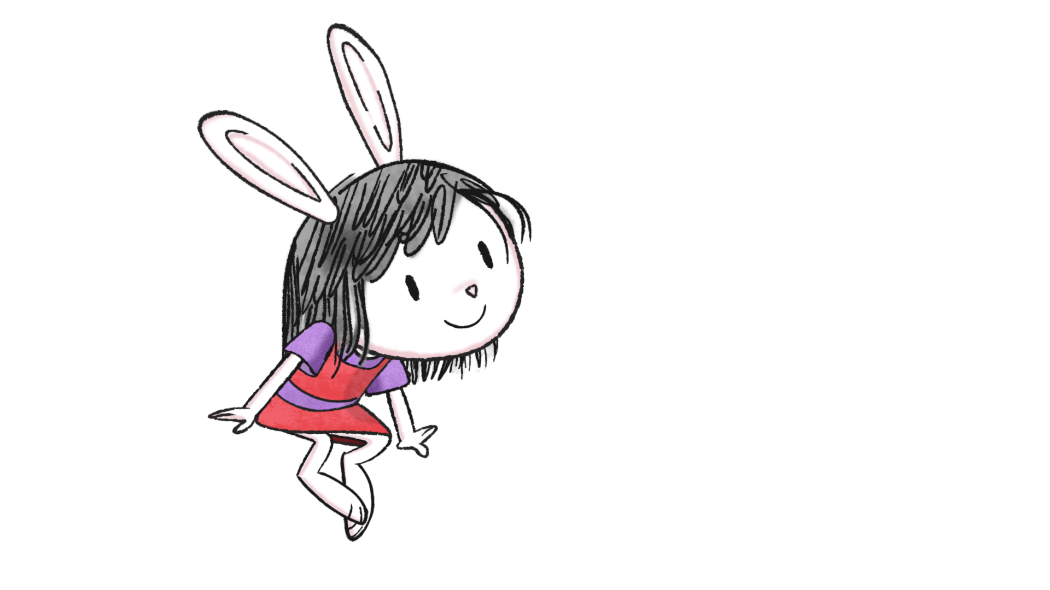

ELINOR WONDERS WHY

WRITERS UPDATE MEETING NOTES: WEDNESDAY, MAY 8TH 1:00pm – 3:00pm

PBS Opening Comments:

PBS is so excited about the show, everyone wants an Elinor bunny for their desk. They are thrilled and encourage the team to keep up the good work because they are very happy with how everything is going.

J&D Opening Comments:

Thank you everyone, you guys really bring the love and all have great attention to detail. Everyone is very happy with the writing. Thanks everyone for putting your hearts and souls into the scripts.

What’s really working well for the show is when you answer natural kid questions. Something that happens in real life but you don't see on TV. Something that is natural and happens all the time that the audience can relate to.

Seeing our kids giggle at the animatics always makes us happy. If we make the stories and the characters memorable, it makes the lessons memorable.

Notes for Writers Doc:
- This is about following your curiosity. Make yourself four years old and think “what would I find interesting about the world.”
- Always start with your kids questions
- Something that your 4 or 5 year old would encounter everyday
- Try to find the natural design element that could fit into the story. Look at the natural world and see where it could fit in.
- We want our characters to be spit balling at all times and interacting like kids do, especially when they are brainstorming
- Not a lot of plot happens in this show BUT a lot of brainstorming
- Make crazy kids theories and try to solve them in a fun way
- If you think you need more action in story put in some fails
- If you go over any assumptions please flag it right away for Kathy
- Scripts are falling a little short in Leica. Encourage you to play out some of the action scenes and have fun with it
- The page numbers are not set in stone and are NOT as important as the line counts
- Find those moments where you can express the curiosity in the story
- Stories should have a gag in every beat Look for as many small, often physical, gags and jokes as possible, especially in “explanatory” sections

Kid Questions Doc:
- Best stories are the ones where the kids can ask questions and can figure out the answers by observing what’s around them
- Want kids to say while watching “I’ve always wondered that too.”
- There’s curiosity questions and problem solving questions
- is it possible for this show to solve the top 50 science questions kids ask their parents
- Answers to questions are super simple
- Follow your curiosity!

Writers Questions:
- Always fun to have great visual representation of their thoughts like; books and thought bubbles
- There has been very few overlap in pitch ideas - so keep pitching everything!
- Avoid bird houses
- We’ve already done a good number of insect, bird stories
- We haven’t really explored water stories, fish, dolphins, etc.
- Pitches should be surprising and cool, kid-like
- WATER: There are streams of water in the park where kids can get very close to the and observe in a safe environment. As well as a lake.
- We always try to avoid having animals in cages like aquariums
- Remember Mammals always talk!
- Water and water safety is always a sensitive area for PBS. They are open to have them in the water, definitely would have to have a parent or life guard with the characters, they all feel comfortable in the water and can swim. Think of the characters as your kids and how would you feel if they were in the water. They would need to have life jackets on. There are also a lot of cute life jackets out there to choose from
- Mr. Rabbit - definitely a scientist and loves teaching kids about science but they haven’t nailed down what he does all day
- Locations and Seasons - So far being in Animal Town has served us well. If Elinor is going to go anywhere it will have to be a trip. Elinor’s grandparents live in the desert.
- We especially are looking for Spring and Summer stories
- Story Idea: A story about the seasons could be interesting!
- Visiting the City: We do have the downtown which is growing, there’s a bus/train station
- Story idea: There is nature in a city
- Ari’s cousin could live in the big city
- Observing from each other: The mammals can still observe each other and learn from them. Think of questions that the animals won’t be able to answer themselves, their personality traits. The characters will then have to observe
- Story Idea: Little kids think about teeth all the time
- When you’re working on a story please do your research
- Holiday episode possibilities: Valentines Day, Halloween, Winter Holiday
- J&D will be writing an Earth Day Special

Other Notes:

- Stay tuned for the process of sharing scripts and animatics

- Stay tuned for a document with new character descriptions. Any dialogue from the characters that writers usually don’t write for, etc. Possible recording of characters

- Please don’t pitch Interstitial ideas. There is a whole different team of Interstitial Writers. A group of scientists!

