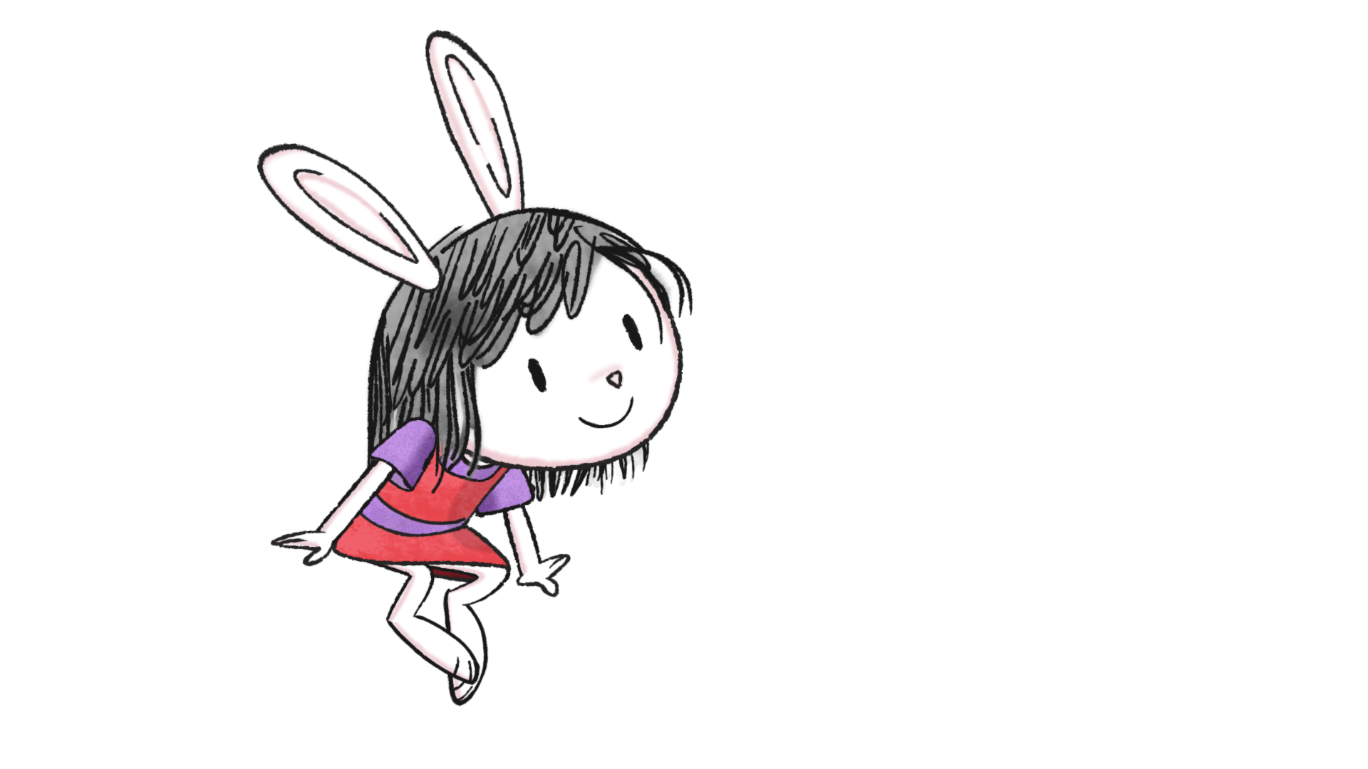

ELINOR WONDERS WHY

WRITERS UPDATE AGENDA: WEDNESDAY, MAY 8TH 1:00pm – 3:00pm

1) Introductions

2) Watch Elinor Teaser

3) PBS touch-base (any opening comments?)
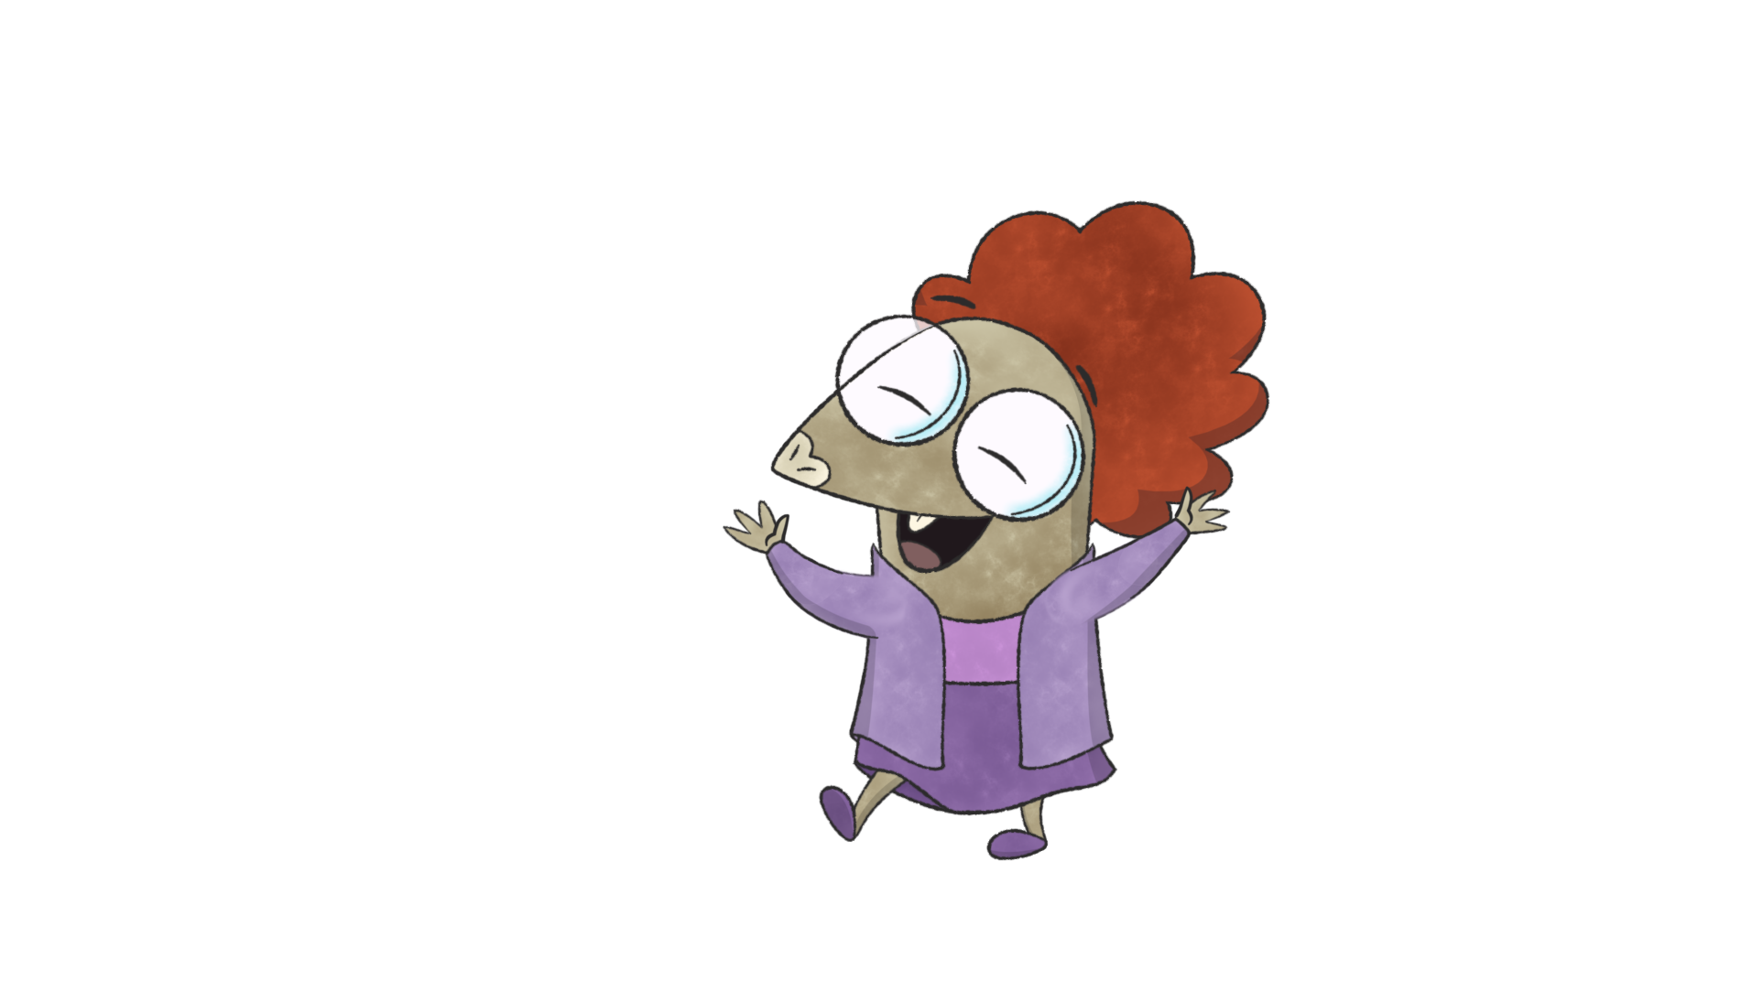
4) Review Notes For Writers Doc

5) Review Kid Questions Doc

6) Review Script Assumptions Doc

7) Any Questions, Comments, Observations?

