ELINOR WONDERS WHY
Why’d You Do it That Way?
By Kate Barris
December 2nd, 2019

Elinor’s Question: Is there just one right way to do a thing?

Logline: Elinor, Olive and Ari want to make spiderwebs to decorate the classroom for Halloween, but is there one right way to make a spiderweb?

Curriculum Goals:
LS3. Observe ways that animals and plants get what they need to live and grow
LS8​. Observe and describe similarities and differences across different types of plants and animals
ND3. Understand that structures and materials in the natural world can be used or can inspire the engineering of structures with similar function in the designed world.

SYNOPSIS
Elinor, Ari and Olive arrive in the classroom to discover Mz. Mole putting out pumpkin decorations for Halloween. They want to help! So Mz. Mole suggests they make some spiderweb decorations, and hands them some balls of string. They love that idea! They get right to work, and within seconds, Ari says he’s done! He shows them a huge mess of string he made. Ta da! A spiderweb! Elinor says, “Mmm, I don’t think that’s what a spiderweb looks like.” Ari is perplexed. “It’s not?” Elinor takes a piece of paper and illustrates what she thinks a spiderweb looks like: a traditional orb web (she describes how to draw it, so the kids at home learn how to draw too). Now Olive looks perplexed. “Mmm, that’s not how I’ve always drawn spiderwebs.” She draws her version - a triangle web. Ari says he’s always drawn them like this: He makes a huge mess on the page.
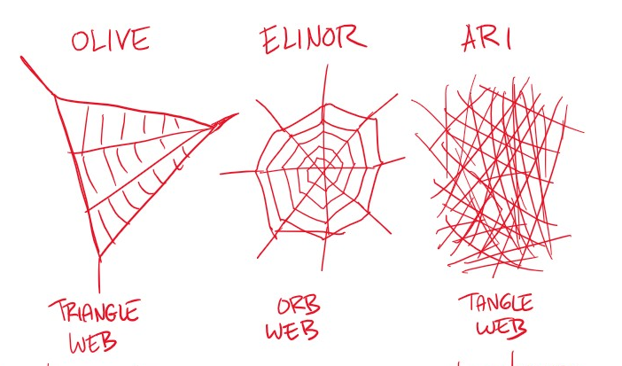

They seem to be in a stand-off. They each think that the way they draw the web is what a web looks like, because that’s how they’ve always drawn them. They turn to Mz. Mole, who pauses to think. “I’m trying to remember what a spiderweb looked like the last time I saw one.” The kids realize they haven’t seen a spiderweb for a while. There’s a natural solution to their problem: Let’s go outside and try to find spiderwebs!

Outside the kids hunt around looking for a web. They find a spider and decide to observe it. Looking closely, they see (for the benefit of the audience) how a spider weaves webbing. Cool! The spider finishes the web and… it looks like an orb web. Ahah! Elinor was right! Olive and Ari are confused. Why did they think spiderwebs looked different? Then one of them spots a different kind of spider. They see that it spin a web that looks like Olive’s drawing. Olive was also right! Then they spot another web that looks like Ari’s: just a big tangled mess. The kids realize: spiders make webs in all kinds of ways!

Back in the classroom, the kids update Mz. Mole on what they learned. Mz. Mole confirms that there are many different kinds of spiders, and they make webs in all kinds of ways. There’s even a spider that makes a little home made of webbing. Animals in Nature do things in all kinds of different ways. The kids realize that there’s isn’t one way to make a web, and they all make their string webbing differently and hang them around class. Mz. Mole thinks the spiderweb decorations are wonderful – because they’re all different!

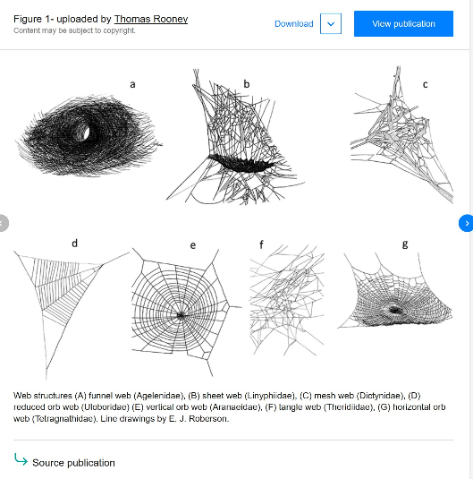

Sara Notes:
Why'd you do it that way?- This could be fun and seasonal! Possibly, the title could be more positive and I feel that the focus should be on the process/ science and engineering practice of "making models in science" rather then on being right or wrong. This is what the NGSS has to say about what young children should understand about making models. Drawings are models but it could be fun if the kids were using yarn on a peg board or just gluing yarn down to make the models. They can compare their different models to each other and to the real thing...talk about how their models are slightly different (flat versus three dimensional, thinker strands and less of them made of yarn versus thin threads with lots and lots). One of the other pieces we teach is about "revising your model" after you learn more. If they make models and they look different so they decide to go investigate and collect more information...then they might add to their model when they return.
- Distinguish between a model and the actual object, process, and/or events the model represents.
- Compare models to identify common features and differences.
- Develop and/or use a model to represent amounts, relationships, relative scales (bigger, smaller), and/or patterns in the natural and designed world(s).
- Develop a simple model based on evidence to represent a proposed object or tool.

