ELINOR WONDERS WHY
Sr. Tapir Says Adios (and Hasta Luego)
PREMISE - March 17, 2020
By Jorge and Daniel

Elinor’s Question: Why are the birds flying in formation at night and making unusual sounds?
LS8. Begin to understand that there are many different kinds of living things and how they may be the same or different:
d. Identify seasonal adaptations in physical characteristics or behaviors of animals
(Elinor observes and identifies the different behaviors of birds who migrate in the fall).

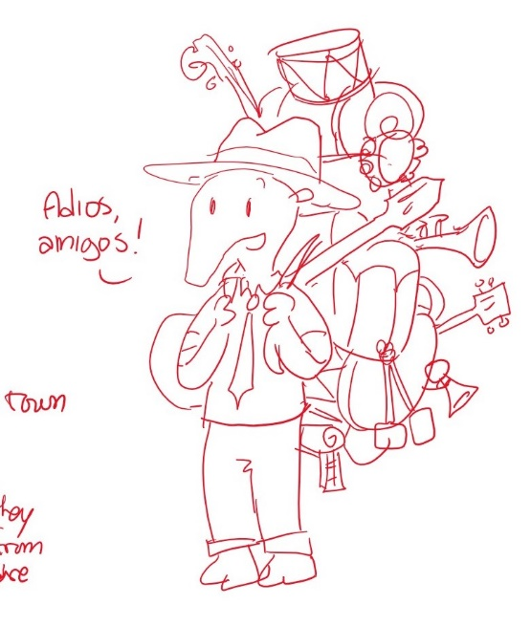
Logline: Sr. Tapir bids his farewell, as it’s time for him to go on the road again. Elinor is sad, until she hears some interesting sounds in the middle of the night.

It’s a late Fall day, and the kids are gathered around Sr. Tapir as he finishes singing a fun song. The kids all clap, and ask for another, but Sr. Tapir has some important news to tell them: he’s leaving Animal Town. What? You’re leaving, Sr. Tapir!? As he packs up his things, Sr. Tapir explains that he is a travelling musical instrument salesman and performer, and he goes from town to town, and that now it’s time for him to move on. He prefers the warm weather, so he’s going to go south. The kids are super bummed. Who’s going to sing us songs about scientists now? Sr. Tapir reassures them and tells them not to worry, because he’ll be back again next year when it warms up again!
Elinor, Ari and Olive walk to Elinor’s house. Along the way, the kids talk about how they are bummed to see Sr. Tapir go. Ari has an idea: we should do something special for him before he takes off tomorrow, to say goodbye. But what? They talk about making him a present, but they don’t want him to have to carry something. As the sun sits low in the sky, the kids arrive at the house, and they see Ranger Rabbit (Elinor’s mom) refilling the bird feeder in the porch. The kids tell Ranger Rabbit about Sr. Tapir, and she empathizes with them. That night, Elinor is awoken to some strange sounds. She’s never heard these sounds before, what could they be? She wakes up her mom and they listen together out the window. Their super good rabbit hearing narrows in on some strange chirping sounds. In the light of the moon, they see a flock of birds (species TBD, maybe more than one) some flying in a V pattern. Why are the birds flying at night, in that weird pattern and making that sound? They see another and another. Elinor observes that the birds are all heading off in the same direction, making the chirping sounds. That’s so interesting. She remembers it’s getting colder, and says the birds must be leaving for the winter. Elinor thinks maybe that’s why they are singing a different song. Mom confirms: the birds are migrating (that means they are going south for the winter), and when they do, they make special bird calls. Elinor feels a little sad: the birds are leaving too? Mom reassures her: that’s just the way Nature is. Don’t worry, they’ll be back again next year. That reminds her of Sr Tapir. Elinor feels better and tells her mom that she knows just what to give Sr Tapir as a going-away present.
The next day, as Sr. Tapir gets ready to hit the trail and walk, Elinor arrives with the rest of the children, and says they’ve prepared something special for Sr. Tapir: a special song! She explains to Sr. Tapir that birds have a special song when they leave for the winter, so they wrote a song just for him to remember them by until next year. The kids sing a farewell song about birds, and farewells, and coming back next year, because Adios doesn’t mean Adios forever, it can also mean Hasta Luego (see you later). Sr. Tapir tells them they are great, and they don’t need him to teach them about great scientists. They are great scientists themselves! And now he has a new special song to take with him on his travels.

