Elinor Wonders Why
“A WONDERFUL JOURNEY”
OUTLINE
Jorge Cham, Katherine Sandford and Daniel Whiteson
April 7, 2020

ACT I

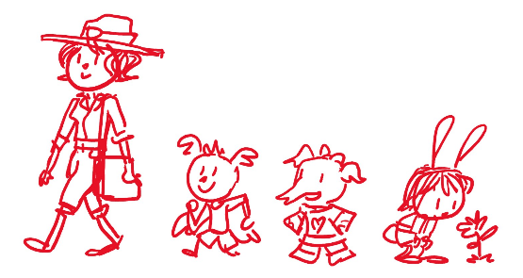
  - EXT. ANIMAL TOWN – DAY

It’s a beautiful day in Animal Town. We open on ELINOR looking curiously at a small nature scene: a bee lands on a flower, a ladybug takes flight. Suddenly, we hear RANGER RABBIT (Elinor’s Mom) call out to her. “C’mon Elinor.” We pull wide to reveal they are in the center of town on a bustling day and Elinor had stopped to look at some plants in one of the green areas. ARI and OLIVE are there as they follow Ranger Rabbit around town. Elinor stands up and joins the others, giggling and playing lightly. As the intro music and credits play, we see our group marching around town. Ari is in front, excited and confident, followed by Olive, who is holding her notebook and satchel. As they walk, we see Elinor continuing to be curious, looking and poking at things here and there. Finally, they arrive at Mr. Raccoon’s bakery.

1.2. INT. MR. RACCOON’S BAKERY – DAY

Ding! The door chimes. Inside, we catch Mr. Raccoon doing something funny (e.g. precariously balancing a big stack of donuts). He settles and greets them warmly and asks how he can help them. Ranger Rabbit explains she is taking the kids camping this weekend, and is buying supplies (she has a satchel that’s half full). The kids are SUPER excited. They tell Mr. Raccoon they are going somewhere they’ve never been before: Hidden Lake! It’s gonna be so much fun. Ari is especially excited, and shows off the new compass his parents got him to help them find their way. It’s a small toy on a string necklace. He demonstrates how it always points the same way, no matter how you turn. He tries some fast turns and ends up dizzy and plopping to the ground. Still works!

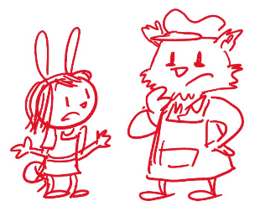
Mr. Raccoon loads them up with snacks for their trip, including the “best baked crackers in town” (though of course, he’s the only baker in town) and offers them a treat. Elinor gets curious and asks Mr. Raccoon a series of funny questions that stump him (E.g. Mr. Raccoon, why do donuts have holes? Oh, Mr. Raccoon gladly explains it’s because they’re baked that way. But why are they baked that way? Because he makes holes in them. Yes, but WHY does he make holes in them? Um... Because donuts have holes in them. Yes, but WHY do donuts have holes in them? Oh. Um... uh...) That’s a good question, Elinor! Olive agrees and says Elinor is really good at asking questions. I think that’s wonderful, says Mr. Raccoon. This piques Elinor’s interest. Ranger Rabbit says it’s time to move on and they bid adieu to Mr. Raccoon.

1.3. EXT. OUTSIDE MRS. HIPPO’S STORE - DAY

Outside of Mrs. Hippo’s store, Ranger Rabbit tells them she’s going to step inside to get a few things and the kids talk outside. Elinor tells her friends she DOES ask a lot of questions. That is SO interesting. Ari and Olive agree. They flashback to a couple of instances where Elinor asked a lot of questions and funny things happened. Remember that time you asked Mz. Mole SO many questions, she forgot all about recess? In thought bubbles, we recreate the scenes to humorous effect. Those WERE pretty good questions. The kids giggle. Or that time we were putting on a music show with Sr. Tapir, and Elinor missed her cue to sing because she was following a butterfly around? Another flashback thought bubble. Wow, I do ask a lot of questions. Hmm, Elinor wonders, I wonder why I ask so many questions? Why DO I wonder why?

1.4. EXT. WHY DO I WONDER WHY SONG MONTAGE

Elinor sings “Why do I wonder why?” The song starts out small and builds as her curiosity takes her all over, interacting in fun ways with the town plants, bugs, animals and residents.

Why do I wonder why songbirds sing?
And how many feathers are in their wings?
Why do I wonder why leaves are green?
Why do I wonder… so many things!

Why do I wonder if fish have ears?
And if they don’t, then how do they hear?
Why do I wonder why trees are tall?
Why do I wonder… anything at all?

Why, why, why?
I wonder why!
There’re so many things
I find interesting!

Why, why, why?
I wonder why!
Why do I wonder
I want to know why

Why do I wonder why bees have stripes?
And why are there so many different types?
Why do I wonder where mushrooms grow?
Why do I wonder… I want to know!

Why, why, why?
I wonder why!
There’re so many things
I find interesting!

Why, why, why?
I wonder why!
Why do I wonder
I want to know why

(bridge)
When I have a question
I go and explore
But now I wonder:
What is wondering for?

Why, why, why?
I wonder why!
There’re so many things
I find interesting!

Why, why, why?
I wonder why!
Why do I wonder
I want to know why

1.5. EXT. OUTSIDE MRS. HIPPO’S STORE - DAY

The song ends and the kids are back near Mrs. Hippo’s store. As they giggle and talk, Elinor refines her question: I know I ask a lot of questions, but what is asking questions good for? Dun, dun, dun! Olive says it’s a wondering mystery. Ari, who took off his compass and has been fidgeting with it, tells them that Elinor is the only bunny he knows that can ask a question about asking questions! As he extends his arms for emphasis, the compass flies out of his hands and lands in a nearby bush. Oh no! The compass!

The kids run over to look for it. After a beat of looking, the bush rustles and out pops a frog. A frog? What’s a frog doing in the middle of town? I dunno, says Ari, but look! It has my compass! The compass fell through the shrub and landed around the frog’s body. Poor frog, says Elinor! Ari tries to approach the frog to get the compass but each time he tries to grab it, the frog jumps away at just the right time. Oof! Ari tries one last lunge, but the frog skips away and starts going down the sidewalk. Come back, frog! At that moment, Ranger Rabbit comes out. As the kids give chase, Elinor yells back “We’re chasing a frog, Mom!”

1.6. EXT. ANIMAL TOWN - DAY

The kids run/hop after the frog in a fun chase sequence through town. Residents move and jump out of the way to funny results. (E.g. As the lamb triplets skip rope, the frog joins them for a bit as it hops up and down and then moves along. When the kids try to get through, Ari gets all tangled up. Mz. Llama, carrying a big basket of fruit, gets startled, throwing the fruit in the air. She tries to catch them all with her basket and the kids arrive just in time to help her catch the last few. The frog does an impressive series of hops on top of a few characters waiting at the bus stop: it hops onto one of the goat twin’s head as she bends down to pick something up, to her twin’s head, then Farmer Bear, then Mr. Moose’s head, then down Mr. Hamster and unto Mz. Mole. The frog lands on the book she’s reading. After a confused beat, the frog leaps away). The chase takes them slightly out of the town center, to a nearby dry creek bed.

1.7. EXT. FROG CREEK - DAY

At the creek, the kids observe the frog. There it is! It looks... lost (the frog seems to hop around, not sure where to go). The kids mention this is where they usually find frogs, but the creek looks dry now. Elinor thinks that’s why the frog was in town: the creek is dry and the frog didn’t know where to go. Olive remembers reading about it in her Nature book. She takes it out and reads: frogs like ponds and creeks that have just the right amount of water to have plants growing on them. Aww, poor frog. The frog takes another hop and drops the compass. Ari grabs it, and the kids watch as the frog hops away, continuing its search. Bye, frog!

At that moment, Mom catches up to them. Before she can talk, though, her radio squawks. It’s Deputy Mouse’s voice. Ranger Rabbit explains Deputy Mouse is helping Mrs. Beaver build the new road into town. Actually, it’s not too far from Hidden Lake. Ranger Rabbit grabs the radio and speaks into it.

1.8. EXT. INTERCUT RADIO CALL: ROAD BY THE RIVER PROJECT – DAY

We cut to the road site, where Deputy Mouse and Mrs. Beaver and her workers are working. Deputy Mouse informs Ranger Rabbit that everything is going smoothly and they should be done in no time. We see the crew clearing branches off to the side near a river.

1.9. EXT. FROG CREEK - DAY

Ranger Rabbit ends the radio call and gets back to the kids. She says they have all the supplies they need for the trip. Woo hoo! The kids are excited. They can’t wait to go exploring! Ranger Rabbit tells Ari and Olive that they’ll be leaving the house bright and early. We’ll be there, Ranger Rabbit! Checking his toy compass, Ari says, “Your house is THAT way.” Uh, actually, Ari, our house is THIS way (the opposite way). Huh. Ari shakes the compass. Maybe this thing doesn’t work that well. They all giggle. As they all walk off, Elinor hangs back a bit, still curious, and the camera lingers on the dry creek bed.

1.10. INT. ELINOR’S ROOM - NIGHT

Later that night, Ranger Rabbit tucks Elinor in bed. Elinor has lots of questions: What time are Ari and Olive coming tomorrow? How long will it take to get to Hidden Lake? What’s it like there? What are we going to find? Mom tells her my, you do ask a lot of questions! But now it’s time to sleep. Good night, my hunny bunny question asker.

Elinor stares out the window with quiet excitement, and sings a slower reprise of the song she sang earlier:

Why do I wonder
What makes stars so bright?
Why do I wonder
Where spiders sleep at night?

When I have a question
I go and explore
But now I wonder:
What is wondering for?

We end with a beautiful shot of the curious bunny Elinor looking up into the starry sky.

END OF ACT I

ACT II

2.1. EXT. RABBIT HOUSE NIGHT/DAWN (WIDE)

Starry night becomes beautiful dawn in Animal Town.

2.2. EXT. ELINOR’S HOUSE – DAY

We start on a close-up of Ranger Rabbit’s loaded backpack and pull out to show her putting in a few last things. MR. RABBIT comes up and gives her one last thing to pack: a loaf of his world-famous carrot cake. Aw, thanks sweetie. From off-screen, we hear a familiar voice: “Who’s ready to go… EXPLORING!” It’s Elinor and she’s bounding out of the house, wearing a hiking hat. From up the path we hear “I am!” and “Me too” and we look to see Ari and Olive arriving (also wearing hats and small backpacks) with their parents. The kids greet each other warmly. They’re very excited.

The parents greet each other also, and Mr. Rabbit says they’re going to have so much fun at Hidden Lake. Ranger Rabbit puts on her backpack and tells everyone it’s time to go, does everyone have everything they need? Ms. Elephant dotes on Olive, making sure she has her hat, sunscreen, pillow, etc. Did you pack your sketchbook and books to read? Yep, Mom! Ari says he’s ready to go. Mr. Bat asks him, aren’t you forgetting… Robin? Mr. Bat takes out Ari’s favorite plush birdie. Ari tells him, that’s ok Dad! I don’t think I need Robin. I’ll be fine. Ok… says Dad. After a beat, Ari changes his mind and grabs Robin and hugs him. Who’s my favorite birdie buddy?

Oh, says Mr. Rabbit, don’t forget, here’s the map to Hidden Lake. Mom says she remembers how to get there, but a map is always a good idea. A map? Cool! The kids open it up to see it and they ooh and ahh. Can we be the official map holders, Mom? Sure kids, you can be our official navigators. Awesome. After goodbyes, they are off!

2.3. EXT. ANIMAL TOWN - DAY

Adventure music begins as Ranger Rabbit and the kids leave the house and walk through familiar scenes on their way out of Animal Town, waving to their neighbors as they hike along.

2.4. EXT. TRAILHEAD - DAY

The scenery starts to look less familiar, more rugged and wild (though they are still on a path) as Ranger Rabbit and the kids leave town. Eventually they come to the trailhead – an arched bower of branches leading to a green and golden trail. “Whooooaaa, I don’t think we’ve ever been this far into the forest before,” says Ari in awe. “Yeah,” says Olive, “this all looks new to me.”

“Gasp! You know what that means…” says Elinor bouncing with anticipation. “We’re now EXPLORING!” Whoa, cool. As Mom looks on, the kids look down the path and ask questions: I wonder what we’ll find? Yeah, what’s over there? Are we going to see new animals or bugs? Or maybe new plants? Those are great questions, kids. This jogs something inside of Elinor. Gasp! Ari! Olive! I think I figured out one thing that asking questions is good for. What is it Elinor? Exploring! Whenever we go exploring, it’s because we were wondering about something. Mom thinks for a beat, and says she’s right. All exploring always starts with a question. Awesome!

As they set out along the path, off into the unknown, we hear the beats of a song coming up.

2.5. EXT. EXPLORING SONG MONTAGE

The kids sing “The Exploring Song” as they hike through awesome vistas, doing fun things like swinging off branches, looking at plants and under rocks, crossing log bridges, etc.

Explore, Explore, just walk out the door!
The whole world is there, what are you waiting for?
Explore, explore, then explore some more,
You don’t know what you’ll find until you explore.

Who knows where you’ll go, and what you will see,It could be a forest, a cave or the sea,You might climb a mountain, or wade through a bog
Or you might find a town under a rock, or a log!

Explore, Explore, just walk out the door!
The whole world is there, what are you waiting for?
Explore, explore, then explore some more,
You don’t know what you’ll find until you explore.

What’s beyond that tree, you might want to know
It all starts with asking, where should I go?
Or you might want to ask, who will I meet?
It’s all there for you, just ask and you’ll see!

Explore, Explore, just walk out the door!
The whole world is there, what are you waiting for?
Explore, explore, then explore some more,
You don’t know what you’ll find until you explore.

(bridge)
The world is full of wonders
For us to discover
All you need you to have
Is a little bit of wonder

Explore, Explore, just walk out the door!
The whole world is there, what are you waiting for?
Explore, explore, then explore some more,
You don’t know what you’ll find until you explore.

END SONG MONTAGE.

2.6. EXT. TRAIL – DAY

As the song ends, our group continues hiking. The three kids are walking behind Ranger Rabbit holding the map open. In the map, we get a little view of the area: Hidden Lake is fed by a small river upstream, and pours out to another small river downstream (waterways are painted blue). The downstream river goes to Animal Town, with a smaller creek branching off and going near the trail. There’s a fork in the trail near the creek.

Ranger Rabbit asks the kids how they’re doing on the map. The kids are confident and say that they are right on track. Just keep walking and then make a right when we reach the water creek.

As they walk, the kids talk about the fun things they want to do at Hidden Lake. Ari can’t wait to eat marshmallows over the campfire. Olive can’t wait to try out her new drawing pencils. She brought TWO blue pencils so she can paint all of Hidden Lake. As the kids and Mom banter and have fun, we see them walk near a dry creek bed and miss the trail turn.

2.7. EXT. FURTHER DOWN THE TRAIL – A SHORT TIME LATER

The group continues walking along the trail and come upon a wooded area. Overhead, the clouds move and darken the scene a little. Ranger Rabbit pauses and thinks. Hmmm, I don’t remember this part being on the way to Hidden Lake. Uh oh, say the kids. Can you check the map, Olive? Olive checks: we were supposed to turn at the creek with water. Have we passed the creek? I don’t remember seeing any water, says Mom. Ari gets a little overdramatic. Are we lost? Oh no, we’re lost! Mom reassures them. No worries, we’re still on the trail. All we have to do is turn back. We’ll figure this out.

But just then, the kids hear some rustling over in the nearby bushes. What’s that? Gasp! It’s coming closer. What is it? There’s a little bit of a kid-friendly scare moment as the rustling gets nearer. Who’s there? Ari takes Robin out and hugs him. I’m so glad you’re here, Robin! A few more rustles, and then someone steps out of the bushes. It’s… It’s… a young (25-ish) female Latinx Coatimundi, dressed in outdoor exploring clothes with interesting accents (like a colorful scarf) and wearing a backpack and a wide hat. “BIANCA??” says Ranger Rabbit.

“Ranger Rabbit!?” says Bianca, in excited disbelief. The scene lightens. The kids let a breath out. It’s so good to see you! Mom introduces Bianca and the kids. Bianca is an old friend of Ranger Rabbit’s. What are you doing all the way out here, Ranger Rabbit? Ranger Rabbit says they are on their way to Hidden Lake. Ah, actually that’s where Bianca is camping right now, but you’re a bit way off. You were supposed to turn at the creek. But that’s ok, here I’ll show you the right way.

2.8. EXT. TRAIL – DAY

The group is back where the trail forks. Oh, says Ranger Rabbit, I see. We missed the creek because it’s dry, but… that’s odd. Creeks shouldn’t be dry this time of year. Bianca says a lot of the creeks on this side of the lake are dry. Elinor chimes in that they saw a dry creek in Animal Town too. Hmm… Ranger Rabbit thinks thoughtfully. Well, come on, let’s go says Bianca.

2.9. EXT. TRAIL TO HIDDEN LAKE – DAY

As they walk, Ranger Rabbit asks Bianca what she’s doing here, and Bianca tells them she’s here to get ideas. Ideas? asks Elinor. Ranger Rabbit explains that Bianca is an Inventor. What! Cool! SO Cool, you INVENT things? Yes! Says Bianca. I invented THIS for example. Bianca shows off a fun invention from her hat or her backpack. It’s a bit of a gizmo that does something fun/funny and that is inspired by Nature (though we don’t know that at this point, it will be revealed later). Wow! Cool! The kids are amazed.

Ranger Rabbit says that Bianca was just like you, Elinor, when she was a little girl. She LOVED to ask lots of questions. Elinor is now doubly amazed. You can read it in her face: Someone just like me??

At that moment, they come upon an opening in the trees as the trail bends and looks out unto… HIDDEN LAKE. Finally! Choir sings. It’s a beautiful view. Hidden Lake delivers. Gorgeous. Wow! Cool!

Bianca turns left and tells them to follow her to her campsite.

2.10. EXT. TRAIL TO CAMPSITE – DAY

As the adults continue talking, the kids are hanging back a bit. They talk excitedly about Bianca. She’s an inventor, that’s SO cool. Can she invent food for us? Ari is hungry. Elinor says she’s never met an inventor before. Yeah, says Ari in whispers, I thought they were supposed to wear lab coats and have crazy white hair. At that moment, Bianca turns around and responds to them: Well, my hair isn’t white, but it is a bit unruly today! Gasp! How did you hear us? Bianca unveils another fun/funny invention, like an electronic ear gizmo (also bio-inspired but not yet revealed) connected to an earbud in her ear. I also invented this. It lets me hear from afar. WOW. Cooool… I don’t know if Bianca can be any cooler says Ari.

Oh, by the way, says Bianca. I have marshmallows for all of us for tonight. Ok, says Ari, I was wrong. They all giggle as they head to the campsite.

2.11. EXT. CAMP SET UP MONTAGE – DAY/NIGHT

In a musical montage, we see the group set up their tents and settle in with funny moments shown. We see the sun set over the mountains above Hidden Lake, as the sky darkens and fills with stars.

2.12. EXT. CAMPSITE – NIGHT

We come back from the montage on Olive in front of the campfire, telling the group a kid-friendly spooky story. Ari grips Robin for comfort in a funny way. Mom is paying attention to the story while Elinor and Bianca sit a bit to the side. What kinds of inventions do you invent? All kinds! Like this one! She shows another fun gizmo/gadget that helps her roast marshmallows. Elinor asks where she gets her ideas, and Bianca points to all around them. Right here! I get my ideas from Nature! Huh? thinks Elinor. Right now, I’m looking for ideas from frogs. Oooh, we love frogs! Bianca offers to show them tomorrow.

At that moment, Ranger Rabbit says it’s time to turn in. It’s been a long day.

As the kids go into their tents, Elinor hangs back and sticks her head out the tent. This has been an awesome trip so far. She can’t wait until tomorrow. She sings a little bit of the explorer song from before. Who knows where you’ll go, or who you will meet… It might be someone, who thinks just like me…

END OF ACT II

ACT III

3.1. EXT. CAMPSITE – MORNING

The sun rises, filling the sky with glorious reds and oranges that are reflected in the lake. It’s the next morning and we catch the campsite as it gets ready for the day. The kids are poking and playing around while Bianca and Mom wash the breakfast pans. The kids look at the remains of some of Ari’s failed marshmallow experiments from last night, including a big blob of sticky marshmallow at the end of a stick. Yow, that’s sticky!

Bianca finishes rinsing a pan and looks around, wondering where to put them. Ranger Rabbit has an idea to hang a drying line and gets some cord from her backpack. She goes over to the nearest two trees, which are a good distance apart. Uh oh, says Elinor, will the cord reach? Mom says not to worry, this is a bungee cord, see? It’s stretchy. She ties one end and stretches it over to the other tree, and the kids go oooh. Ari plays with the extended cord (hangs and bounces). It’s so stretchy! He tries pulling it all the way down. Careful Ari, says Ranger Rabbit, you might… Sproing! The bungee launches Ari up into air, and he comically floats down, a little thrown off. The kids check on him and giggle after a classic Ari pun.

Bianca finishes hanging up the pans and turns to the kids: Ok, who’s ready to go see some frogs?? The kids are super pumped. Yay! Awesome, we love frogs! Frogs are the best! Mom chimes in that if they are looking for frogs, there’s a great spot near the lake that is always full of frogs. A thought bubble shows the audience a bog filled with frogs of all kinds and, importantly, just the right amount of plants in it. Fantastic! says Bianca. Ranger Rabbit takes out her map and shows Bianca where the spot is, when suddenly, her radio squawks. It’s Deputy Mouse again.

3.2. EXT. INTERCUT RADIO CALL: ROAD BY THE RIVER PROJECT – DAY

We cut to a scene of Joe Mouse at the head of the clearing of the new road into Animal Town nearby, and it looks like something has gone amiss (e.g. they’ve been clearing the sticks and branches on the ground to make space for the road, but there are just too many) and Mrs. Beaver and her crew are standing around looking tired. They need Ranger Rabbit to come and help them sort it out.

Oh dear, says Ranger Rabbit. They need me up the river near here. Bianca offers to help: you can leave the kids with me, and you can go help Deputy Mouse. Really, are you sure? Of course! We’ll get along just fine, right kids? Ari and Olive and Elinor say yes. Mom checks with the kids to make sure they have everything they need, and then gives Bianca one of her radios to call in case they need anything.

Ranger Rabbit waves goodbye telling them she will be back soon. Elinor assures her Mom not to worry – they will all be just fine.

Ok kids, says Bianca, now let’s go find those FROGS!
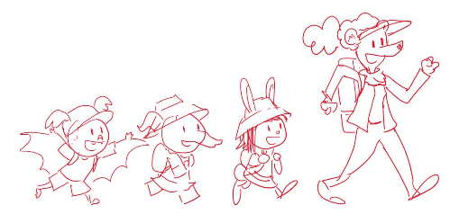
3.3. EXT. TRAIL TO THE LAKE – DAY

As Bianca and the kids walk to the frog spot, they talk. Olive tells her it must be so cool to be an inventor. Yeah, says Ari, where do you get your ideas? Bianca tells them that you can get ideas from all kinds of places, but she likes to get hers from Nature. Nature? Yes, Nature is FULL of ideas! For example, she got the idea for this (the first gizmo she used earlier) when she was studying Andean condors last summer (a thought bubble shows her observing a condor high up a mountain). She then explains an amazing fact about condors that inspired her design. Whoa, cool…. And she got the idea for this (the hearing gizmo she used before) while studying moths in the jungles of Africa (a thought bubble shows her peeking through some vegetation at a moth). Moths have some of the best hearing of all the animals in the world. Awesome!

And in fact, Ari, you’re WEARING an idea from Nature right now! Wha? Ari looks down, and sees he’s covered in seed burrs. He looks back at the bush he just came through. Elinor goes over and picks one out. We’ve seen these seeds before! Olive chimes in: yeah, they have little tiny hooks that make it stick to the loops in clothes. Bianca gizmos a magnifying glass and they look closer at the hooks in the burr. Elinor remembers that the seed inspired someone to make a kind of tape that sticks together without being sticky. Yes! says Bianca. Ari remembers that his hat uses that kind of tape. He takes it off and SKKKKRTCH! Whoa, you’re right, Bianca, Nature does have lots of ideas. That’s right, says Bianca, ideas are all around us.

The kids look around. But how do you find them? Why, says Bianca, you just have to be curious! You mean, says Elinor, ask questions? Yes, says Bianca. If you look around and ask yourself, “How does that work?” or “Why is that like that?” you might learn a new idea you didn’t know before. This jogs something inside of Elinor. Gasp! Ari, Olive! That’s something ELSE that asking questions is good for. Getting ideas! Exactly, says Bianca! And they launch into a song.

3.4. EXT. NATURE IS FULL OF IDEAS SONG MONTAGE

Bianca starts the song and is then joined by the kids, as they poke around the surrounding area and also go into montages of inventions that were inspired by Nature (a bit like Sr. Tapir interstitials).

Nature is full of ideas
You find them everywhere
Just ask yourself a question
The answers are out there!

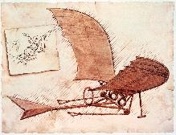
Did you know that airplanes
Were inspired by birds?
We looked to the sky
And saw them fly
And we wondered,
how can WE go as high?

And did you know that helicopters
Were inspired by dragonflies
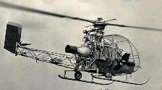
We saw them hover
Over and under
And it made us feel
Full of wonder!

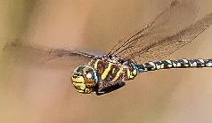
Nature is full of ideas
You find them everywhere
Just ask yourself a question
The answers are out there!

And did you know that even cars
Have ideas from the sea
We saw some swimming fish
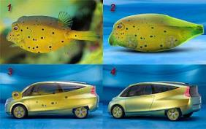
And it made us wish
We could make cars
That go swish swish swish!

Nature is full of ideas
You find them everywhere
Just ask yourself a question
The answers are out there!

(Kids bridge)
It’s true you see it all around
Amazing ideas to be found
All you have to do
Is be curious
And you might find
Some ideas, too!

(All together)
Nature is full of ideas
You find them everywhere
Just ask yourself a question
The answers are out there!

END SONG MONTAGE.

3.5. EXT. TRAIL TO THE LAKE – DAY

As we come out of the song, we’re back on the trail that leads to the lake and the frog area. Elinor recaps that Nature really is full of ideas. She’s excited that she found something else questions are good for: finding ideas! Bianca says Elinor mentioned that before and asks her what she means, and Elinor explains that she’s always asking questions, and she started to wonder why? And now she knows, asking questions is good for exploring and it’s good for getting new ideas. Bianca reinforces that, and tells her when she was a little girl, she asked a lot of questions too. And she still does today! So never stop asking questions, Elinor. I won’t, says Elinor! Ok, let’s go find those frogs!

3.6. EXT. FROG BOG – DAY

They keep walking and come up on the area in the map where Ranger Rabbit said there should be lots of frogs. But… they don’t see any frogs. The area looks like a bog that’s been flooded. All the plants are mostly underwater. No frogs.

That’s odd. The group decides to split up and look around for frogs. Ranger Rabbit said this area should be full of frogs, but they don’t see any. Here we build up to a HILARIOUS GAG for one of our kids. Something that will make kids at home laugh out loud. Not sure what it is yet, but something physical and really funny. Meanwhile, Elinor starts to notice the plants all look like they are under the water. Hmmm.

The gag climaxes, and the end result is that they find one frog. There’s one! Great! Let’s observe it. They comically hide behind a log to study the frog. As they observe, the frog watches silently as a fly meanders by. Suddenly, the frog acts! In a flash, it shoots its tongue out, catches the fly and gobbles it up. Wow! What just happened?? That was cool! They watch it eat another bug. Whoa.

Elinor wonders how the frog can stretch its tongue so much. Bianca says that’s what’s been making her curious about frogs, and why she came to observe them. She explains in a drawing in her design sketchbook that frog tongues are really stretchy, they can stretch twice the size of their body. And they’re really sticky at the end, which is how the catch the bug. That’s SO interesting! What a great idea!

The kids try to think of inventions they could invent using this idea. They think reaaaalllly hard, but… nuthin. That’s ok, says Biancaa. Ideas for inventions don’t always come right away. But it’s good to ask the questions and make the observations and then your brain can think about it.

At that moment, the frog hops away. This makes the group refocus on the issue of the frogs. Where are the other frogs? Bianca wonders what happened to them? Ari thinks maybe they got lost coming here. This makes Elinor think about the earlier incident, which they recap for Bianca. Elinor says she noticed that the plants here all seem to be underwater. Olive remembers that frogs like water that’s not too shallow and not doo deep. That’s it! Maybe this water is too deep for the frogs. Hmm, thinks Bianca. It looks like it flooded recently. I better tell Ranger Rabbit.

She radios Ranger Rabbit, who is just arriving at the road site. They explain the situation, and Ranger Rabbit says that it is worrisome, and that she’ll look into it as soon as she gets back.

Ok, well, let’s head back to the campsite. As they get ready to go, we do a recall gag to the earlier hilarious gag to button the act.

END OF ACT III

ACT IV

4.1. EXT. PATH BESIDE THE LAKE – DAY

Walking back along the lake, we see Ari and Olive having a bit of fun, while Elinor talks to Bianca. Elinor tells Bianca she’s worried about the frogs. If their favorite place is full of water, where are they going to go? Bianca tells her she’s worried too. The lake water does look higher. What could be doing that, asks Elinor? Bianca says it’s hard to say. Sometimes in Nature, things happen in one place that affect the plants and animals in other places. Everything is connected, even us.

Elinor thinks on that for a second. Bianca says that’s why we need to help Nature when we can, especially if we cause changes in it. And that’s what your mom does, she looks out for Nature and everyone in Animal Town. Does asking questions help, asks Elinor? Sure it does! Asking questions and getting ideas from Nature is how we learn more about it.

4.2. EXT. EVERYTHING IS CONNECTED DITTY MONTAGE

Bianca sings to Elinor, and later also Ari and Olive, a short sweet ditty about how everything in Nature is connected, even us. As she sings, the kids take in a larger view of the trees and plants and animals around them.

Everything’s connected,
That’s the beauty of our world,
Everybody has a place,
Every boy and girl

Every plant and creature,
Be it big or be it small
We are all in this together
Nature, you, me, and all

Everything’s connected,
That’s how Nature goes,
And every plant and animal.
Has a special role,

When something happens somewhere
It affects another place
It can make things change
In unexpected ways

Everything’s connected,
That’s the beauty of our world,
Everybody has a place,
Every boy and girl

Every plant and creature,
Be it big or be it small
We are all in this together
Nature, you, me, and all

4.3. EXT. PATH BESIDE THE LAKE – DAY

As they come out of the song, Bianca suggest they take a break and they find a spot along the lake. Ari’s stomach grumbles and says that a snack would be great. Olive takes the opportunity to draw Hidden Lake and takes out her sketch book and crayons. Ari makes some funny commentary about the snack he’s eating. A beat later, we hear Olive sounding a little frustrated.

Elinor goes over and sees that Olive is drawing the lake, but keeps having to change it as the sticks in the lake keep moving. Elinor looks over and notices that there are sticks and bits of branches in the water, and they are all slowly floating in one direction. Huh, that’s interesting. She gets curious: where are the sticks going? She starts to follow them along the edge of the lake, and the rest of the party gets up and joins her.

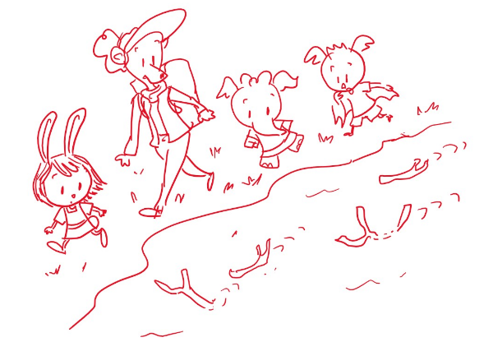
As they follow the sticks, the kids comment that there seem to be more and more sticks as they are going. Several beats of mysterious and curious following later, the group arrives at the end of the path, and they see the sticks go around a bend in the lake’s edge. Huh, there they go, where are they going? Suddenly, Bianca’s hearing gizmo picks up a sound.

I hear something. Hold on. She follows the sound into the brushes up to a small rise.

4.4. EXT. RIVER BLOCKAGE OVERLOOK – DAY

Bianca and the kids emerge on the other side of the bushes. A little down below them, the group discovers where all the sticks have been going: they are being collected unto the outflow of the lake below, stuck together by the flow against some rocks.

The kids observe and figure out what’s going on: the sticks are all bunching together and blocking the water. The water can’t come out of the lake. That’s what’s making the water in the lake higher. Yes, because it can’t go out. The kids look at the map, and pointing to it (and maybe marking the dam), they also piece together that it’s probably what’s causing the creeks in Animal Town to dry up. Gasp! These sticks are affecting everything, especially the poor frogs!

Bianca decides to radio Ranger Rabbit.

4.5. EXT. INTERCUT RADIO CALL: ROAD BY THE RIVER PROJECT – DAY

Bianca informs Ranger Rabbit what they discover, and Ranger Rabbit realizes that the pile of sticks and branches they’d been clearing was too close to the river and the water has been dragging them away. With Deputy Mouse and Mrs. Beaver they make a quick plan to move the pile. Elinor asks if they should try to clear the sticks blocking the water (it’s making the water too deep for the frogs!), and Ranger Rabbit tells her usually we have to be careful about changing things in Nature, but since they caused the stick pile, we need to fix it. Ranger Rabbit tells them to be careful and do what they can, and that they will be right there as soon as they can.

4.6. EXT. RIVER BLOCKAGE OVERLOOK – DAY

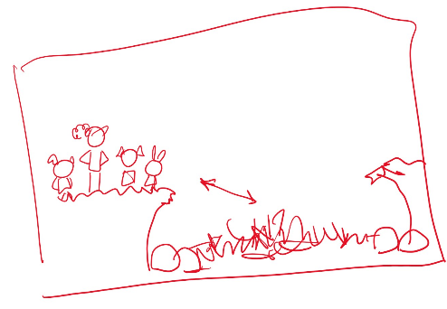
Back at the lake, the kids and Bianca decide they have to try to help. Bianca thinks about what to do (Hmm…) and Elinor suddenly has an idea. She wonders if asking questions can help. Bianca thinks that’s a great idea. Olive says she can make a drawing of the sticks. On her sketchpad, she doodles a general diagram of the situation. The kids and Bianca are on a small overlook above the rocks and sticks.

Ok, says Elinor, how can we get the sticks out of the water? That’s great, Elinor, says Bianca. Now the next step is to come up with ideas. Ari offers to fly over and get the sticks. Hmm, says Bianca, that might not be safe for you, Ari (there is some splashing from the mild current hitting the sticks). Olive has an idea: can we use your invention to get the sticks, Bianca? Hmm, let’s try it. Bianca uses her gizmo (an extendable condor claw?) but it’s not long enough. Awww. That’s ok, Bianca says, not every idea always works out. We have to keep trying. Elinor thinks, where else can we get ideas… The kids have a collective recollection of the earlier frog observation: in a thought bubble, they remember the frog catching a bug from across the lily pad. They all gasp at the same time: we could do like the frog! Aha, says Bianca! An idea from Nature, I love it!

The kids then think, how can we make a frog tongue? Hmmm… they think for a beat, and then Ari says he knows exactly what to use! I’ll be right back! He flies off in the direction of the campsite.

4.7. EXT. CAMPSITE – DAY

We see Ari fly over the lake area and then cut to him landing on the campsite. He puts down the drying pans and grabs the bungee cord. Before he leaves, he thinks and has another great idea.

4.8. EXT. RIVER BLOCKAGE OVERLOOK – DAY

Back at the river blockage, Ari flies back holding the bungee cord and hands it to Bianca. The bungee cord! It’s stretchy like a frog’s tongue! But how can we make it sticky too? Ta da! Ari unveils what he had in a paper bag: the blob of marshmallow he had made the night before. Marshmallows are really sticky! Great thinking, kids!

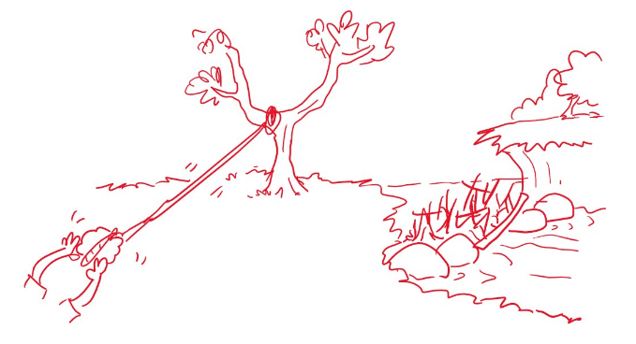
The group wraps one end of the bungee cord around the marshmallow blob, and ties the other end to a nearby small tree branch, making something of a slingshot.

They pull back the marshmallow blob and… frog tongue away! The blob flies through the air and plop! Lands on the stick pile, temporarily sticking to some sticks. Yes! We did it! The bungee cord pulls taut and the kids and Bianca pull on it. But suddenly, the marshmallow blob unsticks and comes flying back, landing in front of them (or on Ari for humor?). Oh no! the marshmallow isn’t sticky enough! What do we do?

Elinor reminds them: that’s ok, not all ideas always work. We have to keep trying. Hmm… what else do we know is sticky? Suddenly, Elinor remembers the seed burrs, and on a flashback, we see the closeup of the little hooks catching the loops. That’s it! Maybe we can use a hook, just like the seed burrs. Another idea from Nature, Bianca loves it! But how to get a hook?

Bianca extends her condor gizmo to scratch her chin in thought. Olive notices the gizmo’s claw end and says that part sort of looks like a hook. She sketches her idea for the group. Bianca agrees and takes it apart. She refashions it as a hook at the end of a short arm, and ties the end of the bungee cord to it (after untying it from the marshmallow). Ok, kids let’s try this.

They pull back on the cord and let it fly! Away frog tongue/condor claw! The hook lands and hooks unto a large branch in the middle of the pile. Yes! It hooked! The kids and Bianca pull on it (being safe of course with Bianca in front). Nnnnngh! It’s not moving! Nnnngh! Suddenly, the branch moves and comes loose! Yes! The hook loosens and slacks down the overlook. The kids and Bianca look on as the rest of the stick dam collapses and starts to flow down the river. Yes! We did it!

The kids do a celebration dance. Ranger Rabbit Radios back, and tells them they are on their way, but Bianca tells her that the kids solved the problem. Wow, how? They asked questions and got a little idea help from Nature. Awesome, laughs and cheers all around.

The kids look on as the last of the sticks washes downstream and water flows out of the lake. They look down and they can already see a little bit of the water level go down.

Elinor remembers: the frogs! Let’s go check on them! Yes! They run off screen.

4.9. EXT. FROG BOG – DAY

The group arrives back at the frog area and they look around. They can see the water level slowly receding. Look, now you can see more of the plants. It looks more like a normal frog pond. As they look on, a small brown frog hops over from some nearby bushes and jumps in the water, looking happy and content. We did it! Now the frogs can come back! Yes!

On good feelings and high fives, we…

END ACT IV

ACT V

5.1. EXT. CAMPSITE – DAY

It’s the next day and everyone is packing up to leave camp. Ranger Rabbit is back, and the kids have a bit of goofy fun (maybe a marshmallow callback gag, or something related to their backpacks).

Well, it’s time to go. Ranger Rabbit asks where Bianca is going next, and Bianca says she’s not sure, wherever Nature takes her! The kids get ready to say their goodbyes to Bianca. We button up the threads for the secondaries: Ari has a fun interaction with Bianca about her inventions (he has some amazing ideas for a gizmo that can roast 20 marshmallows at once) and Bianca asks Olive about her drawings. Olive shows her a really beautiful drawing of Hidden Lake, and if you look closer, you can see all of them, and the frogs of course. Bianca encourages them to keep having fun ideas and to keep drawing.
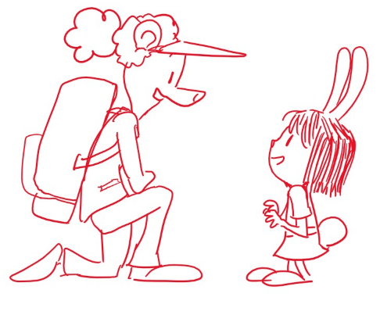
It’s Elinor’s turn. Bianca kneels down and they have a quieter moment. Elinor tells her it was SO much fun to meet her, and Bianca says “Me too!” Bianca says she hopes Elinor found all the answers she was looking for, and Elinor says yes, she learned SO much. Bianca encourages her to keep on asking questions. It’s always good to listen to that little bit inside all of us that wants to know how things work or why they are the way they are. Elinor looks down at herself and asks, “We all have a little bit of wonder inside?” Yup, says Bianca, there’s wonder inside all of us.

Ok, kids, let’s start our hike back. The group sets off from the campsite and we do a short montage as they walk back the way they came in.

5.2. EXT. TRAIL TO HIDDEN LAKE – DAY

At the entrance to the forest, where we first revealed Hidden Lake, the group stops (still over music) and they part ways with Bianca (she goes the other way). Hugs and fun waves as she sets off. On a wide shot, we see them walk in different directions as we get one last look at Hidden Lake (goodbye lake!).

As the group starts walking down the path, Ari makes a funny comment, and Elinor and Mom have a short conversation. Did you have a fun trip, Elinor? Yeah! I learned that asking questions is good for LOTS of things. It’s good for exploring, it’s good for finding ideas, and it’s good for solving problems. Yes, says Ranger Rabbit, asking questions is wonderful.

With that, we launch into our final song: a sweet uplifting song that recaps what we’ve learned and done and winds us down. As they sing, the kids hike back to Animal Town over beautiful Nature scenes and flashbacks to the previous key moments.

5.3. EXT. IT ALL STARTS WITH ASKING QUESTIONS SONG MONTAGE

It all starts with questions
It almost always does
So keep on asking questions
‘Cause who knows where it goes

It might help you to explore
And visit places that are new
Who knows what you’ll find
It might be something good

You might discover a new town
Or make a new friend
It all starts with asking
What’s around the bend?

It all starts with questions
It almost always does
So keep on asking questions
‘Cause who knows where it goes

It might give you new ideas
Things you didn’t know before
Who knows what you’ll learn?
That’s what asking’s for

Why is it like that?
And what does it do?
You just have to ask
And then you’ll know it too

It all starts with questions
It almost always does
So keep on asking questions
‘Cause who knows where it goes

(bridge)
The best part of asking questions
Is when you get to ask,
How can you help others with
the questions that you have?

It all starts with questions
It almost always does
So keep on asking questions
‘Cause who knows where it goes

On the last few bars, we see our group get to Animal Town and to the Rabbit House. Mr. Rabbit and the Bats and Ms. Elephant are all there to greet them and the kids say their goodbyes and give each other hugs. As the end notes of the song play, we see Elinor follow her parents into the house, taking one last look back at the world outside.

5.4. EXT. FROG CREEK – DAY

It’s some time later, and we cross-fade to the frog creek from the beginning of the special. We see the green frog we saw earlier sitting happily on a floating lily pad. The creek is filled with water again, and we pull out to show that there are more green frogs happily swimming about, and that Elinor is there curiously looking at them. All is right with the world, and Elinor looks happy wondering. The frog zips its tongue at a nearby fly and Elinor gasps and giggles.

From off-screen, we hear Ari make a funny comment. Let me guess, he says, are you wondering, Elinor? Olive is with him. Yes, I am! says Elinor cheerily and they all look at the frogs together. I wonder, says Elinor… why do frogs like to hop? They have really long legs, why don’t they just walk? Ari and Olive seem stumped. I don’t know, says Ari. Maybe because… hopping is more fun? He hops around comically, and the kids giggle. I know, says Olive as she takes out her notebook, let’s observe them and see if we can figure it out. Yes, says Elinor, we need more observations! On giggles and light playing, we pull out of the frog creek, up and over the trees and buildings and we settle on a beautiful view of the area. It’s another wonderful day of wondering in Animal Town.

END OF SPECIAL

CREDITS

POST CREDIT SCENE
On a bonus post-credits scene, we see Mr. Raccoon at his bakery, munching on a snack with one hand, and reading a book with the other. The cover reads “All about Donuts: The ‘hole’ truth behind everyone’s favorite treat”. Suddenly, he stops chewing and slaps his head. “So THAT’S why donuts have holes!” CUT TO BLACK

