Elinor Wonders Why
“A WONDERFUL JOURNEY”
OUTLINE
Jorge Cham, Katherine Sandford and Daniel Whiteson
Draft 2, May 6, 2020

SEP1a, c. Demonstrate curiosity about the greater world outside of their local environment. Identify a problem that can be solved by the design a new or improved object or tool (engineering). [The kids get curious and investigate why the water level at Hidden Lake has risen, and find the source of the problem]

SEP4d. Talk about and reflect on what happened during an investigation or when solving a problem, and why it might have happened/ [The kids record and discuss their observations about the problem at the lake]

SEP3e. Design and build a solution to a simple problem (engineering). [The kids design and build a way to dislodge the sticks causing the water level to rise]

LS2a. Identify body parts of animals and their function. [The kids learn about frog tongues and their function.]

LS5d. Identify and observe the consequences of how plants and animals impact the environment. [The kids learn that changing the water level of a frog’s habitat changes their behavior]

ET1b, c. Define a simple problem that can be solved through the design of a new or improved tool or technology. Begin to understand that engineering is a collaborative process during which ideas can be exchanged and shared with others while defining a problem and working to design, test and revise a solution. [The kids identify the problem at the lake and work collaboratively to design a simple tool to solve the problem]

ET2b. Use a variety of low-tech tools including writing, drawing and painting utensils, scissors, magnifiers, balance scales, ramps, pulleys, hammers, screwdrivers, sieves, tubing, binoculars, whisks, measuring cups [Elinor and her friends use tools like the notebook and rope to design their solution to the problem at the lake]

ES3b, c. Demonstrate an awareness of and the ability to discuss in simple terms the need for conservation, recycling, and respect. for the environment. Participate in simple activities to care for the environment [Elinor and her friends realize the road project is affecting the frogs, causing the crew to modify their methods]

ND1. (RTL Crosscutting concept ‘Patterns’) Understand that modes of life in the natural world and engineered solutions in the designed world have common patterns, and engineers often look to natural patterns for inspiration. [The kids learn from a biomimetic inventor about different bio-inspired designs and solutions]

ND3. (RTL Crosscutting concept ‘Structure and Function’) Understand that structures and materials in the natural world can be used or can inspire the engineering of structures with similar function in the designed world. [The kids use what they learn about frog tongues to design a simple solution to the lake problem]

ND4. (RTL Crosscutting concept ‘Flows, Cycles, and Conservation’) Appreciate the way that elements in the natural world change, interact and are re-used, and how we can organize our designed world to better fit and care for the environment. [Elinor and her friends realize the road project is having an impact on the lake and the frogs]

ND5. (RTL Crosscutting concept ‘Cause and Effect’): Appreciate that events are connected to each other via cause and effect, and that similar links can be found in the natural and designed worlds. [Elinor and her friends realize the road construction is causing changes to the lake and to the frog habitats]

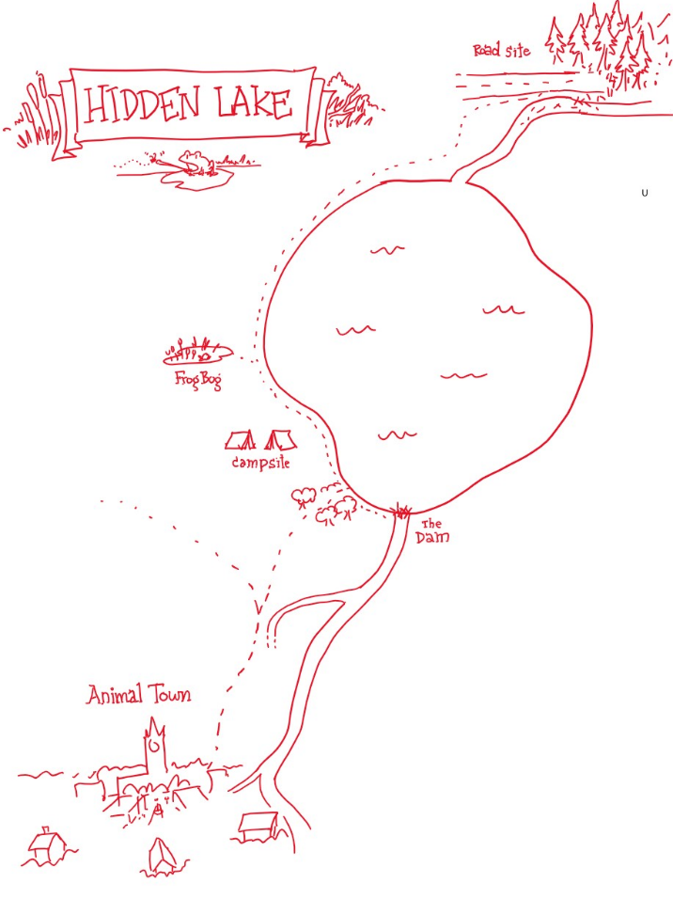

ACT I

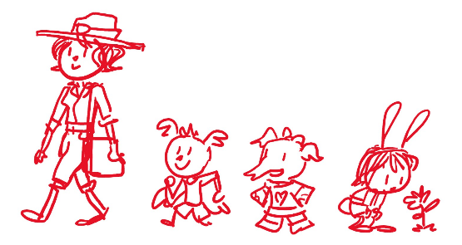
- EXT. ANIMAL TOWN – DAY

It’s a beautiful day in Animal Town. We open on ELINOR looking curiously at a small nature scene: a bee lands on a flower, a ladybug takes flight. Suddenly, we hear RANGER RABBIT (Elinor’s Mom) call out to her. “C’mon Elinor.” We pull wide to reveal they are in the center of town on a bustling day and Elinor had stopped to look at some plants in one of the green areas. ARI and OLIVE are there as they follow Ranger Rabbit around town. Elinor stands up and joins the others, giggling and playing lightly. As the intro music and credits play, we see our group marching around town. Ari is in front, excited and confident, followed by Olive, who is holding her notebook and satchel. As they walk, we see Elinor continuing to be curious, looking and poking at things here and there. Finally, they arrive at Mr. Raccoon’s bakery.

1.2. INT. MR. RACCOON’S BAKERY – DAY

Ding! The door chimes. Inside, we catch Mr. Raccoon doing something funny: he precariously balances a big stack of baked goodies and sets them down on the counter. He settles and greets them warmly and asks how he can help them. Ranger Rabbit explains she is taking the kids camping this weekend, and is buying supplies (she has a satchel that’s half full). The kids are SUPER excited. They tell Mr. Raccoon they are going somewhere they’ve never been before: Hidden Lake! It’s gonna be so much fun! They love going on trips.

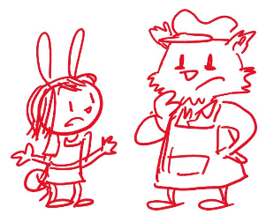
Mr. Raccoon says he’s going to gather some snacks for them to take on their trip, including the “best baked crackers in town” (though of course, he’s the only baker in town) and offers them goodies while they wait (as long as it’s ok with Mom). Yes! Elinor and Olive grab a treat from the top of the pile, but Ari has his eye on a special donut wedged at the bottom of the pile. He rubs his hands and tries to pull the donut out carefully, but uh oh, the whole pile starts to wiggle. The pile teeters and totters while Ari desperately tries to keep them from falling, but some end up plopping on top of Ari and one donut ends up around Elinor’s ear. As Mr. Raccoon returns, Ranger Rabbit tells him they’ll buy a few extra treats for the trip.

Elinor gets curious and asks Mr. Raccoon a series of funny questions that stump him about donuts. Mr. Raccoon, why do donuts have holes? Oh, Mr. Raccoon gladly explains it’s because they’re baked that way. But why are they baked that way? Because he makes holes in them. Yes, but WHY does he make holes in them? Um... Because donuts are supposed to have holes in them. Yes, but WHY do donuts have holes in them? Oh. Um... uh... That’s a good question, Elinor! Olive agrees and says Elinor is really good at asking questions. Yup, says Ari, there’s no better question asker than Elinor. I think that’s wonderful, says Mr. Raccoon. This piques Elinor’s interest. Ranger Rabbit says it’s time to move on and they bid adieu to Mr. Raccoon.

1.3. EXT. OUTSIDE THE POST OFFICE - DAY

Outside of the town post office, Ranger Rabbit tells them she’s going to step inside to get a package that arrived for her. The kids say they’ll wait outside, and they talk. Elinor tells her friends she DOES ask a lot of questions. That is SO interesting. Ari and Olive agree. They flashback to a couple of instances where Elinor asked a lot of questions and fun things happened. Remember that time you asked Mz. Mole SO many questions, she gave us extra recess so we could keep exploring? In thought bubbles, we recreate the scenes to fun effect. Those WERE pretty good questions. The kids giggle. Or that time we were putting on a music show with Sr. Tapir, and Elinor asked so many questions about birds, that he made a whole new song about them? Another flashback thought bubble. Wow, I do ask a lot of questions. Hmm, Elinor wonders, I wonder why I ask so many questions? Why DO I wonder why?

1.4. EXT. WHY DO I WONDER WHY SONG MONTAGE

Elinor sings “Why do I wonder why?” The song starts out small and builds as her curiosity takes her (and Olive and Ari) all over, poking around and interacting in fun ways with the town plants, bugs, animals and secondary characters we know from the series (think “Belle” from Beauty and the Beast).

[Lyrics not yet final. Will finesse with composers]

Why do I wonder why songbirds sing?
And how many feathers are in their wings?
Why do I wonder why leaves are green?
Why do I wonder… what does it mean?

Why do I wonder if fish have ears?
And if they don’t, then how do they hear?
Why do I wonder why trees are tall?
Why do I wonder… anything at all?

Why, why, why?
I wonder why!
There’re so many things
I find interesting!

Why, why, why?
I wonder why!
Why do I wonder
I want to know why

Why do I wonder why bees have stripes?
And why are there so many different types?
Why do I wonder where mushrooms grow?
Why do I wonder… I want to know!

Why, why, why?
I wonder why!
There’re so many things
I find interesting!

Why, why, why?
I wonder why!
Why do I wonder
I want to know why

(bridge)
When I have a question
I go and explore
But now I wonder:
What is wondering for?

Why, why, why?
I wonder why!
There’re so many things
I find interesting!

Why, why, why?
I wonder why!
Why do I wonder
I want to know why

1.5. EXT. OUTSIDE THE POST OFFICE - DAY

The song ends and the kids are back near the Post Office. As they giggle and talk, Elinor refines her question: I know I ask a lot of questions, but what is asking questions good for? Dun, dun, dun! Olive says it’s a wondering mystery. Ari tells them Elinor is the only bunny he knows who can ask a question about asking questions!

At that moment, Ranger Rabbit comes out of the Post Office, putting away a small package and reading a letter she’s opened. What’s that, Mom? asks Elinor. Mom explains it’s a letter from her old friend Bianca. The letter says Bianca is coming to town to visit, but first she’s going to stop at Hidden Lake to camp for a few days. Hidden Lake? That’s where we’re going! says Elinor. Yes, says Mom, maybe we’ll see her there.

Mom puts away the letter and re-focuses: Ok, should we continue getting things for our trip? Yeah, say the kids. Ari asks if Ranger Rabbit is going to get marshmallows. He loves roasting marshmallows over the campfire. Haha, yes we’ll ask Mr. Hippo if he has marshmallows at his store. Marshmallows and camping, says Ari, what could be better than that? Suddenly, they hear a <RIBBIT!>. Ribbit??

We pull out and see a little green frog in the middle of the sidewalk next to them. It’s a frog! Elinor walks a few steps and says hi to the frog. Mom walks up and wonders what a frog is doing in the middle of town? It’s so cute, says Olive. Just then the frog hops away. It’s hopping away! The kids look at Mom and asks if they can follow the frog, and Mom proposes that she go get the rest of the things and meet the kids back here in a short while. Ok!

6.EXT. ANIMAL TOWN - DAY

The kids follow (not chase) the frog through a short, fun and gentle but mysterious sequence, watching, observing and even protecting the frog with beats like:

The frog hops onto a bench around the corner where Mz. Mole is reading a book about frogs, then it jumps right on her book. She adjusts her glasses, “Wow these illustrations are so life-like” – the frog hops off with the kids following.

The frog is hopping across the sidewalk. Here comes Koa on his skateboard. Ari stops him like a crossing guard so the frog can cross.

The frog hops behind the general store, where there’s a little ditch. The kids put a piece of wood across it so the frog can cross.

The frog hops towards a nearby dry creek bed.

1.7. EXT. FROG CREEK - DAY

At the creek, the kids observe the frog. There it is! It looks... lost (the frog seems to hop around, not sure where to go). The kids mention this is where they usually find frogs, but the creek looks dry now. Elinor thinks that’s why the frog was in town: the creek is dry and the frog didn’t know where to go. Olive remembers reading about it in her Nature book. She takes it out and reads: frogs like ponds and creeks that have just the right amount of water for them. Aww, poor frog. I wonder where all the water went, asks Elinor. The kids watch as the frog hops away, continuing its search. Bye, frog! (it does find a nice puddle not far away) [NOTE: Our frog expert confirmed this is typical frog behavior]

At that moment, Mom catches up to them. Ah, I figured this is where the frog was going. The kids explain what they observed, and Ranger Rabbit says that is unusual. She says she’ll have Deputy Mouse look into it. Speaking of Deputy Mouse, she should check in on him. She takes out her radio and calls for Deputy Mouse.

1.8. EXT. INTERCUT RADIO CALL: ROAD BY THE RIVER PROJECT – DAY

Through an intercut radio call, we see Ranger Rabbit talking to Deputy mouse and we learn that he’s helping Mrs. Beaver clear space for a new road into town. Did he find the site ok? Yes, it’s right near Hidden Lake. At the road site, we see Deputy Mouse and Mrs. Beaver and her workers working (some are carting dead branches away, Mrs. Beaver is chomping them down into smaller pieces, taking one or two for a quick snack). Deputy Mouse informs Ranger Rabbit that there are a lot more branches and sticks on the floor than they thought there would be, but so far everything is going smoothly. We see the crew clearing branches off to the side near a river. Ranger Rabbit tells him to call her if any problems come up.

1.9. EXT. FROG CREEK - DAY

Ranger Rabbit ends the radio call and gets back to the kids. She says they have all the supplies they need for the trip. Woo hoo! The kids are excited. Did you get marshmallows? Unfortunately… Mr. Hippo was out of marshmallows. No marshmallows! Ari does a funny over-dramatic dizzy spell and faux-faint and plops on the ground. I’m sorry Ari, says Mom. Ari pops his eyes open. That’s ok! I’m still excited to go. They all giggle. Maybe he’ll bring extra pickles! The kids can’t wait to go exploring! Ranger Rabbit tells Ari and Olive that they’ll be leaving the house bright and early. We’ll be there, Ranger Rabbit! As they all walk off, Elinor hangs back a bit, still curious, and the camera lingers on the dry creek bed.

1.10. INT. ELINOR’S ROOM - NIGHT

Later that night, Ranger Rabbit tucks Elinor in bed. Elinor has lots of questions: What time are Ari and Olive coming tomorrow? How long will it take to get to Hidden Lake? Is it really hidden? What’s it like there? What are we going to find? Mom affectionately tells her my, you do ask a lot of questions! She thinks for a second and says, “Actually, you know who you remind me of?” Who? “My friend Bianca, she asked a lot of questions when she was little.” Really? “I hope you get to meet her on our trip”. But now it’s time to sleep. Mom tucks Elinor in and suggests she keep dreaming of more questions, we’ll answer them all tomorrow. Ok, Mom. Good night, my hunny bunny question asker.

Mom turns out the light and leaves the room, and Elinor stares out the window with quiet excitement. She sings a slower reprise of the song she sang earlier:

Why do I wonder
What makes stars so bright?
Why do I wonder
Where spiders sleep at night?

When I have a question
I go and explore
But now I wonder:
What is wondering for?

We end with a beautiful shot of the curious bunny Elinor looking up into the starry sky.

END OF ACT I

ACT II

2.1. EXT. RABBIT HOUSE NIGHT/DAWN (WIDE)

Starry night becomes beautiful dawn in Animal Town.

2.2. EXT. ELINOR’S HOUSE – DAY

We start on a close-up of Ranger Rabbit’s loaded backpack and pull out to show her putting in a few last things. MR. RABBIT comes up and gives her one last thing to pack: a loaf of his world-famous carrot cake. Aw, thanks sweetie. From off-screen, we hear a familiar voice: “Who’s ready to go… EXPLORING!” It’s Elinor and she’s bounding out of the house, wearing a hiking hat. From up the path we hear “I am!” and “Me too” and we look to see Ari and Olive arriving (also wearing hats and small backpacks) with their parents. The kids greet each other warmly. They’re very excited.

The parents greet each other also, and Mr. Rabbit tells the kids they’re going to have so much fun at Hidden Lake. Ranger Rabbit puts on her backpack and tells everyone it’s time to go, does everyone have everything they need? Ms. Elephant dotes on Olive, making sure she has her hat, sunscreen, pillow, etc. Did you pack your sketchbook and books to read? Yep, Mom! Ari says he’s ready to go. Mr. Bat asks him, aren’t you forgetting… Robin? Mr. Bat takes out Ari’s favorite plush birdie. Ari tells him, that’s ok Dad! I don’t think I need Robin. Ok… says Dad. After a beat, Ari changes his mind feigning bravado. Well, I don’t want Robin to feel alone. Maybe he should come with me. He grabs Robin and hugs him. Who’s my favorite birdie buddy?

Oh, says Mr. Rabbit, don’t forget, here’s the map to Hidden Lake. A map? Cool! The kids open it up to see it and they ooh and ahh. Can we be the official map holders, Mom? Sure kids, you can be our map guides. Awesome. After goodbyes, they are ready to take off. Are we ready explorers, asks Elinor? Yeah! reply her friends. The kids recite the explorer’s pledge: Explorers are brave… Explorers are kind… Explorers are curious… Who knows what we’ll find! And with that, we hear the beats of a song montage and they are off!

2.3. EXT. ANIMAL TOWN (EXPLORING SONG MONTAGE #1) - DAY

Adventure music plays and the kids sing the first part of “The Exploring Song” as they leave the house and walk through familiar scenes on their way out of Animal Town, waving to their neighbors as they hike along.

[Lyrics not yet final. Will finesse with composers]

Explore, Explore, just walk out the door!
The whole world is there, what are you waiting for?
Explore, explore, then explore some more,
You don’t know what you’ll find until you explore.

Who knows where you’ll go, and what you will see,
It could be a forest, a cave or the sea,
You might climb a mountain, or wade through a bog
Or you might find a town under a rock, or a log!

Explore, Explore, just walk out the door!
The whole world is there, what are you waiting for?
Explore, explore, then explore some more,
You don’t know what you’ll find until you explore.

2.4. EXT. TRAILHEAD - DAY

The scenery starts to look less familiar, more rugged and wild (though they are still on a path) as Ranger Rabbit and the kids leave town. Eventually they come to the trailhead – an arched bower of branches leading to a green and golden trail. “Whooooaaa, I don’t think we’ve ever been this far into the forest before,” says Elinor in awe. “Yeah,” says Olive, “this all looks new to me.”

As Mom looks on, the kids look down the path and ask questions: I wonder what we’ll find? Yeah, what’s over there? Are we going to see new animals or bugs? Or maybe new plants? Those are great questions, kids. This jogs something inside of Elinor. Gasp! Ari! Olive! I think I figured out one thing that asking questions is good for. What is it Elinor? Exploring! Whenever we go exploring, it’s usually because we were wondering about something. Yeah, says Olive, like what’s out there? Or what are we going to find, says Ari. Mom thinks for a beat, and says they’re right. Exploring often starts with a question. Awesome!

As they set out along the path, off into the unknown, the kids sing the second part of the song.

2.5. EXT. EXPLORING SONG MONTAGE #2

The kids sing the rest of “The Exploring Song,” focusing on questions as they hike through awesome vistas, doing fun things like swinging off branches, looking at plants and under rocks, crossing log bridges, etc.

Explore, Explore, just walk out the door!
The whole world is there, what are you waiting for?
Explore, explore, then explore some more,
You don’t know what you’ll find until you explore.

What’s beyond that tree, you might want to know
It all starts with asking, where should I go?
Or you might want to ask, who will I meet?
It’s all there for you, just ask and you’ll see!

Explore, Explore, just walk out the door!
The whole world is there, what are you waiting for?
Explore, explore, then explore some more,
You don’t know what you’ll find until you explore.

(bridge)
The world is full of things
For us to discover
All you need to have
Is a little bit of wonder

Explore, Explore, just walk out the door!
The whole world is there, what are you waiting for?
Explore, explore, then explore some more,
You don’t know what you’ll find until you explore.

END SONG MONTAGE.

2.6. EXT. TRAIL – DAY

As the song ends, our group continues hiking. The three kids are walking behind Ranger Rabbit holding the map open. In the map, we get a little view of the area, and the kids describe what they see: That’s Hidden Lake. Look, there’s a river that goes into it, and a river that goes out of it (waterways are painted blue). This river (the downstream river) goes to Animal Town, but there’s a smaller creek that comes off and goes near the trail. That’s where we have to turn to get to the lake.

Ranger Rabbit asks the kids how they’re doing on the map. The kids are confident and say that they are right on track. Just keep walking and then make a right when we reach the water creek.

As they walk, Elinor walks up and asks Mom about Bianca. Mom, did you know your friend Bianca when you were little? Yes, says Mom, we used to play together when we were kids. A thought bubble shows a cute flashback of a little girl Ranger Rabbit playing with a little girl Bianca as they both curiously look at things. I think you’ll really like meeting her. She’s an Inventor.

What! Ari and Olive join in the conversation. She’s an inventor? You mean, she invents things? Yes! Inventing means you come up something new that helps you do something. Wow, that is SO cool. Can she invent a machine that makes marshmallows? Ari mimes a robot (bee boop) making marshmallows (need. Marshmallows. boop). They giggle. Olive wonders if she can invent something to help her draw. As the kids and Mom banter and have fun, we see them walk near a dry creek bed and miss the trail turn.

2.7. EXT. FURTHER DOWN THE TRAIL – A SHORT TIME LATER

The group continues walking along the trail and come upon a wooded area. Overhead, the clouds move and darken the scene a little. Ranger Rabbit pauses and thinks. Hmmm, I don’t remember this part being on the way to Hidden Lake. Uh oh, say the kids. Can you check the map, Olive? Olive checks: we were supposed to turn at the creek with water. Have we passed the creek? I don’t remember seeing any water, says Elinor. Uh oh, says Ari (who has Robin out), but don’t worry Robin, we’ll figure it out. Mom reassures them. I’m sure we just missed it. Let’s turn back.

But just then, the kids hear some rustling over in the nearby bushes. What’s that? Gasp! It’s coming closer. What is it? There’s a little bit of a kid-friendly scare moment as the rustling gets nearer. Who’s there? Ari hugs Robin tightly. I’m so glad you’re here, Robin! A few more rustles, and then someone steps out of the bushes. It’s… It’s… a female Latinx Coatimundi, dressed in outdoor exploring clothes with interesting highlights (like a colorful scarf) and wearing a backpack and a wide visor hat. “BIANCA??” says Ranger Rabbit.

“Ranger Rabbit!?” says Bianca, in excited disbelief. The scene lightens. The kids let a breath out. It’s so good to see you! Big hugs (maybe a special greeting they used to have as kids?) followed by laughter. Mom introduces Bianca and the kids. The kids are a bit starstruck. You’re Bianca? SO Cool, you INVENT things? Yes! Says Bianca. I invented THIS for example. Bianca shows off a fun invention from her backpack. It’s like an extendable gripper, but instead of telescoping, it unfurls like a butterfly proboscis. Wow! Cool! The kids are amazed.

Bianca asks them what they are doing all the way out here, and Ranger Rabbit explains they were headed for the camping area. Ah, says Bianca, actually that’s where I’m camping right now, would you like to join me? The kids excitedly say Yes! But you’re a bit way off. You were supposed to turn at the creek. That’s ok, here I’ll show you the right way.

2.8. EXT. TRAIL – DAY

The group is back where the trail forks. Oh, says Ranger Rabbit, I see. We missed the creek because it’s dry, but… that’s odd. Creeks shouldn’t be dry this time of year. Bianca says a lot of the creeks on this side of the lake are dry. Elinor chimes in that they saw a dry creek in Animal Town too. You’re right, Elinor. Hmm… Ranger Rabbit thinks thoughtfully. Well, come on, let’s go, says Bianca.

2.9. EXT. TRAIL TO HIDDEN LAKE – DAY

As they walk, Ranger Rabbit asks Bianca what she’s doing here, and Bianca tells them she’s here to get ideas from Nature for her inventions. Ideas from Nature? asks Elinor. Yes, Nature is FULL of ideas! For example, she got the idea for this part (the unfurling part of the the extendable gripper) when she was studying butterflies in the jungle last summer (a thought bubble shows Bianca observing a butterfly in a jungle). Butterflies have a long mouth that rolls up, and I thought, what a great idea to store something long! But then I thought, how can I use it to grab things? So I looked for ideas in Nature, and I learned that bird beaks are really strong and good for grabbing things, so I made this part just like a bird beak (a thought bubble shows Bianca at a design desk prototoyping the beak gripper - https://www.festo.com/group/en/cms/10237.htm). Whoa, cool...

Ranger Rabbit says that Bianca was just like you, Elinor, when she was a little girl. She LOVED to ask lots of questions. Elinor is now doubly amazed. You can read it in her face: Someone just like me?

At that moment, they come upon an opening in the trees as the trail bends and looks out unto… HIDDEN LAKE. Finally! Choir sings. It’s a beautiful view. Hidden Lake delivers. Gorgeous. Wow! Cool!

Bianca turns left and tells them to follow her to the campsite. A special compartment opens in her backpack that stows away the gripper gizmo in a fun way. Wow, says Ari to Olive and Elinor. An inventor. Could Bianca be any cooler?

Oh, by the way, says Bianca. I brought along too many marshmallows. Will you help me eat them all? Ok, says Ari, I was wrong. They all giggle as they head to the campsite.

2.11. EXT. CAMP SET UP MONTAGE – DAY/NIGHT

In a musical montage, we see the group set up their tents and settle in with funny moments shown. We see the sun set over the mountains above Hidden Lake, as the sky darkens and fills with stars.

2.12. EXT. CAMPSITE – NIGHT

We come back from the montage on Olive in front of the campfire, finishing telling the group a kid-friendly spooky story. Ari grips Robin for comfort in a funny way, and Elinor sits next to Bianca. Bianca uses her extendable gripper to pick up a marshmallow and add it to the ones in Ari’s stick. So cool. Elinor asks Bianca what she’s going to invent next, and Bianca explains that she’s trying to invent a new kind of sticky tape, so she’s here to get ideas from frogs. Oooh, we love frogs! says Elinor. Bianca offers to bring them along to look for frogs tomorrow. Cool!

At that moment, Ranger Rabbit says it’s time to turn in. It’s been a long day.

As the kids go into their tents, Elinor hangs back and sticks her head out the tent. This has been an awesome trip so far. She can’t wait until tomorrow. She sings a little bit of the explorer song from before. Who knows where you’ll go, or who you will meet… It might be someone, who wonders like me…

END OF ACT II

ACT III

3.1. EXT. CAMPSITE – MORNING

The sun rises, filling the sky with glorious reds and oranges that are reflected in the lake. It’s the next morning and we catch the campsite as it gets ready for the day. The kids are poking and playing around while Bianca and Mom wash the breakfast pans. The kids look at the remains of some of Ari’s failed marshmallow experiments from last night, including a big blob of sticky melted marshmallow at the end of a stick. Yow, that’s sticky! Ari pokes it with a finger and tastes it. And sweet!

Ranger Rabbit finishes rinsing a pan and looks around, wondering where to put them. Bianca has an idea to hang a drying line and opens a special compartment in her backpack that spews out several rope ends. Take your pick! Ranger Rabbit pulls on one and goes over to the nearest two trees, tying one end to each tree. The rest of the ropes in Bianca’s backpack retract and the compartment closes. Ari plays with the extended rope (hangs and bounces). Check it out, I’m in a circus! Careful Ari, says Ranger Rabbit, you might… Ari comically (whoa whoa!) loses balance and spins around the rope, flying off before fluttering and plopping down. The kids check on him and giggle after a classic Ari pun.

Bianca finishes hanging up the pans and turns to the kids: Ok, who’s ready to go see some frogs?? The kids are super pumped. Yay! Awesome, we love frogs! Frogs are the best! Mom chimes in that if they are looking for frogs, there’s a great spot near the lake that is always full of frogs. She points to an area in the map painted with a little pond, and a thought bubble shows the audience a bog filled with brown frogs and, importantly, just the right amount of plants in it. Fantastic! says Bianca. Ranger Rabbit gives the map to Bianca when suddenly, Ranger Rabbit’s radio squawks. It’s Deputy Mouse.

3.2. EXT. INTERCUT RADIO CALL: ROAD BY THE RIVER PROJECT – DAY

We cut to a scene of Joe Mouse at the head of the clearing of the new road into Animal Town nearby, and it looks like something has gone amiss. Deputy Mouse tells Ranger Rabbit that they’ve been clearing all the sticks and branches on the forest floor to make room for the road (we see the pile of sticks again near the river), but… they found a really big stick. The camera moves to reveal a big old dead tree blocking their way. We see Mrs. Beaver’s workers trying to move it to no avail, and Mrs. Beaver looking exhausted to the side. They need Ranger Rabbit to come and help them sort it out.

3.3. EXT. CAMPSITE – MORNING

Oh dear, says Ranger Rabbit. They need me up the river near here. Bianca offers to help: I’ll stay with the kids, and you can go help Deputy Mouse. Really, are you sure? Of course! It’ll be just like when we were kids and went exploring. We’ll get along just fine, right kids? Ari and Olive and Elinor say yes. Mom checks with the kids and then gives Bianca one of her radios to call in case they need anything.

Ranger Rabbit tells them she will be back shortly. Elinor assures her Mom not to worry – they will all be just fine.

Ok kids, says Bianca, now let’s go find those FROGS!
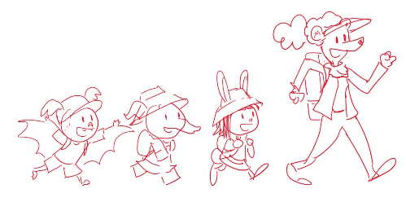
3.4. EXT. TRAIL TO THE LAKE – DAY

As Bianca and the kids walk to the frog spot, they talk. Olive tells her it must be so cool to be an inventor. Yeah, says Ari, and you get your ideas from Nature? Bianca tells them that you can get ideas from all kinds of places, but she likes to get hers from Nature. Why Nature? Because Nature is FULL of ideas! Everywhere you look, Nature has found a way to do something or solve a problem.

Oh, like you got your idea for how your stick rolls up from butterflies? We see a thought bubble of the invention next to the animal that inspired it. Yep. And the grabber at the end from bird beaks? Yep (another thought bubble), that’s right! Cool…

The kids look around. But how do you find ideas? Why, says Bianca, you just have to be curious! You mean, says Elinor, ask questions? Yes, says Bianca. If you have a problem, or if you’re just looking for ideas, all you have to do is look around and ask yourself, “How does that work?” or “Why is that like that?” and you might learn something new you didn’t know before. This jogs something inside of Elinor. Gasp! Ari, Olive! That’s something ELSE that asking questions is good for. Getting ideas! Asking questions is good for getting ideas! Exactly, says Bianca! And they launch into a song.

3.5. EXT. NATURE IS FULL OF IDEAS SONG MONTAGE

Bianca sings the song and is then joined by the kids, as they poke around the surrounding area and also go into montages of inventions that were inspired by Nature (a bit like Sr. Tapir interstitials). This is a fun song, with possibly a more trombone-based style, and a more call and response cadence with rhyme scheme ABCB/ABCCBC.

[Lyrics modified but not yet final. Will finesse with composers. Syllable count in () for consistency check]

(chorus)
Nature is full of ideas (8)
You find them everywhere (6)
Just ask yourself a question (7)
The answers are out there! (6)

(verses)
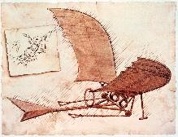
Did you know that airplanes (6)
Were inspired by birds? (6)
We looked to the sky (5)
And saw them fly (4)
And we wondered, (4)
How can WE go as high? (6)

Did you know dragonflies (6)
Inspired helicopters? (7)
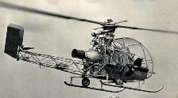
We saw them hover (5)
Up and under (4)
Made us wonder, (4)
How can WE also flutter? (7)

(chorus)
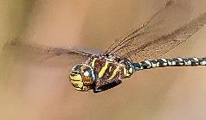
Nature is full of ideas
You find them everywhere
Just ask yourself a question
The answers are out there!

(verse)
Did you know even cars (6)
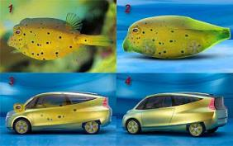
Have ideas from the sea? (7)
We saw swimming fish (5)
It made us wish (4)
That somehow we (4)
Could make CARS go swish swish! (7)

(chorus)
Nature is full of ideas
You find them everywhere
Just ask yourself a question
The answers are out there!

(Kids bridge)
It’s true you see it all around (8)
Amazing ideas to be found (9)
Be curious, that’s all you have to do (9)
And you might find ideas, too! (8)

(chorus, all together)
Nature is full of ideas
You find them everywhere
Just ask yourself a question
The answers are out there!

NOTE: A fun series about how nature inspired the design of airplanes and helicopters can be found here:
https://www.amazon.com/gp/video/detail/B01LY26JQ4/ref=atv_hm_hom_1_c_iEgOEZ_2_3 (Episodes 1 and 7). Reference for box fish car: https://www.the-scientist.com/notebook-old/mercedes-and-the-boxfish-47247

END SONG MONTAGE.

3.6. EXT. TRAIL TO THE LAKE – DAY

As we come out of the song, we’re back on the trail that leads to the lake and the frog area. Elinor recaps that Nature really is full of ideas. She’s excited that she found something else questions are good for: finding ideas! Bianca says Elinor mentioned that before and asks her what she means, and Elinor explains that she’s always asking questions, and she started to wonder why? And now she knows, asking questions is good for exploring and it’s good for getting new ideas. Bianca reinforces that, and tells her asking questions is good for lots of things. Ok, let’s go find those frogs!

3.7. EXT. FROG BOG – DAY

They keep walking and come up on the area in the map where Ranger Rabbit said there should be lots of frogs. Bianca looks at the map and at the location (this is her first time here), but… they don’t see any frogs. The area looks like a bog that’s been flooded. All the plants are mostly underwater. No frogs.

That’s odd. The group decides to split up and look around for frogs. Ranger Rabbit said this area should be full of frogs, but they don’t see any. Here we build up to a FUNNY GAG for one of our kids. Something that will make kids at home laugh. Not sure what it is yet, but something physical and funny. Meanwhile, Elinor starts to notice the plants all look like they are under the water. Hmmm.

The gag climaxes, and the end result is that they find one frog. There’s one! Great! Let’s observe it. They comically hide behind a log to study the frog. Bianca takes out a notebook and prepares to scribble. What are you doing, Bianca? Bianca says whenever she observes nature she likes to draw it. “I do that too!” says Olive, and she pulls out her notebook.

As they observe, the frog watches silently as a fly meanders by. Suddenly, the frog acts! In a flash, it shoots its tongue out, catches the fly and gobbles it up. Wow! What just happened?? That was cool! They watch it eat another bug. Whoa.

The kids talk about what they think they just saw. Elinor says she thinks the frog wanted to eat the fly, but it was too far away. But then, Ari says, it used its long tongue to get the fly. Olive shows her sketch of a frog on one side and the fly on the other side, separated by water, and connected by the tongue. Yes, says Bianca, isn’t that amazing?

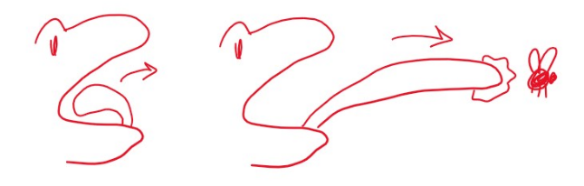
Elinor wonders: how does the frog catch the fly? Bianca shows them her sketchbook, which has a close up side diagram of the frog tongue. She explains in a drawing in her design sketchbook that frog tongues are really sticky because they have a special kind of saliva. That’s why she’s here to study frogs. She wants to make a glue or a tape that’s just as sticky as the frog tongues. Cool… That’s SO interesting! What a great idea!

But then Ari wonders: how does the frog shoot its tongue so fast? I don’t think I can shoot my tongue that fast (they all try a few times, to giggles). Ah, says Bianca, that’s another interesting idea that frog bodies have. She explains with another drawing that frogs bend their tongues back and then use their muscles to throw the tongue out towards the fly [Science ref: https://www.dropbox.com/s/d8klu95yqskamo4/jeb176289.full.pdf?dl=0]. Whoa cool.

The kids wonder if they could use that idea to make an invention. They try to think of what they could invent using this idea. They think reaaaalllly hard, but… nuthin. That’s ok, says Bianca. Sometimes you have a problem and you use ideas to solve them, and sometimes you just have to wait for the right problem to come along. But it’s good to ask questions and make observations and then your brain can remember it later.

At that moment, the frog hops away. This makes the group refocus on the issue of the frogs. Elinor wonders: Where are the other frogs? Bianca wonders what happened to them, too. Ranger Rabbit said there are supposed to be a lot of frogs here. Ari thinks maybe they got lost coming here. This makes Elinor think about the earlier incident, which they recap for Bianca (with help for the audience via a thought bubble). Elinor says that back in Animal Town, the creek was dry, but here she noticed that the plants all seem to be underwater. Olive remembers that frogs like places that have just the right amount of water for them (she takes out her book again). If it’s dry, or if there’s too much water, they don’t like it. That’s it! Maybe there’s too much water for the frogs and that’s why they’re not here. Hmm, thinks Bianca. It looks like it flooded recently. She looks back in the direction from where they came. And it looks like the water is coming from the Lake.

Olive says, “Poor frogs… If this is their home, then where are they going to go?” Elinor thinks and says that they have to help the frogs. Yes, the kids all agree! Bianca looks proud and loves that the kids want to help. Let’s do it! Let’s see if we can figure out what’s happening. It looks like the water is coming from the lake, so let’s head back there and check it out.

END OF ACT III

ACT IV
4.1. EXT. PATH BESIDE THE LAKE – DAY

Bianca and the kids are on a quest to figure out what is causing the flooding at the frog’s home. They arrive back at the lake and Bianca looks at the water and traces it back in the direction of the Frog Bog. Yes, it looks like there is too much water in the lake, and some of it is spilling over to where the frogs live. In a thought bubble, we see what she’s thinking: a cross-sectional view of the lake and bog and a simple animation of the water rising.
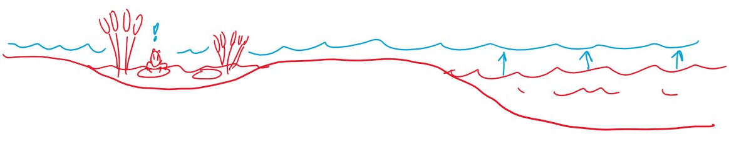

Elinor wonders: but why is there too much water in the lake? I don’t know says, Bianca. Hmm, thinks Elinor, we need more observations! Let’s look at the lake and see if we can figure it out. Great idea, says Bianca. Yeah, says Olive, I’ll draw the lake in my sketchbook. Another great idea, says Bianca! Elinor hops over to the lake’s edge and peers out. Hmm, I don’t see what could be making the lake be so full of water. Ari has a few ideas: maybe there’s a GIANT that’s pouring water from a giant bucket on the lake. Mmm, that’s… another great idea, Ari, but I don’t see any giants. Ari looks over the lake. Maybe it’s an INVISIBLE giant?

At that moment, we hear Olive sounding a little frustrated.

Elinor goes over and sees that Olive is drawing the lake, but Olive says she keeps having to change it as the sticks in the lake keep moving. Elinor looks over and notices that there are sticks and bits of branches in the water, and they are all slowly floating in one direction. Huh, that’s interesting. She gets curious: where are the sticks going? They all look at each other shrug. Let’s follow the sticks! says Elinor. She starts to follow along the edge of the lake, and the rest of the party follows her.

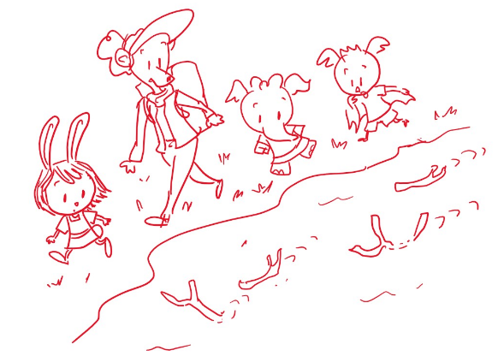
As they follow the sticks, the kids comment that there seem to be more and more sticks as they are going. Several beats of mysterious and curious following later, the group arrives at the end of the path, and they see the sticks go around a bend in the lake’s edge. Huh, there they go, but where are they going? Bianca thinks she hears something, and she listens as her ears scan the area. Suddenly, she picks up a sound.

I hear something! She follows the sound into the brushes up to a small rise.

4.4. EXT. RIVER BLOCKAGE OVERLOOK – DAY

Bianca and the kids emerge on the other side of the bushes. A little down below them, the group discovers where all the sticks have been going. Look, says Elinor, that’s where all the sticks are going. Yeah, says Olive, They’re floating down the lake and getting stuck on those rocks. It looks like they’re blocking the water from going through to the river. Hmm, you’re right kids, says Bianca. Elinor has an idea: Gasp! Maybe THAT’S why there’s too much water in the lake. The sticks are blocking the water from going down the river.
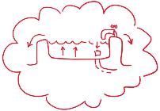
Yeah, says Ari, it’s just like my bathtub. If I block where the water goes away, the tub fills up and spills over! We see him imagining this in a thought bubble.

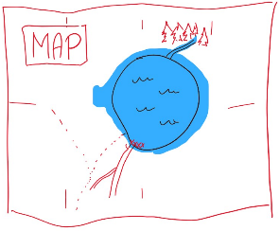
Amazing, says Bianca! I think you kids figured it out. She takes out the map Ranger Rabbit gave her and opens it up. The map envelopes the screen and animates as she talks. There’s water coming into the lake, but the sticks are blocking the water from going out, so it stays in the lake. She also realizes: and that’s why the creeks you saw earlier are dry. The sticks are blocking the water from getting to them.

Gasp! We have to get the sticks out! say the kids. Yeah, it’s changing where the frogs live here and in Animal Town!

Hmm, says Bianca. I think I might know where the sticks are coming from. She takes out the radio and calls Ranger Rabbit.

4.5. EXT. INTERCUT RADIO CALL: ROAD BY THE RIVER PROJECT – DAY

We see the road project site as the workers use some ropes and pulleys to move the log out of the way. Ranger Rabbit picks up the radio, and Bianca informs her what they discovered. Ranger Rabbit realizes that the pile of sticks and branches they’d been clearing from the forest floor was too close to the river and a lot of the sticks have been falling in and getting dragged away by the current. With Deputy Mouse and Mrs. Beaver they make a quick plan to move the pile. Let’s do it!

4.6. EXT. RIVER BLOCKAGE OVERLOOK – DAY

Back at the lake, the kids and Bianca think about how they can get the sticks out that are blocking the water. Yeah, we have to get the sticks out so the lake doesn’t have too much water. Bianca thinks about what to do (Hmm…). Ari offers to fly over and get the sticks. Bianca says that might not be safe for you, Ari (there is some splashing from the mild current hitting the sticks). Olive has an idea: Maybe you can use your invention to get the sticks, Bianca. Good idea, let’s try it. Bianca uses her extendable gripper but it’s not long enough. Awww. That’s ok, Bianca says, not every idea always works out. We have to keep trying.

Elinor suddenly has an idea. She wonders if asking questions can help. Asking questions is good for exploring, and it’s good for getting ideas. Maybe it’s good for solving problems too. Bianca thinks that’s a great idea. Asking questions is very helpful when you’re trying to solve a problem. Ok, let’s do it!
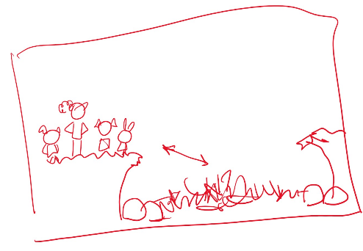
The kids gather together to think this through. Bianca says the first question you should ask is “What’s the problem?” Olive says she can make a drawing of the sticks. On her sketchpad, she doodles a general diagram of the situation. The kids and Bianca are on a small overlook above the rocks and sticks. The problem is that the sticks are too far away for us to reach them.

That’s great, Olive, says Bianca. Now the next step is to come up with ideas to reach the sticks. What can we use to solve the problem? The kids think. Hmmmm… Elinor has a thought bubble recollection of the earlier frog observation: She remembers the frog catching a bug from across the lily pad. Gasp! We could do like the frog! The frog used its long tongue to get the fly on the other side of the lily pad. Yeah, says Olive! Wait, says Ari, you think we need to use our tongues? He sticks his tongue out, and the others giggle. Olive catches on and says we need to make Bianca’s invention more like a tongue. Aha, says Bianca! An idea from Nature, I love it!

The kids then think, how can we make a frog tongue? Hmmm… they think for a beat, and then Elinor knows what to use! She asks Bianca if she still has ropes, and Bianca says yes of course! She opens the rope compartment of her backpack and the kids pull out some rope and tie it to the base of the proboscis gripper. There! Now it’s long like a frog tongue! Brilliant, says Bianca! Let’s try it.

The kids give her room, and Bianca tries tossing the gripper with the rope, but because of the distance and the weight of the rope, she can’t toss it far enough to reach the sticks. Aww.

This time, it’s Elinor who eggs everyone on. Don’t give up, let’s keep trying! What other question can we ask? Hmm, Ari thinks and has a question: Maybe we need to ask HOW the frog throws its tongue out? You’re right, Ari. Learning from Nature doesn’t always mean copying exactly what you see, but learning how Nature does it. Elinor asks Bianca to see the drawing she made earlier of the frog tongue. Bianca takes out her notebook and lays it out next to Olive’s.

The frog bent it’s tongue back and then the tongue went flying out. How can we do that? At that moment, Ari leans in thought on a small tree, which bends under his weight. Whoa. Gasp, says Elinor. Maybe we can use the tree to throw our frog tongue. Olive catches on and sketches it in her notebook. We can use the tree to pull back our frog tongue, and then the tree will bend back and throw it to the sticks. Amazing, says Bianca. It’s a nature-inspired catapult!

Bianca goes over to the tree and places the gripper on a branch and pulls the tree back. The kids help pull her back and… frog tongue away! The gripper flies through the air and plop! Lands on the stick pile and grabs a stick/branch. Yes! It worked! The kids and Bianca pull on the rope (being safe of course with Bianca in front). Nnnnngh! It’s not moving! Nnnngh! Suddenly, the branch moves and comes loose! Yes! The kids and Bianca pull the branch and look on as the rest of the stick dam collapses and starts to flow down the river. Yes! We did it!

The kids do a celebration dance. They radio Ranger Rabbit back, and tell her they solved the problem. Wow, how? Elinor chimes in that they did it by asking questions. It’s good for exploring, for getting ideas, and for solving problems. Awesome, laughs and cheers all around. Mom tells her she’ll help Deputy Mouse finish making room for the road and then go back to the campsite.

After they hang up, The kids look on as the last of the sticks washes downstream and water flows out of the lake. Bianca tells the kids how proud she is of them. I’m so glad you love asking questions. Elinor in particular beams. Bianca tells them that when she was a little girl, she asked a lot of questions too. And she still does today! So never stop asking questions, kids. We won’t, says Elinor!

They look down and they can already see a little bit of the water level go down.

Elinor remembers: the frogs! Let’s go check on them! Yes! They run off screen.

4.9. EXT. FROG BOG – DAY

The group arrives back at the frog area and they look around. They can see the water level slowly receding. Look, now you can see more of the plants. It looks more like a normal frog pond. As they look on, a small brown frog hops over from some nearby bushes and jumps in the water, looking happy and content. A few other frogs join it. We did it! Now the frogs can come back! Yes!

Wow, says Elinor. I didn’t know that what happens in once place could change things for plants and animals in other places. Yes, says Bianca. Everything is connected, even us. Elinor thinks on that for a second. That’s why we need to help Nature when we can, especially if we cause changes in it.

4.2. EXT. EVERYTHING IS CONNECTED DITTY MONTAGE

Bianca and the kids sing a short sweet ditty about how everything in Nature is connected, even us. As she sings, the kids take in a larger view of the trees and plants and animals around them.

[Lyrics modified but not yet final. Will finesse with composers]

Everything’s connected,
That’s the beauty of our world,
Everybody has a place,
Every boy and girl

Every plant and creature,
Be it big or small
Are all in this together
You, me, and all

Everything’s connected,
We all have a role
Every plant and animal
That’s how Nature goes

When something happens somewhere
It can change another place
It might make it different
In unexpected ways

So let’s take care of Nature
We’re all in the same world,
Everyone can lend a hand
Every boy and girl

Every plant and creature,
Be it big or small
We are all in this together
You, me, and all

END ACT IV

ACT V
5.1. EXT. CAMPSITE – DAY
It’s the next day and we see the sun rise over Hidden Lake. Everyone is packing up to leave camp. Ranger Rabbit is back (she came back yesterday), and the kids have a bit of goofy fun (maybe a marshmallow callback gag, or something related to their backpacks).

Well, it’s time to go. Ranger Rabbit asks where Bianca is going next, and Bianca says she’s not sure, wherever Nature takes her! The kids get ready to say their goodbyes to Bianca. We button up the threads for the secondaries: Ari has a fun interaction with Bianca about her inventions (he has some amazing ideas for a gizmo that can roast 20 marshmallows at once). Bianca asks Olive about her drawings. Olive shows her a really beautiful drawing of Hidden Lake, and if you look closer, you can see all of them, and the frogs of course. Bianca encourages them to keep having fun ideas and to keep drawing.
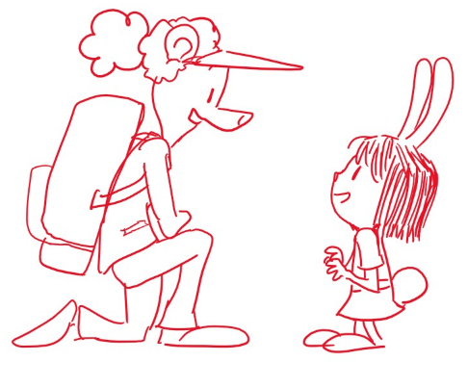
It’s Elinor’s turn. Bianca kneels down and they have a quieter moment. Elinor tells her it was SO much fun to meet her, and Bianca says “Me too!” Bianca says she hopes Elinor found all the answers she was looking for, and Elinor says yes, she learned SO much. Bianca encourages her to keep on asking questions. It’s always good to listen to that little bit inside all of us that wants to know how things work or why they are the way they are. Elinor looks down at herself and asks, “We all have a little bit of wonder inside?” Yup, says Bianca, there’s wonder inside all of us. Who knows, maybe you’ll be a scientist, or a Ranger like your mom one day. Or maybe an inventor like you, says Elinor! Haha, says Bianca, I’m sure you can be anything you set your curious little mind to.

Ok, kids, let’s start our hike back. The group sets off from the campsite and we do a short montage as they walk back the way they came in.

5.2. EXT. TRAIL TO HIDDEN LAKE – DAY

At the entrance to the forest, where we first revealed Hidden Lake, the group stops (still over music) and they part ways with Bianca (she goes the other way). Hugs and fun waves as she sets off. On a wide shot, we see them walk in different directions as we get one last look at Hidden Lake (goodbye lake!).

As the group starts walking down the path, Ari makes a funny comment (a callback with his plush birdie), and Elinor and Mom have a short conversation. Did you have a fun trip, Elinor? Yeah! I learned that asking questions is good for LOTS of things. It’s good for exploring, it’s good for finding ideas, and it’s good for solving problems. Yes, says Ranger Rabbit, asking questions is wonderful.

With that, we launch into our final song: a sweet uplifting song that recaps what we’ve learned and done and winds us down. As they sing, the kids hike back to Animal Town over beautiful Nature scenes and flashbacks to the previous key moments.

5.3. EXT. IT ALL STARTS WITH ASKING QUESTIONS SONG MONTAGE

[Lyrics modified but not yet final. Will finesse with composers]

(chorus)
It all starts with questions
Everybody knows
So keep on asking questions
‘Cause who knows where you’ll go

(verses)
It might help you to explore
And find things that are new
Who knows what you’ll find
Or what you’ll get to do

You might find a whole new town
Or make a new friend
It all starts with asking
What’s around the bend?

(chorus)
It all starts with questions
Everybody knows
So keep on asking questions
‘Cause who knows where you’ll go

(verses)
It might give you new ideas
You didn’t know before
Who knows what you’ll learn?
That’s what asking’s for

Why is it like that?
And what does it do?
You just have to ask
And then you’ll know it too

(chorus)
It all starts with questions
Everybody knows
So keep on asking questions
‘Cause who knows where you’ll go

(bridge)
The best part of asking questions
Is when you get to ask,
How can you solve problems with
the questions that you have?

Start with asking what’s the problem?
And you’ll soon find out
You can help others when
You figure it all out

(chorus)
It all starts with questions
Everybody knows
So keep on asking questions
‘Cause who knows where you’ll go

On the last few bars, we see our group get to Animal Town and to the Rabbit House. Mr. Rabbit and the Bats and Ms. Elephant are all there to greet them and the kids say their goodbyes and give each other hugs. As the end notes of the song play, we see Elinor follow her parents into the house, taking one last look back at the world outside.

5.4. EXT. FROG CREEK – DAY

It’s some time later, and we cross-fade to the frog creek from the beginning of the special. We see the green frog we saw earlier sitting happily on a floating lily pad. The creek is filled with water again, and we pull out to show that there are more green frogs happily swimming about, and that Elinor is there curiously looking at them. All is right with the world, and Elinor looks happy wondering. The frog zips its tongue at a nearby fly and Elinor gasps and giggles.

From off-screen, we hear Ari make a funny comment. Let me guess, he says, are you wondering, Elinor? Olive is with him. Yes, I am! says Elinor cheerily and they all look at the frogs together. I wonder, says Elinor… why do frogs like to hop? They have really long legs, why don’t they just walk? Ari and Olive seem stumped. I don’t know, says Ari. Maybe because they don’t have shoes? Or maybe, Elinor says, hopping is more fun? She hops around like a frog, and the kids giggle and join her. I know, says Olive as she takes out her notebook, let’s observe them and see if we can figure it out. Yes, says Elinor, we need more observations! On giggles and light playing, we pull out of the frog creek, up and over the trees and buildings and we settle on a beautiful view of the area. It’s another wonderful day of wondering in Animal Town.

END OF SPECIAL

CREDITS

POST CREDIT SCENE
On a bonus post-credits scene, we see Mr. Raccoon at his bakery, munching on a snack with one hand, and reading a book with the other. The book cover shows a donut on a parchment roll (implying a history or ode to donuts). Suddenly, he stops chewing and slaps his head. “So THAT’S why donuts have holes!” CUT TO BLACK

