ELINOR WONDERS WHY
“The Pokey Plant”
PREMISE – 11/3/2019
By Daniel Whiteside and Jorge Cham

Elinor’s Question: Why do cacti have thorns?
Logline: Elinor brings home a cactus and learns what makes it cool.

Curriculum Goals:
LS1a; Identify and describe the physical characteristics of a variety of animals and plants [ they note how the cactus looks different from other plants]
LS2d: Explore how different external features of an animal help it survive in its environment [ a cactus has thorns to protect its water ]
SEP – TBD at Outline
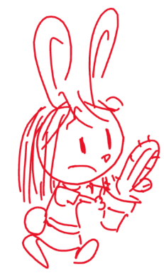
It’s Plant Day at school! Elinor is excited to get a beautiful plant to take home. Ms. Mole is going to hand out plants for kids to take home, care for them, and then report to the class how it went. But when Ms. Mole hands out the plants, all the pretty or fun plants get taken by other kids, and she is left with a cactus, which looks neither pretty nor fun.

She seems a little disappointed at first, because it’s not what she was expecting, but when Olive and Ari interact with her plant, it raises her curiosity. Olive reads the plant’s instructions and says that the plant only needs to be watered once a week. And Ari gets gently poked (in a funny way) by the spikes. It makes Elinor wonder, why is this plant so different? Why does it have spikes and no leaves?

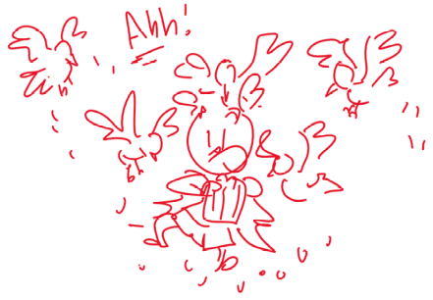
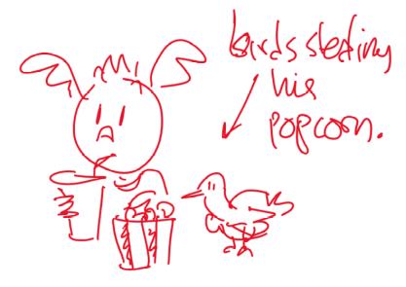
Elinor can’t figure it out, so she needs MORE OBSERVATIONS. They make a list of ways plants and cacti are similar and different, and walk around comparing the plants. They noticed that the cactus is round, not thin and dry-looking like most plants. When Olive accidentally pokes the cactus with a dry stick, they realize the reason the plant doesn’t need as much watering is that it already has a lot of water inside. Olive looks it up in her Nature book and they learn that cacti grow in the desert, where there isn’t a lot of water, which makes them a frequent target for thirsty animals (poor cactus, thinks Elinor!).

At that moment, Ari gets hungry and starts to eat a bag of popcorn from his backpack. Some birds that have been following them along land next to Ari and try to steal his popcorn. Ari tries to fend them off, but there’s a lot of them! He wishes he had a way to keep the birds away, and grabs a nearby crayon, pointing it at the birds in all directions. This makes Elinor imagine the cactus in the desert, and in a thought bubble she pictures animals approaching the cactus but getting warded off by the spikes. Elinor realizes the spikes in the cactus are to keep animals from stealing its precious water.

Back in school, Elinor gushes about how cool the plant is in her class presentation.

