ELINOR WONDERS WHY
“A Garden for All!” by Michael Foulke
PREMISE – Feb. 24 2020
Elinor’s Question: How can Hazel have her own garden if she doesn’t have a yard?
Curriculum Goals:
- LS5. Begin to understand that animals and plants depend on other living things and nonliving things in the environment to meet some of their needs:
b. Identify the habitats of familiar animals and plants in the environment
c. Recognize that each kind of living things has a habitat that has resources to meet its unique needs (Elinor and Hazel learn they need soil, sun and space to grow strawberries)
- ET1. Begin to understand that asking questions, making observations, and gathering information are helpful in thinking about problems, and that it is important to clearly understand the problem before beginning to design a solution (Elinor and Hazel learn what they need to have before they can design a rooftop garden to grow strawberries – soil, sun and space)
- SEP: To be determined at outline

One day, Elinor is playing with her new friend Hazel, a very outgoing lioness. They are in Elinor’s garden picking strawberries, and Hazel says that it’s really cool that Elinor has this garden. Elinor explains that the strawberries were so yummy because her garden has really nice soil, lots of room for fruits and veggies and gets loads of sun. Strawberries are so good! They pick a basket to bring to Hazel’s dad. After they finish picking the strawberries, the kids head to Hazel’s apartment 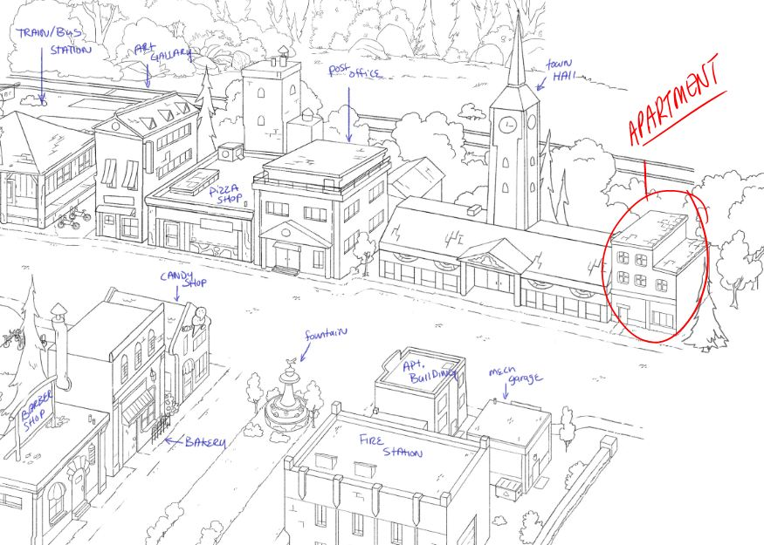 in town feeling good about bringing her dad strawberries. As they arrive, they see Hazel’s father (Mr. Lion) on the balcony dusting some rugs. It’s a dirty job, but some lion’s gotta do it! They run up the stairs to the apartment and Hazel excitedly shows her Dad the strawberries they picked.
Mr. Lion loves the strawberries and tells the kids to bring them to the kitchen. In the kitchen, Hazel says that she wishes she could have a garden just like Elinor and at her old house, so she could grow things like strawberries and carrots and other yummy treats! Never one to turn down a challenge, Elinor decides that the rest of their playdate should be spent figuring out how to get Hazel a garden in their new apartment! How hard could it be? After all, all you need is space, soil and sun. But Hazel doesn’t have a backyard like Elinor to put a garden in. Elinor is sure that if they work together, they will figure out how Hazel can have a garden even though she doesn’t have a yard!
The first thing they need is soil, so they look around Animal Town and find Ms. Llama is planting a new tree behind her store, which means she has to dig a big hole in the ground to plant the tree! She is more than happy to let the kids take all the left-over soil from the hole she dug, especially since it’s going towards a garden, which she loves! As luck would have it, Mrs. Llama is also throwing away the wooden barrel that the tree came in, so the kids are more than happy to take it off her hands since the barrel will make a great container for Hazel’s apartment garden! Looks like the soil is taken care of, now the kids need to find some space for a garden in Hazel’s apartment! When they arrive back at Hazel’s apartment, she suggests they use the biggest open space in the whole house… the bath tub. Elinor and Olive aren’t so sure about dumping a whole bunch of dirt into the bathtub, but Hazel assures them that it’s fine, she does it every day. Hazel then shakes and a whole bunch of dirt shakes off of her and into the bathtub. Before they unpack that, Elinor and Olive decide that the bath-tub may not be a good space for a garden anyway, because there is no sun shining on the tub, so the plants won’t grow. So where?
The kids are checking out the apartment when Mr. Lion comes back in from the balcony, having finished cleaning the rug. As he enters, he comments about how hot it is on the balcony with all that sun shining on you! Elinor then has a great idea! The balcony gets plenty of sun and should have plenty of space to set up a garden! When the kids go out on the balcony, they quickly discover that Elinor was right! It is then revealed that Elinor brought over some strawberry SEEDS. Over a song montage, the kids then help Hazel set up an amazing new garden right in the wooden barrel on the balcony and plant the seeds! It really is the perfect sunny spot for an apartment garden.
We come out of the song montage, it’s some time later and the kids admire the seedlings poking out of the ground. Hazel thanks her friends and tells them they were right, anyone really can have a garden anywhere as long as you have the three S’s: soil, sun and space! As she looks over her brand new, beautiful balcony garden, Hazel can practically smell the strawberries already! Then Elinor remembers the last thing they need – water. It may not start with an S, but you can’t grow strawberries if you don’t water your garden.

Sara Notes:
A garden for everyone- I like the idea that people can help plants grow in many places. To design a garden for the apartment, it is important to think about the "needs" of the plant...water, sun, and "space". Technically plants don't need soil..they need nutrients and stability they get from the soil but for this age group I think it is OK if Elinor notices that the strawberries grow in soil in her yard so they should get soil for the apartment garden too. The bathtub scene is really fun.

PBS Notes:
A few observations with “Garden”:

- Elinor should set up the phrase “The 3 S’s” earlier in the episode so that it is more of a sticky, repeatable takeaway.
- Let’s foreshadow the strawberry seeds earlier as well. No need to have them coincidentally appear.
- PBS had modeling/standards issues with the bathroom scene. 1) We prefer not to suggest that the bathroom is a suitable place for children to play unsupervised. 2) Can’t imagine a viewer not getting into a lot of trouble for suggesting she dump a pot of dirt into the tub. 3) Having Hazel shake off all that dirt makes her seem unkempt.
- Can’t think of a reason why they can’t shoot down the bathroom idea before they even enter it.
- We definitely need to have Mr Lion on the balcony at all times if the children are going to be out there. Moreover, he should explicitly say that it is dangerous to be up this high and not to play on the balcony without a grownup. This unfortunate beat of housekeeping is necessary if the writer wants to tell a balcony story.

Overall note: We’d prefer to frame the idea of building a balcony garden so that it’s more of an exciting discovery that they can create a garden in this new way. It felt sad at the beginning to tee this up as, “I can’t because I don’t have...” We don’t want to focus on what kids don’t have—no matter where they live. So whatever the writers can do to keep the epiphany focused on breakthroughs and creative inspiration rather than “making lemonade” would be preferable to PBS.

