ELINOR WONDERS WHY
More Than One Right Way
By Kate Barris
December 19, 2019

Elinor’s Question: Are all spider webs the same?

Logline: Elinor, Olive and Ari want to make spiderwebs to decorate the classroom for Halloween, and they all think they know what a spider web looks like. But who’s right?

Curriculum Goals:
LS8​. Observe and describe similarities and differences across different types of plants and animals. (Elinor And her friends observe the different patterns of spiders’ webs).
SEP2. Developing and using models
a. Represent observable, concrete objects, events, and findings in many different ways. (Elinor and her friends made models of these different spiders’ webs.)

EXT. NEAR ELINOR’S HOUSE – DAY

Ari and Olive are waiting to meet up with Elinor so they can walk to school together. They’re surprised she’s late because it’s Halloween, which they’re all very excited about. Then they hear a sound and see some rustling in the bushes. As they go to investigate, Elinor leaps out with a loud “Boo!” They jump in surprise. “Did I scare you?” Elinor asks. Olive and Ari look at each other and shake their heads. “Nah.” They weren’t scared. Olive asks, “Why were you trying to scare us?” Elinor responds, “Because getting a good scare is the greatest thing about Halloween.” Olive and Ari look at each other again. “Nah.” Olive and Ari know what the greatest thing is. “Costumes!” says Olive. At the same time as Ari says, “Candy!” They look at each other. Huh? How can there be more than one “greatest thing” about Halloween?” Olive explains why she loves the costumes. She and her mom come up with an idea and then they both work together to make the costume, which is so much fun. Elinor explains that she loves the suspense of being scared by all the spooky decorations their neighbours put out. And Ari? He just loves candy – what else does anybody need to know? They admit that it’s possible they can all be right.

EXT. SCHOOLYARD – MOMENTS LATER

As they arrive in the schoolyard, Elinor is still talking about the scary things that happen on Halloween and how much fun that is. Ari insists that nothing ever scares him. But just then, Olive points to the school window and says, “What’s that?” They look at the window and see a silhouette of Mz. Mole who seems to be holding a head in her hands! Ari screams and leaps behind Olive. But just then, Mz. Mole opens the curtain and they see that she’s actually holding a pumpkin, which she sets down on the window sill. Elinor concludes that she must be decorating the classroom for Halloween. Ari insists that he knew all along it was a pumpkin. He was just kidding about being scared. Elinor and Olive smile, amused by their friend.

INT. CLASSROOM – MOMENTS LATER

Elinor, Olive and Ari run into the classroom and greet Mz. Mole, who is putting out all kinds of Halloween decorations. They want to help! Mz. Mole suggests they make some spiderweb decorations. They love that idea! She asks them if they know how to make a spiderweb. Elinor, Olive and Ari are sure they know exactly how to make a spiderweb. Mz. Mole suggests they show her by making a model. She hands them each a ball of yarn, a board and some glue and they get right to work.

While Olive and Elinor stretch out some yarn and start attaching stands in different spots to create a model of a spider web, Ari turns his back to them. We see his arms flying but we can’t see what he’s doing. In a few short seconds, he says, “I’m done.” He turns around to show that he’s made a big messy tangle of yarn. “Ta da! A spiderweb.” Elinor says, “Mmm, I don’t think that’s what a spiderweb looks like.” Ari is perplexed. “It’s not?” Elinor holds up her board and proclaims, “This is what a spiderweb looks like.” It’s a traditional orb web. She winds another piece of yarn around to show how it’s done. “See? If you keep putting lines of yarn around like this, in a kind of circle, you get a spiderweb.” Now Olive looks perplexed. “Mmm, I don’t think that looks like a spiderweb.” She holds up her version, which has strands of yarn attached in a triangle shape. ”This is what a spiderweb looks like,” Olive states. “I think.” Ari shakes his head and holds up his mess of yarn. “Uhn uhn. It’s like this.”
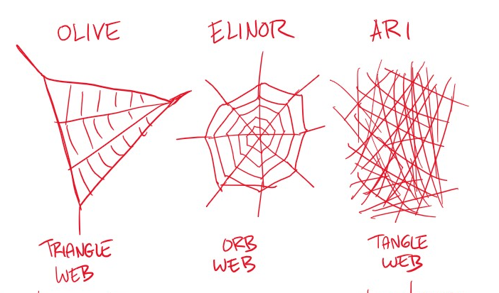

They seem to be in a stand-off. They turn to Mz. Mole, and ask her which spiderweb is right. She pauses to think. “I’m trying to remember what a spiderweb looked like the last time I saw one.” The kids realize there’s a natural way to find out who’s right. Elinor says, “We need more observations!” Oliver agrees. “If we find a spiderweb, we’ll see who’s right.” Ari’s practically out the door. “Let’s go!”

EXT. SCHOOLYARD – MOMENTS LATER

Outside the kids hunt around looking for a web. But where do you find a web? Olive gets an idea. Since spiders make webs, maybe if they find a spider, it’ll lead them to its web.

They search in and around trees, and suddenly, Elinor announces she’s found a spider on a branch. Olive and Ari hurry over to see. They’re disappointed that there’s no sign of a spiderweb anywhere in sight. They’re just about to turn away when the spider falls off the branch! They’re concerned that it might have hurt itself. But then they see that it’s actually suspended by a silky strand. Wow! Where’d that come from? Olive checks in her nature book and discovers that the spider makes its own silk to weave the web. When they look back at the spider, they see that it’s quickly creating a web. So cool! And when it’s done … it looks like an orb web. “Ahah!” Says Elinor. “I was right.” Olive and Ari are confused. Both of them were sure a spiderweb looked different. But why would they think that if it isn’t true?

As Olive is pondering this question, she suddenly spots another spider. Ari points out that it looks different than the first spider they saw. They see that it starts to spin a web and to their surprise, it looks different from the first web they found. Olive notices, “It’s not making circles like the one you found, Elinor.” They look carefully and as the web is created, they agree, it looks like Olive’s model. So Olive was also right!

Ari looks a little down, and then Elinor gets an idea. “If one spider makes a web that’s like my model and a different spider makes a web that’s like Olive’s model…” Olive gets what she’s going for, and then Ari does too. “Then maybe another kind of spider makes a web like my model!”

They look around and find a spider hiding in a web that looks like Ari’s: just a big tangled mess.

“So,” Olive concludes, “There’s more than one right way to make a spiderweb.” Elinor’s face lights up. “Just like there’s more than one great thing about Halloween.” The kids can’t wait to tell Mz. Mole what they’ve discovered.

INT. CLASSROOM – MOMENTS LATER

As they race into the classroom, they’re surprised to see what looks like a ghost floating through the room! Ari does a back flip in reaction! Then Mz. Mole peeks out from behind the ghost/sheet that she’s about to hang in the corner. Ari insists he wasn’t scared by that either. The kids update Mz. Mole on what they learned – that there isn’t just one way to make a spider web – there’s at least three. Mz. Mole confirms that there are many different kinds of spiders, and they make webs in all kinds of shapes. Animals in Nature do things in all kinds of different ways. Now that the kids have learned a little about how each of the webs looks, they can make spiderwebs that look like the real thing. As they make their webs they sing a song:

SONG: MORE THAN ONE RIGHT WAY

You do it your way
And I’ll do it mine.
We each have our own way
And that’s just fine.

‘Cause there’s more than one way
To do almost everything.
And each of those ways is right, right?
Yes, each of those ways is right. Right!

Elinor: My web’s circle
Ari: And my web’s a mess!
Olive: Mine is a triangle,
Is that right?
Elinor & Ari: Yes!

‘Cause there’s more than one way
To do almost everything.
And each of those ways is right, right?
Yes, each of those ways is right. Right!

By the end of their song, they’ve finished their different webs and they hang them around class. Mz. Mole thinks the spiderweb decorations are wonderful – because they’re all different!

Sara Sweetman Notes:
More than one right way: I really like the main part of the story...the web design (haha) as a model and noticing the differences between different spider webs. We build models in science to help predict or describe something or to help revise our thinking. I'd like to see their spiderweb designs be more purposeful. If maybe at first they don't have an idea of how to build the web and then they learn about the different webs and create different webs to explain that different spiders make different webs. Models (and science) should focus less on being "right" or "wrong" rather they should help us learn something.

