ELINOR WONDERS WHY
Leaf Charms
OUTLINE – 09/27/2019
By Jorge Cham and Daniel Whiteson

Elinor’s Question: Are all leaves the same shape?
Logline: Elinor and Camilla learn to appreciate all the charming shapes of leaves.

Curriculum Goals:
LS6. Understand that individuals of the same kind of plant or animal are recognizable as similar but can also vary in many ways:
a. Contrast individuals of the same kinds of plant and animal [ they compare leaves]
ND1. (RTL Crosscutting concept ‘Patterns’): Understand that modes of life in the natural world and engineered solutions in the designed world have common patterns, and engineers often look to natural patterns for inspiration. [ the leaves inspire the charms]
SEP: TBD at outline

- FOREST – DAY


Our scene opens as Elinor and her mom are walking through the forest on their way to Camilla Dromedary’s house. It’s a nice spring day. Through conversation we learn that Ranger Rabbit is going to meet with Camilla’s parents to help them with some forest project, and that Elinor can play with Camilla while they talk. Elinor says she’s going to ask Camilla if she wants to go exploring together.
As they walk, Elinor notices something interesting on the floor. It’s an unusual looking leaf:

Whoa, what a cool looking leaf. As they approach Camilla’s house, Elinor’s mom calls her and she puts the leaf back on the floor.

- CAMILLA’S HOUSE – DAY

While the adults start talking, Elinor runs up to Camilla’s room. Elinor says hi to Camilla, who’s playing with some of her things. Camilla greets her excitedly. Camilla has a bit of a dramatic personality. She’s nice, but she talks with a certain air about her. She welcomes Elinor to her room, and gives her the grand tour, as if she’s touring a royal residence. She shows Elinor where she keeps her costumes, her artwork nook, her collection of diaries (with pictures of herself), and especially her collection of charm bracelets and necklaces.
Elinor asks Camilla if she wants to go outside and explore together, but Camilla says thanks but no thanks. She just doesn’t think outside is that fun. It’s all just trees and it’s all just... green. Hmm, then what else can they play, asks Elinor? Camilla knows just what they should play....
A crossfade later, we see that Camilla has blinged out Elinor:
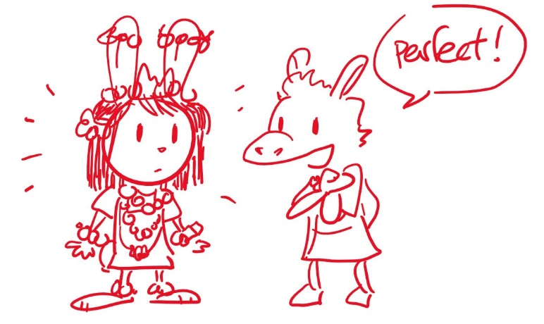
Elinor looks in the mirror and thinks it’s fun. They giggle together. Camilla tells her she now has lots of FLAIR. Elinor gets interested. What’s Flair? Camilla explains that Flair is when you have things on that are special or unique.

Camilla shows Elinor her favorite charm. It’s on a necklace and it’s a shiny version of the leaf that Elinor saw earlier. Gasp! She tells Camilla she saw a leaf that looks just like it outside. “Really?” says Camilla, “I must see this!”

- FOREST – DAY

Outside, Elinor (she took off some of the bling) and Camilla find the leaf that Elinor saw earlier. It does look like Camilla’s favorite charm! But Camilla thought all leaves looked the same. She picks up a regular oval pointed leaf, and they compare the two leaves, noting the differences. Elinor explains that not all leaves look the same and that different shape leaves come from different kinds of trees. So, each kind of tree has its own kind of leaf. Camilla is now hooked. She says, “That… is… so…” Elinor finishes for her: “Interesting?” “Yes!” Elinor has an idea: let’s find the tree where this leaf came from. Camilla thinks that’s a fabulous idea.

In a series of learning moments, Elinor and Camilla look for the tree that has the fan shaped leaves. At each stop, they compare the shape of the leaves and Elinor reveals something she knows about leaves:

- They compare the leaves to a tree or plant that has really big leaves. Wow, Camilla didn’t know there leaves that big. Elinor says that big leaves like that let the plant drink LOTS of sunlight because the leaves are so big.
- They compare the leaves to a tree or plant with leaves that are not green (purple or green with white patterns). Camilla is amazed, she thought all leaves where green.
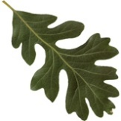
- They compare the leaves to a tree or plant with really wiggly shaped leaves. Wow, Camilla thought all leaves were round. Elinor says she read in her nature book that wiggly shapes like this help keep the leaves nice and cool.

At each stop, Camilla collects a sample of the leaf they are observing (she picks it up from the ground).

They keep walking around and when it looks like they can’t find the tree with the fan shaped leaf, a leaf falls from overhead and lands on Elinor. Camilla spots it: that’s it, that’s the leaf! They find a beautiful Ginko tree and examine all the leaves on it with that shape.

Wow, says Camilla, she didn’t know that there were so many different kinds of leaves, and all of different sizes and shapes and colors. Nature sure has a lot of flair! On their wonder and excitement, they segue into the ditty:

Let’s look here
Let’s look there
Leaves are laying
Everywhere

Some are pointy
Some are round
Camilla: Look at this one
I just found

Some are long
Some are thin
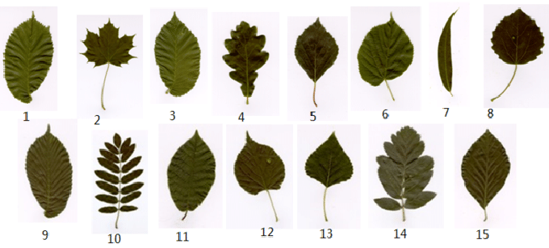
Elinor: That’s the biggest leaf
I’ve ever seen!

Let’s look here
Let’s look there
Who knew Nature had
So much flair!

During the ditty, the kids look around more and compare leaves of different sizes and shapes and patterns.

We end the montage and the kids are in the forest. Camilla looks at all the leaves she’s collected and has a thought: I have an idea what we can do with all these leaves!

- CAMILLA’S HOUSE - DAY

Back at the house, Ranger Rabbit and Camilla’s parents are done with their work and come up looking for the kids. At Camilla’s bedroom, the kids do a big reveal: Tada! Elinor is blinged out again, and Camilla is also blinged out, but with leaves!
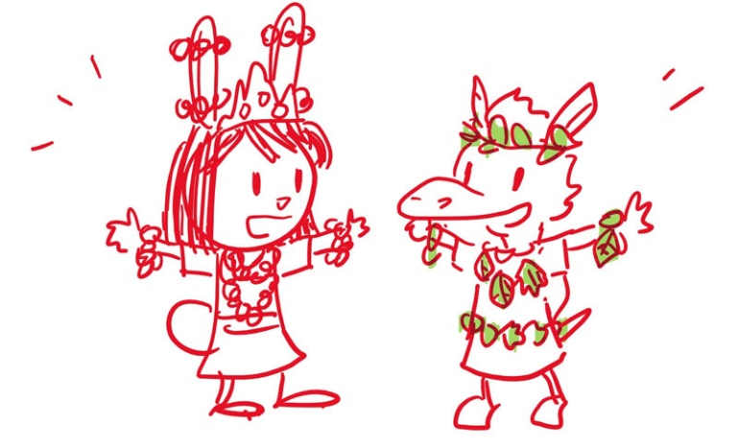

The kids recap what they learned. Camilla says she thought all trees and leaves were the same, but now she knows: there are lots and lots of different kinds of leaves. Ranger Rabbit confirms and points out that the trees also look different: tall or short, thin or tall.

Elinor says that Nature has lots of good ideas, not just for solving problems, but also for art projects! Yes, says Camilla. Nature has lots of FLAIR.

