ELINOR WONDERS WHY
Owl Girl Redux
PREMISE – June 12, 2019
By Katherine Sandford

Elinor’s Question: What kind of owl is awake in the daytime and lives on the ground?
Logline: Elinor thinks she knows everything there is about Owl until, while visiting her grandparents, she meets a burrowing owl.
Curriculum Goals:
LS6. Understand that individuals of the same kind of plant or animal are recognizable as similar but can also vary in many ways:
a. Contrast individuals of the same kinds of plant and animal
b. Observe and recognize how we are the same and different from others
ND1. (RTL Crosscutting concept ‘Patterns’): Understand that modes of life in the natural world and engineered solutions in the designed world have common patterns, and engineers often look to natural patterns for inspiration.
SEP: TBD at outline
Elinor is VERY excited because she's going to spend the whole weekend with her Grandparents BiBi and BaBa (while her parents have a quick get-away – Palm Springs?). She's all ready to go, having packed all her essential observation gear to do some exploring in the desert, but best of all she’s wearing her Owl Girl costume - she can't wait to show it to BiBi and Baba! Sure enough, her grandparents are super-impressed with her costume, but EVEN more impressed with Elinor’s first-hand knowledge of OWLS that she observed herself (they are very big, sleep during the day, they fly high and silently through the air, and make nests waay up in trees, and they go “whooo”.). But when Elinor tells BiBi that she is sure she knows EVERYTHING there is to know about Owls, BiBi smiles skeptically. Really? You know EVERYTHING about owls? Are you sure? Yup, sure for sure - Owls are Elinor’s thing!

Later, Elinor is playing in the back yard as BiBi putters around her potting shed, mildly complaining because BaBa has put HIS woodworking tools all over her gardening space – again! Oh, Baba. Suddenly Elinor hears a little rustling in the grass beyond the fence. What’s that? She looks over and she sees two big yellow eyes. It’s a small bird and it looks sort of like an Owl, but it can’t be, Elinor tells her grandmother. Owls are BIG, and they sleep during the day – this owl should be home in bed! They agree she needs MORE OBSERVATIONS. First Elinor makes a list of everything she knows about owls, then off they go out into the desert behind BiBi’s house to observe the bird. Okay, owls are birds and this is a bird, Owls have big eyes and this bird has big eyes. Hmmm, maybe. But at that moment the little bird runs off! Wha? Owls don’t run, they fly – Elinor is SURE! Then the Owl ducks into a little hole in the sand. Is that where the owl lives? In that little hole? That can’t be an Owl, Owls live in trees! But then the bird pops out and of the hole and says “whoooo”. At that moment Elinor considers changing her mind, but how can this be an Owl when it doesn’t do some of the things she observed Owls doing? Puzzled she explains her situation to Bibi.

“Ahhh, interesting,” says BiBi. "But you and I are both bunnies, and we do some things differently. For example you hop around a LOT more than I do.” This helps Elinor figure it out: Maybe not all owls do the same things! That explains everything! BiBi compliments Elinor on all her observations and confirms that Elinor’s found a Burrowing Owl. Elinor facts are correct for most owls, Burrowing Owls are special. Elinor finds this all SO INTERESTING! Then, as Elinor and Bibi are watching the little Owl comes out of his hole and arranges a row of rocks, bottle caps and shiny bits of tinfoil around the entrance. Bibi is amazed – SHE never knew Burrowing Owls did that! Really? Elinor is similarly amazed that there’s something her grandmother didn’t know! As Elinor and her grandmother are theorizing why the little owl places things around his burrow, a sand tortoise walks by, then pauses and keeps going. Maybe the Owl put up that little fence to tell everyone to keep out. That makes sense AND it gives Bibi an idea! Back at home she and Elinor make a ring of potted plants around Bibi’s gardening shed to keep BaBa and his tools out – then the two scientists happily settle in to do some more observing. You can never know everything about anything - especially not Owls!

Sara Sweetman Notes:
Owl Girl Redux- I think the take away message here would be "We should always keep our minds open to learning new ideas because there are often exceptions to the rules and nature does often surprise us AND within species there are similarities and difference (variation, helps the species survive).

https://www.smithsonianmag.com/science-nature/the-little-owls-that-live-underground-203543/

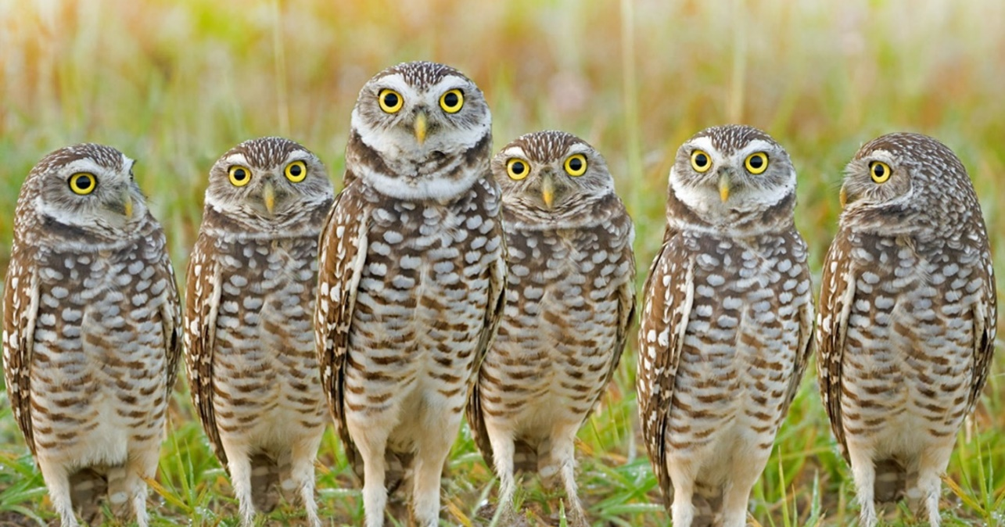
I think this is really cute, and I think it's pretty much there. If you want to send this along to get feedback, that's fine with me.

For me, it's still not crystal-clear what the central message of the episode is, or what the core lesson that kids watching the episode are supposed to take away.

Is the central message:
- That not all owls are nocturnal, or sleep in trees, or fly around?
- That not all animals from the same family behave the same way?
- That not all animals that we normally think of as being the same kind of animal have the same behaviors?
- That sometimes you think you know everything about something, but there can be exceptions?
- That you should never assume you know everything about something, because you could be wrong?
- That sometimes animals adapt their behavior to different environmental conditions?
How would you write the main lesson of the episode in one kid-friendly sentence?

I think once you lock that in, it will help shape the inquiry part. Right now, it feels a little fuzzy. E.g. she makes a list of attributes and finds that this owl doesn't match all of them, but she still concludes it's an owl? (It's almost the opposite lesson they learn in "Ari's Cousin"). She also doesn't figure things out on her own, Bibi seems to tell her the answers.

Here is my brainstorming suggestion: once you get to the point where she makes the list of attributes and she marks which ones the burrowing owl matches and which ones it doesn't, she gets to the crux of the episode - the main conundrum: How can this bird be an owl if it doesn't match all of the items on the list? She's pretty sure it's an owl because it looks like an owl, but it doesn't do the things she thought owls do.

At that point, Bibi chimes in and tries to guide Elinor to the answer using a small analogous situation that you set up earlier in the episode (kind of like Mz. Mole does in Feathers) that suggests that not all animals of the same kind do the same things. Her prodding ends in something like, "You and I are both bunnies, but we do things differently" (it could be Bibi and Elinor, or Bibi and Baba). This makes Elinor figure it out: Maybe not all owls do the same things! That explains everything! And this leads Bibi to say the main lesson of the episode, which would be: "That right. Sometimes Nature surprises you, and not all of the same kind of animal do the same things."

Not sure that all makes sense but hope it helps, and I'm happy to discuss.

Thanks,

J

