ELINOR WONDERS WHY
Butterfly Drinks
OUTLINE – July 17, 2019
By Jorge Cham & Daniel Whiteson

Elinor’s Question: How do butterflies drink from flowers?
Logline: Elinor loves her butterfly suit, but how is she supposed to drink when her arms are now wings?
Curriculum Goals:
- LS2. Understand that animals have different body parts that are used in different ways to meet their needs, and that plants have different parts that help them survive and grow:
- a. Identify body parts of animals and their function [ They learn how butterflies have long straw-like mouths]
- LS3. Understand that all animals need food in order to live and grow, that they get their food from plants or from other animals, and that plants need water and light to live and grow:
- a. Observe ways that animals and plants get what they need to live and grow [Butterflies drink from flowers using their straw-like mouths]
- ND3. (RTL Crosscutting concept ‘Structure and Function’): Understand that structures and materials in the natural world can be used or can inspire the engineering of structures with similar function in the designed world. [ Straws are like an butterfly (or elephant) proboscis]
- SEP1. Asking questions (science) and defining problems (engineering)
b. Ask more complex questions about observable phenomena
c. Ask and/or identify cause and effect questions that can be answered by an investigation
d. Identify a problem that can be solved by the design a new or improved object or tool (engineering) (Elinor asks questions about the butterfly, including how it drinks from flowers, and then she develops a drinking straw “proboscis” for her butterfly costume).

- EXT SCHOOLYARD – DAY

It’s another day of wonderful possibilities in Animal Town. At Elinor’s school, Mz. Mole is addressing the class just before letting them out at the end of their school day on a Friday. Mz. Mole reminds them that it’s INSECT DAY on Monday so they can come dressed as their favorite insect. After a funny exchange with the kids, Mz. Mole says to pick an insect that they think is special in some way.

As they walk out, Elinor, Olive and Ari talk about what insect they’ll make their costume of. Olive says that there are SO MANY SPECIAL BUGS that she doesn’t know how to pick. She lists a few cool bugs/bug facts, like
- There are more kinds of beetles than plants
- Caterpillars have twelve eyes
- Lady bugs can fold their wings under their shells

Ari cracks a bunch of bug jokes, which the kids laugh/groan at.

Elinor says that she’s going to make her costume a butterfly! She loves so many kinds of bugs, but butterflies are one of her favorite! Ari makes a joke about why it’s called a butterfly. Does a butterfly fly like… butter? The kids giggle. Elinor thinks she knows all about butterflies, and can’t wait to make the costume.

- INT ELINOR’S KITCHEN – DAY

Later that day (or the next day), Elinor is in her kitchen table with papers and crayons. Her dad arrives with a box of craft supplies and asks Elinor if she’s ready to make her costume. Elinor enthusiastically says she is and shows her dad the drawing she just finished making: it’s a kid-sketch of a simple butterfly costume with two big colorful wings.

She explains that she wants to be a butterfly and she wants to be able to flap her wings. Mr. Rabbit tells her that, actually, butterflies have four wings, not two. He makes a quick sketch that shows that a butterfly wing is actually two wings. Elinor is shocked. She thought she knew everything there was to know about butterflies. They have four wings, and not two? What else does she not know?? She decides she needs more observations if she’s going to make a butterfly costume. Let’s go outside!
- EXT ELINOR’S YARD -- DAY

Elinor and her dad go exploring in the yard outside their house. Soon, they spot some butterflies and go over quietly to observe them. In an science CU, she sees that indeed a butterfly wing is actually two wings, and they have four in total. So cool! She notices all the butterflies are hanging around the flowers in the yard. She sees a few land on different flowers, though they have their backs to her and she can’t see up close what they are doing. She asks her dad what they are doing, and Mr. Rabbit explains that they are drinking their lunch! Butterflies drink the nectar, which is like a watery juice that all flowers have inside. Whoa, so cool.

Elinor and her dad observe the butterflies take off and flutter about, and Elinor comments on how she loves all the bright colors in their wings. Mr. Rabbit says that not all butterflies are bright and colorful. Some don’t want to be seen and use their wings to hide in nature. At that moment, a green butterfly whose wings look just like leaves moves its wings right next to Elinor and she gasps in wonder at it. Elinor is inspired. Let’s go make my costume!

- EXT ELINOR’S KITCHEN -- DAY

Inside, Elinor and her dad get to work. We have a little montage of them finishing a new sketch of the costume (with four wings) and then working on the costume: cutting out the wings, decorating them.
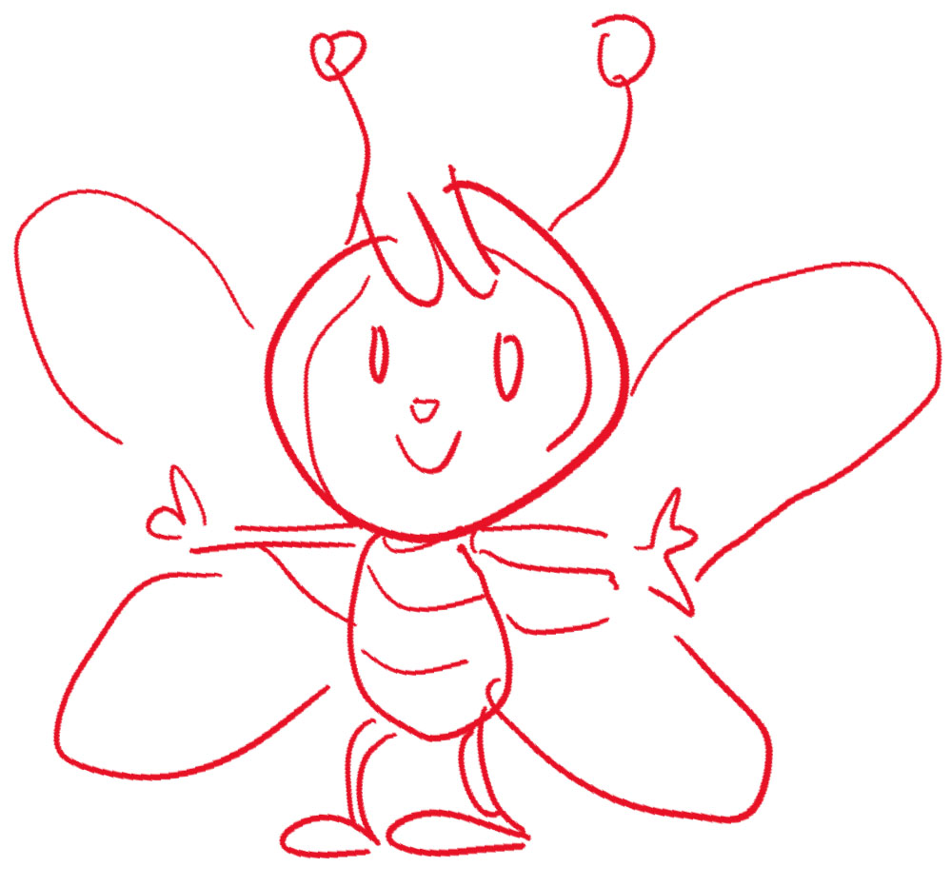
And finally the big moment: she tries it on!

Just then Ranger Rabbit gets home, and Elinor shows off her costume to her mom, who thinks its lovely. Then she shows her mom how she has four wings, not two! How cool! But when she tries to make the wings flap, she finds that she can’t. She jiggles her body, which moves the wings a bit, but they don’t flap and flutter. How can she make her wings move like a real butterfly’s?

Just then, she thinks of an earlier moment in which Ari flapped his wings and she has an idea: she takes some more crafting material and makes two wrist straps and attaches them to the wings. She also takes two pieces and ties the two wings on each side together.
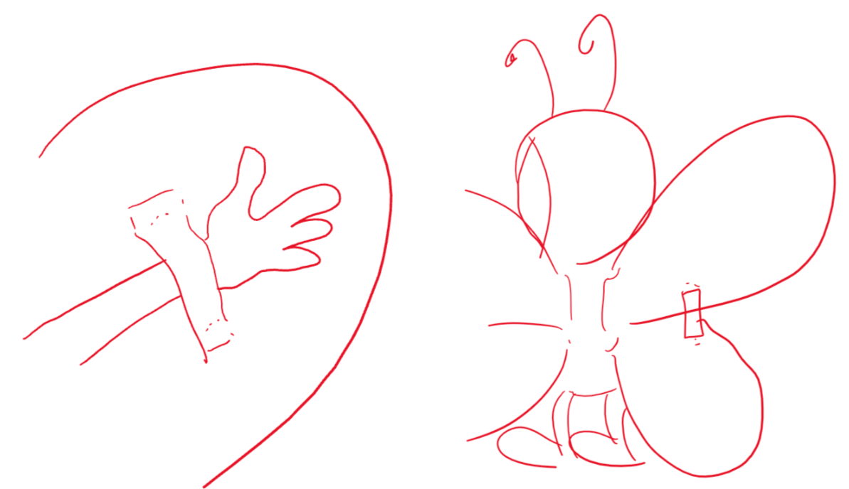

Elinor puts the costume back on and puts her hands through the straps. She tries it out: she can flap her wings! Awesome! Over giggles and laughter, she runs around the kitchen flapping her wings.

Mr. Rabbit brings some glasses of lemonade over for them all. The parents take a nice drink, but at that moment Elinor realizes: she can’t use her arms in the costume! The wings don’t bend forward enough for her to grab the glass, much less bring it up to her mouth. She comically leans over and tries to lap the lemonade up with her tongue, or tip the glass over with her mouth, making a mess. Uh-oh. How is she going to drink her lemonade?

Her mother reminds her that she attached her wings to her arms. Elinor realizes and takes her arms out and drinks her lemonade. Phew, it’s a good thing she has real arms. But this makes her curious. How do butterflies drink?
“I never thought about it before, how DO butterflies drink?”

She knows that they drink nectar from flowers, but she doesn’t understand how that works. How do they get the nectar OUT? She knows that nectar is a liquid inside the flower, but do the butterflies tip the flower using their feet, the way she drinks from a cup? Or suck it out with butterfly-lips? We see thought bubbles for each, which look pretty silly, obviously not the way nature does it.

Elinor decides she needs MORE OBSERVATIONS.

- EXT ELINOR’S YARD -- DAY

Elinor and her father get a magnifying glass and go outside again, where there are some butterflies flitting around the yard near the milkweed they planted.

They have some silly moments chasing butterflies around until Elinor finds one resting. She takes a close look, admiring its wings and looking carefully at its legs. The butterfly flies off and lands on a flower. Elinor and her dad VERY QUIETLY (comically exaggerated) follow it and take a close look.

They watch as the butterfly UNROLLS something from its head and pokes that into the flower. [ ref: https://www.youtube.com/watch?v=03S73-3Tw_0]

Her dad tells her that it’s called a “Proboscis”. Wow, thinks Elinor. They watch it use its proboscis. We have an Science ECU moment where we see the butterfly drinking.

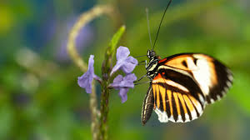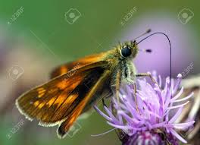

Elinor notices that the butterfly drinks with that suuuuper long tube-like thing, just like a straw. It’s crazy! It’s amazing! How did she never know this SUPER INTERESTING fact about butterflies?

Butterflies can’t
Hold a cup
And they have no lips
To drink nectar up

Butterflies have
A special nose
Long and open
Like a hose

They use their tongue?
To drink from flowers
Sucking up juice
Is their special power

Now Elinor knows how butterflies drink. And she knows how to make her butterfly costume even better!

- INT CLASSROOM – DAY

Ms. Mole calls the class to order and welcomes everyone to Insect Day! She’s wearing a bee costume.

The kids get together and show their costumes. Ari shows off his dragonfly costume. He says dragonflies are really good at hovering in one place, and demonstrates. Olive shows them her ladybug costume. It can fold its wings. Then it’s Elinor’s turn. She shows everyone the cool wings on her butterfly costume and flaps around. Awesome all around!

Mz. Mole sits them all down to have a drink of water. Olive and Ari sit at a table and drink their water from cups. Uh oh, but how is Elinor going to drink her water? Elinor says that butterflies are not just colorful, they’re super interesting! They have everything they need built into them. She reveals that the nose of her costume comes off and unrolls and is actually a working long straw. She shows them all how butterflies drink. You can learn a lot if you observe closely enough. Everyone is delighted by Elinor’s long straw.

Ari ends with another bug joke.

Sara Sweetman Notes:

I like that this flows through this engineering design process. Her problem is that she wants to be a butterfly for insect day but she doesn't look like a butterfly so she must make a costume. She engages in science observation to help her imagine and plan the costume, she makes the costume, and then when she tests it out she realizes she can't drink, so then she has to 'redesign' the costume to improve how it works. Because this follows the engineering design process it would be great to include these words when possible into the script.
Sara

