ELINOR WONDERS WHY
“Olive’s Family Reunion”
OUTLINE – July 31 2019

Elinor’s Question: Why do we look like some members of our family?
Logline: Olive goes to meet some of her extended family, and learns how traits can pass along from parents to their kids.

Curriculum Goals:
- LS1c: Categorize a variety of animals and plants based on their physical characteristics [ They compare how the cousins look similar and different]
- LS6. Understand that individuals of the same kind of plant or animal are recognizable as similar but can also vary in many ways: Contrast individuals of the same kinds of plant and animal [ They compare how the cousins look similar and different]
- SEP1. Asking questions (science) and defining problems (engineering)
b. Ask more complex questions about observable phenomena
c. Ask and/or identify cause and effect questions that can be answered by an investigation
(Elinor and Olive ask questions about why Olive’s uncles don’t look more like Olive and he mother and plan an investigation)
- SEP3. Planning and carrying out investigations
a. Identify and use a greater variety of tools to extend the senses for observing, measuring, and recording data about objects and events
b. Compare and contrast objects and events by describing similarities and differences in detail
d. With guidance, plan and conduct simple investigations using simple tools (Elinor and Olive measure and record the size of Olive’s uncles’ ears and trunk).
- SEP4. Analyzing and interpreting data
a. Collect, describe, and record observations in greater detail and in various ways
c. Record observations to describe patterns and/or relationships in the natural and designed world(s) in order to answer scientific questions and solve problems.
d. Talk about and reflect on what happened during an investigation or when solving a problem, and why it might have happened (Elinor and Olive discover that children inherit a mix of traits from their parents).

- OLIVE’S HOUSE – DAY

We open on Olive packing her satchel. She’s humming and happy, but she has comically too many books for her satchel. She keeps trying to squeeze one more in, but another one pops out. Nearby, Elinor is looking at a photo album of Olive’s family. Wow, says Elinor, you look SO much like your mom. In the photo album, we see pictures of Olive and her mom together, and also pictures of Olive next to older pictures of when her mom was her age. They do look alike! Olive joins her and confirms that everyone always says the same thing. They have the same nose, the same ears… She is the spitting image of her mom. Elinor comments they also have the same nice smile.

At that moment, Olive’ mom knocks on the door and asks if the girls are ready to go. Olive packs the photo album and says they are almost ready. She tells Elinor she is so happy that Elinor is coming with her and her family to the Elephant Family Reunion today. Elinor is going to have so much fun. Olive describes the games her family likes to play together: trunk water-shooting contests, sack races, etc. Elinor agrees it sounds really fun. Elinor says that she sometimes visits her grandparents but hasn’t ever been to a reunion of the whole family before.

Olive says she’s especially excited for Elinor to meet her uncles. Her mom has three brothers: Lou, Jim and Usain. They are extra fun and cool, and Olive can’t wait for Elinor to meet them. Yay! Elinor helps Olive squeeze her books into her bag and they are off!

- INT TRAIN – DAY

We see a montage of Elinor and Olive and her family as they leave the house and head for the train station. In the train, Olive and Elinor play and giggle as Mr. and Dr. Elephant read. We see them disembark at a small station and walk towards a clearing where the Elephant Family Reunion is taking place.

- EXT FOREST CLEARING - DAY

The group arrives at the Elephant Family Reunion (it’s kind of like a big picnic). Wow! Elinor has never seen so many elephants before. There are young elephants, older elephants, elephants of different shapes, shades and sizes, all playing and talking and having fun. Olive’s uncles come over to greet them and welcome them to the reunion.

There’s Uncle Lou, who is a huge book lover, like Olive. He is always lending books to Olive from his personal library (that’s why Olive’s bag is stuffed full of books to return). Uncle Lou has an especially long and thin trunk.

There’s Uncle Jim, who is very silly, and makes a lot of jokes. Uncle Jim has especially long ears.

Then there’s Uncle Usain, who... is a rhinoceros.

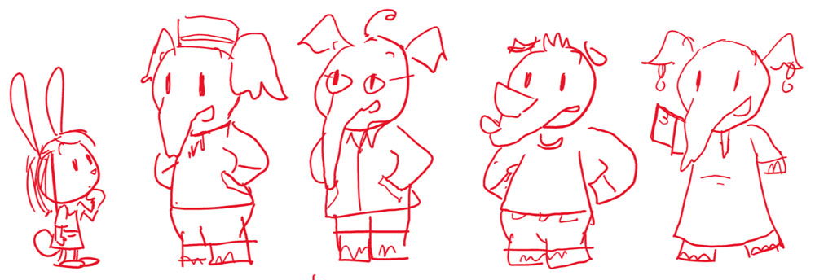

Through all of this, Elinor is delighted to see Olive’s uncles, but is clearly curious about something. She is especially curious when she sees Uncle Usain.

Olive introduces Elinor, her curious friend, to everyone. Uncle Jim says he’s also curious: he wonders what will be served for dinner, and if it’s not his favorite banana-shaped pasta, he won’t eat it.

After a bit more talk, Olive’s parents and her uncles move ahead to greet and talk to other family members. Elinor stays back, thinking about something. She says, “That’s so interesting...” Olive thinks Elinor is talking about dinner, but Elinor says that what she finds interesting is that Olive’s uncles look really different from what she thought they would. She thought they would look like Olive and her mom, but they don’t. “What do you mean?” asks Olive. Well, says Elinor, Uncle Lou has a long and thin trunk, but Olive’s mom doesn’t. And Uncle Jim has really long ears, unlike Olive and her mom. And Uncle Usain, well... he’s not an elephant at all! They all look somewhat alike (even Usain has some similarities) but they also have differences even though they are brothers and sister. Why is that? Olive says that she never really noticed, she just thinks of them as her family!

Elinor and Olive decide they need MORE OBSERVATIONS. They head into the Family Reunion to observe her uncles.

- PICNIC AREA - DAY

In an investigative music montage, Elinor and Olive track down Olive’s uncles and her mom and look more closely at the traits that set them apart. While Uncle Lou is talking to other elephants, Elinor and Olive surreptitiously study him up close, measuring his trunk using their hands. Then they run over to Olive’s mom and compare it to her trunk (and to other nearby elephants’ trunks, for good measure). Then they go over to Uncle Jim, who is helping himself to the lunch buffet. Elinor and Olive bring over a chair and climb up to study and measure his long ears, then go back to the mom to compare their measurement. Finally, they track down Uncle Usain, who is about to compete in one of the sack races. They study his small ears, and the two horns he has instead of a trunk. The girls have to finish their observations/measurements on the run, since the sack race started!

The girls reconvene in the middle of the reunion area and recap what they’ve observed. Uncle Lou does have a thinner and longer trunk than Olive’s mom; and Uncle Jim does have longer ears, unlike Olive’s mom. And Uncle Usain, he doesn’t have a trunk OR big ears. Why do they look so different than Olive and her mom? It’s a mystery alright.
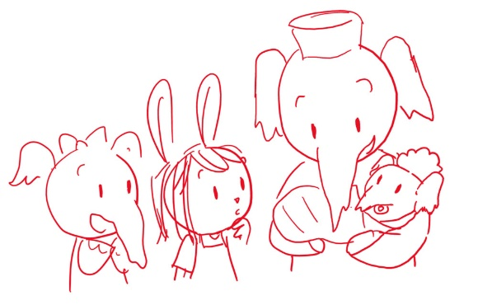
At that moment, Uncle Jim walks over to them. He’s finished eating and is now holding a baby elephant. Look who just woke up from her nap. He introduces Olive to her newest cousin, little baby Rose, his daughter. Olive is amazed and super excited to meet her. Aww, she’s so cute! Little Rose has long ears and curly hair. Olive notes that she looks a lot like Uncle Jim. Yes, he says, little Rose has long ears, just like her daddy. Olive also loves her curly hair. Uncle Jim says that Rose got that from her mother. Little Rose’s mom then walks up, and we see that she has a big head of curly hair. Elinor is curious. She asks Uncle Jim what he meant when he said Rose got her ears from him and her hair from her mom. Uncle Jim explains that everyone gets different traits (those are the things that make you who you are, like your nose or your ears or your hair) from their parents. Sometimes you get a mix of them from both parents, and sometimes you get most of them from only one parent. For example, his other daughter Kathy has his ears, but she doesn’t have her mom’s curly hair. Kathy peeks from behind her mom (she’s a toddler elephant). Or like Olive, who looks mostly like her mom. Ohhh...

At this, Elinor has a realization. She asks Olive if she can look at her family photo album again, and if she has a picture of her grandparents. Olive says she does and finds a photo of her two grandparents with their four kids (Olive’s mom and her three uncles). Elinor and Olive study the photo and make a few connections: They see the pattern! Olive’s Uncle Lou has a long nose like his mother (Olive’s grandma). Uncle Jim has big ears like his father (Olive’s grandpa). They understand that we all get some traits from our parents. But wait, what about Uncle Usain? Uncle Usain explains that he is adopted. He got his traits from his rhinoceros parents, but when they couldn’t take care of him, Olive’s grandparents took care of him and became his parents. Uncle Lou chimes in: He doesn’t look like an elephant, but he’s our brother! Family means more than just looking the same.

- SONG MONTAGE

Elinor and Olive sing a song as they walk around and appreciate the diversity of different elephant shapes, shades and traits:

Families play
And families eat
They gather together
And share a treat

Sometimes you look
Like your mother
And have a nose like your
sister or brother

Sometimes you look
Like your father
And maybe your ears
Are a little bit larger

Sometimes you look
Like nobody else
You can be the only one
Who looks like yourself

Families love
And help each other
Mothers and fathers
Sisters and brothers

- PICNIC AREA -- DAY

After the song, Olive and Elinor are back where Olive’s family had gathered. Elinor recaps what they learned: how we are all different and special because we get different traits from each of our parents. Uncle Lou asks if Elinor and Olive are ready to go play some games now. Yes! Olive grabs Kathy’s hand and tells Elinor she can’t wait for Elinor to meet her other cousins. Elinor is so glad she came. She feels like she gets to be an “elephant for a day”! Uncle Lou tells her she’s the most curious elephant he ever met. She’s part of the family now! On laughter and giggles, we see Elinor and Olive head into the reunion to play as we...

END

(DESIGN NOTE: If this is feeling design-heavy, here are some alts: Olive and her family can walk to the reunion instead of taking the train. The reunion can take place in the same spot as the Town Picnic. The picnic can be a modest affair, and re-use/re-mix some of the elephants from the dog smell interstitials?).

