ELINOR’S TOWN
Zig-Zag Plant
PREMISE –May 31, 2018

Elinor’s Question: Do plants grow straight up towards the sky?
Logline: Elinor is intrigued when she and her friend find a plant that has grown in a zig-zag.
Curriculum Goals:
- LS1b: Record observations about an animal’s or plant’s physical appearance [ they record the shape of the plants ]
- LS3. Understand that all animals need food in order to live and grow, that they get their food from plants or from other animals, and that plants need water and light to live and grow:
  - a. Observe ways that animals and plants get what they need to live and grow [ They grow up!]
  - c. Help care for living things at home or in the classroom [ they take care of plants in their classroom]
- ND.
- SEP: TBD at outline

Elinor’s class is growing some seedlings to plant around the school. They pack them in dirt and give them water and put them in the sun. A week later, they all sprout and Elinor, Ari and Hazel take good care of their seedlings. But they come in after a weekend and find that one of the seedlings looks a lot different:
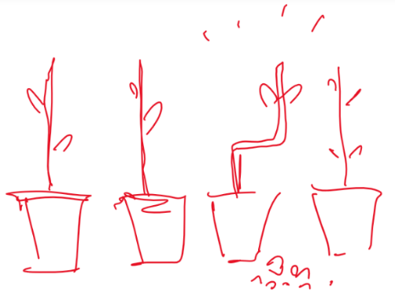
It looks like a zig zag!

The kids are completely puzzled by this. It’s a mystery! Elinor decides they must know the answer and begins an investigation. They consider the possibilities. Maybe this is a different kind of plant? They check and confirm that this is the same type of plant. Maybe it’s in a different kind of pot or soil? Nope, also the same. They start to think about what determines which way plants grow.

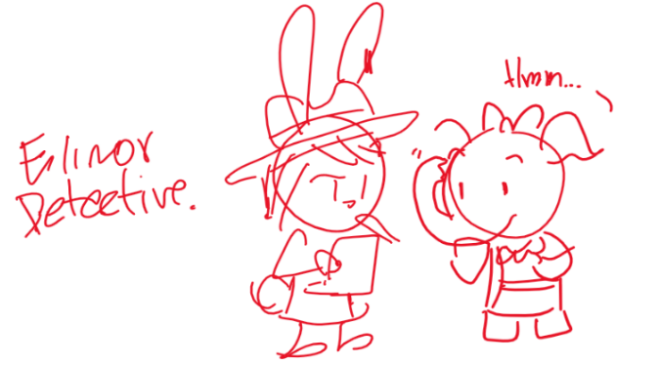Proceeding like a detective story, the kids try different things and interview the rest of the kids in class and Ms. Mole. Slowly the piece together what happened: Ari knocked over the plant right before they left for the weekend (hence the small amount of dirt near the plant), but at some point in the middle of the weekend, Ms. Mole came into school to tidy up, and put the plant right side up. Since plants always grow up (in the direction away from the ground), the seedling grew into a zig zag shape!

Having solved the mystery of the zig zag plant, the kids try to experiment: they make a whole row of zig zag plants and plant them in the garden.

Sara Sweetman Notes:
Zig Zag Plant- Are they planting seedlings or seeds? It would be hard to plant a seedling upside down... When I first read the guiding question I thought about the amazing vines and plants that we see that zig zag to find the sun and then other plants (types of trees) that are like straight arrows shooting up as straight as they can to reach the sun. Either way plants that need sun have mechanisms to find it...even when they can't walk into it like we do. Alternatively, a common experiment in early grades is to plant seeds in different orientations. It is interesting to kids and adult scientists how seeds sense gravity and the roots always grow down and the stem sprouts up. I think there is something here ...I'm not sure the direction yet though.

