ELINOR WONDERS WHY
EP # 141 “The Zig-Zag Plant”
OUTLINE – June 30, 2019

Elinor’s Question: Do plants grow straight up towards the sky?
Logline: Elinor is intrigued when she and her friend find a plant that has grown in a zig-zag.

Curriculum Goals:
- LS1b: Record observations about an animal’s or plant’s physical appearance [ they record the shape of the plants ]
- LS3. Understand that all animals need food in order to live and grow, that they get their food from plants or from other animals, and that plants need water and light to live and grow:
  - a. Observe ways that animals and plants get what they need to live and grow [ They grow up (against gravity) and some also grow towards the sun.]
  - c. Help care for living things at home or in the classroom [ they take care of plants in their classroom]
SEP1. Asking questions (science) and defining problems (engineering)
b. Ask more complex questions about observable phenomena
c. Ask and/or identify cause and effect questions that can be answered by an investigation (The kids ask questions as they try to figure out what happened to the zig-zag plant).
SEP3. Planning and carrying out investigations
d. plan and conduct simple investigations using simple tools (Using the magnifying glass and the notebook, the kids plan their investigation of the zig-zag plant).
SEP4. Analyzing and interpreting data
d. Talk about and reflect on what happened during an investigation or when solving a problem, and why it might have happened (The kids reflect on what might have happened to the zig-zag plant).
SEP5. Using mathematics and computational thinking
d. Use measurement tools to measure and quantify properties of observable phenomena and objects (Olive measure the seedlings using books as unit of measure).
SEP6. Constructing explanations (science) and Designing Solutions (engineering)
a. Use background knowledge experiences, and data to construct reasonable explanations and theories of natural phenomena (science)
b. Look for and describe patterns and relationships in natural phenomena (science)
c. Use and apply productive science discourse to support an explanation
d. Use evidence to support a theory (science) or solution to a problem (engineering) (The kids use their knowledge of the ways plants grow (always up) and the evidence they gather to try and understand why the zig-zag plant has grown so differently than the other seedlings)
SEP7. Engaging in argument from evidence
a. Engage in discussions before, during, and after investigations
b. Support thinking and argue ideas with evidence (After engaging in discussion of the evidence, the kids come up with a reasonable idea of what happened to the zig-zag plant).

- EXT ELINOR’S SCHOOL – DAY

It’s another bright sunny day in Animal Town. Elinor and Olive are outside looking at a low table set outside their classroom, on the playground side. On the table are rows of tiny seedling plants in small pots. “Look how they’ve grown!” says Elinor. “Wow,” says Olive, “and it’s only been a few days!” Behind them, their friend Ari is doing some would-be acrobatics. “Ok, I almost got it... and... backflip!” He does a flip, flapping a little wildly with his wings, but lands flat on his stomach. “Oof! I did say almost.” The girls giggle and help him up, and at that moment Mz. Mole joins them, holding a book. “How are our class plants doing, kids?” she asks.

“Amazing!” says Elinor. “We planted these seeds only a few days ago, and look how much they’ve grown!” “Yeah,” says Olive, she loves how they are all growing straight up from the soil all at the same time. The girls pose as the plants and stand up really straight. Mz. Mole explains that plants always grow “up,” no matter which way you plant them! She shows them a few pictures from her book: plants grow up towards the sky in sloped mountains, and even in almost-vertical rock faces. The kids think that’s really cool. Elinor looks back at the plants and cheers them on: “C’mon little plants! You can do it! Grow up, up, up!” Olive takes out some thin books out of her satchel to measure their height. They’re almost one-two BOOKS high!

Mz. Mole reminds them to give the plants a little extra water today because it’s almost the weekend. Ari doesn’t know what this means exactly, and Mz. Mole explains that it’s the end of the week and there won’t be any school for two days, which means no one will probably be around to water the plants. Two days without school!? What am I going to do with all that time, wonders Ari. Mz. Mole giggles, and says she’s sure you kids find lots of ways to have fun. Elinor says she can’t wait to see how much the class plants will have grown by then.

- EXT. ANIMAL TOWN

We see the sun set, the night pass, and the sun rise over Animal Town twice to mark the passing of two days. NOTE: here we could also show a montage of the kids doing weekend activities to mark the passage of time.

- EXT/INT ELINOR’S SCHOOL – TWO DAYS LATER

It’s the start of a new school day. Elinor and Olive run towards the school and catch Mz. Mole as she is opening the door to the school. Well, you’re both here bright and early, Mz. Mole comments. Elinor and Olive explain how they can’t wait to see how the class seedlings are doing after the weekend! It’s been two days and they want to see how much the plants have grown. Mz. Mole opens the front door and the kids come in, hurriedly drop their things in their cubbyholes, and head for the side door.

Mz. Mole looks after them, and shrugs as more kids start coming in.

- EXT SCHOOL (PLAYGROUND SIDE) – DAY

Elinor and Olive rush out the side door to go check on the seedlings. Wow, look, they’ve grown even more! The seedlings have indeed grown, and look about two or three times taller. Olive takes out her books and measures the plants: one-two-three-four BOOKS high! They grew a lot! Just then, Ari comes out with some panache to join them. He tells them he spent the whole weekend practicing his backflip. Watch: the tries it again, with more effort, but still can’t quite get it. He flaps his wings a little wildly and ends up on his stomach again. Oof! Olive helps him up. Aww, says, Ari, he practiced all weekend for two whole days. He dusts himself off and asks how the plants are doing. Elinor excitedly tells him they’ve grown a lot in the last two days. They’re all growing up, up… up? As we pan on the plants, they notice something odd: all the plants are pointing up, but one plant looks like a ZIG-ZAG!
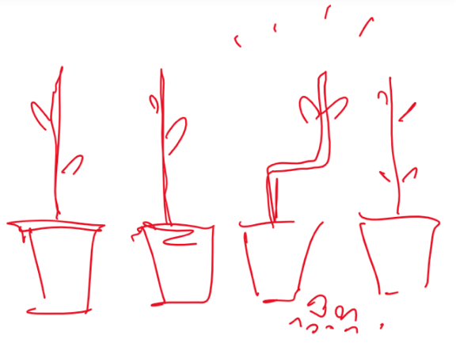

WHOA! The kids are amazed. Ari thinks it’s pretty cool, and does some zigs and zags himself. But Elinor and Olive are extremely curious. They haven’t seen that before. Why did this plant grow in a zig-zag and not in one straight line up like the others? Is it a different kind of plant? Hmm, no, the leaves and everything else look the same. Is the pot the same? Yes. Is the dirt different? They pull out a magnifying glass and check, but it looks the same. At that moment, they notice a little mound of dirt near the zig zag plant. “Wait a minute, what’s this?” It’s a little bit of dirt. None of them remember that being there before. Where did it come from?

Elinor thinks for a beat, then says, “Hmmm… I think we have a MYSTERY, which means…” She runs back into the classroom, rummages through the class costume bin, then comes back outside. “This is a job for the science detectives!” she exclaims as she puts on a kid’s detective hat. “Awesome,” says Olive, “I love to play detective. I’ll take notes.” “Cool,” says Ari, “My dad reads a lot of detective stories. He says it’s always the butter that did it.” You mean the butler, Ari? Says Olive. YES, says Ari, it’s always the butler with the butter. The kids giggle.

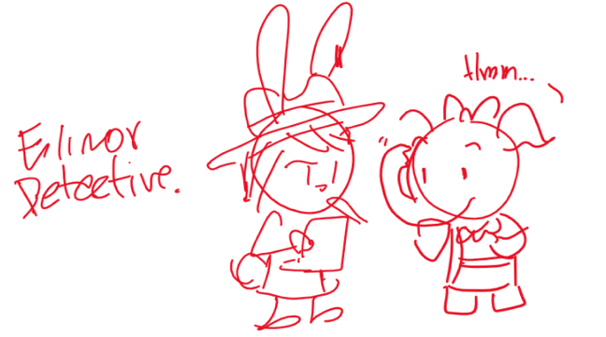
Ok, What should we do first? Elinor says the first thing scientists and detectives do is make observations and look for clues. Let’s look for clues! The kids march in a line, stooping low and examining the ground with their magnifying glass. After a quick loop around the immediate area, they come back to the same place. Did you notice any clues? Nope. Hmm, what else do scientists and detectives do?

They ask questions, says Elinor! They look around at the other kids playing in the playground. Let’s ask the other kids to see if they know what happened to the zig zag plant.

- EXT PLAYGROUND – DAY

They run out to the playground and we go through a series of cuts as the kids interview a few kids (mostly to comedic effect). Camilla isn’t very helpful, she goes off on a tangent about something unrelated. Koa is totally chill and doesn’t remember anything (uh, which plants?). Sally looks nervous and denies everything.

- EXT SCHOOL (PLAYGROUND SIDE) – DAY

The kids return to the table with the plants, having made no progress. “Hmm, no one knows what happened to the zig zag plant,” says Elinor. Olive looks over her notes. “Well, we WERE the last ones to leave school that day. And I don’t remember seeing anything happen to the plants.” “Hmm,” says Elinor, “I remember we were right here talking to Mz. Mole, and then we left to go home.” She re-enacts what happened slightly, starting from the table and walking off a few steps. Then, Ari realizes something.

He says: “I remember I practiced doing my backflip one last time before we left. I was standing right here…” He tries a backflip (unsuccessfully again), and as he flips, his wing knocks over the zig-zag plant, spilling a second little pile of dirt. Elinor notices. Look, Ari knocked over the plant and spilled a little bit of dirt, just like the little pile of dirt that was here this morning. He must have knocked over the plant the day we left, and that’s how the first pile of dirt got there. That would explain it, says Olive, looking at her notes. Oops, says Ari, I didn’t notice. Elinor looks closely at the sideways plant. That means... the plant was left on its side when we went home. On a science CU, she examines the first bend in the zig zag: she follows the plant out of the dirt and then up as it turns towards the sky. Gasp! I think I know what happened!

Elinor explains, illustrated by a thought bubble: Right before we left, Ari knocked over the plant, so the plant was left sideways, but plants always grow UP so... the plant changed which way it was growing! In the thought bubble we see Ari knock over the plant, then a close view of the seedling on its side as it changes growth direction up to create the first zig in the zig zag. Wow, the kids think. That is SO INTERESTING! It’s like Mz. Mole says, plants always grow UP, no matter which way the ground is. The kids are feeling great, but then Olive thinks of something. That explains the first zig in the zig zag. But, what caused the second zag? Why is the plant bent one way, and then bent the other way? Hmm... the kids are left puzzled.

At that moment, Mz. Mole walks by, noticing the plant on its side. She comes over and puts the plant right-side up again, saying “Mmm, this plant got knocked over again!”

Elinor keys in on the word “again.” Mz. Mole, did you say the plant got knocked over again? The kids realize they haven’t interviewed Mz. Mole! Olive flips a new page on her notebook. Mz. Mole tells them that she came in during the weekend to clean up and found Ari’s plant pot on its side, so she set it straight.

The kids piece together what happened. THAT’S why the plant grew in a zig zag! We see the full story in a thought bubble with Elinor’s narration:

- Ari knocked over the plant as he did a backflip
- The sideways plant started growing up one way.
- Then Mz Mole came in and put the plant right side up.
- The corrected plant then kept growing in the original direction.

That’s it! We solved the mystery! Plants always grow up, so if you put it sideways and then right side up again, it’ll grow like a zig zag!

On their positive energy, we segue into a ditty:

Up, up, up!
Plants grow up
No matter how flat
Is the ground they’re on

Up on a mountain
Or on a hillside
Plants will grow
Up to the sky!

We had a mystery
Of the zig zag plant
What could have made
It grow like that?

Up, up, up!
Plants grow up
No matter how flat
Is the ground they’re on

We end the song montage on a shot of the zig zag plant. The kids ask Mz. Mole if it’s ok for the plant to grow like that. Mz. Mole says of course! There’s no wrong way for a plant to grow. As long as it’s growing up towards the sky, it’ll get all the air and water and sun it needs. Well, says Olive, I think it looks really cool. Can we make this our special plant? Absolutely, says Mz. Mole. Awesome! The kids cheer and high five each other. In his excitement, Ari does a backflip and... he lands it! He did a backflip! Wow, Ari, how did you do it?

I just did like the plant, says Ari, and went up, up, UP! On laughter and merriment, we...

END

Sara Sweetman Notes:
I think this outline is good. I like stressing and making explicit about what activities we can do when we don't know why something happened. For science learning and practices sake, I'd like to see the discovery of the crooked plant lead to the discovery that plants grow up toward the sun. After they interview (find out Ari might have knocked the plant over) and research in a book and/or Mz. Mole and find out trees grow up. Then they put those two things together to come to understand the zig zag plant.
I think when talking about growing up it should be in the context of growing up toward the sun. Because in the wild some plants grow crocked to better reach the sun.

