EWW 135 Interstitial
Senor Tapir Musical Moment
Karen Washington, Queen of Urban Gardening
By Laura Sams

Follows A Garden for All - Elinor is determined to help her friend Hazel make a garden even though she lives in an apartment. They build one on her balcony.

Curriculum: Karen Washington, called the Queen of Urban Gardening, followed her curiosity to figure out whether she could create gardens in New York City, starting with her own small garden in the backyard of her Bronx home.

LS3. Understand that all animals need food in order to live and grow, that they get their
food from plants or from other animals, and that plants need water and light to live and
grow: (c) Help care for living things at home or in the classroom
- Intro scene in which Sr. Tapir and the kids are at Mz. Llama’s fruit stand. Mz. Llama has a basket of ripe red tomatoes, and she hands a tomato to each kid. Senor Tapir comments “This looks delicious amiga. Did you grow these in Animal Town?” Mz. Llama says she sure did. Sr. Tapir says he has a song about Karen Washington, a farmer who wondered if she could grow fresh fruits and vegetables in the middle of New York City, an even bigger city than Animal Town.
- Senor Tapir sings a song about Karen Washington, who wondered whether she could grow fresh fruits and vegetables in New York City neighborhoods. Karen grew up in New York City, and one day she tasted a tomato that a friend grew in a home garden. It tasted so good that Karen wondered if she could grow fresh food in her own backyard, instead of buying food that came from farms far away. The backyard garden grew! Then she wondered if she could help her neighbors grow gardens in the empty spaces around the neighborhood. That worked too. Now Karen helps people grow gardens all over the city so that everyone can eat fresh food. The song’s emphasis is on her curiosity about whether folks could get fresh fruits and veggies in the city, without the food coming from farms far away.
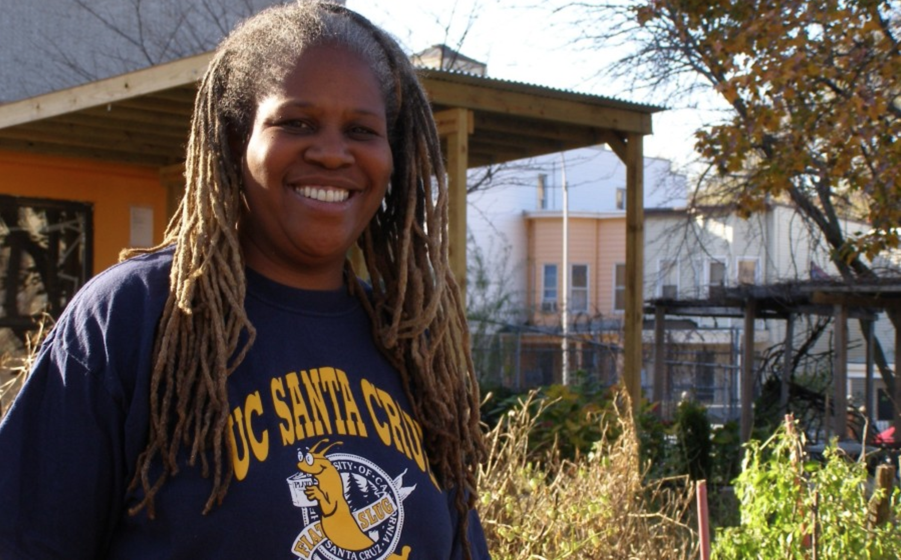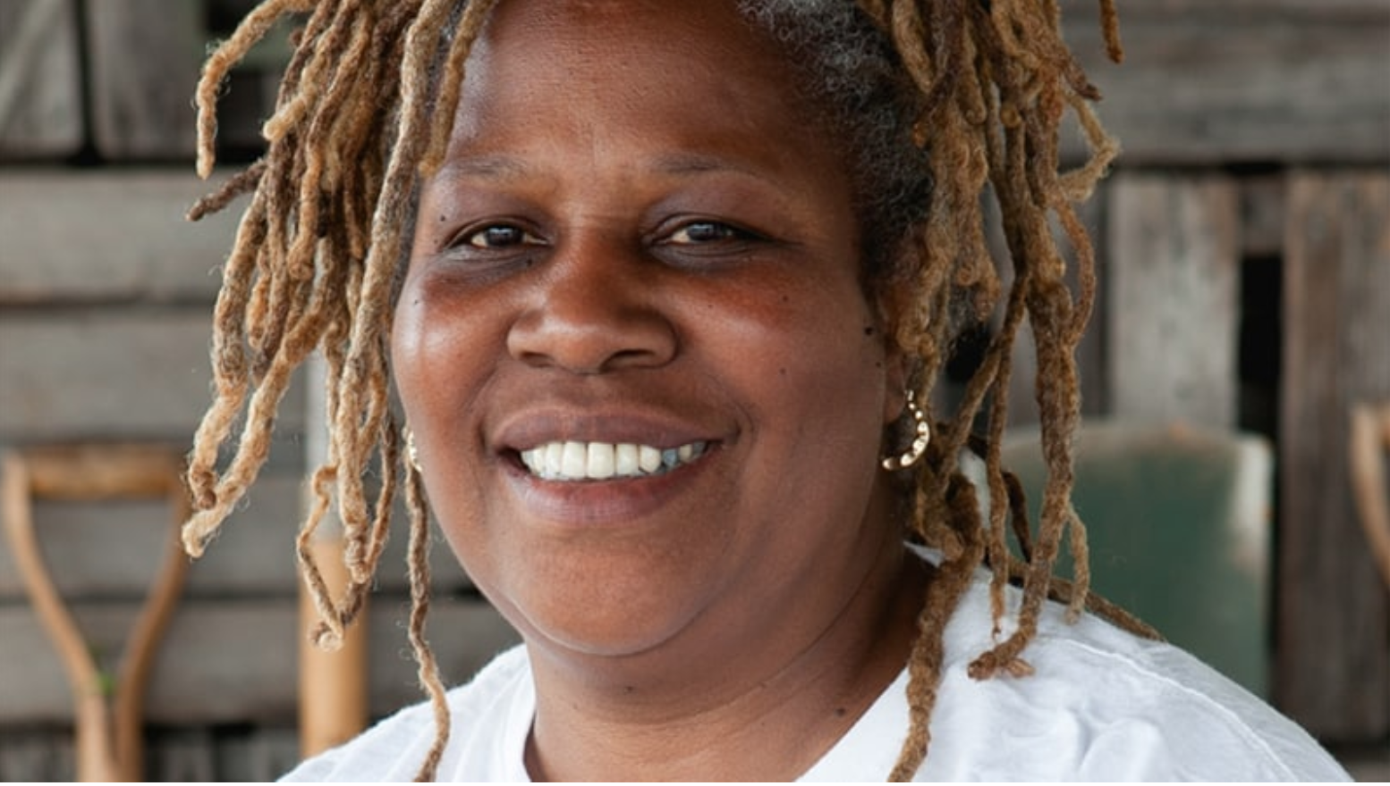

- End scene in which Mz. Llama gives Sr. Tapir his tomato. Then Sr. Tapir says “Salud, amigos,” and he and the kids all hold their tomatoes up in the air briefly, then all take a bite at the same time. Yummmm.
PBS Notes:
For the Karen Washington interstitial, a couple of things to ponder:

- We want to be especially mindful that we don’t insinuate that home gardens feed “everyone,” as I think some of the language suggests. Food insecurity is something PBS pays a lot of attention to, and it’s probably not something that can be eradicated based on a few urban gardens. PBS can’t make that guarantee to children or families, so we want to make sure that the language (and/or lyrics) are not offering a miracle.

- In terms of how KW is introduced and framed, it’s not clear if there were no gardens in NYC (or any other city) before Karen? Our understanding is that she was more of an urban garden activist and helped discover locations where urban gardens could be established. http://www.riseandrootfarm.com/karen-washington If we can just confirm that this is being framed accurately, that would be great.

