ELINOR WONDERS WHY
EP 133 These Sneezes
By: Dave Dias
OUTLINE June 6, 2019

Elinor's Question: Why do we sneeze?
Logline: When Olive’s sneezing disrupts their game of tag,
Elinor tries to figure out why we sneeze.
Curriculum Goals:
SEP4 - Analyzing and interpreting data. (d.) Talk about and reflect on what happened during an investigation or when solving a problem, and why it might have happened. LS2 - Understand that animals have different body parts that are used in different ways to meet their needs, and that plants have different parts that help them survive and grow:
- Identify body parts of animals and their function. (Elinor discovers that sneezes help get unwanted things out of your nose.)

[J&D NOTES:
- This is a much improved outline, nice work!
- There are lots of really nice funny physical moments.
- It needs a tiny bit of sharpening about what they know and when they know it (see comments below)
- Let’s do as much of the “process of understanding” out loud as possible, so the audience can participate rather than have it revealed.
- Some story tweaks:
  - Olive shouldn’t know that flowers make her sneeze. That’s the mystery they solve in the third act.
  - The rolling wagon gag is funny, but as it is, it has Olive sneezing even though she’s away from the source of the pollen. i.e. Why is she still sneezing when they are pursuing the wagon? If kids (in story and at home) are going to figure out why she was sneezing, they need to associate the sneezing with the presence of what’s causing her to sneeze: She sneezes when she breathes in the pollen, and she doesn’t sneeze when she’s not breathing the pollen.
  - So, let’s put Olive IN the wagon with some flowers. Instead of carting library books, have the kids cart around potted flowers (maybe they are carting them to give them away, or to take them to the park for Ranger Rabbit to plant). (Having them cart books didn’t seem to pay off anyway). Then in the tag game, Olive accidentally falls into the wagon, and ends up holding one of the potted plants. As she holds the plant, she breathes in the pollen and starts sneezing. The sneezing causes the wagon to start rolling down the slight hill, and the continual sneezing gives it extra pushes:
  - 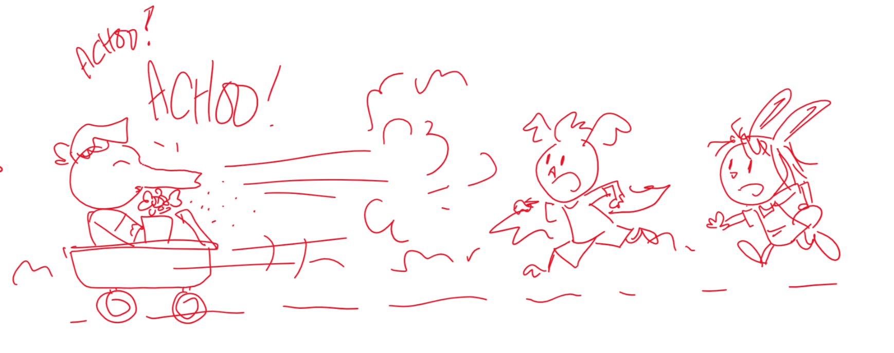
  - Finally, they catch up to the wagon and either stop it, or maybe it hits a bump which sends Olive up in the air (but she still saves the plant) or it just rolls to a stop. She gets up and sneezes one last time, then puts the flower down. This makes her stop sneezing. The idea is to make it clear: flower -> sneezing. This can add to the mystery: the kids see she stops sneezing and wonder, “What made Olive sneeze?”
  - In the library, some story tweaks: the kids figure out that dust makes them sneeze on their own, then the librarian confirms and guides them through the nose cross section.
]

1. EXT. PARK - DAY
Walking along a park path, OLIVE and ARI are with ELINOR as she pulls a WAGON filled with LIBRARY BOOKS. Olive’s impressed by how many library books all three of them have to return! Elinor says the books aren’t all theirs, some of them are her parents’ books that need returning too.
As the girls talk, Ari quietly drops behind them, flies up, and lands on top of the books upon the wagon so he can get a free ride. Elinor suddenly finds the wagon harder to pull now. Olive helps her pull the handle, but both of them find it slow going. Ari tries to stifle his amusement, but the girls hear him, realize he’s sitting on the wagon now, and stop pulling. Gotcha, Ari says, and the trio laugh.
For making the wagon full of books even heavier, Olive thinks Ari should be the one to haul it the rest of the way to the library. “Only if you can tag me first,” he says, leaping off the wagon. The girls smile; an impromptu game of tag? Yeah!!! “I’ll tag you, Ari!” “No, I’m going to tag him first!” “I’m too fast to be tagged!”
The kids giddily chase each other around some FLOWER BUSHES lining that section of the park path. Elinor gets close to tagging Ari, but he deftly glide-evades her. Stealthily, Olive kneels behind the flower bush to pounce on Ari, getting her face right up to some FLOWERS in the bush. Suddenly, her nose twitches -- a sneeze is coming on! It builds, and builds, and JUST as Elinor tags Ari: “Tag! You’re--”...
AAAAAA-CHOOOO!!! LEAVES AND PETALS blast out of the bush, startling both Ari and Elinor and sending them stumbling backward: “Yaaa!” Ari bumps into Elinor, who bumps into the wagon... which starts rolling away slowly down the path (though Elinor doesn’t notice this yet).
Elinor asks Olive if she’s okay. Yes, Olive replies, she gets sneezy around some kinds of flowers and she forgot about that when she kneeled behind this flower bush. AAAA-CHOOO!
Ari double-takes as he sees the wagon of library books rolling away down the path: “Oh no, the library books!” Ari, Elinor and Olive all give chase, with Olive continuing to sneeze as she RUNS: AAA-CHOOO!! AAA-CHOOO! AAAA-CHOO! Olive’s trumpet-blast sneezes startle other park-goers they pass:
The GOAT TWINS stop walking as the trio race past them after the wagon. AAA-CHOO! The force of Olive’s sneeze slides the twins apart, much to their chagrin! MARTHA COW is doing YOGA beneath a TREE. The kids race past her. AAAA-CHOO! A BUNCH OF LEAVES shake off the tree and cover Martha. SALLY BEAVER is trying to fly her KITE in the park, but there’s zero wind. The kids race past her. AAA-CHOOO! The blast from Olive’s sneeze billows Sally’s kite up into the air, and she happily flies it around: “Thanks!”
The wagon’s about to roll off the path and into the POND! Elinor is the first to get to the wagon and she grabs the handle. Ari and Olive grab a hold of her and together they help pull the wagon to a stop just before the wagon lands in the water. The friend’s breath a collective: “Whewwww!”
Elinor and Ari wonder why Olive sneezed so much all of a sudden. Olive isn’t sure, but she prefers playing tag when she’s not sneezing. Her friends want to help Olive, but they realize that, although they’ve all sneezed before, they don’t know anything about sneezing. “Why DO we sneeze, anyway?”
The friends consider some possible reasons. They all think sneezing’s kinda funny and loud. Ari says he’s loud when he laughs -- maybe sneezing is another way of laughing? He tries sneeze-laughing and it sounds totally goofy, eliciting laughter from the trio. Olive wonders if sneezing is their bodies’ way of communicating to people loudly? Like saying ‘hello’, but instead you say: ‘aaaa-chooo!’?
Elinor wants to do some investigating. None of the friends have a book about sneezing, but they just so happen to be going to the very place where they can get any book: the library! C’mon! Elinor leads Olive and Ari away, with Ari pulling the wagon -- too enthusiastically, as some books on it fall off. He groans, puts them back on, and starts again, this time pulling slower so the books will stay on.

2. INT. LIBRARY - FRONT DESK - LATER
Elinor opens the door, Olive enters and Ari follows with the wagon full of books. They bring it to the front desk where THE LIBRARIAN, a sensitive twenty-something male antelope, (name TBD maybe call him by his first name, because of his age?) greets the kids with a big smile and thanks them for returning their library books on time. Now what would they like to read next?
Elinor says they could use a hand finding a book on something that almost caused their wagon to roll into the pond today: sneezing! The librarian responds with appropriate intrigue. Ahh, sneezing is indeed a fascinating subject! He can definitely help them “aaa-choose” the right book! In fact, he might know of the perfect book for their investigation!. Follow me, he says -- walk this way!

3. INT. LIBRARY - AISLES / KIDS AREA - MOMENTS LATER
The Librarian leads them into the aisles, walking normally to start then doing some irregular walks: long steps, slow steps, side steps. The friends giggle, he did say “Walk this way,” as they mimic the librarian’s walking. A LIBRARY PATRON gently shushes the kids as they pass. They whisper “sorry”, then giggle more quietly.
They arrive at the KIDS AREA, framed by low bookshelves displaying PICTURE BOOKS, plus a variety of seating options in the READING NOOK, like club chairs and floor pillows for young visitors to kick back with a book. The Librarian leads them to a set of low shelves where OLDER KIDS BOOKS are kept (they look more traditional and less colorful and flashy as newer books.
The Librarian looks closely at the shelf, saying the book he’s thinking of is about noses and sneezing. But it’s an older book and nobody’s checked it out in a while... Gently, he finds the book, pulls it off the shelf, and shows it to Elinor, Ari, and Olive. The kids examine the book and notice how DUSTY it is. “I’ll fix that,” says Ari, BLOWING on it.
DUST explodes off the book and envelops them. The kids cough and wave their hands to disperse the dust. “Hooo! That book hasn’t been dusted in forever!” quips the Librarian. He knows what cleaning job he needs to today! Instantly, their faces all scrunch up, noses twitching. Elinor’s ears waggle...
and she SNEEZES: “Aaachooo!” Then Ari sneezes: “Waaaaa-choo!” flinging his wings outwards as his bellow sends him flying backwards like a kite on his self-generated breeze, bumping into a chair and knocking it and himself over. Even the Librarian’s nose gets twitchy and he “Aaaa-chooo!’s as well. Ari and Elinor can’t help but giggle at each other’s sneezes.
Olive comically struggles to hold in her sneeze, huffing and contorting as she covers her trunk. Elinor turns to the Librarian, warning: “Olive’s a loud sneezer.” Then Olive SNEEZES HUGELY: “AAAAAAAA-CHOOOOOOO!!!” The books on the bookshelf beside her blast flat from the breeze! “Very impressive,” the Librarian whispers.
A few LIBRARY PATRONS peer out from behind bookshelves to look at them in surprise or annoyance. The Librarian tells the patrons it’s okay, it’s just a little dusty back here, he’ll get right on cleaning it. He turns to the kids, saying he’ll go sign out that book for them. Elinor and Olive say they’ll go outside to read it so they don’t disturb people in the library with any more sneezing. The Librarian smiles. That’s very considerate of you, he replies. As he goes off to find the duster, Elinor carries the book towards the front desk so they can check it out.
As they walk, Elinor’s expression is one of curiosity. She whispers to her friends that when they sneezed this time, it wasn’t just Olive who sneezed, they ALL sneezed. That’s so interesting! What made them sneeze?
They stop walking to consider this further. They were sneeze-free until they got that dusty book, Elinor recalls. You mean, until Ari blew dust off the book and it got in their faces, Olive adds. In our noses, Ari clarifies. The second he sniffed some in, his nose got super-tickly, and next thing he knew: a-choo! As Ari talks, Elinor is examining the top of the book; it still has some dust left on it. When Ari goes “a-choo”, he waves his hand over the book—

--and accidentally blows that bit of dust off the book right into Olive’s face! Olive’s trunk twitches. Oh no, she’s going to sneeze again, Elinor says. Acting fast, Elinor rushes Olive to a PRIVACY DESK nearby (the one-person kind, with raised sides and back). She has Olive aim her sneeze inside the enclosed desk, while Elinor and Ari block the sides and top of the desk with their bodies to fully enclose the space. Olive sneezes: AAAAAAA-CHOOOOOO! The sneeze is muffled! But the force of it blows Elinor and Ari off their positions and onto the floor: WHOMP!
The kids look around, anxiously. No one peers out to shush them. Whew! Olive confirms what Ari said: dust definitely got in her nose that time, and it immediately made her sneeze. That’s sooo interesting…” says Elinor, she has an idea.

4. INT. LIBRARY - FRONT DESK - LATER
Elinor has the book open on the front desk and is flipping through it just as the Librarian meets them there with a variety of dusters he found. Elinor explains she has an idea about why they’ve been sneezing, so she wants to check the book.
She lands on a CROSS SECTION DIAGRAM OF A TYPICAL MAMMAL NOSE. Whoa, what is that, asks Ari, weirded out. The Librarian explains it’s a cross section, a drawing of what a nose looks like INSIDE. Elinor guides their exploration of the diagram, pointing out that when dust travels into their nose, it irritates it. Together, the kids figure out that your body sneezes to get out whatever went into your nose.
The trio are thrilled they figured that out! But Elinor still has a question: why was Olive sneezing earlier? Was it dusty outside too?
The Librarian stamps the library book and tells the kids to let him know what they discover when they bring the book back. Sure thing, says Elinor, and she leads her friends out of the library. Ari hauls the lone book upon their otherwise empty wagon, relieved at how easy it is to pull this time with only one book on it!

5. EXT. PARK - DAY
Back at the area of the path there were at earlier that’s flanked by the FLOWER BUSHES, the kids look around: there’s no dust around here (it’s a grassy area, no muddy or dirty patches). What made Olive sneeze?
Elinor leads Ari in Olive in retracing their steps back when they first arrived in the park, with Ari sneaking onto the wagon to be pulled too, the girls realizing he was on it, then starting a game of tag that led to them running around this area. Olive hides behind the flower bush again, before remembering what happened there last time, and...
Olive’s nose twitches. Hit the deck, Ari says! This time Elinor and Ari lie flat on the ground, as Olive SNEEZES heavily: AAAA-CHOOO! Leaves and petals blast out of the bush again, but this time, they fly over the prone Ari and Elinor, who stand again, pleased at their quick reactions. Olive steps out from behind the bush, saying it’s the flowers in this bush that made her sneeze this time, not dust.
On closer inspection, Elinor can see that there is a little bit of YELLOW DUST on Olive’s nose. That’s not the same dust that was in the library!
Ari sparks to attention as he examines it. He knows what that yellow dust is! It’s pollen! What’s pollen, Elinor and Olive ask. Ari says it’s the little bits of powder that come from flowers, kinda like really tiny seeds. He knows this because his Grampa is allergic to flower pollen, so he doesn’t keep any flowers in his house.
Elinor beams triumphantly. They figured out why they sneeze! Whenever something gets in their nose like dust or flower pollen, and irritates their nose, she says, they sneeze! It’s how their bodies get that stuff out of their noses!
Off that, Elinor breaks into SONG! Visually, she gestures to the noses of herself and her friends in turn, then returns to the flower pollen she pointed out moments ago:

SONG: "SNEEZE IT OUT"
ELINOR (singing):
Your nose is used for smelling
And it's also used for breathing
When dust or pollen gets in your nose, Your body gets it out by sneezing!
ELINOR/OLIVE/ARI (singing) A-choo, a-choo, achoo-hoo-hoo!
We blew it out, hooray, woo-hoo!
Sneezing! That's what got it out!
From all our noses, so now we shout: That's what sneezing's all about!
SONG ENDS.
Elinor is eager to bring her book home and read more about noses and sneezing. Ari offers to pull the wagon -- if they can tag him again! Elinor and Olive share an eager, knowing look. Tag would be great! Before they start though, Olive asks that they play tag away from any flower bushes so she doesn’t get any more pollen in her nose! The friends race off with the lone-book carrying wagon, and when they’re in a treed area with no flower bushes, they stop the wagon, and giddily resume playing tag without a sneeze to be heard. THE END
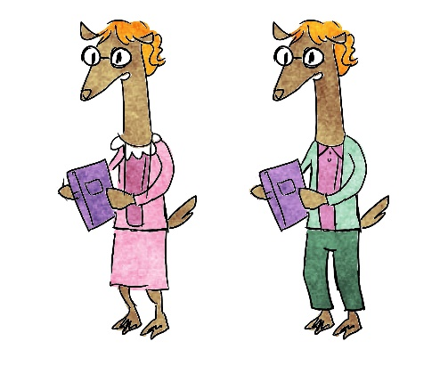
THE LIBRARIAN – From the Bible - transitioning to male as we speak.

Sara Sweetman Note:
I really like the flow of this outline for sneezes. I think the rolling wagon and Olives sneezing 'help' in the beginning will be fun. I love the discovery of pollen by the characters looking for dust. I would caution to not distract the viewer too much from the learning take away...for example, Ari being too sassy in the beginning about the weight of the wagon who has to pull it or the librarian walking in a pattern. I also don't think you need to go to far into the book learning...I think how the kids discover that dust makes them sneeze and then they go back to field and find pollen has deep enough learning connections without going too much into the structure of the nose. I like the draft song! It is fun and supports the learning.

