Elinor Wonders Why
Interstitial 133i
Mz.Mole Rainbow of Root vegetables
By Jorge Cham and Daniel Whiteson
Mar 11 2020

Follows “Underground Soup”

Elinor, Ari and Olive arrive at Mz. Mole’s house. Hi, Mz. Mole! Hello Kids! Mz. Mole tells them they are just in time to help her pick some veggies from her garden. Follow me! But instead of stepping over to her garden, Mz. Mole opens the door to her house and walks down (Mz. Mole lives in a burrow and the door is flat on the ground). The kids look puzzled but follow her down.
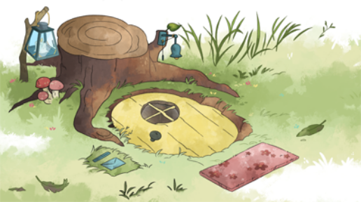

“Why are we going into your house Mz. Mole?” the kids ask as they come down into her kitchen. Your garden is up there! Yes, Mz. Mole tells them, but these veggies grow under the ground. She grabs a ladder and climbs up and pulls something from the ceiling. As she pulls, we cut to a shot above ground of a green leafy plant being pulled down. Schwoop! It disappears. Back underground, we see Mz. Mole holding a radish. The kids are impressed. Wow! Cool. Why does it grow underground, Mz. Mole? Mz. Mole explains: the part we eat is actually the root! There are lots of root veggies. In a simpler animation style, we pan up to a cross section of her garden and do a round up of different root veggies:
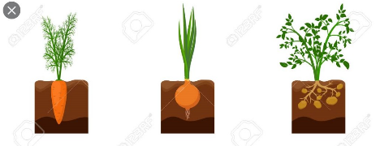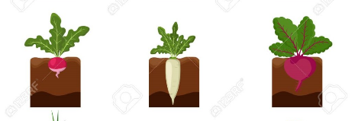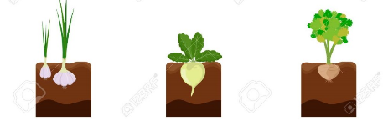
There are onions, radishes, beets, potatoes (Ari: What? Potatoes grow under ground/are roots?? Mind blown), garlic, daikon, rutabagas (Olive: Rutabaga, I like that word!)… and of course.. carrots!

On the last one, Mz. Mole pulls a purple carrot from her roof. Wait a minute, Mz. Mole, that’s not a carrot! Carrots are orange. Ah, Mz. Mole explains, carrots actually grow in different colors: purple, yellow, red… The kids are amazed. Yes, says Mz. Mole, root veggies can be really colorful. She points to her table, which has a rainbow of root veggies. Wow, it’s like a root veggie rainbow! They look delicious!



