EWW interstitial following ep. 131
Ms. Mole Storytime
Ants Share Food
Robert Kalinowski

Follows: ep 131A

131A/B MM: All about how ants share food by barfing into each other mouths. (If time/room, also other ways that ants share food, like honeypot ants).

Curriculum: the kids observe bumping their faces together and wonder what it means. They learn that ants share food, that ants live in a big cooperative group (a colony,) and that ants must share food for the colony to survive. They also learn about some different ways that different kinds of ants share food.

LS1. Understand that ants share food with one another.
LS2. Understand that ants live in large, communal groups called colonies.
LS3. Understand how and why ants in the same colony must share food so that the colony can survive.

D&J top notes: We like this, it’s well done. Overall note is to streamline and simplify. Try to minimize the number of things the audience has to absorb. We suggest cutting the ant specialization and expanding into honeypots etc. Focus on (i) there are lots of ants in a colony (ii) they share food by barfing into each others mouths. That leaves time for the interstitial to breathe, and for the kids in the class to ask questions and react etc.

    - Intro scene where kids are looking closely at two ants interacting with one another. What are they doing..? A magnifying glass zooms in so that we can see in detail that the ants appear to be talking closely..? Or kissing..? 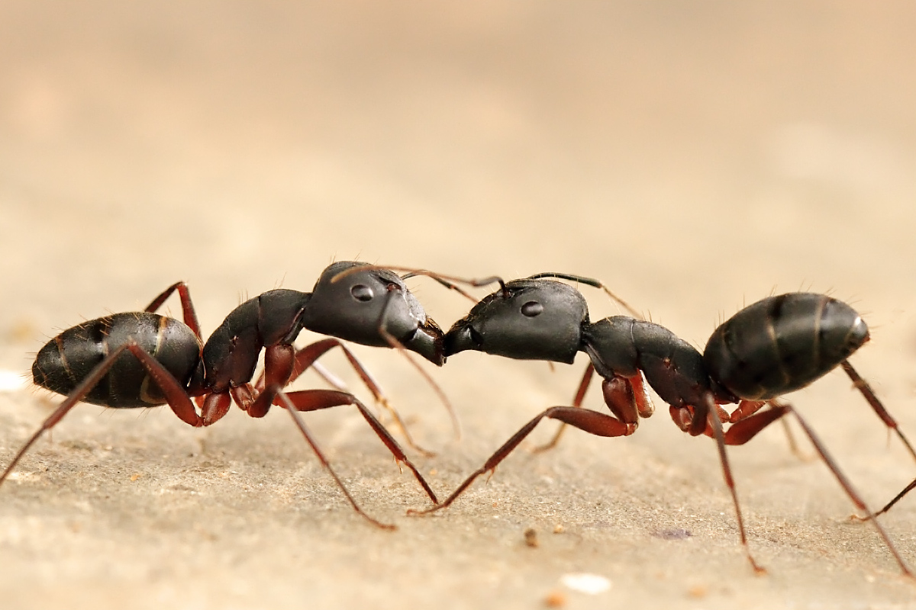
    - Ms. Mole shows up with a pop-up book all about how ants share food. She explains that no ant lives alone -- they all live in big groups called colonies. In the book, we see one ant, then zoom out to see a few, and then zoom out further to see a whole bunch of ants of different shapes and sizes in a big ants’ nest.
    - A series of page flips shows different kinds of ants in the same colony - some are big adults with big jaws exploring the territory outside, others are larvae tucked away in the nest, and one is the queen at the very center of the next. 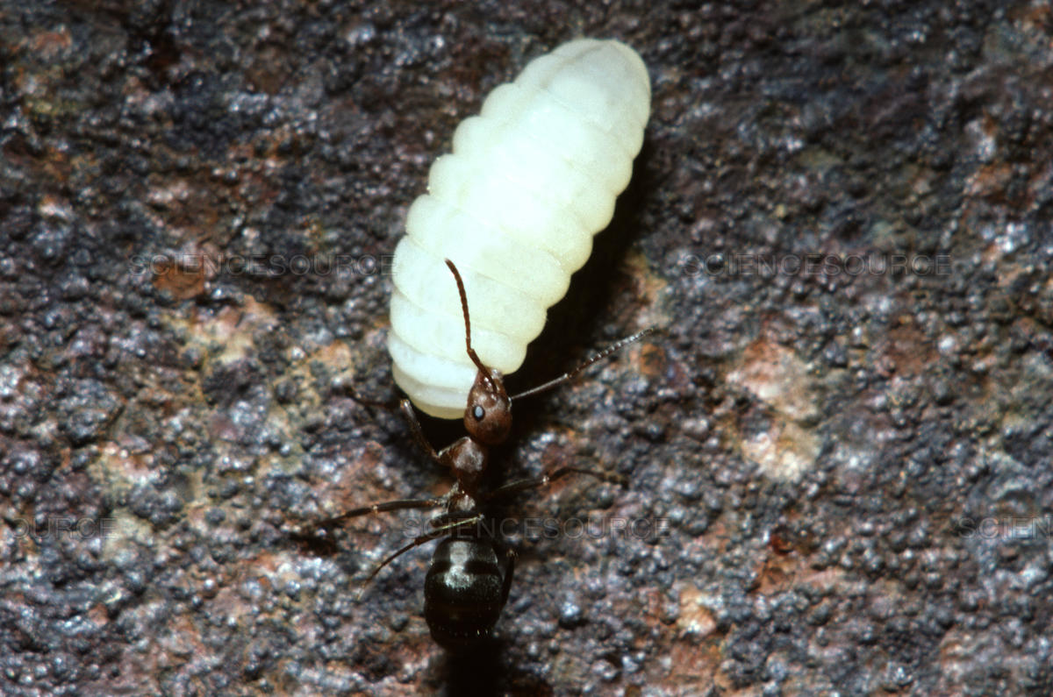(Adult fire ant worker shown with larva)
    - Not all ants can go outside to gather food. Different ants do different jobs, and only some go out to gather food. These ants come back to the nest and share that food. We see an image of food sharing in the book. “But why does it look like they’re kissing!?” says one kid “Noooo! They’re having a fight!” says another. Ms. Mole explains that that’s how ants share food! They don’t have hands or grocery bags, but they do have crops (spaces inside the body) to store food, and they can pass that food along with their mouths!
    - Ms. Mole adds that different kinds of ants share food in different ways. There’s the leaf cutters, where some ants cut down plants and others use it to grow their food; and there’s the honeypot ants, where ants store extra food in their big big abdomens as honey! We see the remarkable picture of a honeypot ant with a full abdomen. “Woah you can see right through it!” says a kid. 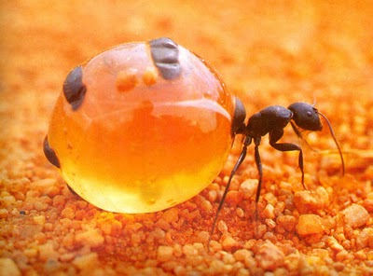(
(A full honeypot ant)
    - Postscript: One kid says to a friend, “hey, you want a bite of my granola bar??” in a muffled voice while holding it in his mouth. MM exclaims, “now now! We use our hands!!”

