EWW interstitial following ep. 131
Ms. Mole Storytime
Ants Share Food
Robert Kalinowski

Follows: ep 131A Olive’s Library

Curriculum: the kids learn about the Honeypot Ant, an ant which stores up food when food is plentiful in the form of honey in their abdomens, and then shares the stored honey when food is scarce.

LS1. Understand that in some environments, food is sometimes plentiful and sometimes scarce.
LS2. Understand that ants live in large, communal groups called colonies, with different ants performing different functions.
LS3. Understand that certain individuals in a Honeypot Ant colony store up food as honey in their bodies when food is plentiful, so that they can share it later when food is scarce.

Overall note: very fun, nice work. Try to simplify further and remove unnecessary elements to deliver the message: honeypot ants store food for later, inside their bodies. We don’t need to know about the change of seasons or dry environments. Just storing food for later is enough. The preserved cherries is a nice analogy.

    - Intro scene: Olive has brought a jar of preserved cherries to share with the class. Ari hasn’t seen cherries in a long time! Olive explains that she picked them last summer with her dad, and they preserved them to share later.
    - Ms. Mole comments that ants store up food and share it later too. The kids are curious and gather around her as she opens up her pop-up book.
    - Ms. Mole explains that in dry environments, ants sometimes have food around that they can collect, but sometimes there isn’t much food around at all. “Like how there’s cherries in the summer, but now there aren’t any..?” offers Olive. The book illustrates with a landscape that at once is colored in with green foliage, birds, and bugs, and then suddenly is very brown and dry.
    - When times are good, the ants collect as much as they can, and some of the worker ants start to store up all this food in their special ant bellies, called “abdomens.” We see a parade of worker ants carry food to the hero ant, and the hero ant gradually transforms from a completely normal looking ant, to swelling bigger, bigger, bigger into the classic honeypot ant shape (see image.) Our hero is so full, she can’t even move!
    - Ms. Mole comments, “here’s a honeypot ant, just full of honey!” Elinor says that she thought honey could only come from bees. Ms. Mole answers, “excellent observation, Elinor! The honey we eat is from bees, but all kinds of insects make honey for themselves, including the Honeypot Ant.”
    - As times get tough and the desert gets dry and brown, there isn’t much food around, so the whole ant colony turns to the ants storing the honey, and these ants share around to the whole group! (We see our hero ant gradually shrink, shrink, shrink back to size! And then she can walk off.) The honeypot ants store up and then share food, and that’s how they get through tough times.
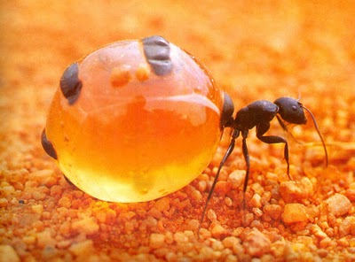
(A full honeypot ant)
    - Postscript: Olive says, “and we jar cherries in the summer, and that’s how we can all share cherries now!” MM: “Let’s eat!”

