ELINOR WONDERS WHY
“The Syrup Tree”
PREMISE – 3/11/2019

Elinor’s Question: Why do trees make sap?
Logline: The kids learn what tree sap is and help Farmer Bear make enough maple syrup for Pancake Sunday.

Curriculum Goals:
LS2b Understand that animals have different body parts that are used in different ways to meet their needs, and that plants have different parts that help them survive and grow. (b) Identify the basic parts of plants and their function. [ The kids learn that trees use sap to move stuff around inside.]
ET1b Define a simple problem that can be solved through the design of a new or improved tool or technology [ The kids design an improved delivery system ]
ND3. (RTL Crosscutting concept ‘Structure and Function’): Understand that structures and materials in the natural world can be used or can inspire the engineering of structures with similar function in the designed world. [ The kids use the branching-tree structure as inspiration for the branching-stream sap delivery system.]
SEP: TBD at outline

The kids are visiting Farmer Bear, this time watching as she prepares to make some of her famous maple syrup. She has a lot of orders to fill today, so the kids decide to help her. They follow her into her grove of maple trees, and are amazed as Farmer Bear taps the trees and captures the tree sap in a bucket. They ask her what that goopy stuff is, and Farmer Bear explains that’s tree sap, which is like tree juice. Elinor is amazed: why do trees have tree juice inside? The kids suggest some ideas: did the trees eat a bunch of fruits to get this juice? Someone suggests that maybe it’s like how animals have blood, to move stuff around their bodies. Farmer Bear says that’s right: trees use the sap to take the water and food from the roots and deliver it to the branches and leaves. The kids are fascinated because they never thought about what’s inside of trees before (we will show with a visual)
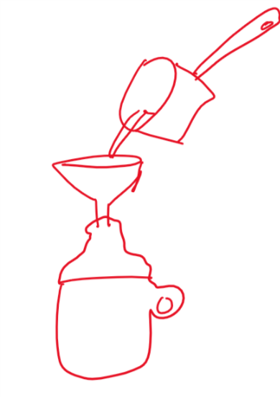

Later, Farmer Bear shows them how maple syrup is made: by boiling the tree sap until it’s syrupy and then pouring it into bottles. There’s one problem though, she only has one ladle, which makes pouring the thick syrup into all the bottle for the big order really slow. Unfortunately, she won’t be able to deliver all these bottles in time for Sunday breakfast, which is when most the town residents like to eat pancakes with syrup!

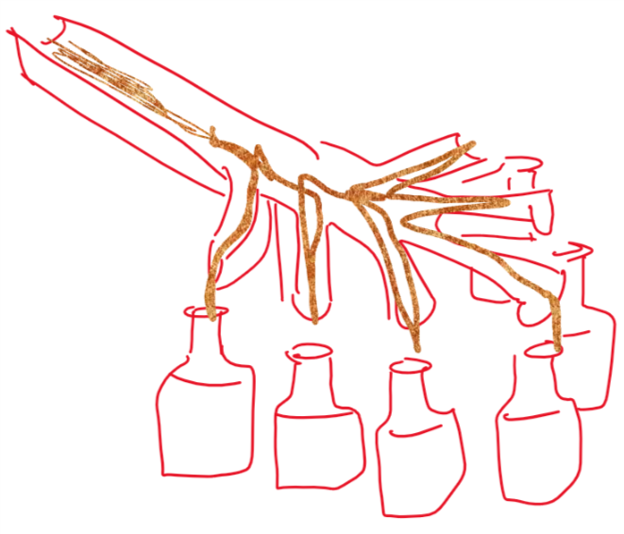
Elinor and her friends try to think of a solution. Elinor thinks back at the idea of the tree sap delivering the water and food to all the different branches and she has an idea! She runs off and after a few moments comes back with Sally Beaver. The kids confer with Sally Beaver and she agrees to help them. They take some old branches and wood and Sally Beaver whips up a delivery system for the maple syrup:

Having multiplied her production capacity, Farmer Bear now feels confident she’ll be able to deliver all the maple syrup in time. Phew, they saved Pancake Sunday!

Sara Sweetman Notes:
I like the idea of exploring that trees make syrup. One of the lessons we often do in New England with preschoolers is to teach that tree that might "look dead" in the winter are really still busy with life on the inside. Many preschoolers think the trees die in the fall and came back to life in the spring. I am thinking about how the "solution" connects to the learning. The solution is to have multiple pathways for the syrup to flow. I think their might need to be more discover opportunities earlier in the script so that the solution idea is built up in the viewer before presented by the characters.

