ELINOR WONDERS WHY
“The Syrup Tree”
Outline Apr 7 2019
By Jorge Cham and Daniel Whiteson

Elinor’s Question: Why do trees make sap?
Logline: The kids learn what tree sap is and help Farmer Bear make enough maple syrup for Pancake Day.

Curriculum Goals:
LS2b Understand that animals have different body parts that are used in different ways to meet their needs, and that plants have different parts that help them survive and grow. (b) Identify the basic parts of plants and their function. [ The kids learn that trees use sap to move stuff around inside.]
ET1b Define a simple problem that can be solved through the design of a new or improved tool or technology [ The kids design an improved delivery system ]
ND3. (RTL Crosscutting concept ‘Structure and Function’): Understand that structures and materials in the natural world can be used or can inspire the engineering of structures with similar function in the designed world. [ The kids use the branching-tree structure as inspiration for the branching-stream sap delivery system.]
SEP1d: Identify a problem that can be solved by the design a new or improved object or tool [ Need a new pouring system for the syrup. ]

1. EXT FOREST - DAY

It’s a late winter day, and Elinor, Ari and Olive are walking through the forest with Ranger Rabbit. They are talking excitedly about eating pancakes at Farmer Bear’s farm for Pancake Day.

Elinor says: “I can’t wait! I looove pancakes.” Olive says she’s going to eat a stack of pancakes THIS high (using her trunk); maybe we see a thought bubble. Ari counters that he’s going to eat a stack THIS high (flying up to show a ridiculously high stack). Elinor says she’s only going to eat one pancake… to start with! They all giggle.

Ranger Rabbit reminds them not to eat too many or they’ll feel too full. Ari says that Mrs. Gorilla’s pancakes are SOOO good that it’s hard to stop eating them. Olive says: “Especially with Farmer Bear’s Special Maple Syrup!” It’s the best! They all lick their lips and pat their bellies as they share a joint thought bubble of a tall stack dripping with syrup.

2. EXT FARMER BEAR’S FARM - DAY

The kids and Ranger Rabbit arrive at the farm. There are a few families already gathered around some picnic tables decorated with tablecloths. Mrs. Gorilla is off to one side, mixing things to make the pancakes. Ranger Rabbit says hello to Mrs. Beaver and they go off to the side to talk.

The kids say hi to Sally Beaver. Is she as excited about Pancake Day as they are? Of course! Ari looks around and comments he wishes he had a chair to sit down on. Sally Beaver says, “No problem!” She grabs a nearby log, and, using her beaver teeth and some tools she had in her pockets, she whips up a little stool for Ari in seconds. Wow! The kids are amazed at Sally! Sally shyly demurs: us beavers are good at building things.

Just then, Farmer Bear walks up. Hello, Farmer Bear! She welcomes the kids and interacts with them. Ari tells her how many pancakes he plans to eat. “Ho ho!” she says, “Mrs. Gorilla definitely makes the best pancakes.” Farmer Bear tells them they’ll get started soon, but first she needs to go finish making the syrup.

This catches Elinor’s attention. You’re MAKING the syrup? Elinor asks if they can join Farmer Bear and help her. Farmer Bears smiles and says, “Of course!”

3. EXT MAPLE TREE GROVE – SHORTLY AFTER

The kids follow Farmer Bear into her grove of maple trees. Farmer Bear is carrying a bucket and some tools. Elinor realizes she has no idea where maple syrup comes from. Farmer Bear explains that it comes from maple trees, which are all around them. The kids think that means that the tree makes some fruit, like the way orange juice or apple juice come from fruits on orange or apple trees. Farmer Bear smiles and says, “You’ll see.”

As they keep walking, Elinor comments on how tall the trees are. They’re so tall! This makes her have a curious thought: She knows that trees get their water and food from their roots… but how do they get that water and food all the way up to all the branches??

Farmer Bear says that’s an interesting question. Just then she stops and, using a hand drill, drills a hole unto the side of a maple tree, and taps the tree with a spile. Ari says, “Whoa!” After a few beats, tree sap starts dribbling from the spile, and Farmer Bear hangs a bucket underneath to catch the liquid. The kids ask her what that watery stuff is, and Farmer Bear explains that’s maple tree sap, and that’s what they make maple syrup out of. It’s like tree juice that flows around inside the tree. The kids are amazed! Farmer Bear suggests that they taste it, and Ari looks a bit skeptical. “Taste a tree?!” But Elinor tries a sip -- hmmm, it doesn’t taste like much, just a little bit sweet… The other kids try it too.

Elinor asks Farmer Bear why trees have juice inside, and Farmer Bear explains that it’s to carry water and food around inside the tree. Elinor has an ah-ha moment. That’s how the water gets from the roots to the rest of the tree! We see a thought bubble with her visual understanding of this: water droplets moving up a trunk and tracing a path and then splitting out to go to various branches).

Ari asks how tree juice gets turned into syrup? Farmer Bear tells them to follow her and find out!

4. INT BACK OF FARMER BEAR’S BARN - DAY

She leads them over to the back of the barn, where she has two big kettles over some logs. She pours the newly collected tree juice into a kettle and starts the fire, explaining that all you need to do to turn tree juice into syrup is to cook it until it gets thicker and sweeter. She shows them the other kettle that has been cooking for a while, stirring it to show that it’s thicker. “Is that one ready yet?” Olive asks? “Maybe we should taste it to find out?” suggests Ari, slyly.

Farmer Bear tells them that this one took a long time, but is now ready for everyone to enjoy with their pancake. She takes out a ladle and scoops some up (letting them taste it) and starts pouring it slowly into a bottle. We see a long line of empty bottles. Elinor asks: “Do you need to fill up ALL of those bottles?” Farmer Bears says yes, that’s how everyone will get to enjoy the syrup. The kids look at each other a little worried.

Just then, Ranger Rabbit finds them. She tells the group that Mrs. Gorilla has finished the pancakes, and everyone is waiting for the syrup. Farmer Bear gets a little flustered, oh my! I haven’t finished pouring the syrup into all the bottles! Maybe they should eat the pancakes without the syrup?

Pancakes without syrup! What a tragedy! Elinor says “That’s like toast without butter” Olive says that it’s like “a sandwich without the ketchup”. Ari says: “It’s like pickles without the peanut butter!”

The kids try to brainstorm suggestions. Can they help? Farmer Bear says that she only has one ladle and the syrup is a bit hot. Can they dip the bottles into the kettle? Then the sides will get all sticky. Can they tip the kettle over and pour it directly? It’s way too heavy and they might get covered in syrup. Ari: “Hmm, would that really be so bad?”

The bottles are arranged near the kettle, spread out across the floor. Elinor has a flash of inspiration: THOUGHT BUBBLE: we see her thinking about how the water spreads out from the root to all of the branches on the tree, and she superimposes that on the kettle + bottles (kettle=trunk or roots, bottles = leaves).

Elinor says: “I think I have an idea!

She runs off and after a few moments comes back with Sally Beaver. The kids confer with Sally Beaver and she agrees to help them. They take some logs and Sally Beaver whips up a delivery system for the maple syrup:

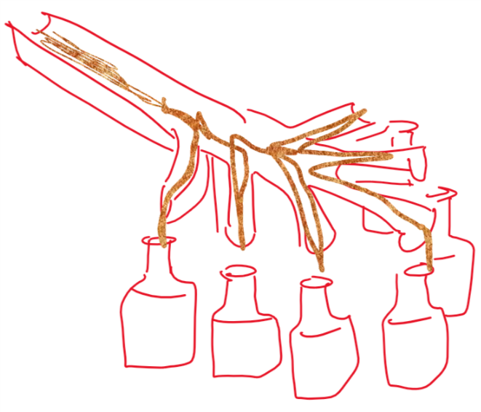

We have a musical montage as they work, with Farmer Bear pouring syrup into the new system, and the kids bringing the bottles there and filling them up. They sing:

Fill the bottles up
Fill them with syrup!
We need a lot
So everyone has enough!

Pour it in the top
And watch it get split up
Just like a tree
It all gets spread about

Fill the bottles up
Fill them with syrup!
We need a lot
So everyone has enough!

At the end of the song, they have filled all the bottles.

5. EXT FARMER BEAR’S FARM - DAY

Having multiplied her production capacity, Farmer Bear now comes out to the gathering with a tray full of syrup bottles, which the kids help distribute. Everyone enjoys pouring the syrup on their pancakes and digs in. Phew, they saved Pancake Day!

Sara Sweetman Notes:

When I was a kindergarten teacher, I loved collecting sap and making maple syrup with them. It never came out great but the process was fun.
Three quick notes:
Elinor " knows that trees get their water and food from their roots… but how do they get that water and food all the way up to all the branches??" but kids viewing may not know that trees take in water and nutrients from the ground. I don't know that needs to be added or focused on..I think it is enough to learn that trees have a system for moving water and sugars around to all parts of the tree. This is a strange phenomenon because the tree is so still (not moving) on the outside but on the inside stuff is happening.,,,weird.
I like that the beginning sets up Sally skills at building with wood. I think it will be important for Elinor to share her idea clearly making a connection between what she learned about how liquid moves in a tree and using that to move it to the bottles.
This would be a great episode to pair with the town picnic for developing a sense of water evaporation and thickening liquids.

