ELINOR WONDERS WHY
“The Pokey Plant”
OUTLINE – 3/25/2019
By Daniel Whiteson and Jorge Cham

Elinor’s Question: Why do cactuses have pokey spikes?
Logline: Elinor brings home a cactus and learns what makes it cool.

Curriculum Goals:
LS1a; Identify and describe the physical characteristics of a variety of animals and plants [ they note how the cactus looks different from other plants]
LS2d: Explore how different external features of an animal help it survive in its environment [ a cactus has thorns to protect its water ]
SEP3b: Compare and contrast objects and events by describing similarities and differences in detail [ they compare the cactus to other plants]
SEP4a: Collect, describe, and record observations in greater detail and in various ways [ they make a list of similariteies and differences between cacti and other plants]
SEP6a: Use background knowledge experiences, and data to construct reasonable explanations and
theories of natural phenomena (science) [ they use what they learned and know to explain why cacti have thorns]

NOTE: Both “cacti” and “cactuses” are correct plural forms of “cactus.”

- EXT SCHOOL – DAY

Open on Elinor approaching school. She’s in a VERY good mood, and stops to sniff several flowers. It’s clear that she LOVES plants. She stops to look at all the different shape leaves and branches.

She runs into Olive and Ari who are also coming to school. Elinor reminds them that today is not just another day at school. It’s PLANT DAY! They had forgotten, but now they are also excited. They are each going to get their OWN plant to take care of at home. Elinor is excited because she LOVES PLANTS!

Elinor says that she helps her dad take care of plants at home, but she’s really excited to get her OWN plant. She’s going to be SO RESPONSIBLE and take care of it all by herself. She knows that if the plant gets everything it needs, it might even make a flower! We see a thought bubble of the plant she is imagining: leafy with a colorful flower.

Ari says that he wants a hanging plant, which would be perfect for his room since he sleeps upside down. Olive wants something colorful and with big leaves.

It’s time for school, so they go in, full of excitement and anticipation.

- INT CLASSROOM – DAY

We hear Mz. Mole call them in, and they bustle excitedly into class. Pan over to Mz. Mole’s desk, which is covered in plants of all different varieties.

We hear Mz. Mole telling them to settle down but we still don’t see her. The kids ask, “Mz. Mole, where are you? Finally, she parts the plants and we can see that she’s been hidden by all the leafiness.

She tells the kids more about Plant Day. They are each going to take a plant home and take care of it. In a few weeks, she wants each of them to tell the class how it went and what they learned! Some kids ask basic questions about taking care of plants: do we have to read to it? Do we have to take it for walks? Do they play games?

Mz. Mole tells them that mostly plants just need light and water, but that each one is different. She shows them that each plant has a small instruction sheet (On a string attached to the pot) with all the details they will need.

Mz. Mole tells the kids to line up. They are all very excited and talking about what kind of plant they are going to get. Elinor is in line behind Koa, Ari, and Olive, and there are several kids behind her.

Mz. Mole has the plants in lines on her desk and she hands them out to the kids in order. Koa gets a really droopy plant. “It’s totally chill.” Ari gets a hanging plant just like he wanted. Yahoo! Olive gets a red-leafed poinsettia. Perfect! They are all very happy.
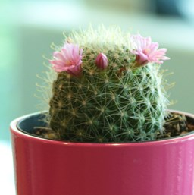
Next, Elinor gets to the front of the line. With her thought bubble showing the plant that she’s expecting, she eagerly waits to get her plant from Mz. Mole. Finally, Mz. Mole hands her a pot: it’s a Rosy Pincushion Cactus [see image, but without flowers].

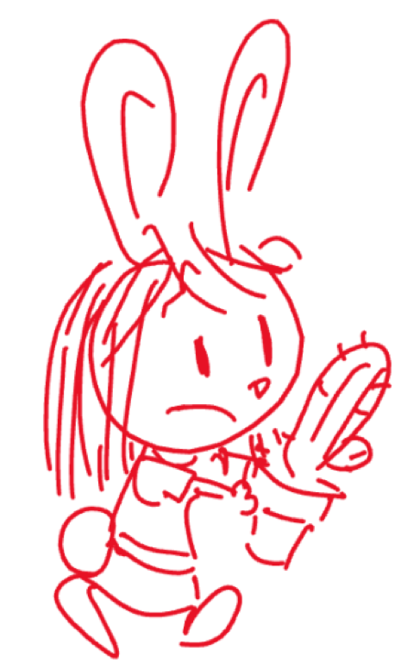
Elinor is confused at first. We see her compare the cactus with the plant in her thought bubble. It doesn’t look anything like what she was expecting!

- EXT. PLAYGROUND – DAY

A short time later, Mz. Mole leads the kids outside so they can all get familiar with their plants.

Olive and Ari catch up to Elinor with their plants. Olive says she got a plant with big red leaves, just like she wanted! Ari says he got a hanging plant, which he’ll hang next to his bed and look at while he’s hanging upside down, which means the plant will… look right side up? He’s confused. Elinor looks at Olive and Ari’s plants. They both look like regular leafy plants. Ari’s plant even has a flower bud already. She’s starting to feel a tiny bit disappointed.

Ari is still trying to figure out the upside down/rightside up situation, when he accidentally backs up into Elinor’s plant. Yow! It’s pokey! Elinor shows them what she got: a cactus. She thought she was going to get a plant and instead she got a cactus!

Olive tells Elinor that it IS a plant! Cactuses are plants. She learned that from her Nature Book. Ari is blown away: Cactuses are plants?? Elinor is also blown away: This is a plant? That is SO interesting! She has so many questions now: But why does it looks so different? Why doesn’t it have any leaves? And why does it have pokey spikes?

Olive looks at the instructions for Elinor’s plant, and reads that the cactus only needs to be watered once a week. This amazes the kids. They compare that to Olive and Ari’s plants, both of which need to be watered every day. Elinor is even more intrigued. This plant is so mysterious. Let’s see if we can answer all these questions. We need more observations!

The kids run out into the school yard.

- EXT. FOREST - DAY

The kids set the cactus down in a spot near the edge of the playground and stand back to observe it, with the other two plants nearby. They recap the mystery: why do cactuses look so different, and why do they have pokey spikes? They decide to observe it carefully, and make a list of the ways cactuses are the same and different from other plants. Olive opens her notepad, and she draws a doodle of the cactus and a doodle of a generic leafy plant at the top of the page. The kids list the similarities, and Olive draws them underneath in the center of the page: they are both green (she draws a patch of green), and both need sun and they both sit in soil (she draws a doodle of a sun and some soil). Ok, now to list the differences. She flips to a new page, and doodles the cactus and a leafy plant again, but this time she draws a big line down the middle, separating the page into two columns. They first write down that the cactus needs less watering, and Olive draws a little water droplet on the cactus side, and a few bigger droplets on the leafy plant side. Then they notice that the cactus is round and thick, while the leafy plants are thin. Olive draws a round shape on the cactus side, and a thin branch on the other side.

Hmmm, the kids think. What could that mean?

Olive wants to know what the cactus feels like, but doesn’t want to get poked. So she picks up a short stick and taps the cactus gently with it. At that moment, Ari, who had decided to sit down, accidentally knocks Olive a little, causing her to poke the cactus a little too hard. Oh no! A dribble of water comes out. The kids think the cactus is ok, and they wonder if that means that the cactus is full of water. Elinor curiously looks at the dribble. That’s it! Says Elinor. Maybe the cactus is thick and round because it’s storing water inside, like a balloon or a water bottle. Maybe that’s why it doesn’t need as much water!

Olive remembers reading something about that in her Nature book. She looks it up and they learn that cactuses grow in the desert, where there isn’t much water. Elinor thinks that would explain why the cactus needs to store water.

But why does it have spikes instead of leaves?

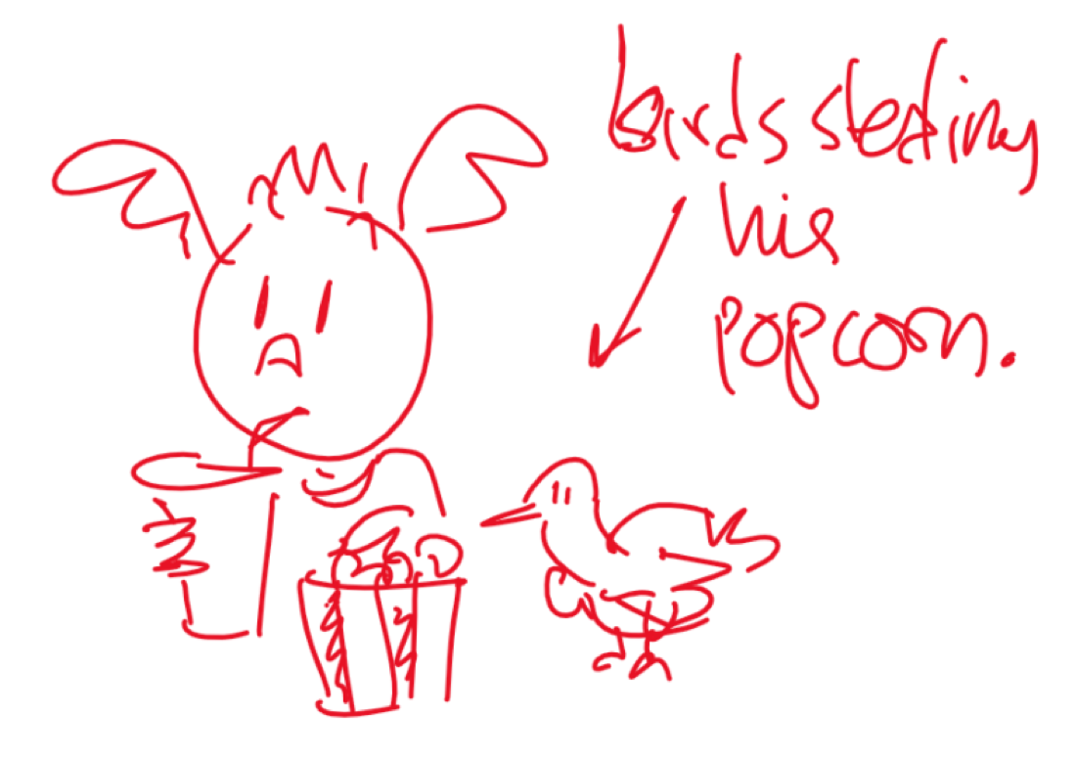
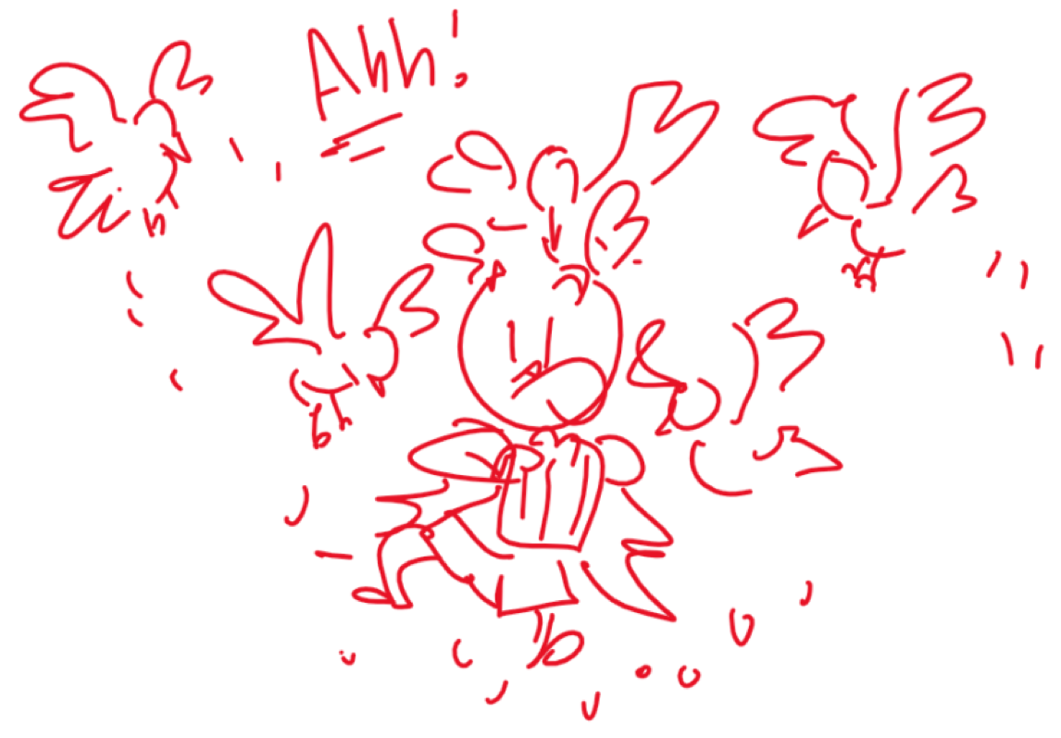
Olive reads on: Because there isn’t a lot of water in the desert, a lot of animals like birds and lizards get thirsty and try to get water from the cactus. Aww, poor animals, thinks Olive. Elinor thinks: poor cactus, what if it doesn’t have enough water to share?

All this talk makes Ari hungry for a snack. He takes out a bag of popcorn and starts munching. A few birds nearby get attracted to the popcorn and land nearby. Ari happily shares a few kernels with the birds, but then more birds show up. One bird hops over and grabs a piece of popcorn. Hey! Ari moves the bag of popcorn away to the other side, but then a bird on that side snags a piece. Ari gets a bit flustered and says: hey birds, I’m sorry but I don’t have enough to share!

He is trying to shoo the birds away in all directions. Elinor watches him and gets an idea. She gets a thought bubble where Ari turns into a cactus and the birds turn into thisty animals. The animals approach the cactus, but then think twice when they get close to the spikes. That’s it! The thorns must keep the animals from drinking the water in the cactus!

They rush to Mz. Mole and explain what they learned. She confirms that cactuses don’t need much water because they are very good at storing the water inside them. But then they need to protect that water with spikes!

Elinor thinks that her cactus is so cool. It’s so clever and different from all the other plants. She sings a little ditty:

Somethings are different
Or not what you thought they’d be
But that’s what makes them special
You just have to listen and see…

A cactus is so cool
It’s not like other plants
It’s round with lots of spikes
ARI: that can poke you in the pants!

Somethings are different
Or not what you thought they’d be
But that’s what makes them special
You just have to listen and see…

Now Elinor is very excited about her cactus and can’t wait to take it home. Gasp! And look! The little buds on top of the cactus have opened up into little pink flowers! Cactuses are the best ever!

At that moment, a few birds have gathered around Ari, looking up at him expectantly. Ari shrugs. He says, “I guess I’m not as cool as a cactus” and starts sharing his popcorn with the birds. On laughter, we pan up and…

THE END

Sara Sweetman Notes:
I like that the kids can compare their plants side by side and really consider if the cactus is even a plant at all. Keeping the content focused on (1) a cactus is a type of plant even though it has no branches or broad leaves (2) that plants have ways to protect themselves, a cactus is really good at protecting itself with its spikes ...is quite a bit of content. I wonder if the characters learn that the spikes are there to protect the cactus (maybe they learn this by observing that animals approach the other two plants but not the cactus, the water inside the plant is a whole other content to learn) ....could inspire the characters to build or design something...to maybe add a little more "doing" of science and engineering to the story.

