ELINOR WONDERS WHY
“The Wind In The Web”
OUTLINE – 3/22/2019

Elinor’s Question: Why are spiderwebs full of holes?

Logline: Elinor and her friends volunteer to help Mr. Raccoon sell his tasty treats, and they learn from Nature that wind will push things, but it can’t push them as hard if they have holes in them.

Curriculum Goals:
LS5b. Identify the habitats of familiar animals and plants in the environment [ Spiders live in spider webs
ND3. (RTL Crosscutting concept ‘Structure and Function’): Understand that structures and materials in the natural world can be used or can inspire the engineering of structures with similar function in the designed world. [They engineer the sign to have wind holes to mimic the spider web].
SEP3b: Compare and contrast objects and events by describing similarities and differences in detail [ They compare the web to the kite and the sign]
SEP7. Engaging in argument from evidence
[ they use the web and kite to explain why the sign blew away and how to fix it]

1. EXT. MAIN FOREST PATH - DAY

It’s a brisk Fall day, and Elinor, Ari and Olive are happily arriving at a special spot in the forest. It’s a small clearing next to the main path that leads into the center of Animal Town. A slight wind is blowing through, kicking up an occasional leaf. The kids comment that they love the fall season and how the leaves change color and fall, and how the weather turns cooler and windier. Olive in particular loves feeling the wind in her face and smelling the cool air. Ari hadn’t thought about it before: wind is air? Yes, says Olive, wind is just air moving!

Just then, the breeze picks up a little, and Ari leans into it, enjoying it like Olive. He opens his arms (and wings) to embrace the wind and… whoa! The wind pushes him back a bit. He leans into it more, but just then a gust blows through and (Whoa! Whoa!) sends him flying and flipping backwards! That wind is pushy, says Ari!

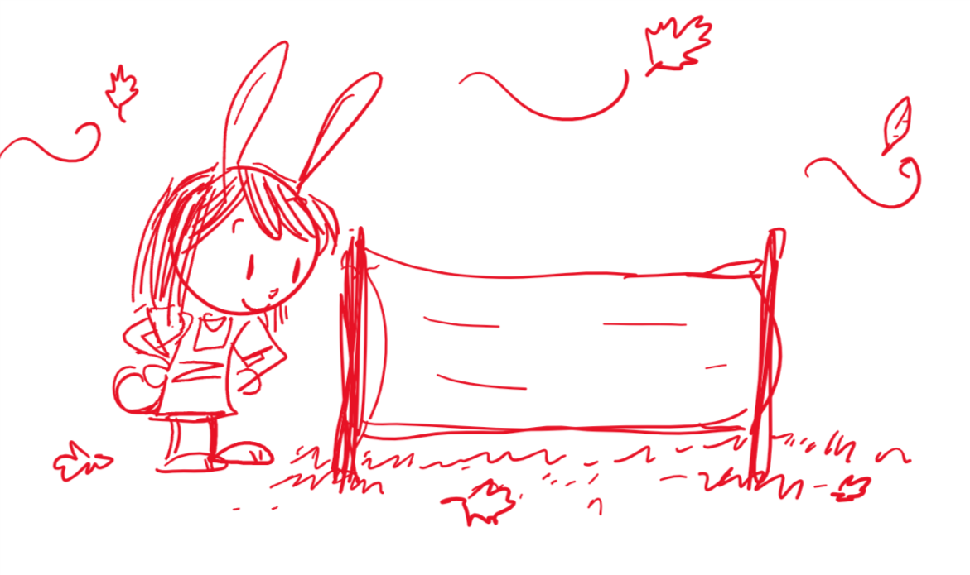
Elinor, who’s been carrying what looks like a rolled-up tarp with two sticks, gets them to focus on the task at hand: They’re here to put up a sign to help Mr. Raccoon tell everyone about the things he’s selling today at the bakery. They unroll the sign, which is a banner with kid drawings of a wedge of soy swiss cheese, some bagels, a pretzel, and a big arrow that will point towards town. Elinor thinks they did a pretty good job, if she says so herself! Everyone is going to want to go try Mr. Raccoon’s soy swiss cheese, bagels and pretzels!

The kids hold up the sign and push the sticks into the ground and look proudly at their work. A passerby walks by and glances at their sign, and the kids form a very enthusiastic tableau showcasing the sign, pointing at it and smiling and nodding for the passerby to check it out. The passerby nods appreciatively and seems convinced to check it out. Yes! The sign is working, the kids think.

As they admire their sign, the wind picks up and the sign flutters. The wind gets stronger and the sign billows and strains. The kids look a bit worried, but after a moment the wind dies down. They sigh in relief, but just then a strong gust comes through and blows the sign out of the ground! Tarp and sticks and all fly off! Oh no! The wind carries the sign out into the forest.

2. EXT. FOREST - DAY

The kids go running to find their sign. They split up, with Ari and Olive going into the trees to look for the sign. Elinor looks around the bushes and finds herself in an area full of fallen leaves. The wind picks up and forms swirls of leaves. Wow! Look at how the wind is pushing the leaves, says Elinor! But then she notices something curious: some of the leaves don’t get pushed by the wind as much. They stay close to the ground and don’t move as much.

She takes a closer look. When she looks closer, she notices that these leaves are older and have lots of holes in them. Hmmm… She thinks. Just then, Ari and Olive come back with the sign. They found it!

The kids walk back to their original spot. On the way, they wonder out loud what to do. It’s so windy they are worried if they just put the sign back it will blow away again. Then people won’t know about Mr. Raccoon’s special treats!

3. EXT. FOREST PATH - DAY

They get back to their spot and think about what to do about their sign. They have some ideas: They could put some branches in front of it, so that the wind doesn’t push it. But then that would block the sign. Maybe they should use some rocks to hold it down? But then they would have to lay the sign flat, and nobody would see it.

Just then, something catches Elinor’s eye. It’s a spider hanging from a thread. The spider climbs up and Elinor follows it to a spider’s web stretched across two branches. Whoa! It’s a spiderweb! We need more observations! The other kids gather around and they examine the web. It’s so cool! Suddenly, the wind picks up again, blowing leaves around them. Elinor notices that the spider’s web is only being affected a little bit by the wind. We see leaves blowing through the air to show the wind, but the web only moves a little. That is so interesting!

She points it out to her friends and they are impressed. They compare the web to their sign and notice that the spider’s web has LOTS of holes in it. Elinor remembers the leaves from earlier, and how they didn’t get pushed by the wind as much when they had holes in it. That’s it!

The wind pushes things, unless there are holes in it, like the spider’s web or the leaves! Elinor has an ah-ha moment. What if they put holes in their sign ON PURPOSE! Olive is shocked by this idea: holes in their sign? Elinor asks for Olive’s scissors from her satchel, and she describes more what she means: just a few holes so that the sign can be more like the spiderweb or the leaves and not get pushed as much by the wind. And she knows just where to put the holes…

The kids get to work on their sign. While they work, they sing a song to summarize what they have learned:

Woosh! Woosh!
The wind goes woosh!
Woosh! Woosh!
The wind can push!

The leaves and sign
Both got pushed
The wind blew them
Woosh woosh woosh!

The spiders web
Didn’t move
The wind went through
Nice and smooth

If we add some holes
Here and there
Our sign won’t go
Anywhere

Woosh! Woosh!
The wind goes woosh!
Woosh! Woosh!
The wind can push!

At the end of the song, the kids stand in front of their sign, admiring their work. The camera reveals where they put the holes: in the holes of the soy swiss cheese, the holes of the bagels, and the holes of the pretzel (as well as a few decorative holes around the edges).

Ari is a bit skeptical as the wind starts to blow. But the kids work together and set up the sign. A big gust comes through and the kids are pretty worried… but the sign shakes a bit and doesn’t blow away! It worked! Ari is very impressed and shows off the sign to some passing animals. Mr. Raccoon is going to be so happy!

4. INT. MR. RACCOON’S BAKERY - LATER

A cross fade later, the kids are now in Mr. Raccoon’s bakery. Customers are walking in from the windy outside. Mr. Raccoon tells them that everyone wants the new treats, and they all mention seeing the sign the kids made. Well, done! The kids tell Mr. Raccoon how they got the sign to stay: they made holes in it, just like the leaves and the spiderweb. That’s very clever, says Mr. Raccoon, the holes probably help the wind get through and not push the sign. He holds up a pretzel and blows through it at Olive. Ari agrees. He holds up a bagel and, looking through it, says that makes a “hole” lot of sense! On laughter, we…

END

Sara Sweetman Notes:
Great outline! I like Ari saying that the wind can be pushy.

For clear making meaning...The kids might notice the wind pushes things like leaves & their sign and if the object is going to stay in place the wind needs to go around (buildings/ trees) or through the objects (spiderwebs). It didn’t work to go around the sign now the holes let the wind go through it.
Fun!

