ELINOR WONDERS WHY
Super Snow Friends
OUTLINE – March 2nd, 2019
By Katherine Sandford

Elinor’s Question: How can I make the snow stickier?
Logline: Elinor and her friends want to build “snow-friends” but the snow isn’t sticky enough.
ES1. Understand that the Earth is made up of a variety of natural materials. a. Explore and describe the characteristics of earth materials such as sand, rocks, soil, water, and air b. Explore water and other Earth materials during play using simple tools. (Elinor and her friends explore the characteristics of snow and water.)
SEP6. Constructing explanations (science) and Designing Solutions (engineering) a. Use background knowledge experiences, and data to construct reasonable explanations and theories of natural phenomena (science) b. Look for and describe patterns and relationships in natural phenomena (science) c. Use and apply productive science discourse to support an explanation d. Use evidence to support a theory or solution to a problem (engineering) (Elinor knows that the weather has gotten colder (from the temperature), and she and her friends figure out this means the snow has less water in it, and theorize that adding water will make it stickier.)

[J&D:
Ok, let’s talk about the weather!

There’s lots of fun here, and a lot of pieces to juggle, so kudos for that. Our general feeling is that this version is a bit complicated, in terms of what we’re asking kids to observe and piece together logically all at once. There’s a lot going on in the aha moment: warmer means melted snow; yesterday was warmer than today; colder means drier snow; drier snow doesn’t pack as well; adding water makes it pack better.

Our suggestion is to take out the idea of mixing in water, since it’s somewhat orthogonal to (or rather a few steps down the logic line from) the lesson that “weather changes the snow”. It would make things more streamlined if the solution the kids find to their problem was closer or more aligned to the core lesson.

Recommendations:
- Move the snow play venue close or adjacent to one of the kids’ houses, so they don’t have to go far to get inside.
- Let’s take out the plot elements of the wet mittens, and maybe also the thermometer (do kids today read physical thermometers anymore?).
- Instead, the kids have to figure out on the second day that the reason the snow isn’t packable today is that yesterday’s was a little melted because it was warmer then. Then we don’t have to talk about water or water content at all: slightly melted snow is just easier to pack because it’s goopier/slushier.
- The kids could learn this lesson, for example, when they come into the house after giving up trying to pack loose snow. They could observe that some of the snow they brought in accidentally melted and became slushier.
- This gives Elinor an idea that sounds a bit crazy but makes sense from a kid perspective: Let’s warm up the snow! They take little play buckets and form a little production line where they bring snow into the house for a bit (next to the fire) and then bring it out to finish their project:
- 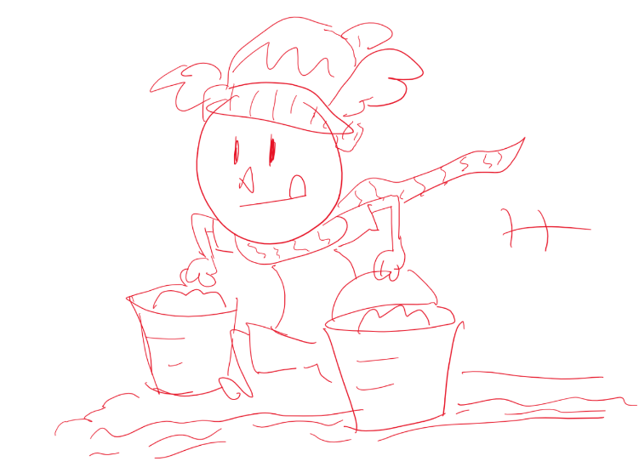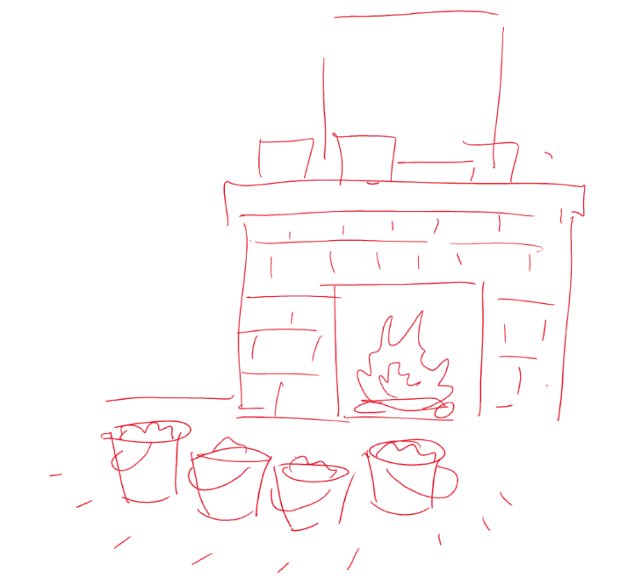
- Then it’s all part of the same lesson: warmer temperature melts snow.

Detailed suggestions below. Thanks!
]

1.EXT. PARK ACROSS FROM OLIVE’S -- DAY
It’s a sunny, mild winter day and a bunch of kids (SALLY, MARY, LIZZIE, and ROLIE) are in the park having a blast building with the sticky snow! They’re making all kinds of snow things – snow forts, snow slides, and lots and lots of snow-balls.
ELINOR, ARI and OLIVE rush up. Wow! Look at all the snow-building! Ari is super impressed at the things their friends have already made. Olive picks up some snow with her trunk and forms a little snow-ball. (Turns out Olive is really good at sculpting snow with her trunk – she has soo many talents!) “No wonder the snow-building is going so well,” she smiles. “The snow seems extra-sticky today!”
“Yup, it sure is…whoa!” says Elinor, as she accidentally rolls a snowball right into Ari. Whoops! He does a little flip and Elinor apologizes, the snowball got so big so fast it just got away from her. Then she demo’s her snow-ball rolling technique. “See how the ball picks up snow on its own when you roll it around!” Cool!
Olive watches, amazed but Ari has already started rolling his own snowball. “Wait, before it gets too big, lets put your little snow ball up on top of my big snow-ball.”
They lift it up – yay! A snow friend! Olive laughs as she notices the little lump on the front of the snowball looks like Elinor’s nose and Elinor realizes, <GASP!> That’s it! She’ll make a snow-friend that looks just like her! Olive and Ari are in! They want to make their own snow friends too.
So they get to work rolling the snowballs together. But after a beat or two Elinor notices that her mitts are getting wet (as are Ari’s and Olives). She considers taking them off, as the weather is so warm. “Yeah, but your hands won’t stay warm if you’re touching the snow,” warns Olive so Elinor decides to keep her wet mitts on.
The kids soon forget their wet hands because now comes the fun part. They start decorating their Snow Friends to look just like them: a snow-bat with wings and fangs, a snow rabbit with a cute nose and bunny-ears, and a snow elephant with big ears and a trunk! It’s going awesomely as the snow is a little slushy and really easy to work with.
As they work a couple of the other kids stop by to notice what they’re doing, “Wow! Snow Friends! What a GREAT idea!” “Elinor, that snow bunny looks JUST like you.” “Well, she will,” says Elinor, “Once I make her other ear.” “I wish I had a snow friend,” says Mary a little wistfully before her sister pulls her back to the snow slide.
But just as their friends run off, Elinor notices a problem. They’re running out of snow and their snow friends aren’t finished. Elinor needs snow for ears, Ari needs snow for his fangs – that’s my best feature! Olive needs snow for a trunk. Ari is particularly disappointed, he looks around and wishes they’d got to the park sooner because the snow got all used up with other projects! He gestures and we see there’s not much snow left and there are grassy bare patches poking through.
Ugh! We NEED MORE SNOW, moans Ari and Olive sensibly reminds him that they’ll probably get more soon, as it is winter. “We just have to wait for it to start snowing.” They wait for a beat, Ari anxiously watching the sky. “No snow yet.” Another beat. Still no snow.
At that moment Olive’s Mom calls her in for dinner. Elinor says she’d better go too, but Ari doesn’t want to leave. “What about our snow friends? My snow-bat is FANG-LESS!” Elinor and Olive promise Ari they’ll meet back in the park tomorrow to finish them. “First thing in the morning?” says Ari. “Sure, IF there’s more snow.”
2.EXT. ELINOR’S HOUSE – LATE AFTERNOON
Ranger Rabbit holds open the door as Elinor hops up. “Did you have fun at the park, sweetie?” Elinor says she sure did, the snow was really sticky and easy to build with, so they made Snow Friends! Nice! Only she got her mitts a little wet, and her boots wet, and her scarf and her coat. “Well that happens when the warm weather melts the snow,” says Ranger Rabbit pointing to a nearby thermometer.
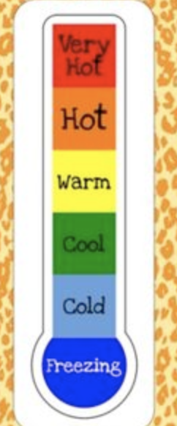
“Ohh, right” says Elinor, she knows how a thermometer works - when the line is up high in the yellow area, the weather is warm, and when the line goes down into the blue part, it means the temperature outside is getting colder.” That’s right, says Ranger Rabbit, now hop inside and we’ll get you out of your wet clothes.
STAY ON: the thermometer, the mercury starts to drop as the sun sets behind it, and then it starts to snow. Then the sun comes up.

3.INT. ELINOR’S ROOM – THE NEXT MORNING
Elinor bounds out of bed and hops to the window. YES!! A blanket of FRESH NEW SNOW! Yes! Now she, Olive and Ari and can finish their snow friends!
4.INT. KITCHEN – MORNING
Elinor is wolfing down her breakfast. “What’s the rush?” wonders Ranger Rabbit and Elinor explains that she and Olive promised Ari they’d go to the park first thing in the morning!” “Well, we’d better bundle you up,” says Ranger Rabbit as Elinor hops off. “It’s quite a bit colder out there today.”
5.EXT. ELINOR’S HOUSE – MORNING
As Elinor hops out, all bundled up, she stops to look at the thermometer. “ooh, the line has fallen in to the blue part. Mom’s right, the weather is colder.” Off she hops.
6.EXT. PARK – DAY
Elinor rushes to the park where she meets up with Ari and Olive. They are all REALLY excited that there’s so much new snow! And they are there early, before all of their friends. Yes! Let’s get building! But they immediately run into problems.
This NEW snow won’t stay packed at all – it just falls apart. What’s going on – why is this snow so different? We need more observations.
The snow LOOKS basically the same, but as Elinor looks at the snow on her mitt she notices a difference. “Remember yesterday the snow was wet.” “Boy do I”, says Ari. “My mom made me take off all my winter clothes by the door so I wouldn’t drip water all over the house!”
“Well, that’s because the SNOW was wet yesterday,” says Elinor “because the weather was warmer and it melted the snow a little.” But now that it’s colder their mitts stay dry. That’s so interesting!
The kids know they can’t make the weather warmer, but they figure out that maybe if they add water to the snow it may have the same effect. But where to get the water? Olive’s house!
7.EXT. OLIVE’S HOUSE – DAY
Olive goes inside and comes out with a bucket of water. Elinor pours it on the snow – it just melts a big hole. “Oooh, cool hole,” says Ari, “But no sticky snow.” They look at the hole. “Hmmmm,” says Elinor, “maybe that was too much water.”
So Olive disappears inside the house and comes out with a little plant mister. They spray it gently on the snow, but nothing much changes. Olive picks up the snow with her trunk – she’s able to make a tiny snowball, but the rest of the snow just falls away. Hmmm. That’s not enough sticky snow to make a snow friend.
Elinor sensibly says that maybe we need not too much water, not too little water, but a medium amount of water that’s just right! What to use? They ponder and Olive has an idea. She runs into the house and comes out with – a full watering can! Elinor pours the water on the snow and Olive tests it- it works! Adding the right amount of water has made the snow just the right stickiness for packing.
8. EXT. PARK -- DAY
Ari is just lugging another watering can of water to the park as Elinor and Olive are finishing up their snow friends. Ari sprinkles the water on the snow, he takes some slushy snow and finishes up the fangs on his snow-bat. Perfect-o! The kids take a moment to admire their work – yup, you’ve never seen a nicer snow-bat, snow-bunny and snow-elephant with wings, bunny ears and a trunk, all made of snow! We did it!
At that moment Olive looks over, feeling a nearby snowdrift with her trunk. Hmmm, there’s still so much snow to build with. OOOH! Elinor has a GREAT idea, she whispers to her friends. They LOVE it – let’s get BUILDING!
SNOW-BUILDING MONTAGE
Elinor, Ari and Olive dig in and start building, all through this montage we see them sprinkling water, rolling snowballs, piling up snow-men and adding to them, but we don’t see exactly what they are making.
Build with snow,
Build with snow.
Just sprinkle some water
And you’re good to go.
Sprinkle the snow,
Sprinkle the snow.
You can make anything
Building with snow.

Yesterday it was warm,
And the sun shone down bright.
The snow it was slushy
And it stuck just right.
Today it is colder,
The snow didn’t stick.
We added some water
And that did the trick.

Build with snow,
Build with snow,
Just sprinkle some water
And you’re good to go.
Sprinkle the snow,
Sprinkle the snow,
You can make anything
Building with snow.

END MONTAGE:
Whew! That was some super snow fun, and we got everything finished just in time - here come our friends!
ANGLE ON: Sally, Rollie, Mary and Lizzie arrive ready for a day of winter play. “Hey Guys, have you been here long?” “What are you build…WHOOOOAA!” The kids stop dead and their eyes go wide. “Look!”
PAN TO REVEAL: “It’s…US!” And it’s true. They’ve made snow friends of their friends!
TA-DAH! Elinor, Olive and Ari are happy to show off the Snow Beaver, the Snow Armadillo and two pretty Snow Goats! “Aww, they look just like us!” cry the Goat Twins in unison.
But Rollie is a little confused – how did they do it? The snow doesn’t stick today at all. Elinor explains what they learned: a little sprinkle of water, not too much, not too little, will make the snow perfect for building. Her friends are impressed. Now THAT’S a handy winter tip!
“Now we ALL have snow friends,” says Olive happily. “What could be better?” “Oh, I dunno, how about..REAL FRIENDS!!” says Ari as he takes off, “Last one to the slide is a rotten snowball!”
THE END
Sara Sweetman Notes:
I love the idea of the characters building snow friends. I was considering how to make this more earth science (properties of snow as a weather phenomena) focused rather than physical science (water snow mixtures). If Jorge and Daniel are not concerned then I won't be either. Maybe we could just point out how snow is different from water/ rain and that will help focus in on snow as a unique weather feature. I am currently developing a preschool assessment and one of the questions asks the preschoolers "Why does it snow?" and their picture answer choices are "because it is cold out" and " because I wished it would". Many preschoolers still think they can wish for certain weather systems. It might be content enough for the characters running out of snow to try to wish for snow/ do a snow dance and find that still doesn't work so they need to make their own or be patient (waiting for the temperature/ weather system). Consider other earth materials for the "missing parts" while waiting for snow.
This outline also made be think about preschoolers conceptions of a "model". Snow friends are great because they look like them but there are many limitations about what they can do. We want kids to be able to distinguish between the real object and a model..this might be an opportunity to address this.

