EWW Interstitial 122
Mz. Mole Story Time:
Daphnia

Follows: Frozen Fish - When the pond freezes, Elinor and her friends become worried about how the fish who live there can survive the winter. With Farmer Bear's help they learn they're fine, resting in the cold water beneath the ice

Curriculum: The kids learn about Daphnia, the cute little water flea, that lives in ponds that dry up. They have special eggs which dry out and wait until the rains and streams fill the pond back up, only then do they hatch.

LS4. Understand that all animals and plants have a life cycle, can reproduce, and change and grow over time:
LS5. Begin to understand that animals and plants depend on other living things and nonliving things in the environment to meet some of their needs:

- Intro scene. Mz. Mole is leading to the kids on a walk. They stop at a dried up pond. The kids remember visiting the pond (Thought bubble?) They remember seeing all sorts of little bugs in the water. What happened to all the things living in the pond?
- Ms Mole opens her book and tells us about how those little bugs survive by laying special eggs that can get totally dried up and then hatch later when the water comes back! Visuals: We see the little Daphnia make its hard-shelled eggs, and lay them. They all get dried up, and when the water comes back they hatch and grow into adults!
- MM gives them all a drink of water, they feel refreshed. Elinor pours a little water into the dry pond, for the thirsty bugs!

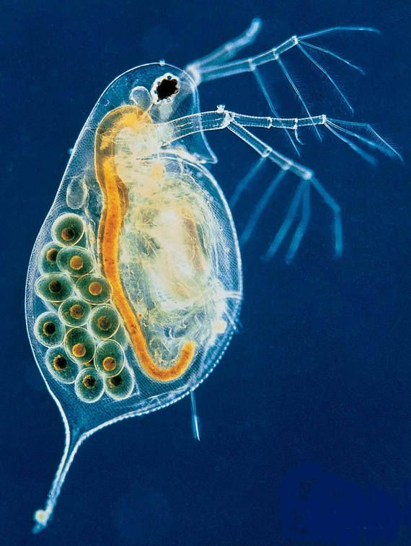
Daphnia

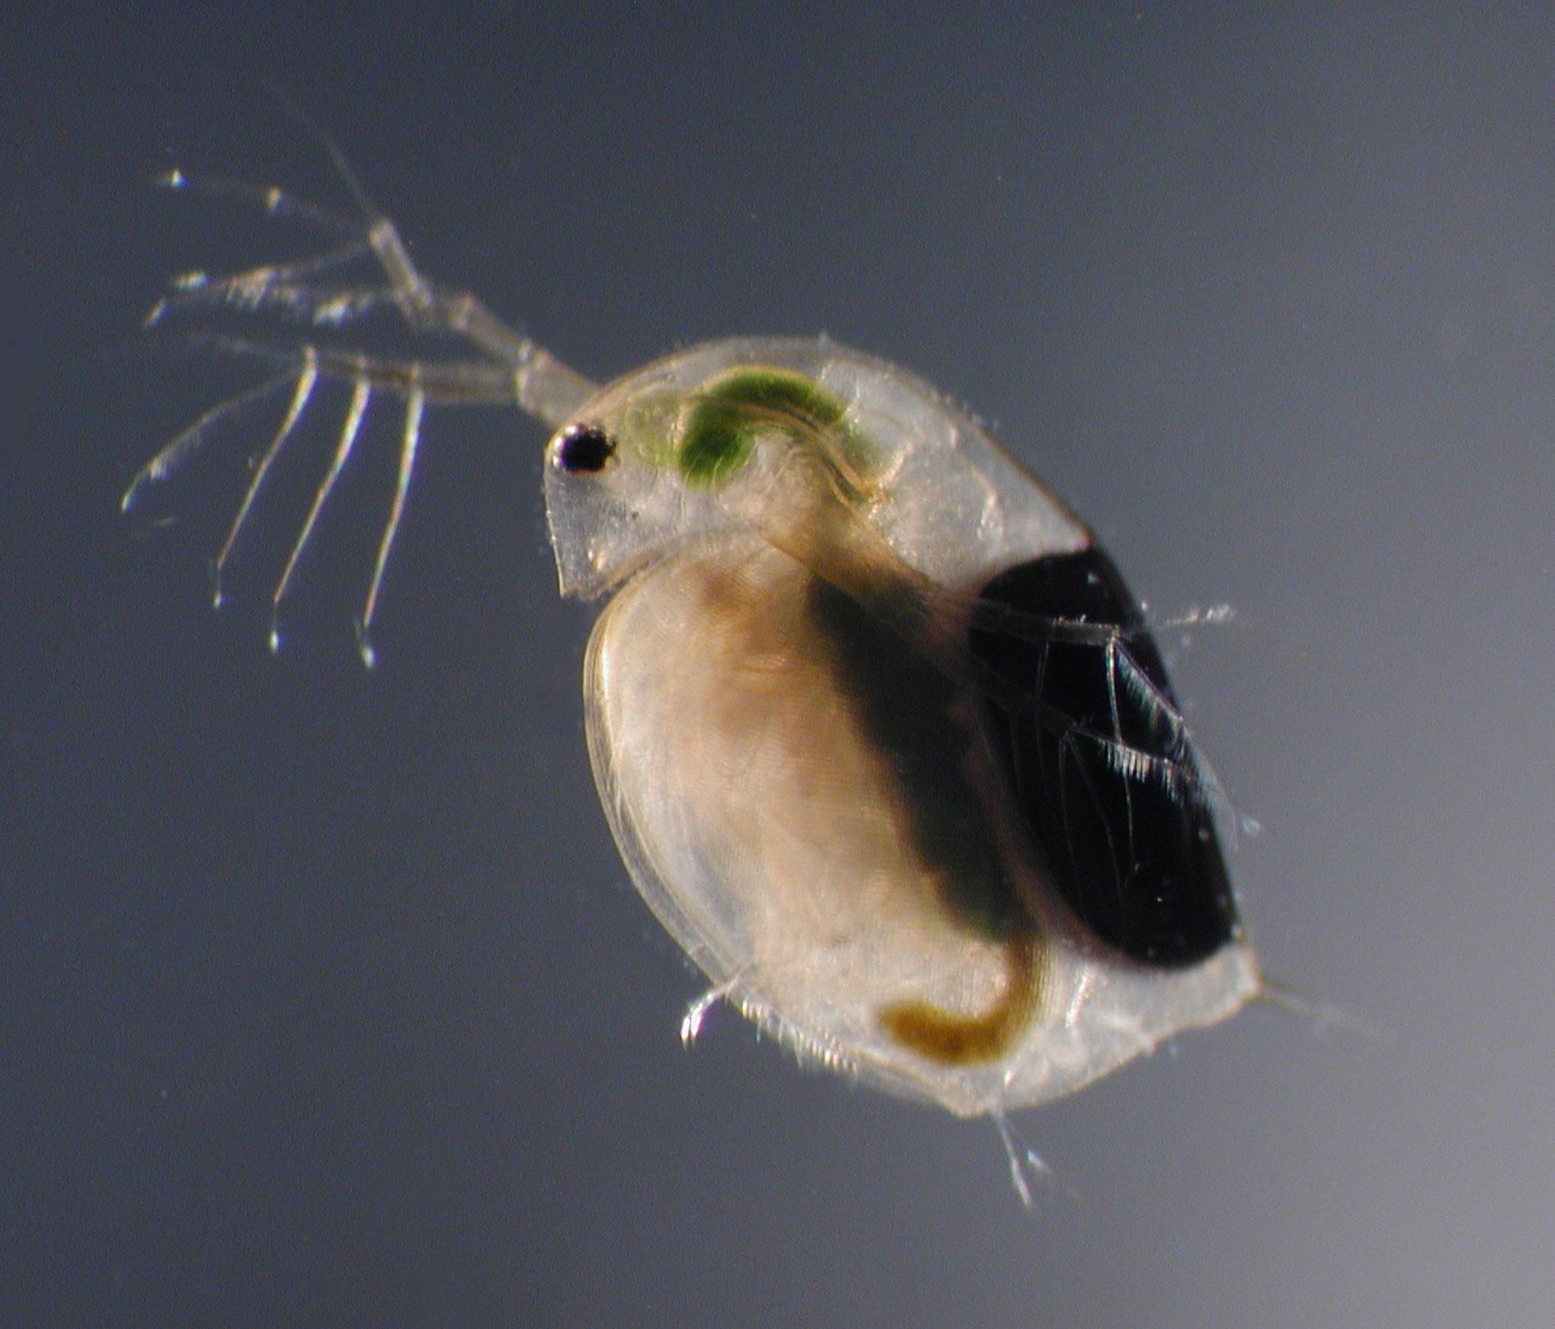
Egg shell on back with two embryos inside

