EWW 120
Senor Tapir Musical Moment:
Fred and Nora Urquhart
By Laura Sams

Follows: “Butterfly Babies” in which the kids go searching for baby butterflies in the park, they’re surprised to discover that caterpillars turn into butterflies.

Curriculum: Scientist Fred Urquhart and his wife Nora followed their curiosity to discover where monarch butterflies go in the fall.

LS4. Understand that all animals and plants have a life cycle, can reproduce, and change
and grow over time:

- Intro scene in which Ari flies in to join the kids and Sr. Tapir, and then a monarch butterfly lands on Ari’s head. Ari says he has been flying around and has seen lots of butterflies flying away. The kids look up to see butterflies flying away from them. Elinor wonders where they are going. Senor Tapir says that every year, monarch butterflies fly away to find more food, and he is going to sing a song about a scientist who wondered where the monarch butterflies go.

- Senor Tapir sings a song about Fred and Norah Uquhart, a married couple who wondered where monarch butterflies go in the fall. When Fred was a boy, he noticed that the butterflies flew away in the fall, and he wondered where the butterflies went. He and Norah put special tags on butterfly wings to track where the butterflies went, and they asked others to let them know if they saw any of those butterflies with tags somewhere else. They spent most of their lives looking for the answer and finally found that millions of monarchs went to a mountainside in Mexico. The song emphasis is on never giving up while following your curiosity.
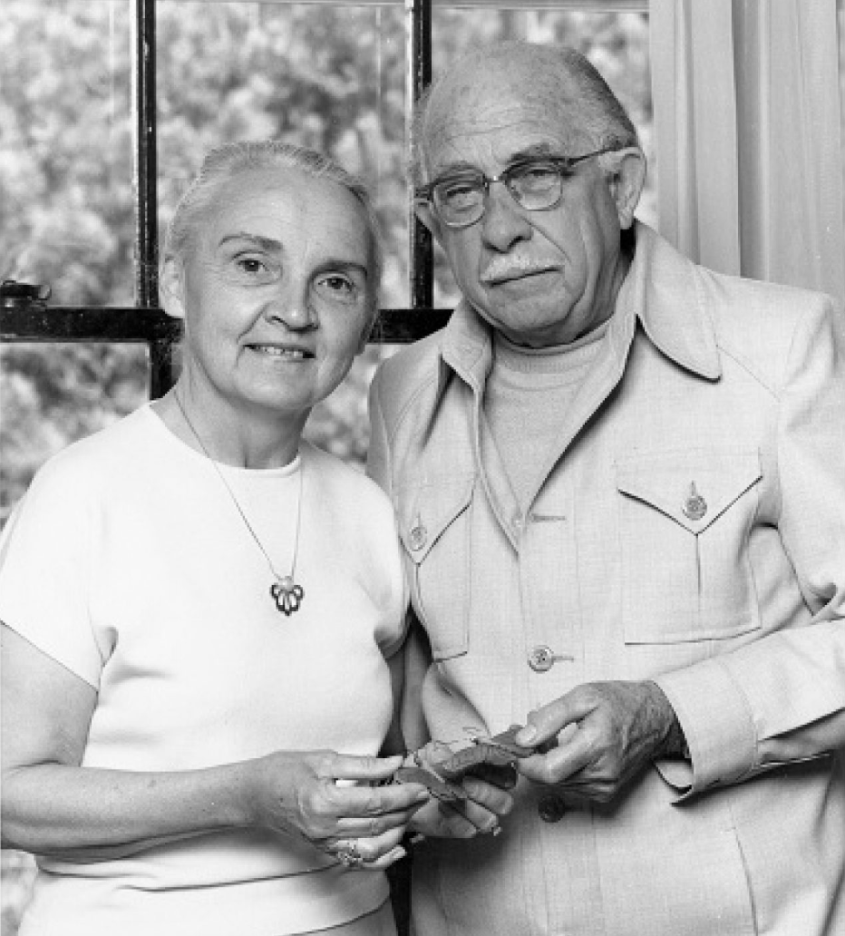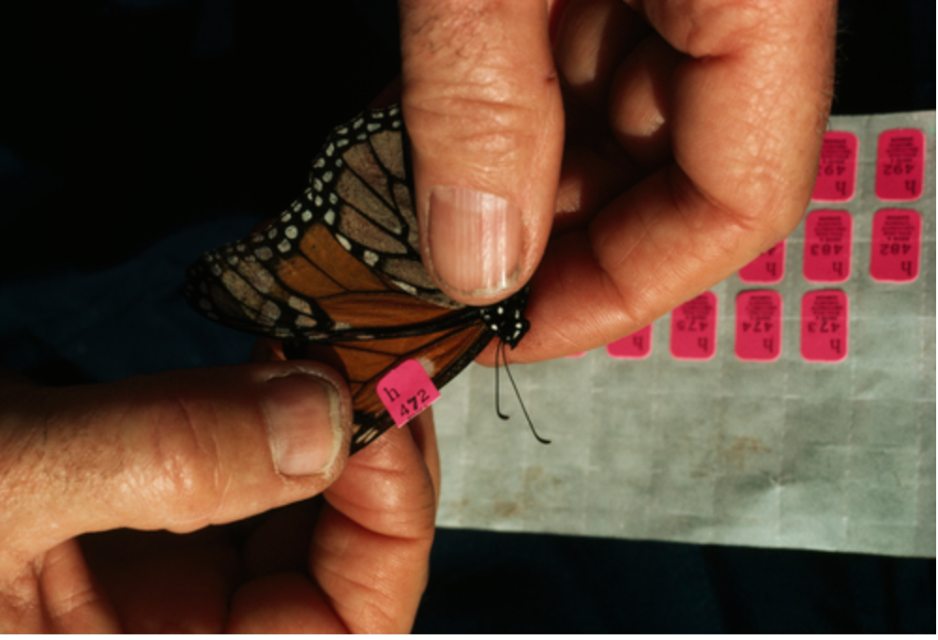

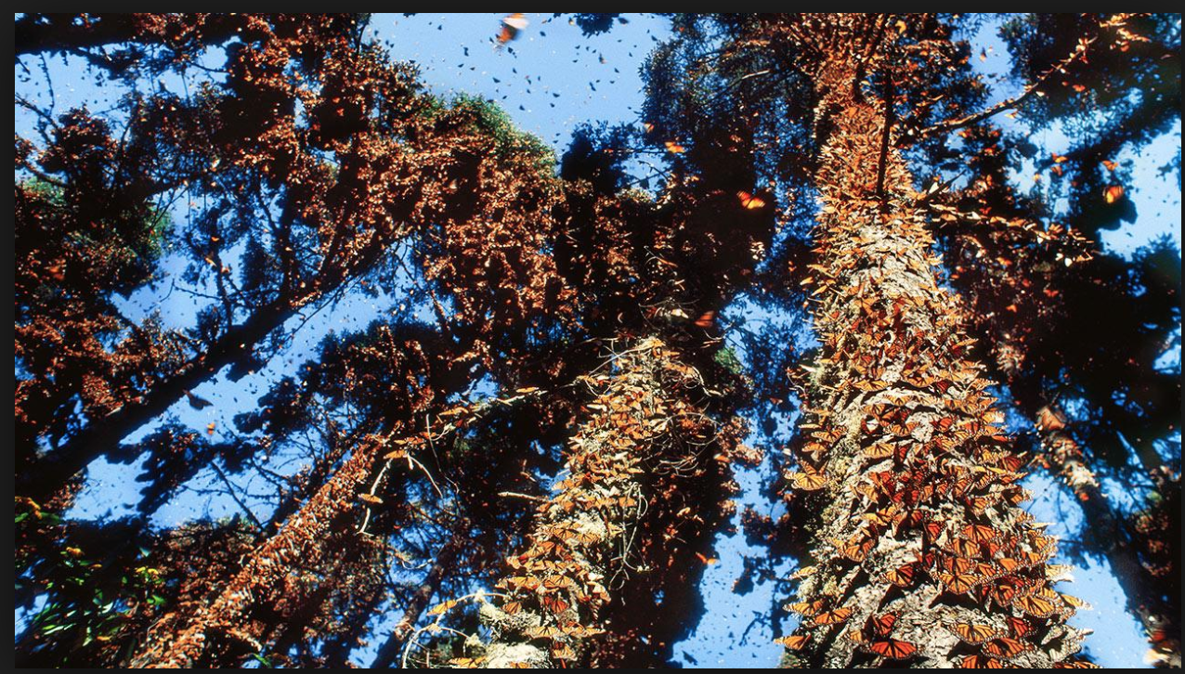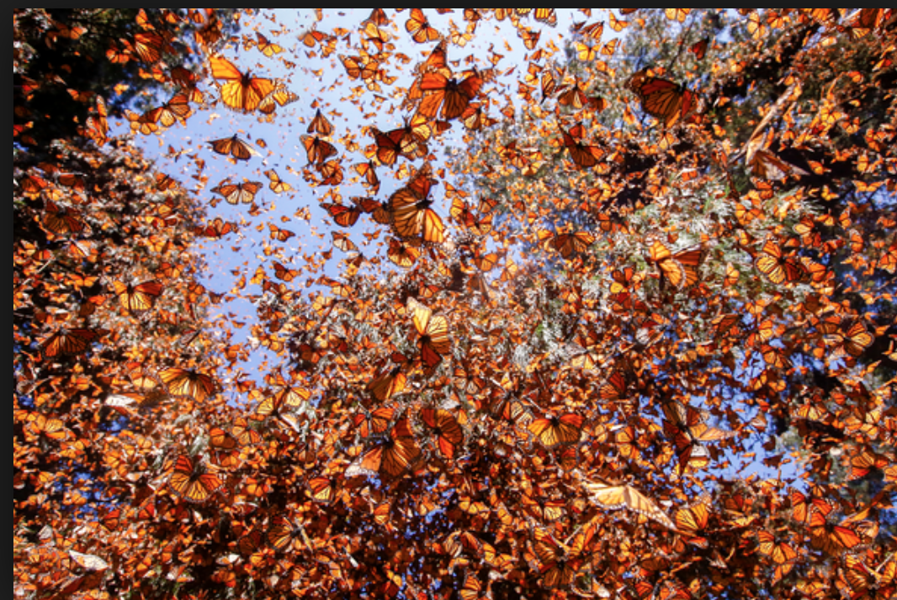

- The end scene shows the butterfly on Ari’s head fly away. Ari says he can’t imagine flying as far as that butterfly can! Senor Tapir says “Adios butterfly!”

