ELINOR WONDERS WHY
EP 120 The Cycle of Leaves
By: Jorge Cham and Daniel Whiteson
OUTLINE – March 11, 2019

Elinor’s Question: Who rakes the leaves in the forest?
Logline: Elinor learns that the forest does its own composting.
Curriculum Goals:
LS5. Begin to understand that animals and plants depend on other living things and nonliving things in the environment to meet some of their needs: (The kids realize that the plants in the forest and the garden depend on the composting leaves for some of their food)
ND4 – Flows, Cycles, and Conservation’: Appreciate the way that elements in the natural world change, interact and are re-used, and how we can organize our designed world to better fit and care for the environment. [ The kids learn that leaves are reused in the forest to make soil; they can do the same with their leaves and veggie scraps. ]

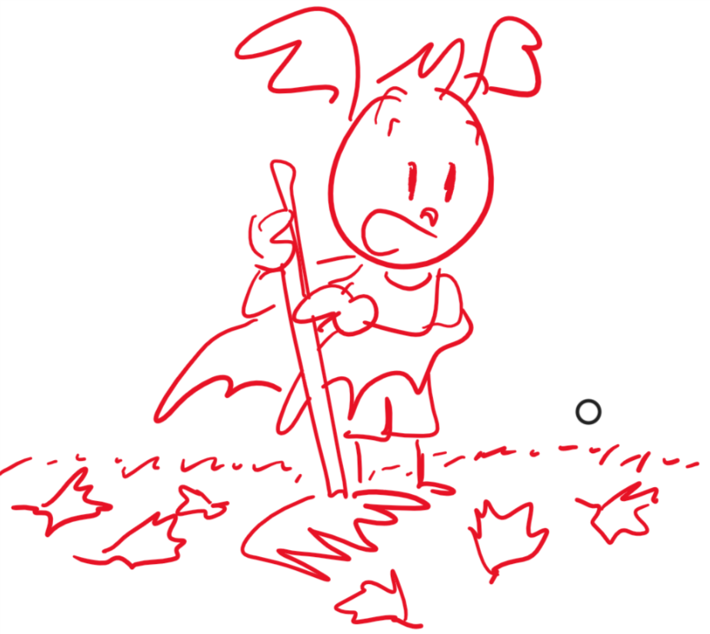
SEP1b Ask more complex questions about observable phenomena [ they wonder where the leaves go]
SEP3a: Identify and use a greater variety of tools to extend the senses for observing, measuring, and recording data about objects and events [ they use a magnifying glass to look closely at leaves]
SEP3b: Compare and contrast objects and events by describing similarities and differences in detail [ they compare the freshest fallen leaves to the oldest ]

SEP6a: Use background knowledge experiences, and data to construct reasonable explanations and
theories of natural phenomena (science) [They combine their knowledge of leaves with what they see to figure out that leaves break down]

SEP8. Obtaining, evaluating and communicating information a. Obtain information through discussing prior knowledge and observations with experts including teachers or knowledgeable adults [ they share their conclusions with Ari’s father, who also tells them about composting ]

1. EXT ARI’S HOUSE -- DAY

Open on a crisp Fall day in Animal Town.

CU: a branch outside Ari’s house. We see a golden leaf quiver in the wind, and then break off of the tree and fall to the ground. A moment later, we see Ari’s dad, MR. BAT, pick up the leaf and examine it. “Yup, it’s Fall, alright!”

PULL BACK AND REVEAL: that the whole yard is covered in golden, red and brown leaves. At that moment, ARI, ELINOR, and OLIVE run up. “Wow! Look at all these leaves!” “The yard is covered in them!” Olive puts down her satchel and the kids have a little bit of fun playing with the leaves: they throw them up in the air, they “swim” in them.

Ari says “Watch this, guys!” He lays down and waves his arms and legs to make a “leaf bird” (like a snow angel) and the other kids follow suit. Each one says which kind of bird it looks like. Elinor’s looks like an owl. Olive’s looks like a flamingo (her trunk made the long neck). Ari’s just looks like a bat. “It’s a leaf bat!”

Mr. Bat pulls up a bin with gardening tools, including several small rakes, and starts taking out some canvas sacks, intending to rake the leaves himself. “Well, time to get started raking the leaves.” Ari decides he wants to be helpful. “I want to help! I’ll rake the leaves, dad!” Mr. Bat is pleasantly surprised. “Are you sure, Ari?” Ari is sure: “Yeah, no problem! I’ll take care of it! I’m a super leaf raker!” Elinor and Olive jump in. “We’ll help, too!”

Mr. Bat is happy to let the kids rake the leaves. He gives them the rakes and the sacks and tells them he’ll be in the backyard getting things ready.

Each kid grabs a rake and they stand there, looking at the sea of leaves. “Let’s rake some leaves!”

MUSICAL MONTAGE: we see the kids doing their best to rake the leaves.

(Lyrics optional, it could be an instrumental montage)

It’s fall! It’s fall!
And leaves are falling down
It’s fall! But now,
Who’s gonna pick them off the ground?

Rake, rake, rake!
We’ll rake them in the yard
Shake, shake, shake
We’ll put them in a bag!

While they sing, we see them working, not very efficiently but very energetically, and having fun. Eventually, despite their goofiness, they get most of the leaves piled into a few bags.

END MONTAGE: The kids are putting the last of the leaves into one of the bags. As Olive holds it open, Elinor drops some leaves in. Olive comments, “We’re almost done guys! Great job!” and Elinor comments, “So many leaves! It’s too bad that the trees don’t need them anymore.” Meanwhile, Ari comments that he’s glad they’re almost done, because then they can go and play and/or get a snack.

Just then, a few leaves drift onto the screen. Ari looks confused for a moment, but rakes the leaves closer to the bag so Elinor can put them in. He takes a satisfied look at the small pile, dusting off his hands to mean “job done”, and prepares to put the rake away. Just then MORE leaves drift onto the screen. He rakes those too, and repeats the same process, but then a few MORE leaves drift in.

Ari asks: “I thought we were done! Where are these leaves coming from?” Elinor and Olive get interested too, and they follow the leaves back to the source, which are the trees at the edge of the forest. They’re all COVERED in leaves that are falling.

PUL OUT to see that Ari’s yard is next to a forest. Ari’s eyes pop! The kids exclaim how many trees and leaves there are. Are they going to have to rake them all??

Olive says they won’t have to rake them; she is sure that only the leaves in yards get raked. But then Elinor asks: So, who rakes the leaves in the forest? If nobody rakes the forest, why isn’t it FULL of leaves? We see a thought bubble that the kids share showing the forest full of leaves up to the tops of the trees. But when they look at the forest, they see that there are SOME leaves on the ground, but not huge piles. They get very curious: What happens to all the leaves that fall down in the forest? If new leaves fall every year, where do they all go? Olive declares that it’s a mystery, alright. Elinor says, “Hmm… That’s SO interesting!”

The kids think about a few ideas. Ari says that maybe the trees rake their own leaves! We see a thought bubble in which trees are raking their own leaves. But then Olive says, “But nobody has seen a tree with a rake before… and trees can’t move like that!”

Maybe the birds pick up all the leaves, says Olive. A thought bubble shows some birds picking up and carrying large stacks of leaves. Elinor says they know some birds use leaves to make nests, but there are too many leaves! The birds can’t use ALL of them.

They decide that none of these ideas seem very likely. They think about it for a beat, then Elinor has an idea: Let’s go look at the leaves in the forest and see if we can figure it out! We need MORE observations!

Olive grabs the magnifying glass and her notepad from her satchel, while Ari signals to his dad, who’s doing something in the back of the house, that they are going exploring. “Great,” replies Mr. Bat, “just make sure you close the bags before you leaf. I mean, leave.” The kids giggle and set off for the edge of the forest.

2. EXT FOREST -- DAY

The kids walk a little bit into the forest. As they walk, they sing a song (possibly a reprise of the earlier song) that summarizes what they want to know.

It’s fall! It’s fall!
And leaves are falling down
It’s fall! But now,
Who’s gonna pick them off the ground?

Where, where, where?
Do leaves in the forest go?
Look, look, look!
That’s what we want to know!

As the song ends, we transition to the kids looking carefully at the leaves around them. Elinor recaps the mystery: If new leaves fall from the trees every year, why aren’t there piles and piles of leaves everywhere? Where do the leaves go?

First, they take a look at leaves in the top layer on the ground. These look fresh, like they just fell off the tree. There are a few different colors and they can bend without breaking. Olive draws a fresh leaf in her notepad.

Ari gathers up some leaves so that Olive has more examples to draw. But when he’s doing that, he notices that the leaves under the top layer look different! They use the magnifying glass to take a closer look.

The leaves at the top look fresh: colorful and flexible, but the ones below are more grey and dry. They crack when they bend them. Olive draws these in her notepad.

They dig down deeper and find some that are barely leaves at all: they are brown and crumbling. Olive draws these, too.

Finally, Elinor looks closely at the soil on the ground and sees little broken up bits of leaves! Olive draws some soil with bits of leaves in it.

Looking at the drawings, the kids understand that the leaves in the forest don’t go away anywhere. They lay on the ground and get old and break into very small little pieces that mix with the soil.

They are excited that they figured out what happens to leaves in the forest and want to rush back to tell Ari’s dad.

3. EXT ARI’S HOUSE -- DAY

They come back to the house, full of excitement. They find Ari’s dad and explain what they learned to him. They show him the drawings in Olive’s and tell Mr. Bat that nobody has to rake the leaves in the forest. The leaves just get old and crumbly and become part of the soil.

Ari’s father confirms what the kids observed. He says that the leaves don’t just become part of the soil, they become part of the food that the plants use to grow.

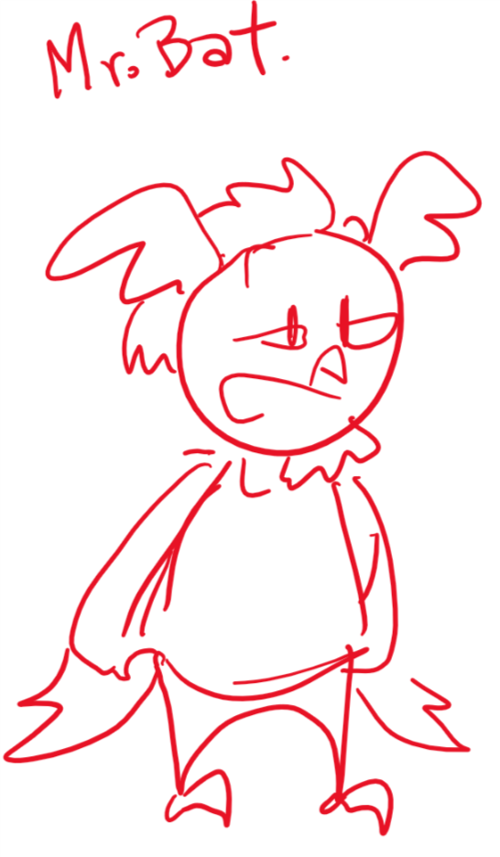
The kids think this is amazing! All those leaves don’t go to waste, they become food for the trees!

Mr. Bat explains that it’s called “composting.” In the forest this happens naturally on the forest floor. Then Elinor looks at the bag of leaves they picked up in Ari’s yard and wonders if they can turn them back into soil. Mr. Bat says that, actually, that was the plan all along!

He brings them over to a corner of the yard where he has a compost pile. He then takes the bag of the raked leaves and feeds it into a hand-cranked leaf chipper. Turning the crank, the chipper chops up the leaves and sprays them over the compost pile, adding a new layer. Mr. Bat then takes a shovel and mixes it around a bit. He explains that the pile acts just like the forest floor, and helps the leaves turn old and crumbly.

The kids are amazed and dig in, using their magnifying glass to see lots of old broken up bits of leaves. They also see bits of vegetables. Ari’s father explains that you can compost leftover vegetables too, which makes the soil great for growing new vegetables.

Elinor peers close up and sees something else surprising!

Worms!

The kids dig excitedly for worms, and Ari finds a super long one. Mr. Bat explains that the worms help turn the bits of leaves into plant food. He then takes a shovel full of the fresh soil and spreads it on the yard, showing the kids that it goes to feed the grass and the plants.

Mr. Bat thanks the kids for being so helpful today. And so curious!

Ari replies: “No problem, dad! You better be-leaf it!” The kids laugh as the camera goes up and back to another golden leaf hanging on a branch. The leaf wiggles and drops as we fade out and…

END.

