EWW Interstitial 119
Mz. Mole Storytime
Fish Ladder
Robert Kalinowski

Follows: “Water You Doing?”

Curriculum: the kids learn that a dam blocks water upriver, and so regulates the flow of water downriver. They also learn that people build fish ladders as a way for fish to swim upstream, around the dam.

LS1. Understand that a dam is a structure people build as a way to block the flow of water in a river, so that past the dam, the flow of water is much less and stays the same year-round.
LS2. Understand that a fish ladder is another structure that people build, as a way to allow fish to swim up river, around dams.

    - Intro scene where kids gather around Ms. Mole at a woodland riverbank. Elinor says hi to some friendly fish in the water. Up in the distance, the kids see a dam, and they ask Ms. Mole what it is. Ms. Mole opens up her pop-up book, and the kids gather around to hear about dams.
    - Ms. Mole explains that sometimes there’s a lot of water in a river, and sometimes there’s only a little. That’s nature’s way! (We see the image of a river, with a lot of water, and then a little water. When there’s a lot of water, the river is wide and takes up much more space; when there’s less water, the river is narrow and takes up much less space.)
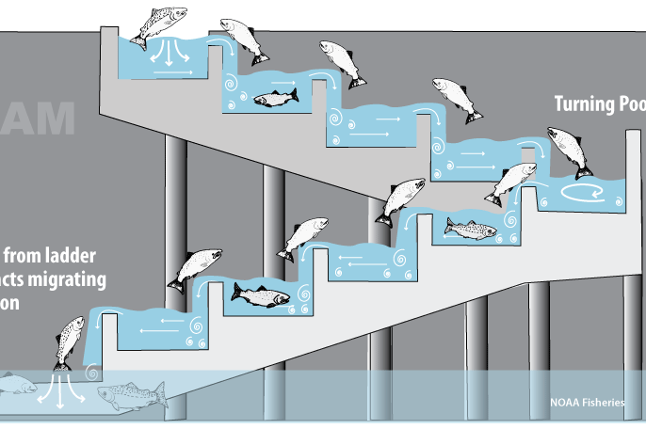
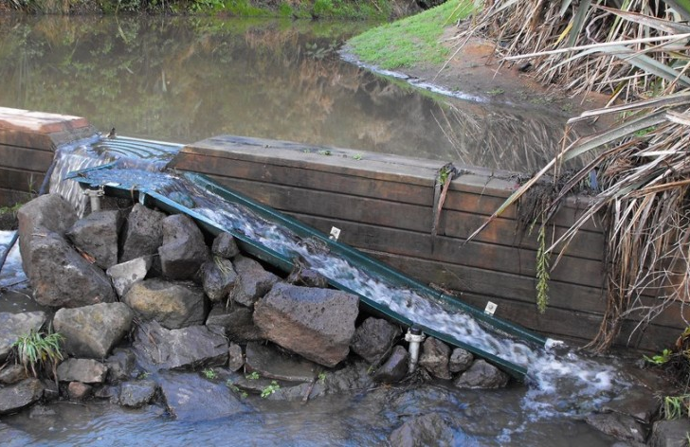

    - Putting a dam in the river makes it so that downstream, the water will always be a little, and the river will always be smaller and narrow. (The book illustrates a dam stuck right in the middle of this river. Upstream, the size of the river still ebbs and flows, but downstream, the river just looks the same. Homes, roads, and shopping centers pop up downstream.)
    - Elinor raises her hand, “But Ms. Mole -- what about the fish that need to swim upstream past the dam??” Ms Mole explains that in order to help the fish, people build a “FISH LADDER” that goes the LOOOONNNNGGG way around the dam. Step by step, fish can get upstream now! (We see the fish ladder rapidly appear, several steps at a time, taking a long curve around the dam. Fish are seen leaping from one step to the next in the instant it is being built.)
    - Ms. Mole concludes that thanks to the dam and the fish ladder, now the river, the dam, the fish, and people can all live in the same area. (Kids look into the book as a big fish jumps from one page to the next with a splash.)
