EWW 117
Senor Tapir Musical Moment:
Lydia Bourouiba, Sneeze Scientist
By Laura Sams

Follows: “These Sneezes” in which kids wonder why they sneeze, and figure out that it’s caused by small irritants: dust, pollen, etc.

Curriculum: Scientist Lydia Bourouiba followed her curiosity to find out what happens to sneezes. She does hilarious experiments that tickle people’s noses to watch where their sneeze droplets go after they sneeze.

LS2 - Understand that animals have different body parts that are used in different ways to meet their needs, and that plants have different parts that help them survive and grow: a) Identify body parts of animals and their function.

- Intro scene in which Sr. Tapir asks the kids if they want to hear a song, but he starts to sneeze in the middle of the word song. (A soo… a soooooh, a ssaaaaachoo! I meant to say a song). He sneezes right on his guitar, and then is embarrassed and wipes it off before he plays.

- Senor Tapir sings a song about Lydia Bourouiba, a scientist who wondered where sneeze droplets go after someone sneezes. It’s hard to see sneeze drops, so she does tests by tickling people’s noses and filming/watching their sneezes in slow motion. She wonders questions like: How big are sneeze drops? What shapes do they make? The emphasis is on her curiosity about where sneezes go.

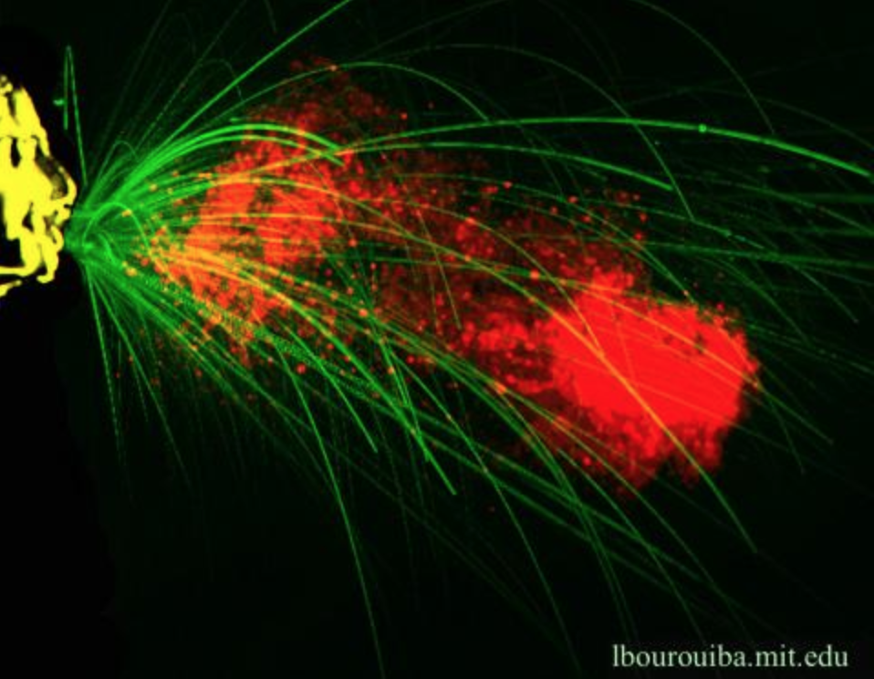

- The end scene shows Senor Tapir asking the kids a question, and he feels like he has to sneeze in the middle of it, thinks it was a false alarm, but then sneezes at the last minute. “Wasn’t that a fun sooo, soooohh, soooaaee . . .” He pauses. “Song? Nevermind, I guess I didn’t have to sneeze after aaa. . . Aaachooo!”
J&D Comments:
Our only note is:
- The song focuses on her question, which is great, but we are left a bit hanging about the answer. Is it possible to weave what she learned about sneezes into the song? Maybe she learned sneezes go much further than anyone thought, etc. If so, you might reflect that also in the outtro scene to re-inforce it.

