First Viewing
Before the episode begins.

Daniel and Jorge overall thoughts:
- We are very excited about the way these can tease out misunderstandings in the minds of the viewer and potentially rectify them during the episode.
- Apologies for the miscommunication, but it may be that this draft is significantly too long. The most expensive element of production is the animation, and we are budgeted for approximately 10 minutes over all three episodes. We have asked pipeline to give an estimate of the animation length of this draft, so that we have an idea for how drastic a reduction might be needed for the next draft.
- It might be helpful if you elucidated some overarching goals for this episode, such as “Does the viewer understand this logic:
  - The bees make honey goopy by taking the water out, so
  - Adding water back in makes it less goopy”
as an example goal. Identifying those would help us evaluate the value a specific moment of conversation.
- Some goals for us are that
  - The viewer develop confidence in the Conv. Agent, meaning that it’s responses are VERY robust and meaningful, never nonsense.
  - The agent works for a very broad variety of children’s experiences (eg never had honey, never heard of honey, never seen a bee drink from a flower, etc)
- We should be explicit about what will appear on the screen during these conversational moments. Options include:
  - White screen with Elinor’s head and shoulders
  - Some non-specific background scene from the EWW world (ie a forest scene), with Elinor’s head and shoulders
  - Current screen frozen, but with Elinor talking to the audience

FV_W1 (first viewing_warming up question 1): Hi I’m Elinor. I’m a kid just like you! Well, almost -- I AM a bunny after all. How old are you?
Valid response: Wow, you’re X (repeat the child’s age), we’re the same age!
Fallback: Wow, we’re the same age!

FV_W2: Today, we’re gonna explore where honey comes from. I love honey! What do you like to eat honey with?
Food entity: Me too!
I never had honey before: Hmm, honey tastes very sweet, just like sugar! I like to eat honey with bread.
I don’t like honey: You don’t like honey, but the bees that make it sure do!
Fallback: Hmm, honey tastes very sweet! I like to eat honey with bread.

FV_W3: Have you ever tried to squeeze honey out of a bottle?
Yes: [Go to FV_W4]
No: You haven’t’? When you squeeze honey out of a bottle you can see that it’s thick and goopy like syrup. (Skip FV_W4)
Fallback: When you squeeze honey out of a bottle you can see that it’s thick and goopy like syrup. (Skip FV_W4)

FV_W4: Is honey thick and goopy like syrup or is it thin and runny like milk?
Thick and goopy: I think so too! Let’s go find out!
Thin and runny: I’m not sure! Let’s go find out!
I don’t know: It’s OK! I’m not sure either! Let’s go find out!
Fallback: Let’s go find out!

During the episode
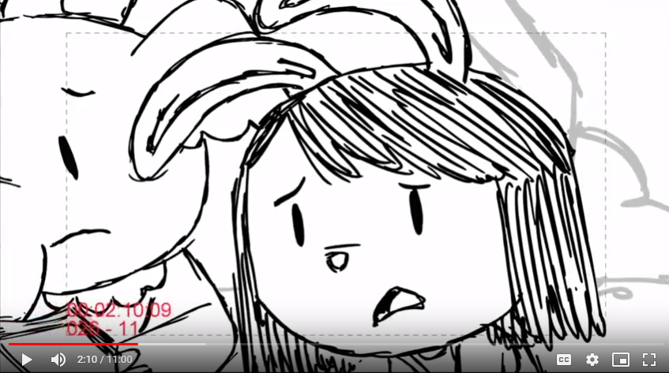

[Elinor sighs]

[2:10]
FV_Q1 (First viewing question 1): Why do you think the line is moving so slowly?
Many_people:Yes, there are so many people in line because everyone wants some of Ms. Gorilla’s ketchup! But I wonder why it’s taking so long for people to get ketchup.
Take_time_to_make_ketchup: Well, I think Ms. Gorilla already made the ketchup. But I wonder why it’s taking so long for people to get ketchup.
Turtle: That is an interesting guess! Turtles walk slowly, but I don’t think there’s a turtle standing in this line. I wonder why it’s taking so long for people to get ketchup.
Snail: I saw a snail too! But the snail isn’t in line. I wonder why it’s taking so long for people to get ketchup.
I don’t know: Hmmm, I wonder why it’s taking so long for people to get ketchup.
Fallback: Hmmm, I wonder why it’s taking so long for people to get ketchup. .

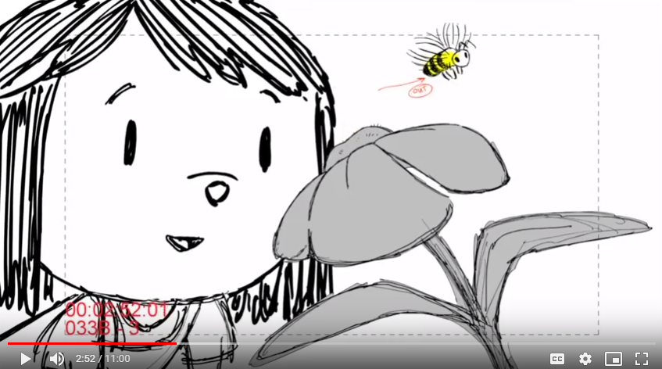

[2:52]
FV_Q2: What do you think the bee is gonna make with the juice from the flower?
Honey: Hmmm, yes! Bees make yummy honey with the juice from flowers.
I don’t know: Hmmm, I think bees make yummy honey with the juice from flowers.
Fallback: Hmmm, bees make yummy honey with the juice from flowers.

[3:47]
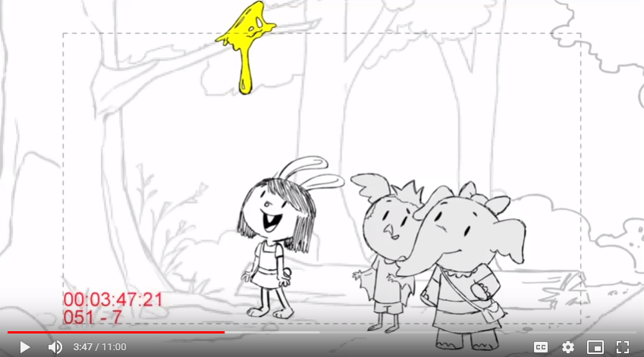

[After Elinor says “The honey is so goopy.” ]
Animation: Elinor turns her head to the audience and ask:
FV_Q3: Goopy, that’s a silly word! What does goopy mean?
Slimy/GooeyThick/Sticky/Slow: Yes, that’s right! Goopy is a word for a liquid that is thick and moves very slowly just like honey.
I don’t know: Well, goopy is a word for a liquid that is thick and moves very slowly just like honey.
Fallback: Well, goopy is a word for a liquid that is thick and moves very slowly just like honey.

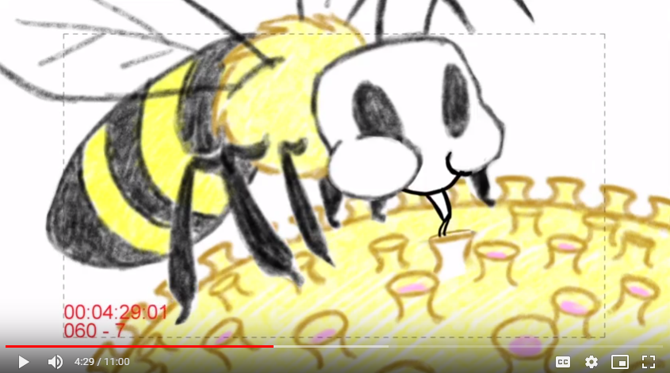

[4:38]
[After Ari said “Wow that’s cool”...]
Animation: Elinor appeared in front of the bee
FV_C1: Oh, so nectar is the juice from the flower. The bee is drinking the nectar from the flower and is going to turn it into honey. How interesting! Please keep reading, Olive!

[5:00]
[After Ari flapped his wings]
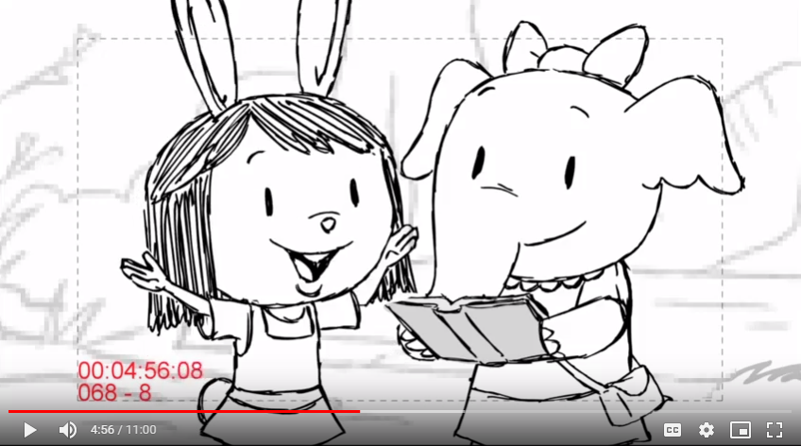

Animation: Elinor turns to the audience
FV_Q4: Ari flaps his wings and we can feel whooshing air! Bees flap their wings too when they make honey. Why do the bees need to flap their wings when making honey?
Take water out: Yes, I think so too! Bees flap their wings to fan the liquid nectar. And as the water comes out, the nectar becomes thicker and thicker! This is called “concentration.” The nectar is being “concentrated” into honey.
Fly: Yes, bees do flap their wings to fly. But when bees make honey, they flap their wings to fan the liquid nectar. And as the water comes out, the nectar becomes thicker and thicker! This is called “concentration.” The nectar is being “concentrated” into honey.
I don’t know: Bees flap their wings to fan the liquid nectar. And as the water comes out, the nectar becomes thicker and thicker! This is called “concentration.” The nectar is being “concentrated” into honey.
Fallback: Bees flap their wings to fan the liquid nectar. And as the water comes out, the nectar becomes thicker and thicker! This is called “concentration.” The nectar is being “concentrated” into honey.

[6:19]
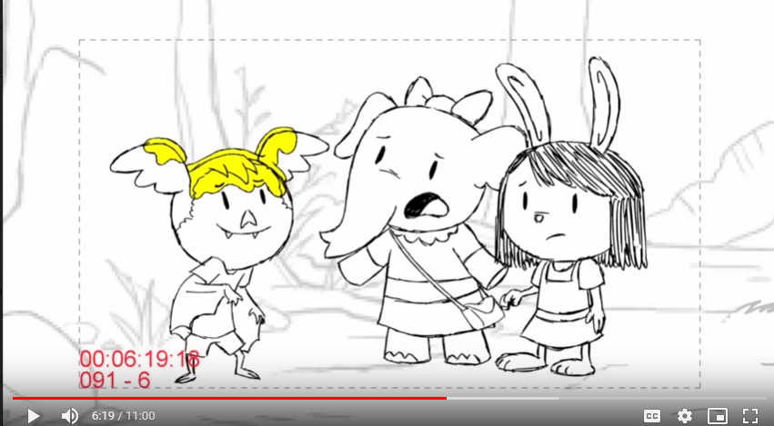

[Olive: How are we gonna get all this goopy honey off you?]
Animation: Elinor turns to the audience
FV_Q5: Uh oh! How can we get the honey off Ari?
Wipe it: Ok that is one way. But the honey is so goopy, it’ll stick to everything! We need to add water to make it less goopy. This is called dilution. Adding water “dilutes” the honey. .
Scoop it: Ok that is one way. But the honey is so goopy, it’ll stick to everything! We need to add water to make it less goopy. This is called dilution. Adding water “dilutes” the honey.
Wash it: Oh yes, use water! We need to add water to make it less goopy. This is called dilution. Adding water “dilutes” the honey.
Add water in: I think that is a great idea! We need to add water to make it less goopy. This is called dilution. Adding water “dilutes” the honey.
I don’t know: Hmmm, the honey is so goopy, it’ll stick to everything! We need to add water to make it less goopy. This is called dilution. Adding water “dilutes” the honey.
Fallback: Hmmm, the honey is so goopy, it’ll stick to everything! We need to add water to make it less goopy. This is called dilution. Adding water “dilutes” the honey.

[8:26]
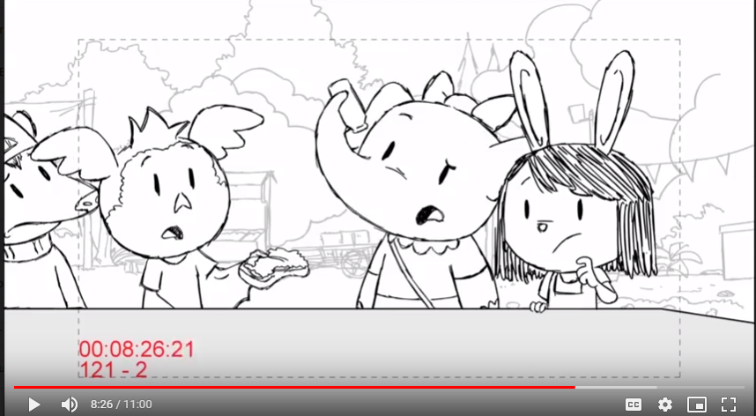

[After Ari and Olive failed to get the ketchup out]
Animation: Elinor turns to the audience
FV_Q6: Oh no! The ketchup isn’t coming out of the bottle! Why do you think the ketchup isn’t coming out?
Goopy/Thick: Yes, Ms. Gorilla's ketchup is so goopy and thick that it sticks to the bottle. We need to find a way to make it runnier.
Sticky/Stuck: Yes, Ms. Gorilla's ketchup sticks to the bottle because the ketchup is so goopy. We need to find a way to make it runnier.
Fallback: Ms. Gorilla's ketchup is so goopy that it sticks to the bottle. We need to find a way to make it runnier.

Second viewing
During the episode

[Elinor sighs]

[2:10]
SV_Q1 (second viewing question 1): Uh oh, here we are, standing in line to wait for the ketchup again. Why do you think the line is moving so slowly?
Ketchup goopy: Yes, that’s right! Let’s help make the ketchup come out of the bottle faster so that the line will move faster.
The line is goopy: Well we can’t say the line is goopy, but you’re right, the line is slow. Ms. Gorilla’s ketchup is so thick and goopy. Let’s help make the ketchup come out of the bottle faster so that the line will move faster.
Many_people: Yeah, everyone likes Ms. Gorilla's ketchup! Her ketchup is so thick and goopy. Let’s help make the ketchup come out of the bottle faster so that the line will move faster.
Take_time: Yeah, it takes time to serve ketchup to everyone in this line! Ms. Gorilla’s ketchup is so thick and goopy. Let’s help make the ketchup come out of the bottle faster so that the line will move faster.
Reprompt: The line is moving really slowly. Do you think it has something to do with the ketchup?
Fallback: Ms. Gorilla’s ketchup is so thick and goopy. Let’s help make the ketchup come out of the bottle faster so that the line will move faster.

[2:52]
SV_Q2: What is the bee drinking from the flower?
Nectar: Yes, that’s right. The bee is drinking nectar from the flower. Nectar is watery and runny, just like juice!
Juice: Yes, that’s right. The bee is drinking juice from the flower. We call the juice from flowers “nectar.” It’s watery and runny.
Honey: There’s no honey in flowers! A sugary juice called “nectar” is in flowers. Bees take this nectar to their hive and turn it into honey.
Water: Hmmm, the bee is drinking juice from the flower. We call the juice from flowers “nectar.” It’s as watery and runny as water though.
Reprompt: Is the bee drinking honey from the flower, or is it drinking nectar from the flower?
Fallback: The bee is drinking juice from the flower. We call the juice from flowers “nectar.” It’s watery and runny.

[3:37]
[After Elinor said “Don’t move, we’re about to get honey”]
Animation: Elinor turns to the audience and ask
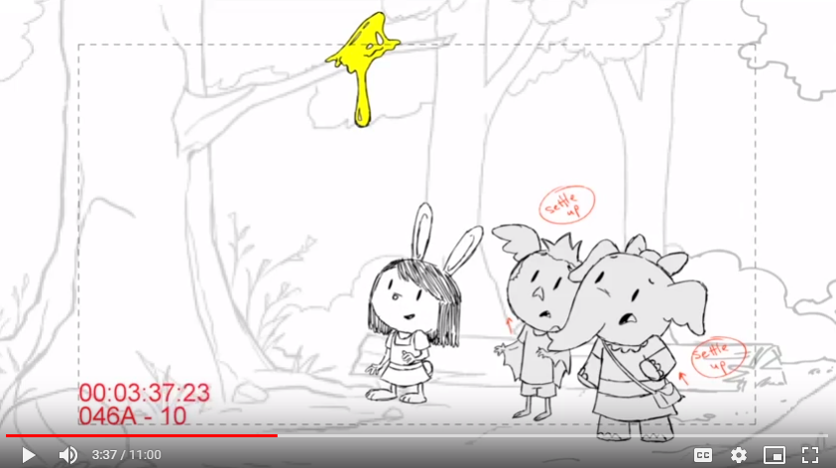

SV_Q3: Why do you think the honey is sticking on the branch and not falling off?
Goopy: Yes, that’s right! The honey is really goopy and thick. It sticks to the branch for a long time, instead of running right off like water.
Sticky: Yes, that’s right! The honey sticks to the branch because it is really goopy and thick. It sticks to the branch for a long time, instead of running right off like water.
Runny: No, honey isn’t runny. The honey is really goopy and thick. It sticks to the branch for a long time, instead of running right off like water.
No_water: Yes, that’s right! When there is very little water in the honey, the honey will be very goopy and can stick to the branch for a long time, instead of running right off.
Reprompt: Is it because the honey is runny like water or is it because it’s sticky and goopy?
Fallback: The honey is really goopy and thick. It sticks to the branch for a long time, instead of running right off like water.

[4:56]
[Elinor said “So taking the water out makes the honey goopy.”]

Animation: Elinor turns to the audience
Probably a question more difficult than the one I asked during first viewing?

SV_Q4: What do the bees do to take water out of the runny nectar?
Flap_wings: Yes, the bees flap their wings to fan the nectar and the water comes out. Then the nectar is “concentrated” into honey.
Pour_water: You can’t take water out of the nectar by pouring it! Instead, the bees flap their wings to fan the nectar and the water comes out. Then the nectar is “concentrated” into honey.
Add_water: The bees are trying to take water out, not add water! The bees flap their wings to fan the nectar and the water comes out. Then the nectar is “concentrated” into honey.
Drink_water: No, the bees flap their wings to fan the nectar and the water comes out. Then the nectar is “concentrated” into honey.
Reprompt: To take water out of the runny nectar, do the bees flap their wings or do they drink the water?
Fallback: The bees flap their wings to fan the nectar and the water comes out. Then the nectar is “concentrated” into honey.

[6:19]

[Olive: How are we gonna get all this goopy honey off you?]
Animation: Elinor turns to the audience
SV_Q5: Hmmm, we need to make the honey less goopy and less sticky. What can we do to make the honey less goopy?
Add water: Yes, that is right! We need to add water to make it less goopy. This is called dilution. Adding water “dilutes” the honey.
Wash it: Yes, that is right! We need to add water to make it less goopy. This is called dilution. Adding water “dilutes” the honey.
Wipe it: No, wiping the honey can’t make it less goopy. We need to add water to make it less goopy. This is called dilution. Adding water “dilutes” the honey.
Reprompt: To make the honey less goopy, do we need to add water in or take water out?
Fallback: We need to add water to make it less goopy. This is called dilution. Adding water “dilutes” the honey.

[8:26]

[After Ari and Olive failed to get the ketchup out]
Animation: Elinor turns to the audience
SV_Q6: Uh oh! The ketchup is not coming out of the bottle. We should dilute the ketchup to make it runnier. How do we dilute ketchup?
Add_water: Yes, you’re right! Adding water dilutes liquids. This makes liquids like ketchup less goopy! Just like how we got honey off Ari’s face!
Take_water_out: No, taking water out concentrates liquids and makes them thicker. Adding water dilutes liquids and makes them runnier!
Reprompt: To dilute ketchup, do we need to add water in or take water out?
Fallback: Adding water dilutes liquids. This makes liquids like ketchup less goopy! Just like how we got honey off Ari’s face!

