First Viewing
Before the episode begins.
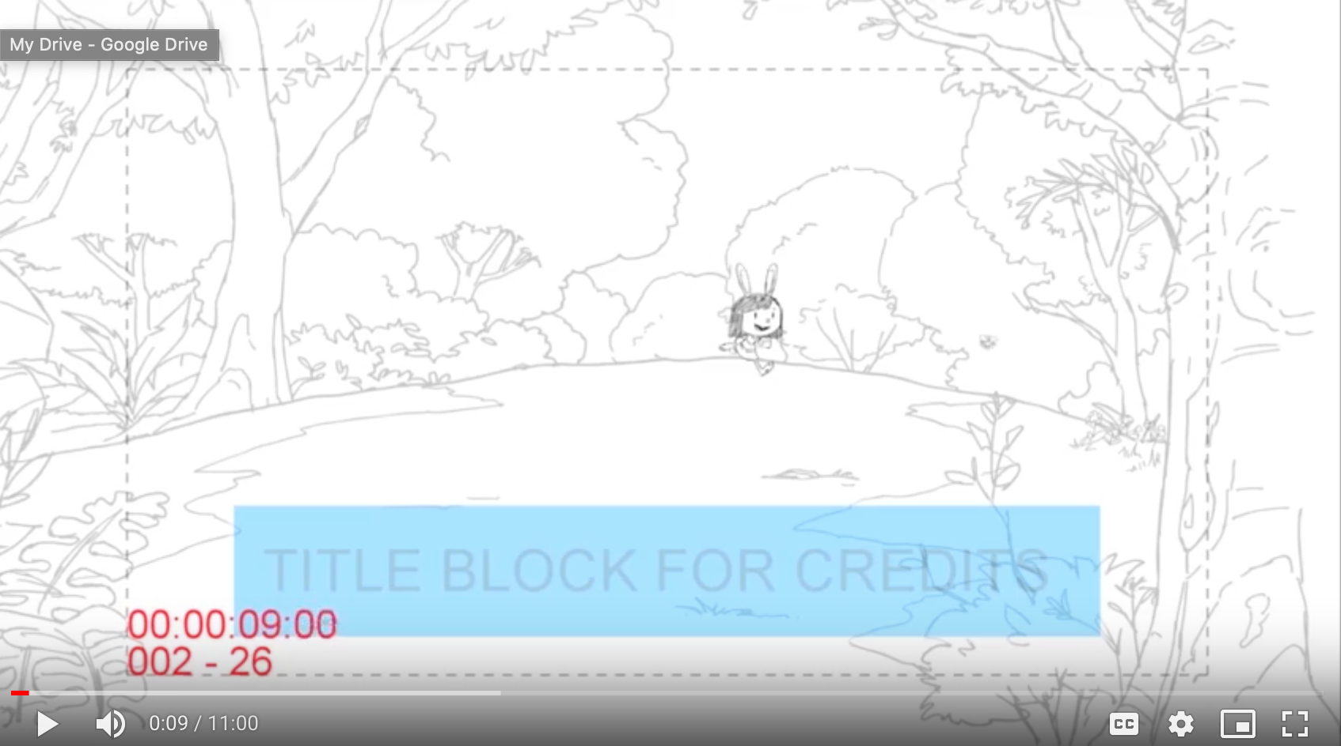

Open on a forest scene (e.g. at 00:00:09). Elinor runs towards the viewers and appears in closeup. Elinor’s position in the closeup scene should be similar with the conversational moment (FV_W2) so that the two scenes can be connected seamlessly (FV_W1 closeup scene could be as the screenshot below, but Elinor is not touching the honey yet).
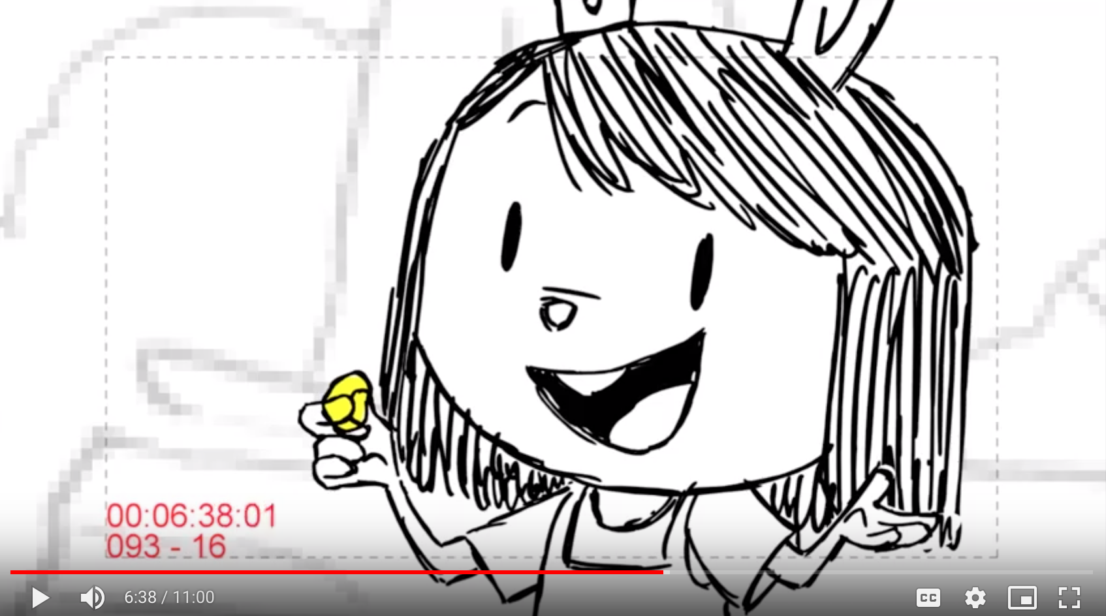

She waves hello to the viewer and says “FV_W1”:

{FV_W1 learning goal:
To connect children’s prior experiences with the episode content}

FV_W1 (first viewing_warming up question 1): Hi I’m Elinor. I’m a kid just like you! Well, almost -- I AM a bunny after all. I love to explore and play outside! I love yummy food, like carrots with honey! Do you like honey?
Yes: Yeah, honey tastes very sweet, just like sugar!
I never had honey before: Hmm, honey tastes very sweet, just like sugar!
I don’t like honey: Oh, you don’t like honey? Well, even friends sometimes like different things!
Fallback: Hmm, honey tastes very sweet, just like sugar!

The waiting-for-response animation begins immediately following the question, and should be fluid with the end of the question. The wait time animation should loop for 60 seconds. The background and closeup remain unchanged so that the end of the question, the wait for responses, and the beginning of the feedback clip can be joined seamlessly. This is true for all of the Conversational Agent interactions.

Whenever Elinor asks a question for which we expect an answer, she should ask with that expectation. The actor might slow down or emphasize certain words, to indicate that a response is invited.

Elinor uses exciting voice when she responds (e.g., “Honey tastes very sweet…”)

{FV_W2 Learning goal:
- Science and Engineering Practices - Making observations: encourage children to use their senses (touching) for observation to collect information
- Content knowledge: Connect children’s everyday experiences with the physical science concept - viscosity of liquid - in the episode}

FV_W2: Have you ever touched honey before?
Yes: [Giggling sound], I’ve done that too! [Go to FV_W3]
No: You haven’t? Well, when I touch honey, it sticks to my finger. Let’s go to a town picnic and explore why honey is so sticky and goopy. (Skip FV_W3)
Fallback: Well, when I touch honey, it sticks to my finger. Let’s go to a town picnic and explore why honey is so sticky and goopy. (Skip FV_W3)

With the line “Have you ever touched honey before,” Elinor’s hand and finger appears on the screen and she straightens up her body. The viewers then see honey on her finger, Elinor’s body movement exactly like from 06:25.08- 06:30.06 (I assume that we could use the animation already in the episode directly),),),), but Elinor should have smiley and warm expression on her face all the time.
As Elinor responses, Elinor presses her thumb and index finger together and separates them, and we can see the honey arc between thumb and index. [exactly as at 6:37]

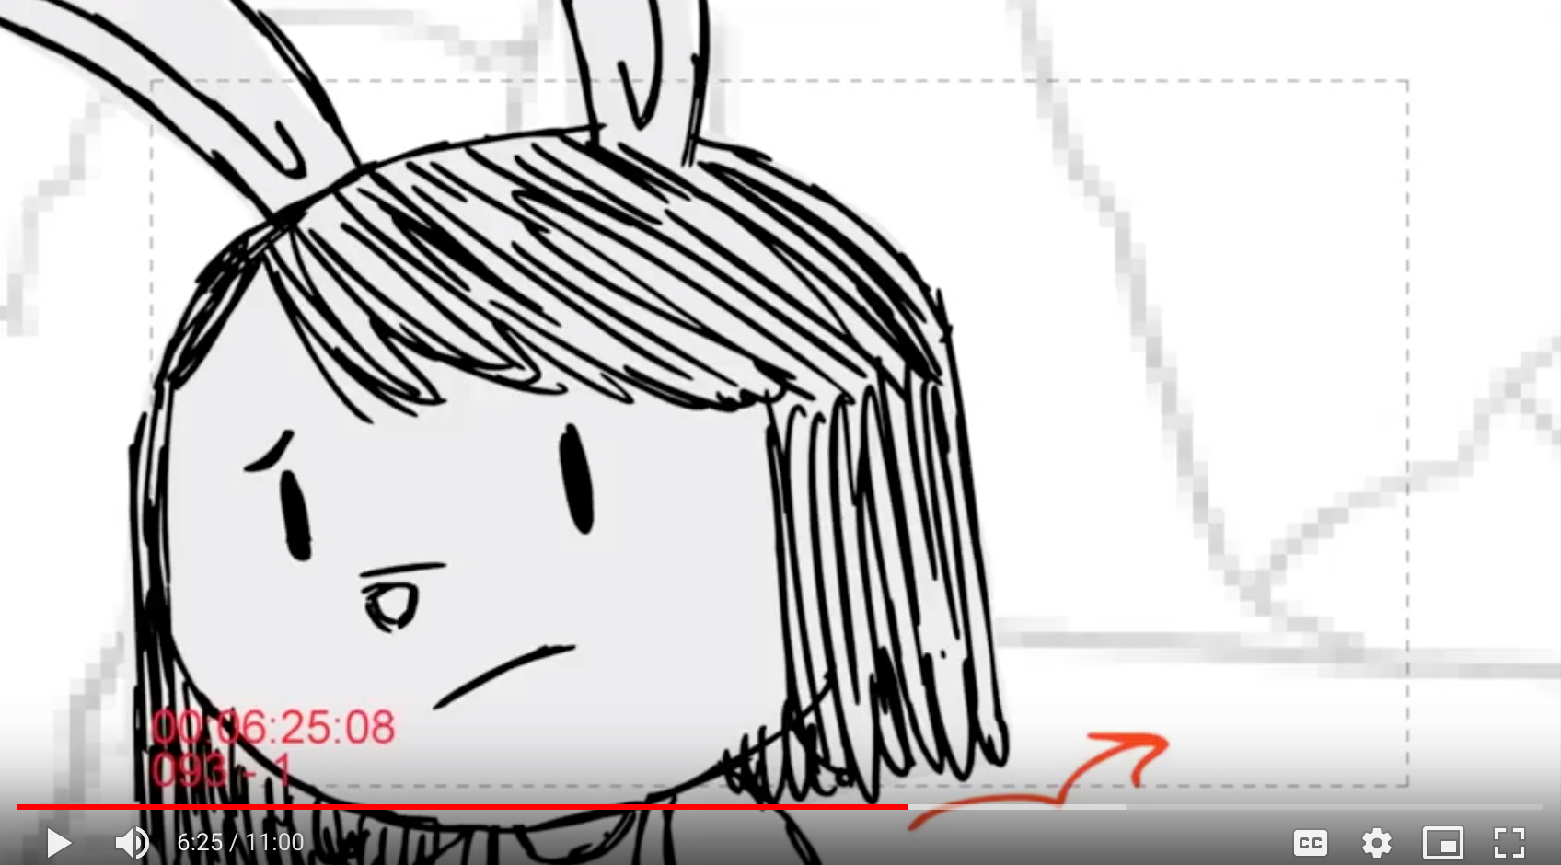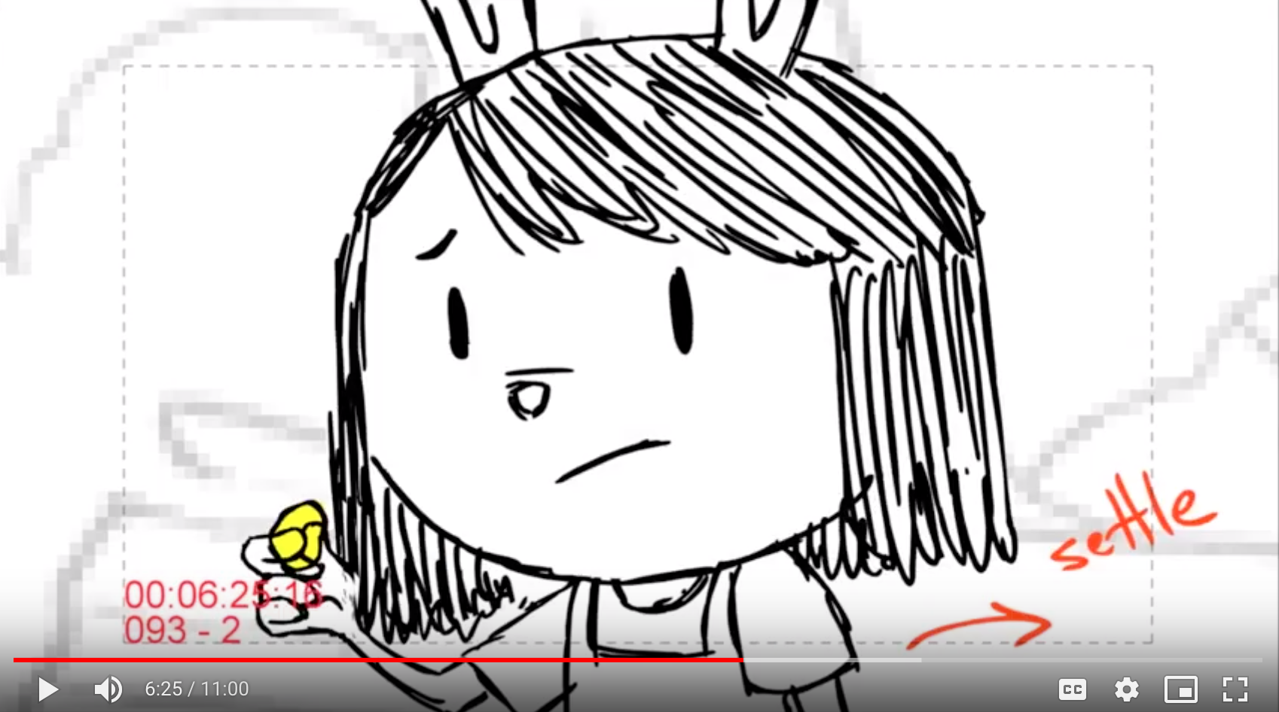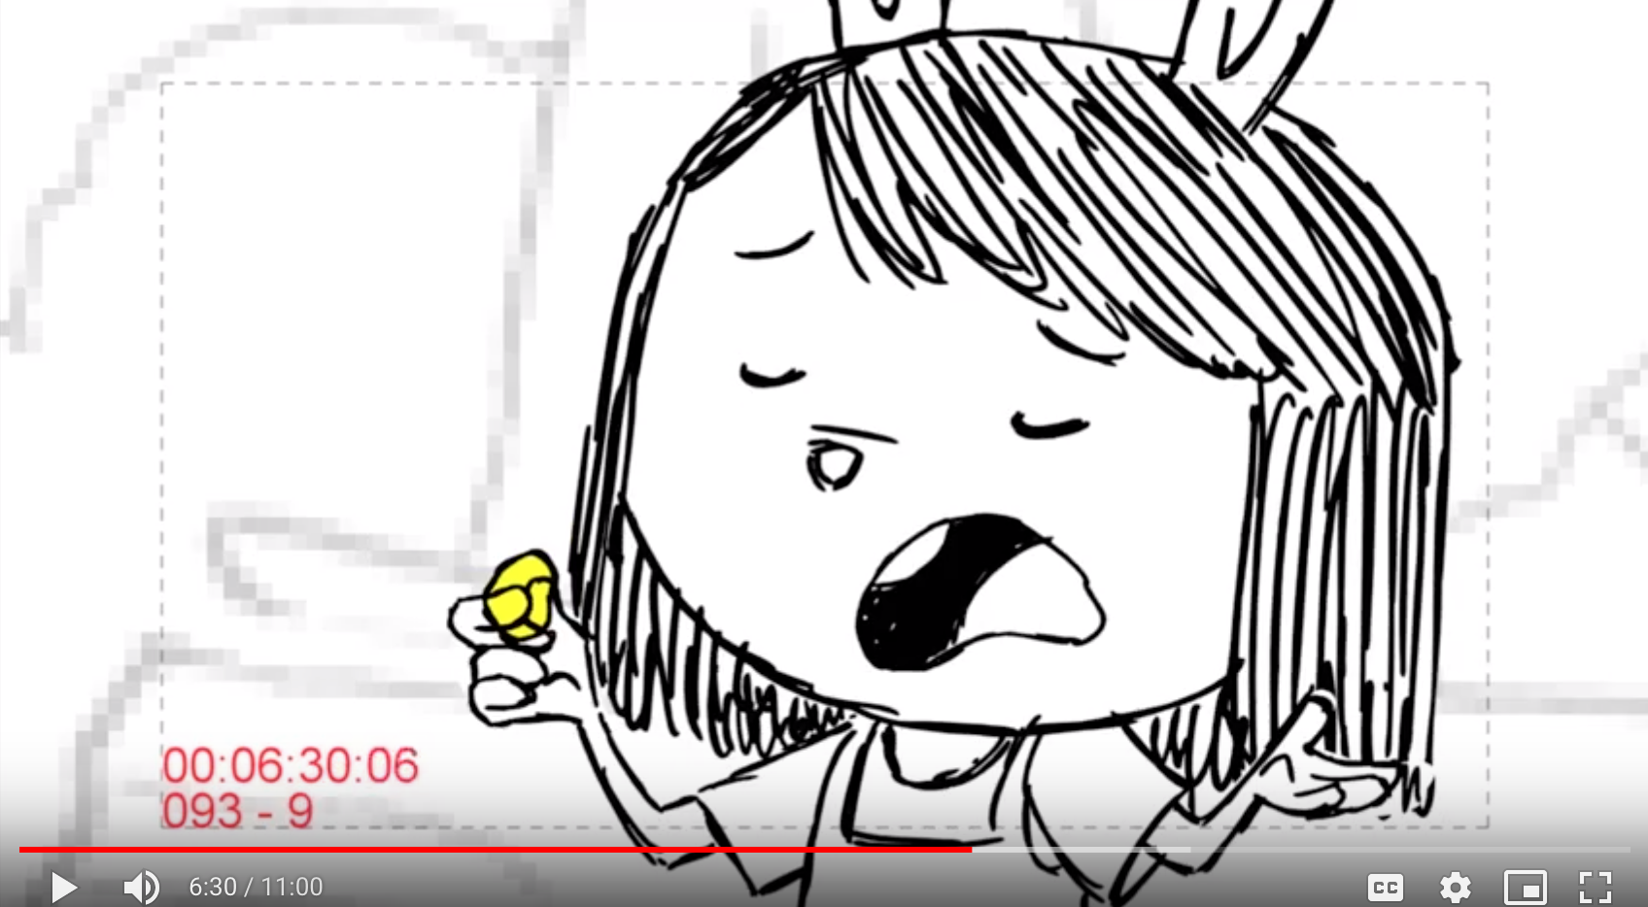

{FV_W3 Learning goal:
- Science and Engineering Practices - Making observations: encourage children to use their senses (touching) for observation to collect information about their world
- Content knowledge: Connect children’s everyday experiences with the physical science concept - viscosity of liquid - in the episode}

FV_W3: Hmmm, how does it feel when you touch honey?
Sticky: Good observation. When you touch honey, it sticks to your finger. Let’s go to a town picnic and explore why honey is so sticky and goopy.
Goopy: Good observation. When you touch honey, it sticks to your finger. Let’s go to a town picnic and explore why honey is so sticky and goopy.
Sweet: Honey tastes sweet, but how does it feel when you touch it? [repeat FV_W3]
I don’t know: Well, when I touch honey, it sticks to my finger. Let’s go to a town picnic and explore why honey is so sticky and goopy.
Fallback: Well, when I touch honey, it sticks to my finger. Let’s go to a town picnic and explore why honey is so sticky and goopy.

With the line, “how does it feel when you touch honey,” Elinor continues to press her thumb and index finger together and separates them, and we can see the honey arc between thumb and index.

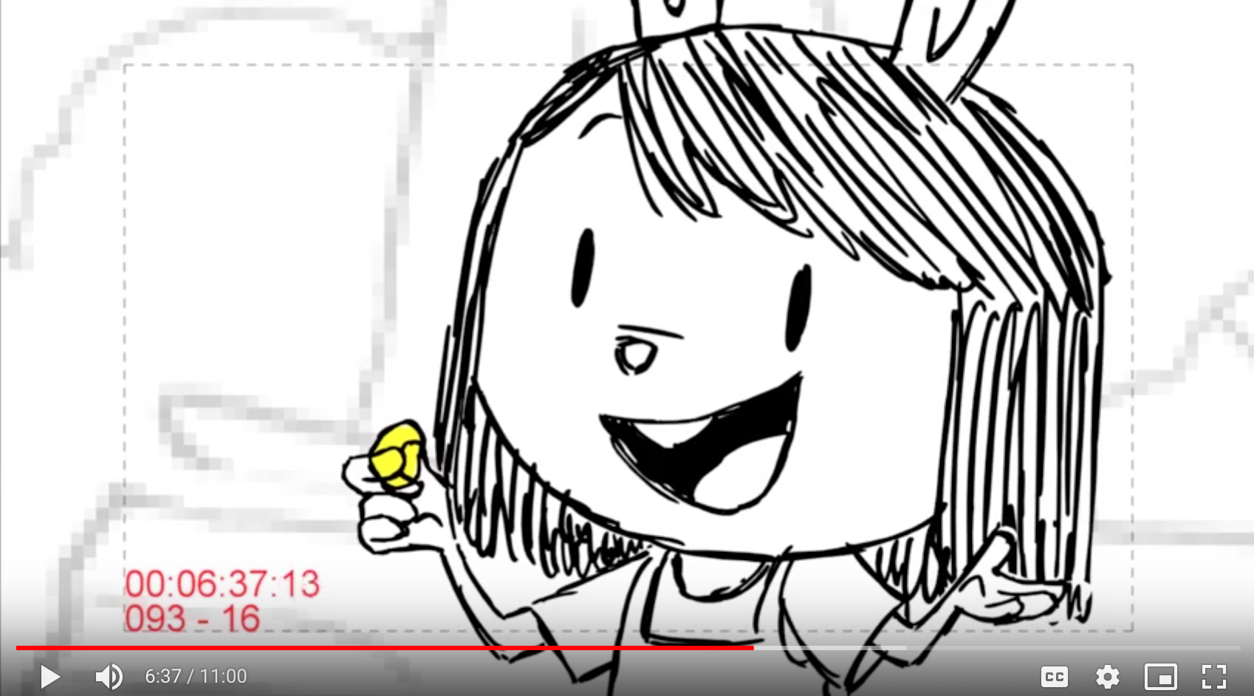

During feedback, Elinor repeats the same motion, of pressing her thumb and index finger together to demonstrate feeling the texture of honey.

During the episode
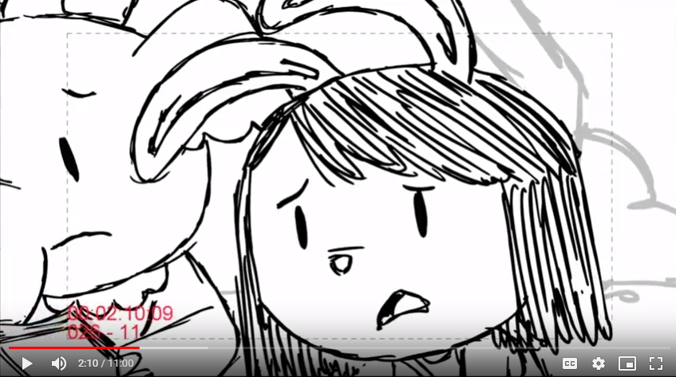

[Elinor sighs]

[2:10]
Elinor sighs (in episode) and immediately turns to the viewer. She straightens up from her slouch and shrugs as she asks the viewer “FV_Q1”. Frame remains closeup as Elinor waits for viewer response.

{FV_Q1 Learning goal:
- Science and Engineering Practices - Asking questions and defining problems: to spark children’s interest and curiosity, and encourage them to identify something that needs a solution (to solve the ketchup problem)
- Content knowledge: To direct children’s attention to the central plot of the story - the ketchup problem}

FV_Q1 (First viewing question 1): Why do you think the line is moving so slowly?
Many_people:Yes, everyone is waiting patiently in line for Ms. Gorilla’s ketchup! But I wonder why it’s taking so long.
Take_time_to_make_ketchup: Well, I think Ms. Gorilla already made the ketchup. But I wonder why it’s still taking so long to get the ketchup.
Turtle: That’s an interesting guess! Turtles walk slowly, but I don’t think there’s a turtle standing in this line. I wonder why it’s taking so long to get the ketchup.
Snail: I saw a snail too! But the snail isn’t in line. I wonder why it’s taking so long to get the ketchup.
I don’t know: I don’t know either. I wonder why it’s taking so long to get the ketchup.
Fallback: Hmmm, the line is sure moving slowly. I wonder why it’s taking so long to get the ketchup.

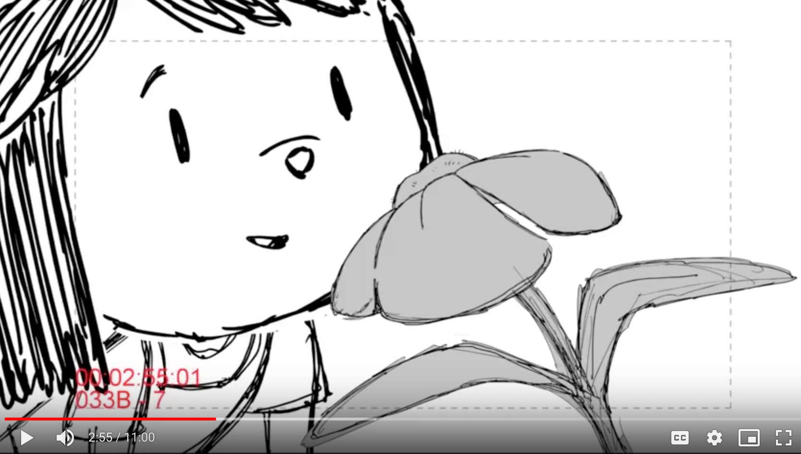

[2:54]

In episode, Elinor gives a quizzical face, thinks for a moment, and then says, “ohhh!” As Conversational Agent, she then turns to the viewer to ask FV_Q2, in an excited and low voice in an intimate, close-up, and highly observational moment. The responses are given in the same low, excited tone.

{FV_Q2 Learning goal:
- Science and Engineering Practices - making observations and predictions: to prime children to use their senses (use eyes to see) for observation to collection information and predict what they think is happening based on their observations and prior knowledge.
- Content knowledge: to connect children’s prior knowledge (association between bees and honey) with life science knowledge (the process of how bees make honey) in the episode}

FV_Q2: Did you see that!?- the bee just drank some juice from this flower! What do you think the bee is gonna make with the juice from this flower?
Honey: Hmmm, yes! Bees make yummy honey with the juice from flowers.
I don’t know: Hmmm, I think bees make yummy honey with the juice from flowers.
Fallback: Hmmm, I think bees make yummy honey with the juice from flowers.

[3:47]
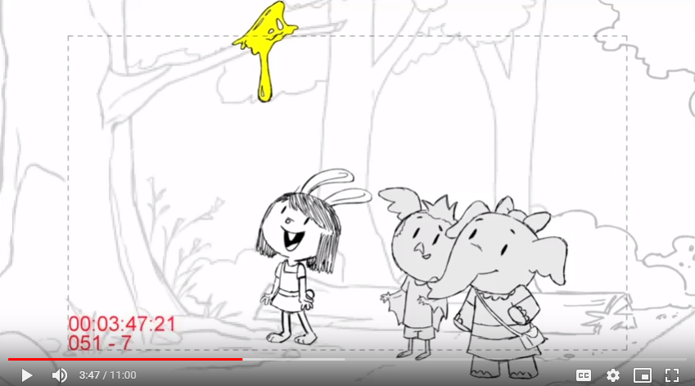

[After Elinor says “The honey is so goopy.” ]

In episode, Elinor says, “The honey is so goopy!” CLOSEUP on Elinor with same background. Olive and Ari are cut out of the closeup. Elinor turns her head to the audience and asks FV_Q3:

{FV_Q2 Learning goal:
- Content knowledge: to ensure the viewers understand the term goopy. }

FV_Q3: Ha ha! I just said a funny word -- “goopy”. What do you think GOOPY means?
Slimy/GooeyThick/Sticky/Slow: Yes, that’s exactly what I mean! Goopy is a word for a liquid that is thick and moves very slowly just like honey.
I don’t know: Well, goopy is a word for a liquid that is thick and moves very slowly just like honey.
Fallback: Well, goopy is a word for a liquid that is thick and moves very slowly just like honey.

[5:02]
[After Ari flapped his wings]
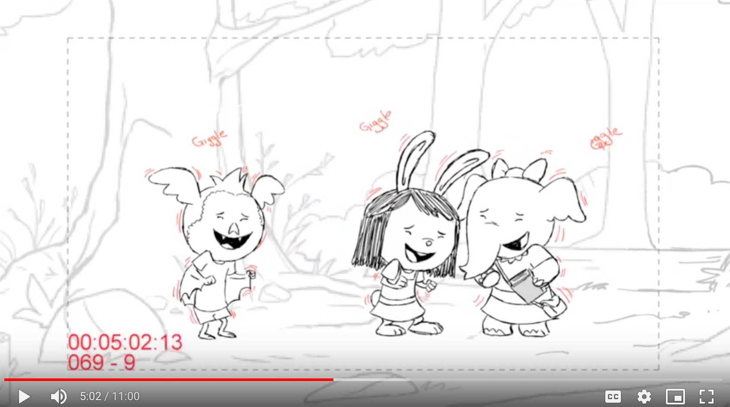

In the episode, Ari flaps his wings as he says, “That is awesome,” and the kids giggle. At about 5:02, we go from the wide shot in the episode to a CLOSEUP for Conversational Agent on Elinor only. Olive is cut out of frame. Immediately following the giggle, Elinor turns to audience
and asks FV_Q4.

{FV_Q4 Learning goal:
- Science and Engineering Practices - developing and using models & Crosscutting concepts - cause and effect: to prime children to construct cause-effect relationships between the bees actions and the concentration of nectars
- Content knowledge: to reinforce children’s understanding of the life science content of how bees make honey; and to introduce a new physical science vocabulary word “concentration” }

<Version 1>
FV_Q4: When Ari flaps his wings, we can feel the air moving and blowing! Bees flap their wings too when they make honey. Why did the bees need to flap their wings when making honey?
Take water out: Yes, Olive’s Nature Book said that bees flap their wings to fan the liquid nectar. And as the water comes out, the nectar becomes thicker and goopier! This is called “con-cen-tra-tion,” nectar is con-cen-trated into honey.
Fly: Yes, bees do flap their wings to fly. But when bees make honey, they flap their wings to fan the liquid nectar. And as the water comes out, the nectar becomes thicker and goopier! This is called “con-cen-tra-tion,” nectar is con-cen-trated into honey.
I don’t know: Bees flap their wings to fan the liquid nectar. And as the water comes out, the nectar becomes thicker and goopier! This is called “con-cen-tra-tion,” nectar is con-cen-trated into honey.
Fallback: Bees flap their wings to fan the liquid nectar. And as the water comes out, the nectar becomes thicker and goopier! This is called “con-cen-tra-tion,” nectar is con-cen-trated into honey.

<Version 2>
FV_Q4: When Ari flaps his wings, we can feel the air moving and blowing! Bees flap their wings too when they make honey. Why did the bees need to flap their wings when making honey?
Take water out: Yes, Olive’s Nature Book said that bees flap their wings to fan the liquid nectar. And as the water comes out, the nectar becomes thicker and goopier! The nectar turns into honey.
Fly: Yes, bees do flap their wings to fly. When bees make honey, they flap their wings to fan the liquid nectar. And as the water comes out, the nectar becomes thicker and goopier! The nectar turns into honey.
I don’t know: Bees flap their wings to fan the liquid nectar. And as the water comes out, the nectar becomes thicker and goopier! The nectar turns into honey.
Fallback: Bees flap their wings to fan the liquid nectar. And as the water comes out, the nectar becomes thicker and goopier! The nectar turns into honey.

[6:38]

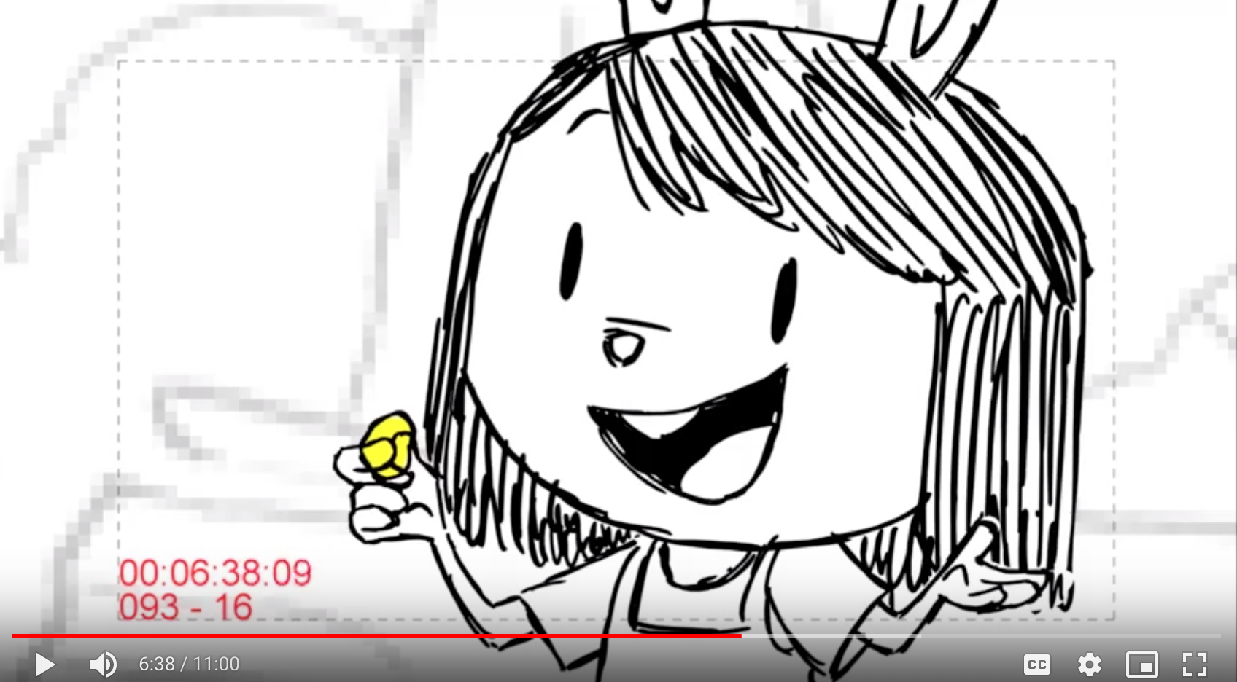

“...then maybe adding water back in, will make it runnier and less goopy!” For Conversational Agent, frame is unchanged (remains as tight closeup on Elinor.) Elinor turns to viewer and asks,

{FV_Q5 Learning goal:
- Science and engineering practices - making predictions: to encourage children to use knowledge from observations and prior experiences (knowing that taking water out will make liquid more goopy) to make an informed hypothesis
- Content knowledge: to prime children to think about the physical science process of dilution immediately following this question; to reinforce that dilution is an “opposite” process of concentration (addition of water vs removal of water) }

FV_Q5: Let’s make a prediction! Do you think adding water in, will get all this goopy honey off Ari?
Yes: I think so too! Let’s try it!
No: Let’s try it and see!
Fallback: Let’s try it and see!

[8:30]
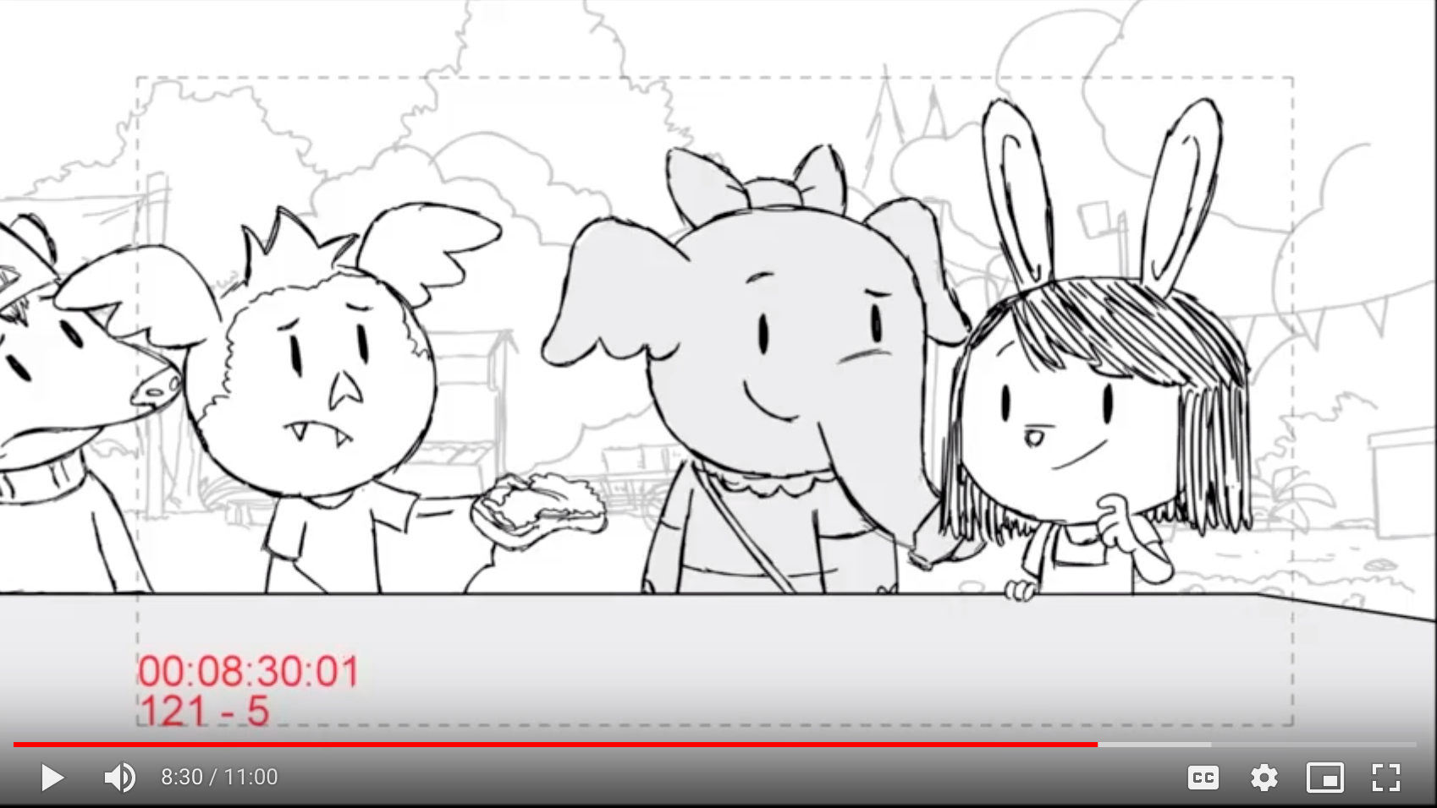

[After Ari and Olive failed to get the ketchup out]
Animation: Elinor turns to the audience

In episode, Ari and Olive fail to get ketchup out of the bottle. Just as Elinor says “hmmm.,” we closeup on her, cutting out Olive. Elinor turns to viewer to ask FV_Q6:

{FV_Q6 Learning goal:
- Science and engineering practices - Constructing explanations and designing solutions: to encourage children to use their prior knowledge (“goopy things move really slow”) to interpret a phenomenon and generate an evidence-based answers.
- Content knowledge: to determine whether children understand liquid with high viscosity moves slowly; to reconnect to FV_Q1 on the slowly-moving line}

FV_Q6: The ketchup isn’t coming out of the bottle! I wonder why? Why do you think the ketchup isn’t coming out?
No_water: Good thinking! Ms. Gorilla's ketchup has very little water! It is so goopy and thick that it is stuck inside the bottle.
Goopy/Thick: Good thinking! Ms. Gorilla's ketchup is so goopy and thick that it is stuck inside the bottle. We need to find a way to make it less goopy.
Sticky/Stuck: Good thinking!, Ms. Gorilla's ketchup is stuck inside the bottle because the ketchup is so goopy. We need to find a way to make it less goopy.
Fallback: Ms. Gorilla's ketchup is so goopy that it is stuck inside bottle. We need to find a way to make it less goopy.

Elinor’s line in mid-shot, “Ari, Olive. I wonder if we could solve the ketchup problem…” follows seamlessly.
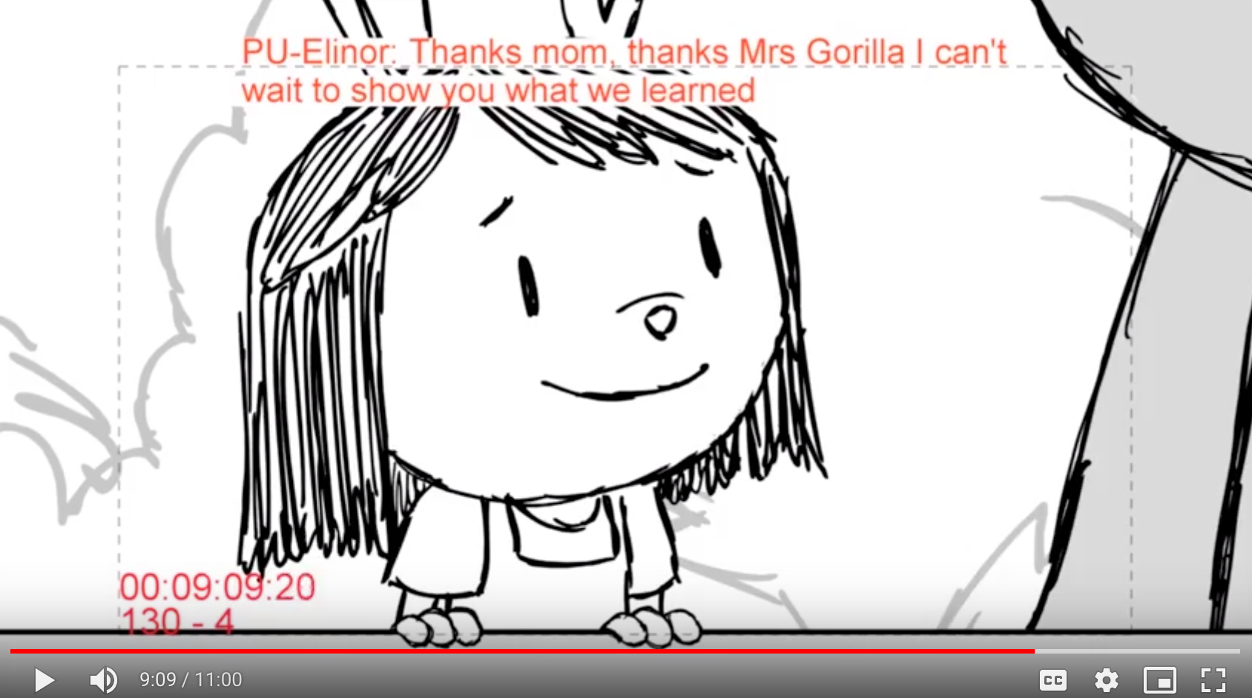

At 9:09, Elinor turns to the viewer, closeup standing behind the ketchup serving table. As a playful aside directly to the viewer, she asks the viewer to guess her next move, given her recent observations and discoveries. Elinor is excited to ask and proud of her newfound knowledge.

{FV_Q7 Learning goal:
- Science and engineering practices - Prediction and constructing explanations and designing solutions: to encourage children to use their prior knowledge (use water to wash honey off Ari’s face) to predict my solution to problem (adding water to the goopy ketchup makes it come out of the bottle more quickly)
- Content knowledge: to determine whether children can transfer the concept of dilution (adding water can make honey less goopy) to a novel scenario (adding water can make ketchup less goopy); and to introduce the physical science vocabulary word “dilution”}

<Version 1>
FV_Q7: Guess what I’m going to do? How am I going to get the ketchup to come out of the bottle?
Ambiguous_water: Yes, that’s what I’m thinking! I’m gonna add water to the ketchup and make it less goopy. This is called “dilution.” Adding water dilutes the ketchup! Let’s see if it works!
Add_water_in: Yes, that’s what I’m thinking! I’m gonna add water to the ketchup and make it less goopy. This is called “dilution.” Adding water dilutes the ketchup! Let’s see if it works!
Take_water_out: Remember how we got the goopy honey off Ari’s face? We sprayed Ari’s face with water, and that made the honey less goopy! That’s called “dilution.” Now I’m gonna add water to dilute the ketchup! Let’s see if it works!
Fallback: Remember how we got the goopy honey off Ari’s face? We sprayed Ari’s face with water, and that made the honey less goopy! That’s called “dilution.” Now I’m gonna add water to dilute the ketchup! Let’s see if it works!

<Version 2>
FV_Q7: Guess what I’m going to do? How am I going to get the ketchup to come out of the bottle?
Ambiguous_water: Yes, that’s exactly what I’m thinking! I’m gonna add water to the ketchup and make it less goopy. Let’s see if it works!
Add_water_in: Yes, that’s exactly what I’m thinking! I’m gonna add water to the ketchup and make it less goopy. Let’s see if it works!
Take_water_out: Remember how we got the goopy honey off Ari’s face? We sprayed Ari’s face with water, and that made the honey less goopy! Now I’m gonna add water to the ketchup and make it less goopy. Let’s see if it works!
Fallback: Remember how we got the goopy honey off Ari’s face? We sprayed Ari’s face with water, and that made the honey less goopy! I’m gonna add water to the ketchup and make it less goopy. Let’s see if it works!

Elinor’s line, “ok, let’s try mixing in water…” follows seamlessly.

Second viewing
During the episode

[Elinor sighs]

[2:10]
Elinor sighs (in episode) and immediately turns to the viewer. She straightens up from her slouch and shrugs as she asks the viewer “SV_Q1”. Frame remains closeup as Elinor waits for viewer response.

{SV_Q1 Learning goal:
- Science and engineering practices - Constructing explanations and designing solutions: to encourage children to use their prior knowledge (what they have seen in the previous viewing - the goopiness of ketchup) to interpret a phenomenon (the line moves slowly) and generate evidence-based answers
- Crosscutting concept - to determine whether children understand the cause-effect relationships between the goopiness of the ketchup and the slowness of the line
- Content knowledge - Physical science concept of viscosity (goopy liquids move slowly)

SV_Q1 (second viewing question 1):Uh oh, we are back in line waiting for ketchup again. Why do you think the line is still moving so slowly?
Ketchup goopy: Oh yeah! Let’s help make the ketchup come out of the bottle faster so that so that everyone can get their ketchup.
The line is goopy: Well we can’t say the line is goopy, but you’re right, the line is slow. Ms. Gorilla’s ketchup is so thick and goopy. Let’s help make the ketchup come out of the bottle faster so that everyone can get their ketchup.
Many_people: Yeah, everyone likes Ms. Gorilla's ketchup! Her ketchup is so thick and goopy. Let’s help make the ketchup come out of the bottle faster so that everyone can get their ketchup.
Take_time: Yeah, it takes time to serve ketchup to everyone in this line! Ms. Gorilla’s ketchup is so thick and goopy. Let’s help make the ketchup come out of the bottle faster so that everyone can get their ketchup
Reprompt: The line is moving really slowly. Do you think it has something to do with the ketchup?
Yes: Yeah, Ms. Gorilla’s ketchup is so thick and goopy. Let’s help make the ketchup come out of the bottle faster so that everyone can get their ketchup.
No: Ummm, I think it has something to do with Ms. Gorilla’s ketchup. The ketchup is so thick and goopy. Let’s help make the ketchup come out of the bottle faster so that everyone can get their ketchup.
Fallback: Ms. Gorilla’s ketchup is so thick and goopy. Let’s help make the ketchup come out of the bottle faster so that everyone can get their ketchup.

[2:55]

In episode, Elinor gives a quizzical face, thinks for a moment, and then says, “ohhh!” As Conversational Agent, she then turns to the viewer to ask FV_Q2, in an excited and low voice in an intimate, close-up, and highly observational moment. The responses are given in the same low, excited tone.

{SV_Q2 Learning goal:
- Science and engineering practices - making observations: to prime children to use their senses (use eyes to notice) for observation to collection information
- Content knowledge: to clarify one common confusion about the life science process of bees making honey (bees gather nectar instead of honey from flowers); to reinforce the low viscosity of nectar}

SV_Q2: I notice that the bee is drinking something from the flower. What is that?
Nectar: Yes, I think so too. The bee is drinking nectar from the flower. Nectar is watery and runny, just like juice!
Juice: Yes, I think so too. The bee is drinking juice called “nectar” from the flower. It’s watery and runny.
Honey: There’s no honey in flowers! A sugary juice called “nectar” is in flowers. Bees take this nectar to their home and turn it into honey.
Water: Hmmm, the bee is drinking juice called “nectar” from the flower. It’s watery and runny.
Reprompt: Hmmm, Is the bee drinking honey from the flower, or is it drinking nectar from the flower?
Fallback: The bee is drinking juice called “nectar” from the flower. It’s watery and runny.

[3:45]
In episode, Elinor leaps up three times toward the honey and shouts, “that’s… so… INTERESTING!!” She lands in a wide shot. For Conversational Agent, we cut to a closeup of Elinor with same background. She turns to the audience and asks in the same thrilled voice SV_Q3:

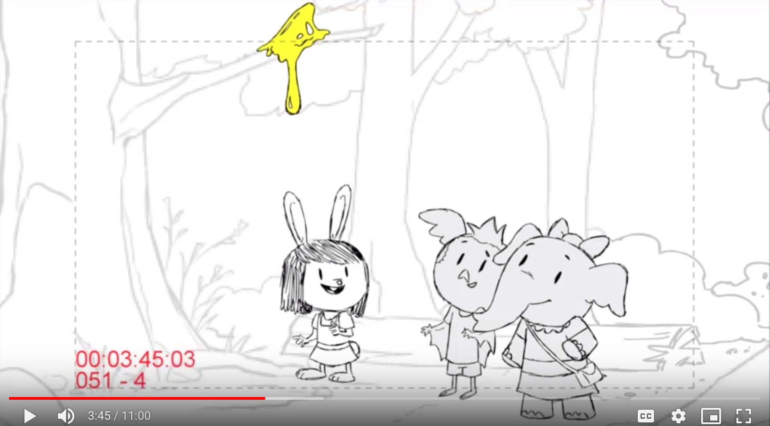

{SV_Q3 Learning goal:
- Science and engineering practices - constructing explanations and designing solutions: to encourage children to use their prior knowledge (what they have seen in the previous viewing - the goopiness of honey) to interpret a phenomenon and generate evidence-based answer
- Content knowledge: to ensure that children understand the physical science concept that high viscosity is an important property of goopy liquids that causes them to stick to things and move very slowly}

SV_Q3: Why do you think the honey is sticking to the branch?
Goopy: Yes, I think so too!
Sticky: Yes, I think so too!
Runny: Well… let’s think about this! If the honey was runny, it would be running off the branch like water!
No_water: Yes, I think so too! There’s very little water in the honey.
Reprompt: Well… let’s think about how it feels when you touch honey! Is the honey runny like water or is it sticky and goopy?
Fallback: Well… let’s think about how it feels when you touch honey.

Elinor’s line, “the honey is so goopy!” immediately follows.

[4:19]
[After Ari flapped his wings]
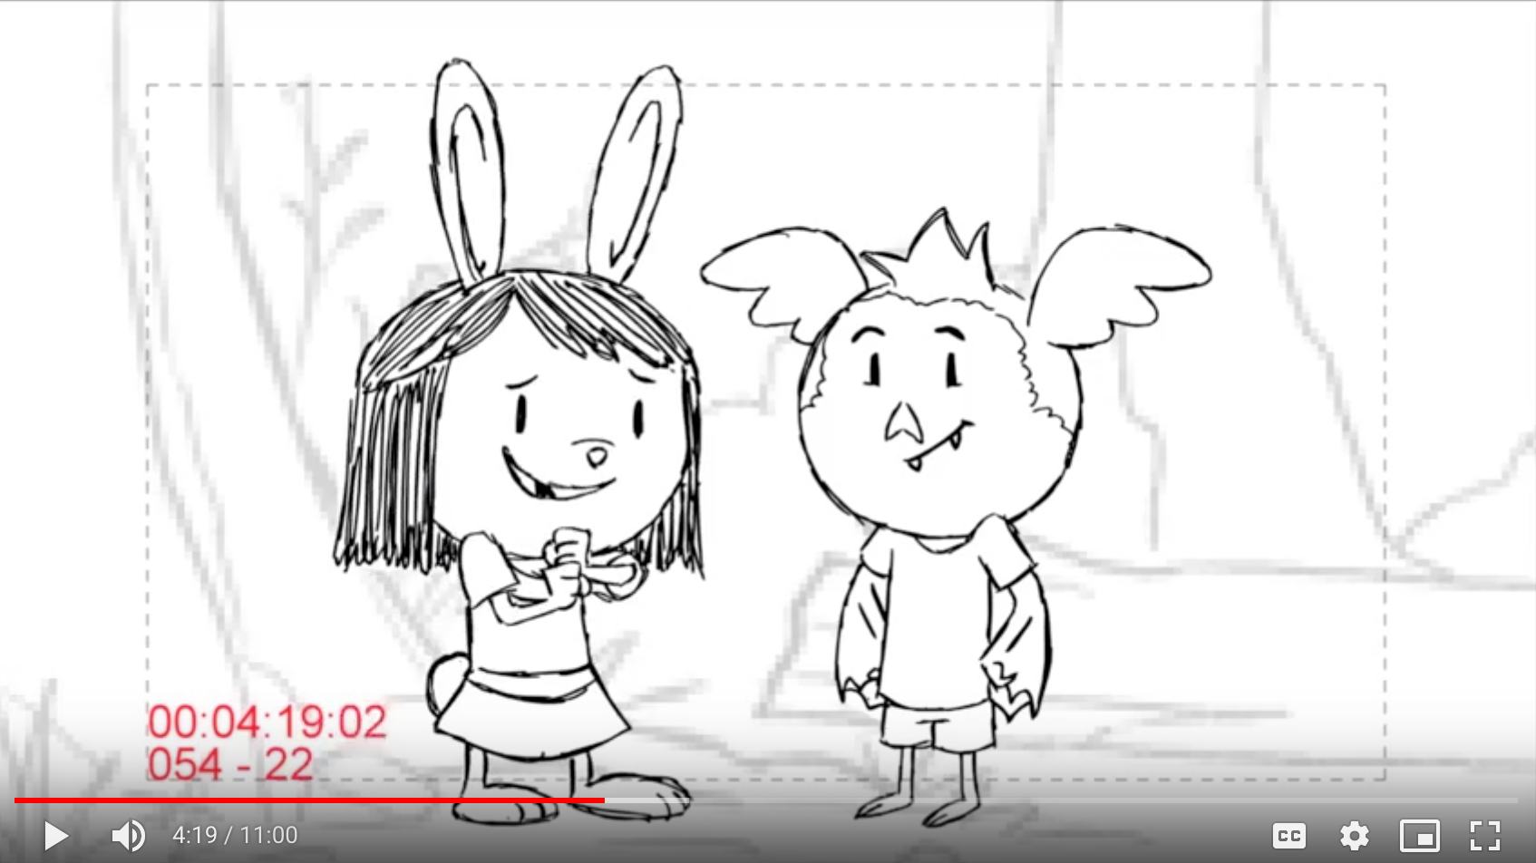

In the episode, Elinor asks, “how did the bees turn something so runny into something so goopy?” Ari offers the hypothesis, “Hm…. Maybe they cook it, like soup!” Elinor hypothesizes, “Yeah or maybe they squeeze it!” For Conversational Agent, cut to closeup of Elinor with same background. She asks the viewer,

{SV_Q4 Learning goal:
- Science and engineering practices - constructing explanations and designing solutions: to encourage children to use their prior knowledge (what they have seen in the previous viewing - the concentration process) to design solutions to problems
- Content knowledge: to ensure that children understand the physical science phenomenon that liquids can be concentrated by removal of water}

SV_Q4: How do you think the bees turn something so runny into something so goopy?
Squeeze: Yeah, when you squeeze something, water comes out, so maybe the bees do that..?”
Cook: Yeah, when you cook soup, water comes out and the soup gets thicker, so maybe the bees do that…?
Take water out: Yeah, when you take water out of something, there’s less water in it, so maybe the bees do that..?
Pour: Yeah, when you pour water out of something, there’s less water in it, so maybe the bees do that..?
Put water in: Hmm… when you put water into something, it gets more runny, and the bees are trying to turn something runny into something goopy.
Put goop in: “Yeah, when you add goop to something, it’ll become goopier! Maybe the bees do that…?
Flap wings: Yeah, bees could flap their wings to fan the nectar! And that may turn the runny nectar into goopy honey...?
Reprompt: Hmm…I’m curious about what you think! To turn something runny into something goopy, did the bees take water out from the nectar or did the bees add water in?
Fallback: Yeah, the bees want to make their runny nectar into thick honey, but I wonder how the bees do it…?

<version 1>

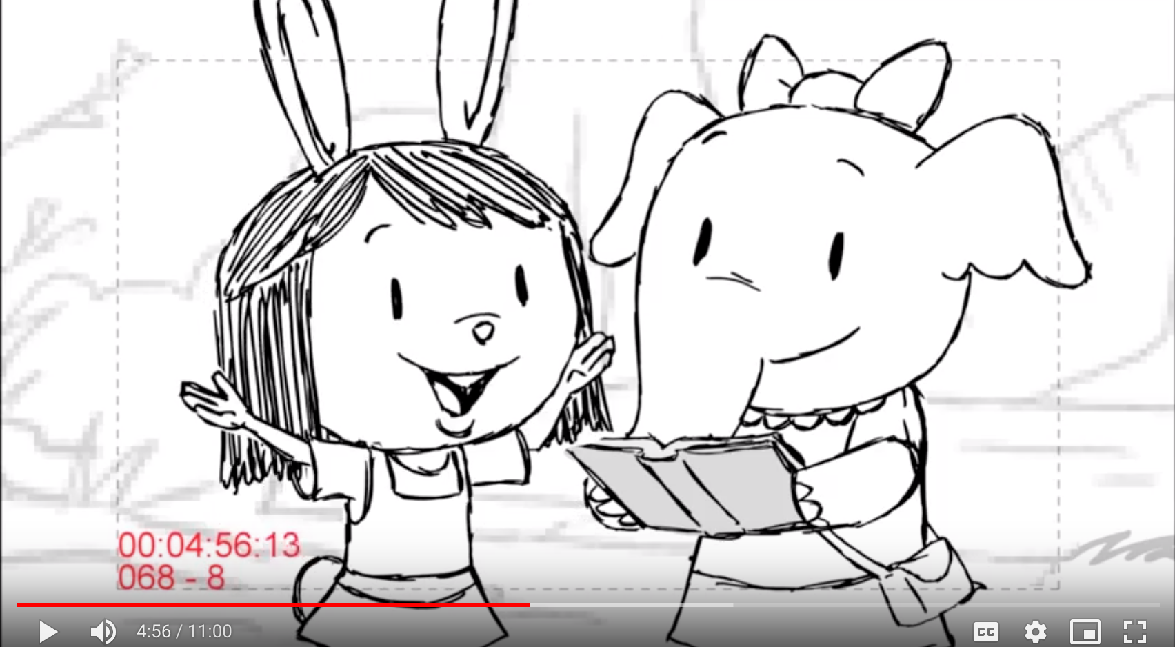

{learning goal: to deepen children’s understanding of this concept by introducing the scientific term “concentration”}

[4:57]
Olive reads from book. Elinor comes over and says, “oh, so taking the water out, is what makes honey goopy.” For conversational Agent, we push into to Elinor, who is still looking at the book over Olive’s shoulder. She continues, “the book says this is called “concentration;” when water comes out of a liquid and it becomes less runny and more goopy! She turns to the viewer and says, “Con-cen-tra-tion… runny things become goopy!”

<remove this scene in Version 2>

[6:26]

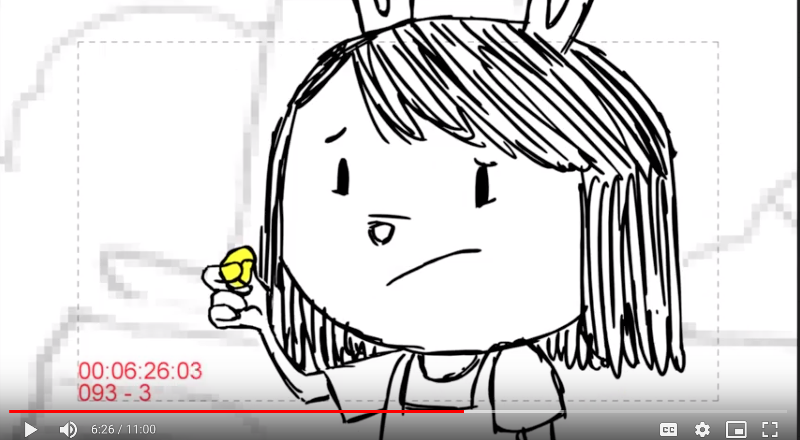

[Elinor: It’s so gooey. Hmm.]
Animation: Elinor turns to the audience

In episode, Elinor touches the honey on Ari’s face and presses her thumb and index finger together in closeup. This same frame is used for Conversational Agent, with honey-covered fingers showing exactly as in the episode. Elinor turns to the viewer to ask FV_Q5. As she waits for responses, she continues to hold up her fingers, showing the honey. In reponses, when she says “the honey is so goopy,” she demonstrates this by closing and opening her thumb and index finger, and looks at her hand briefly before turning back to the viewer.

{SV_Q5 Learning goal:
- Science and engineering practices - constructing explanations and designing solutions: to encourage children to use their prior knowledge (what they have seen in the previous viewing - the dilution process) to design solutions to problems
- Science and engineering practices - Planning and carrying out investigations: to prime children to focus on how Elinor and friends experiment their proposed solution (use water to make honey less goopy)
- Content knowledge: to ensure that children understand the physical science phenomenon that liquids can be diluted by addition of water}

SV_Q5: What should we do to get the goopy honey off Ari?
Wipe it: Ok that is one idea. the honey is so goopy, it’ll stick to everything!
Scoop it: Ok that is one idea. the honey is so goopy, it’ll stick to everything!
Wash it: Oh, use water! That’s an interesting idea!
Add water in: Oh, use water! That;s an interesting idea!
I don’t know: Hmm, let’s think about this.
Reprompt: Hmm, should we use water to get the goopy honey off Ari or should we wipe the honey off?
Fallback: Hmm, let’s think about this.

Elinor’s speech
beginning with “I wonder..” follows seamlessly from each of the Conversational Agent responses above.

[8:39]
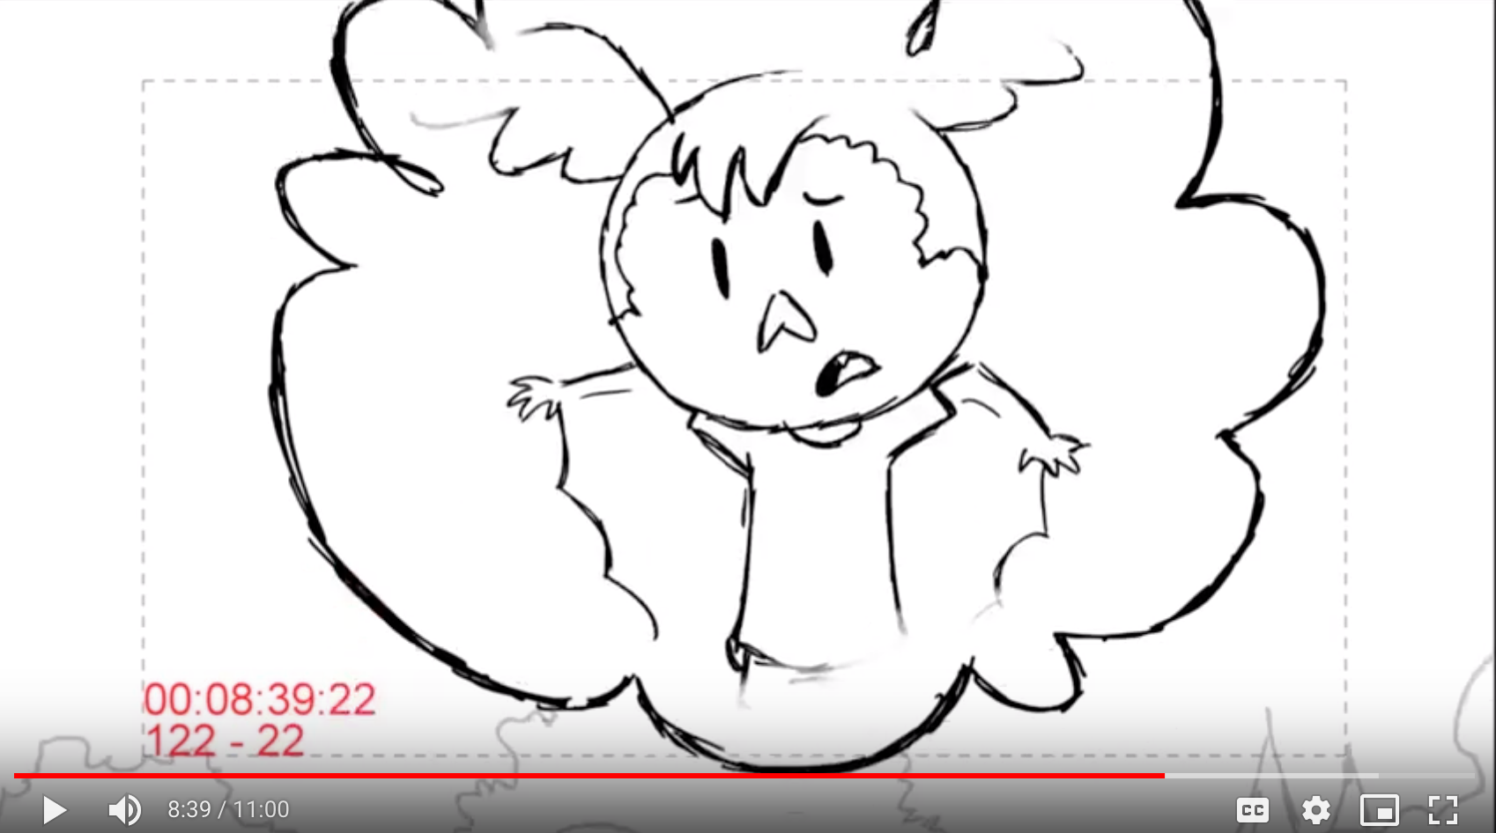

[After Ari and Olive failed to get the ketchup out]
Animation: Elinor turns to the audience

In episode, Ari and Olive fail to get ketchup out of the bottle. Just as Elinor says “hmmm.,” we closeup on her, cutting out Olive. Elinor turns to viewer to ask FV_Q6: i
[After Ari and Olive failed to get the ketchup out]
Animation: Elinor turns to the audience

In episode, Ari and Olive fail to get ketchup out of the bottle. Elinor says “hmmm, Ari, Olive, I wonder if we could solve the ketchup problem, in the same way we solved the honey problem” while a thought bubble illustrates the honey solution. For CA, we cut to closeup from thought bubble to Elinor at the table, immediately following her line and before Olive responds. Elinor turns to viewer to ask SV_Q6:

{SV_Q6 Learning goal:
- Science and engineering practices - constructing explanations and designing solutions: to encourage children to use their prior knowledge (what they have seen in the previous viewing - the dilution process) to design solutions to problems
- Science and engineering practices - Planning and carrying out investigations: to prime children to focus on how Elinor and friends experiment their proposed solution (use water to make ketchup less goopy)
- Content knowledge: to determine whether children can transfer the physical science concept dilution (adding water can make honey less goopy) to another scenario (adding water can make ketchup less goopy); and to reinforce the physical science vocabulary word “dilution”}

<Version 1>
SV_Q6: How about you? What do you think we should do to make the ketchup less goopy?
Add_water: Yes, we added water to dilute the honey and make it less goopy. That’s how we could get the honey off Ari’s face!
Take_water_out: Emm, taking water out would make the honey more goopy. We actually added water to dilute the honey and make it less goopy. That’s how we could get the honey off Ari’s face!
Reprompt: Think about what we did to get honey off Ari’s face, did we add water in or did we take water out?
Fallback: Think about what we did to get honey off Ari’s face: we added water to dilute the honey and make it less goopy!

<Version 2>
SV_Q6: How about you? What do you think we should do to make the ketchup less goopy?
Add_water: Yes, we added water to make the honey less goopy. That’s how we could get the honey off Ari’s face!
Take_water_out: Emm, we actually added water to make the honey less goopy. That’s how we could get the honey off Ari’s face!
Reprompt: Think about what we did to get honey off Ari’s face, did we add water in or did we take water out?
Fallback: Think about what we did to get honey off Ari’s face: we added water to make the honey less goopy!

Immediately following, Olive says, “you mean…” as in script.

Sara Sweetman Top Note:
I think this is much improved over the last draft and liked many of the questions and responses. I like the prediction questions and would love to see some questioning that follows up on what happens after a prediction (predictions are never right or wrong rather what happens matched what you were thinking or even better it doesn't match and you've learned something new- which is the ultimate goal in science). As much as we can get kids to ask questions, make predictions, make connections to their own environment the better. I would love to see questions that ask them about what they drink at home and if it is runny or goopy and questions that get them to compare and contrast more. I worry that some of the questions feel like science text book questions that come at the end of the chapter and are asking questions that promote the misconception that you are good at science if you memorize facts and big fancy words. It is hard fine line because introducing new vocabulary is great and I fully encourage it especially when it helps the child communicate about their new understanding or help to transfer their learning to new situations. Like the word 'liquid' and the word 'flow' (fast and slow). While the introduction of concentration and dilution was done much better in this round I don't think they are words that preschoolers will be able to apply for many years into their lives. It might not hurt to leave it in and research might tell us that preschoolers can successfully use the words right after interacting with the episode, but I would not want that to pull away from the more important process of being able to wonder, observe, predict, and connect/ apply knowledge.
It is interesting how challenging asking questions is in the digital format! Good preschool teachers ask 100s of questions a day but they have the opportunity to correct misunderstandings and redirect thinking. Since AI can't quite do this individually this is really tricky (and exciting)!

