ELINOR WONDERS WHY
“The Wind In The Web”
PREMISE – 3/4/2019

Elinor’s Question: Why are spiderwebs full of holes?
Logline: Elinor and her friends learn from Nature what catches and doesn’t catch the wind when they volunteer to put up a big sign for the town park concert.

Curriculum Goals:
LS5b. Identify the habitats of familiar animals and plants in the environment [ Spiders live in spider webs
ND3. (RTL Crosscutting concept ‘Structure and Function’): Understand that structures and materials in the natural world can be used or can inspire the engineering of structures with similar function in the designed world. [They engineer the sign to have wind holes to mimic the spider web].
SEP: To be determined at Outline

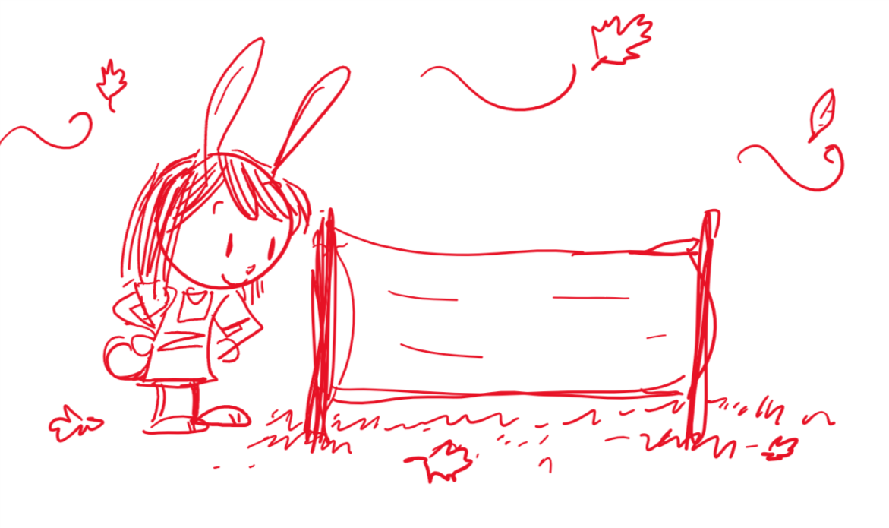
It’s a brisk fall day, and Elinor and her friends Olive and Ari are walking along the forest, holding two sticks and what looks like a rolled-up tarp. As they walk, they talk about how excited they are about the fall season. They love how the weather changes and all the plants change and adjust. When they get to a certain spot, they plant the sticks on the ground and unroll and put the tarp between them, revealing a kid-drawn advertisement for the weekly park concert (it’s just a few doodles of music notes and instruments and an arrow pointing to the concert site). The kids talk about how they volunteered to make the sign to help catch people’s attention so they go to the concert, which Elinor’s mom is helping to organize. After admiring their sign, a sudden breeze blows through, and the sign billows and strains. Then, the wind picks up even more and the sign blows away from the sticks! Uh oh!

The kids go running to find their sign, and as they look around, Elinor notices that leaves also catch the wind and get blown around. She also notices a few birds flying high, holding out their wings and staying afloat against the wind. At that moment, Ari finds the sign and they head back to put up the sign again. As they are putting it up again, Elinor notices a spider’s web in a nearby tree branch and says hello to the spider. The kids are happy with the sign, but then the breeze blows through again, causing the sign to billow and move. As the wind picks up slightly, the sign strains and the kids struggle to keep the sign in place.

Just then, Elinor notices that the spider’s web is only slightly being affected by the wind, and looks back and forth between it and their tarp. She has an Aha! moment. She shares her observations with her friends: things that are wide will catch the wind, but if they have lots of holes in, it will not. In song, she shows her friends how the leaves and bird wings catch the wind, but the web has holes that let the air through. This give Elinor an idea: they cut some holes in the sign (in decorative places) to let the wind through and it no longer blows away. Problem solved, and passersby’s walk by and notice the sign!

Sara Sweetman Notes:

This could be a fun fall show. I think the focus should be on the fact that "air" which is something we move through all the time yet don't think twice about can push/ pull other objects...especially when it is windy. Wind is a major factor in many engineered designs (animal homes to help stay out of the wind or to not get blown down). This is an opportunity for the characters to go through the design process...identify the signs criteria, test out different ideas and work to improve their design from testing data.
Is there research that shows that holes in signs help the sign withstand the wind? - We would want the solution to be an accurate one.

Another story related could be about the construction of weather tools to measure the wind. I have worked with early learners to understand about measuring wind. We make pinwheels and the kids figure out how stronger winds make the pinwheels turn more per a certain time than wind that this less strong. Then they learn that is how an anemometer works.
Sara

PS...the following is from a first grade curriculum that we use in our schools about young children and learning about air. I thought it might be interesting.
Primary students know some basics about air. They know that they breathe air and that air is in balloons and bubbles. When pressed to think about it, they will report that air is all around and that wind is air in motion. Still, primary students have difficulty understanding that air is matter. Their position often is that, if you can’t see, feel, hear, smell, or taste it, it isn’t real. Primary students who depend on firsthand personal experience to validate their universe will question the assertion that air and other gases are substantial.
The question of what makes a gas a gas is not important in early childhood. Rather, students should be introduced to matter in the gaseous state as natural and commonplace. When students capture air, compress air, and move air, they build a repertoire of experiences that contribute to the idea of gas as real stuff. As the module continues, students have experiences in which they put air to use, further enhancing their knowledge of gases.

