ELINOR WONDERS WHY
“Family Matters”
PREMISE – 5/31/2019

Elinor’s Question: How do rabbits get different patterns?
Logline: Elinor goes to meet some cousins, and learns how traits can differ among members of the same species.

Curriculum Goals:
- LS1c: Categorize a variety of animals and plants based on their physical characteristics [ They compare how the cousins look similar and different]
- LS6. Understand that individuals of the same kind of plant or animal are recognizable as similar but can also vary in many ways: Contrast individuals of the same kinds of plant and animal [ They compare how the cousins look similar and different]
- ND.
- SEP: TBD at outline

Elinor and her family are going to a family reunion. On the way to the reunion, Elinor tells her parents that she’s worried that she won’t know the other kids, and she won’t have anyone to play with. When they arrive, they are greeted warmly by all of the family members, though Elinor stays off to one side feeling a little shy. At that moment, her cousins approach Elinor to welcome her to the reunion: cousins Danny, Nia and Alfonso (Alfie).

Elinor is amazed that these kids are her cousins: Danny is a white bunny with brown spots (or is he brown with white spots?!), Nia is an all brown bunny, and Alfonso is… a possum.
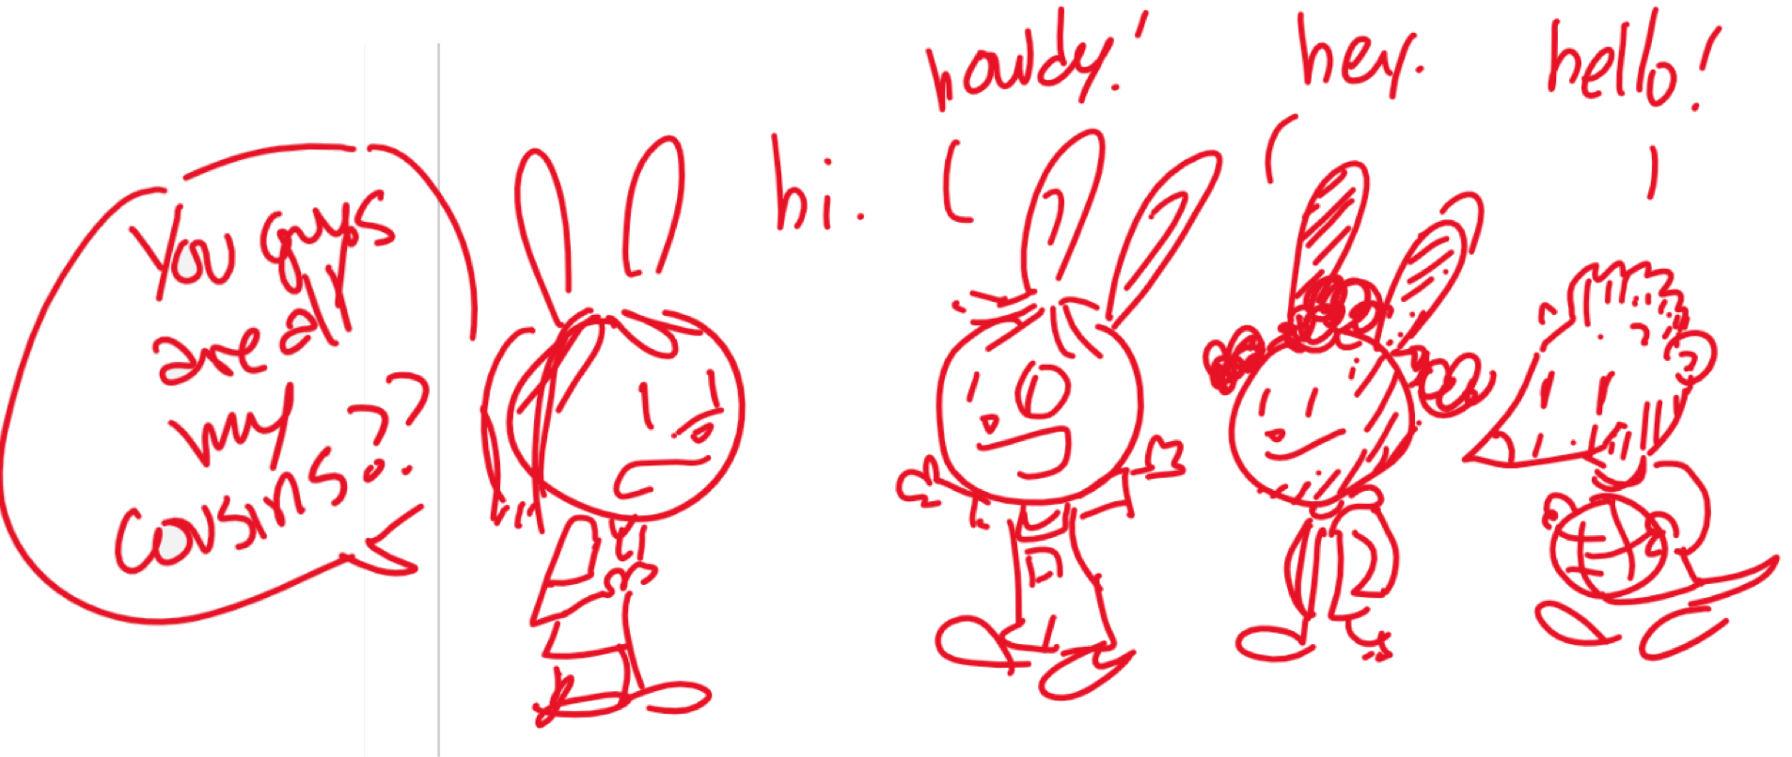
Elinor finds it super interesting that they are related, but they don’t all look the same. She decides she needs more observations to try to figure it out. They take note of family members at the reunion and look at some photo albums to see pictures of other cousins, including some who are all black. Together, Elinor and her cousins ask questions and slowly deduce how each of them are related: Danny’s mom is Elinor’s mom’s sister, but his dad is a brown bunny, which explains why Danny is mixed. Nia has the same parents but came out all brown! The family in the pictures are more distant cousins: her great grandfather was the brother of Elinor’s great grandfather, and that side of the family has black fur. And Alfonso turns out to be adopted. Elinor learns that each of us are a different mix of our parents, and that family means more than just looking the same.

