ELINOR WONDERS WHY
Legs
New PREMISE – Oct. 11, 2019
By Jorge Cham and Daniel Whiteson

Elinor’s Question: Why do different critters have different numbers of legs?
Logline: The kids learn that different situations call for different numbers of legs and they cook up a fun chair for Elinor’s dad.
Curriculum Goals; LS2. Understand that animals have different body parts that are used in different ways to meet their needs.
a. Identify body parts of animals and their function
c. Compare how the external body parts of animals are the same and/or different
d. Explore how different external features of an animal help it survive in its environment
ND3. (RTL Crosscutting concept ‘Structure and Function’): Understand that structures and materials in the natural world can be used or can inspire the engineering of structures with similar function in the designed world.

SEP: TBD at Outline

The Rabbit family is at home on a Saturday, hanging out in the living room. Elinor and her friends are playing/reading, and Mr. Rabbit is leaning back in his favorite chair while he writes down his ideas in a notepad. As he gets lost in thought, he leans back further, until… he tips over. PLOP! Ranger Rabbit checks that he’s alright and with obvious loving care asks him why he keeps doing that, he always falls over. Mr. Rabbit explains that leaning back in his chair is how he gets his best ideas. He says he just really likes to lean back in his chair, that’s how he does his best thinking.
Ranger Rabbit suggests maybe they should go for a walk, that’s also a great way to get ideas. Mr. Rabbit reluctantly agrees, and takes the kids out for a walk. As they walk around, Mr. Rabbit isn’t really getting any ideas, but Elinor notices a bug outside and they examine it. It has six legs. This makes Elinor curious: she’s never thought about it before. Why do some animals have different number of legs than others? Together they look around at more stuff and notice:
Worms have zero legs
Birds have two feet
Lizards have four feet
Bugs have six feet
Spiders have eight feet
Centipedes have lots of legs!
They wonder: why do some critters have more legs? They have some silly ideas: to be better dancers? (fun thought bubbles) To play soccer better? They run into Sally Beaver and her mom who are building a bench. The bench is not quite finished, and only has a few of its legs on it. Ari thinks it looks great and goes to try the bench, but the bench is out of balance and topples over. Mrs. Beaver helps Ari up, and explains the bench is still missing some legs. They add the last few legs and everyone appreciates how the bench is super stable now. This makes Elinor realize: maybe that’s what having extra legs is for: it makes it harder to tip over! The kids figure out that more legs make something more stable. Mrs. Beaver confirms. Olive thinks it’s true: “She’s never seen a centipede trip over!”
That answers their question and gives Elinor an idea: She enlists the help of Sally and her Mom and they make a special attachment for her Dad’s favorite chair: an extra set of legs so he can lean back safely!
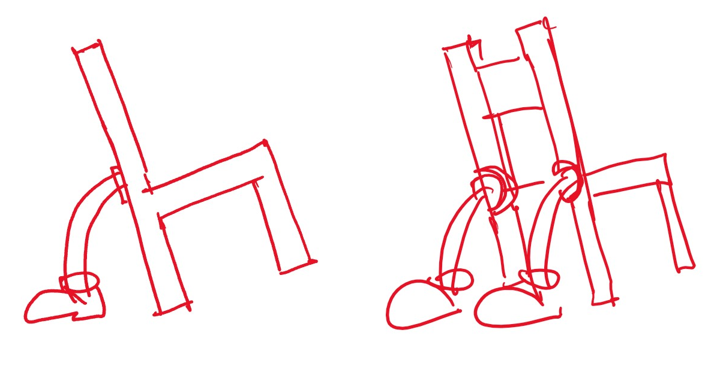

Sara Sweetman Notes:
I like the idea of Elinor noticing that animals have different numbers of legs and that they help with balance. I'm not sure about the "leaning back in the chair" part. As a K teacher I was often asking kids to keep all four legs of their chairs on the ground. Even with all four legs it is amazing how many children fall out of their chairs! I wonder what PBS will say about highlighting this "unsafe" behavior? If they do flag it, it might be interesting to have Mr. Rabbit fall off a three legged stool...then wonder why not animals have three legs and come to the conclusion after observations that three legs are not the best for balance?

