EWW 128
Senor Tapir Musical Moment:
Sada Mire, Archaeologist
By Laura Sams

Follows A Change of Art: When Elinor’s art class runs out of paint, the kids learn to make art using the colors found in nature.

Curriculum: The kids learn about Sada Mire, who followed her curiosity to explore her country of Somaliland and discovered rock art of ancient, beautiful drawings. The drawings were made using natural ingredients.

ES1. Understand that the Earth is made up of a variety of natural materials. a. Explore and describe the characteristics of earth materials such as sand, rocks, soil, water, and air
- Intro scene in which Senor Tapir stands with his hoof over his eyes (as if waiting until it is his time to look). Elinor says, “Almost done . . . I’m painting something very special with a blue color made from blueberry juice!” She uses her hands to finish painting the shape of Senor Tapir with a guitar on a small rock, and when Senor Tapir opens his eyes, he is delighted.
- Senor Tapir sings a song about Sada Mire, a scientist who discovered hundreds of rock art paintings from a long, long time ago. The paintings were made with different colors made from clay, rocks and earth. The paintings of sheep, goats, giraffes, horses and the moon are still bright and beautiful today! The emphasis is on how Sada followed her curiosity to learn more about how folks saw and loved a long, long time ago near where she was born.
- End scene in which Elinor reveals that she has painted one more thing with blueberry juice: music notes around the blue Senor Tapir on the rock.
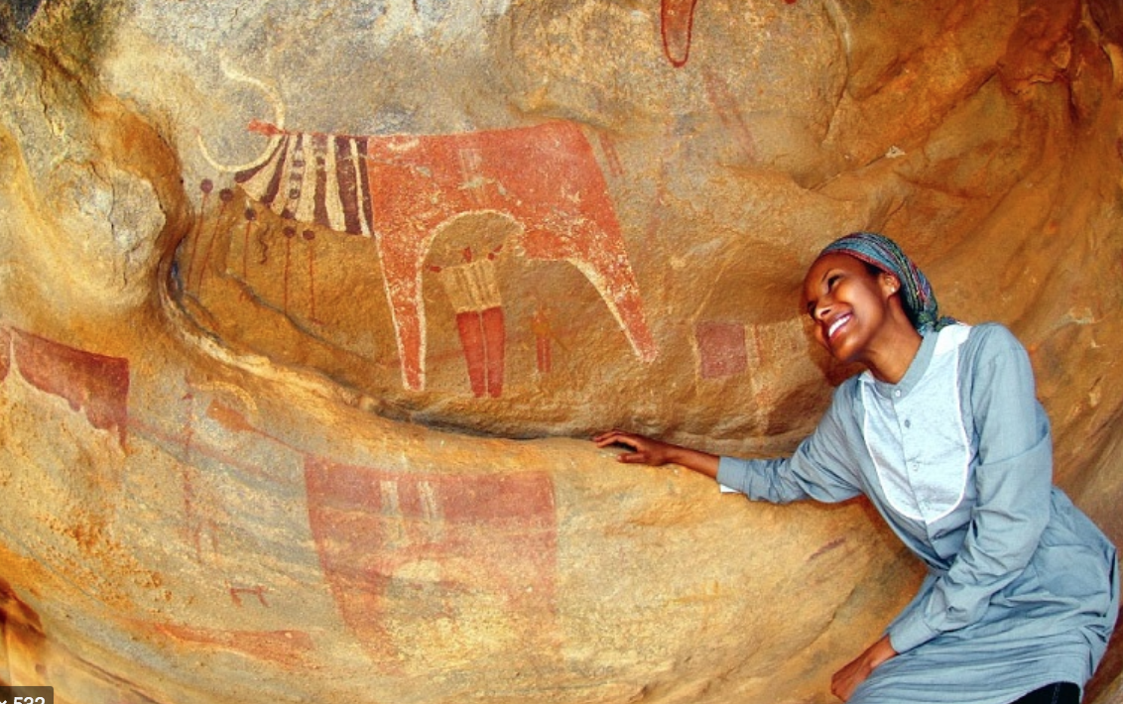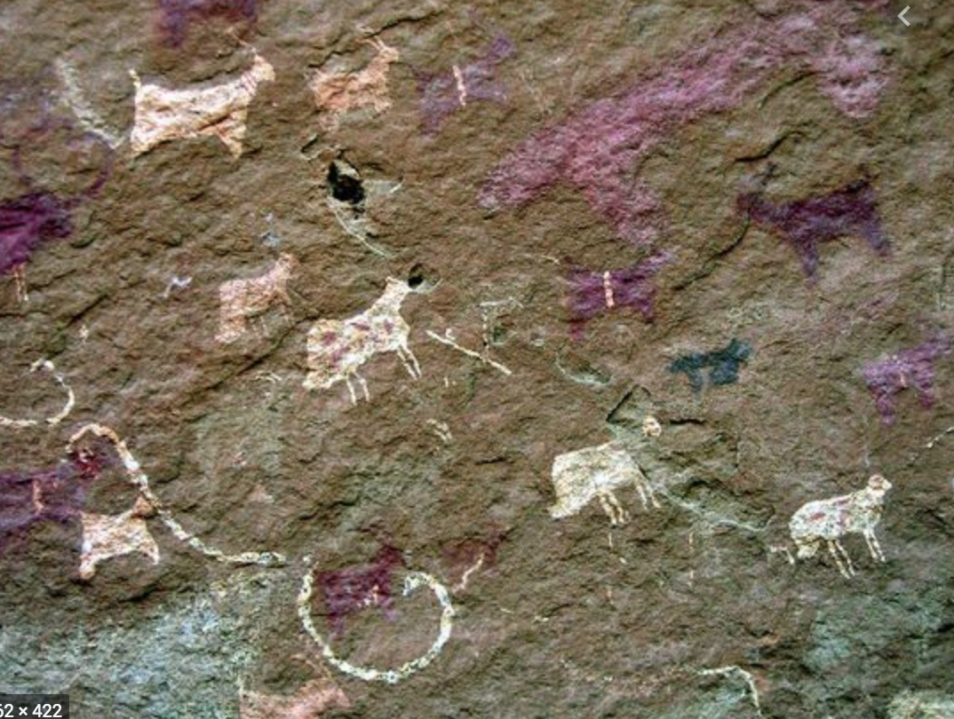
PBS Notes:
We were able to get to this one today. Just a couple of caveats to add to the great notes already:

This archaeologist is a woman of color so we need to make sure the animal chosen for her depiction and coloring are all acceptable to her. PBS would like to see the designs for this one and be kept in the loop in terms of Sada’s approval.

The only other thing—and it’s cosmetic—blueberries actually make a purple stain.

That was it from us though.

