ELINOR WONDERS WHY
EWW127 Bubble House
(formerly Bubble Stuff)
OUTLINE – May 3, 2019
By: Katherine Sandford

Elinor’s Question: How can we make a bubble house like the spittle bug does?
Logline: Inspired by a spittle-bug Elinor, Olive and Ari decide to make a bubble house, but it’s not as easy as they thought.

Curriculum Goals:
- LS5. Begin to understand that animals and plants depend on other living things and nonliving things in the environment to meet some of their needs:
a. Distinguish between living and nonliving things based on background knowledge and
b. Identify the habitats of familiar animals and plants in the environment
c. Recognize that each kind of living things has a habitat that has resources to meet its unique needs (Elinor and her friends observe the spittle-bug’s bubble house, notice how he makes it (by blowing bubbles) and learn why (to hide inside).
ND3. (RTL Crosscutting concept ‘Structure and Function’): Understand that structures and materials in the natural world can be used or can inspire the engineering of structures with similar function in the designed world. [Elinor and her friends are inspired by the spittle bug’s bubbles to make a bubble house of their own).
SEP1. Asking questions (science) and defining problems (engineering)
b. Ask more complex questions about observable phenomena
c. Ask and/or identify cause and effect questions that can be answered by an investigation
d. Identify a problem that can be solved by the design of a new or improved object or tool
(Elinor and her friends ask questions about the nature of bubble house and how it is made, then they replicate the method the spittle bug uses (blow lots of small bubbles) to make a bubble house.
SEP6. Constructing explanations (science) and Designing Solutions (engineering)
a. Use background knowledge experiences, and data to construct reasonable explanations and
theories of natural phenomena (science)
b. Look for and describe patterns and relationships in natural phenomena (science)
c. Use and apply productive science discourse to support an explanation
d. Use evidence to support a theory or solution to a problem (engineering)
(Elinor and her friends observe the spittle bug, then design their own bubble house).

- EXT. FOREST NEAR ELINOR’S HOUSE -- DAY
ARI is trudging along, dragging a big branch along behind him. He passes OLIVE who is busy piling leaves on the ground. “Oooh, watch out, Ari,” says Olive good-naturedly. “You almost dragged your branch through the wall of my leaf house.”
“Whoops. Sorry about that, Olive.” He tries to back up, but it’s awkward. “You could just use the front door.” says Olive with a smile, gesturing to a gap in the leaves. Oh, good idea!
Ari knocks on the pretend door, “Knock, knock, knock,” “Who is it?” “It’s me, Ari.” Olive opens the pretend door. Oh, hi, Ari! How nice to see you.” “Nice to see you too, Olive. Would you mind if I dragged my stick through your house?” “Not at all,” says Olive, “Let me open the back door for you.” Olive opens the pretend back door (another gap in the leaves) and Ari drags his stick through. “Thanks Olive!”
“My stick house is gonna be AWESOME!” says Ari, setting his branch in place close to where ELINOR is looking at something in a tree. “How’s your house coming, Elinor?” But Elinor isn’t working on her house. “Elinor?” Something has caught her eye on a nearby branch. “Ooooh.”
Ari and Olive share a smile. Elinor has found something interesting, better check it out. What is it, Elinor? Their curious friend points to her latest discovery. “Look what I found! Bubbles!”
SCIENCE CU: The kids gaze at a small collection of bubbles resting on a nearby branch. “How did bubbles get on a tree?” wonders Olive, but just at that moment the bubbles move a little. <GASP!> Did those bubbles just WIGGLE?? The bubbles move again, yes, yes they did! How can bubbles move on their own? They aren’t alive, are they?
The kids are pondering this when just at that moment a little spittle bug crawls out. It wasn’t the bubbles moving, it was that little bug INSIDE the bubbles. That is SO INTERESTING! But as soon as the spittle bug hears Elinor’s voice he retreats back into his bubbles.
At that moment, “Hey kids! Who’s ready for some snacks?” calls Mom from the yard. Snacks? Ari does a little flip of joy. “Coming Mom!” calls Elinor and the kids run (and flutter) OS.
- EXT. ELINOR’S BACK YARD -- DAY
“Mom! Mom! We saw a bug that lives in bubbles!” cries Elinor as the kids rush up to the picnic table where Mom has laid out the snacks (veggies sticks, sandwiches and grape juice with straws). As they dive in, (and Aris starts sluuurping his grape juice) Mom tells them it sounds like they’ve found a spittle bug. A spittle bug? Yes, it’s a bug that makes a mound of bubbles to hide inside. Elinor remembers, yes! They saw the spittle bug hiding, I wonder why he does that? “Maybe he wants to feel cozy and safe.” says Olive, explaining that’s why she likes to hide in her leaf house. Ari agrees that’s probably why the Spittle Bug hides in his Bubble House.
“Hmmm, a bubble house?” That idea sparks Elinor’s imagination. “<GASP!> I just had a BUBBLY idea! Let’s make a Bubble House of our own - just like the spittle bug!” This gets Ari and Olive’s attention; a bubble house would be AMAZING! Only problem is, they don’t have any bubbles. No worries, Elinor knows just where to get some. She just needs…
CROSSFADE TO:
- EXT. ELINOR’S BACK YARD – MINUTES LATER
…her BUBBLE STUFF! Elinor is all set up (with a little help from Mom) with a small pail, some dish soap, some water, and bubble wands. Ari is not very knowledgeable about bubble-making, so Elinor quickly but clearly explains how to make bubbles using the loops or bubble wands.
First you mix the goopy soap liquid with some water, stir it, then dip the loop/wand in the soapy solution and then you blow. Out pops a bubble. Cool!
The kids watch it float away. That’s a beautiful bubble, but it’s not a bubble house. What should we do? Olive (who is running around really getting into the bubble-making) has a suggestion: “Let’s just make BUBBLES and figure it out as we go!” Sounds like a plan, so they dive in.
BUBBLE WIPE TO:
THE BUBBLE SONG
The kids are running around blowing bubbles as they sing:
Bubble, bubble, bubble,
We’re gonna blow some bubbles,
To make ourselves a Bubble House
And get inside!

Bubble, bubble, bubble,
ELINOR: Let’s blow a GIANT bubble
And when the bubble’s big enough,
We’ll get inside!

They blow the biggest bubble possible but when Elinor touches it – it Pops!

Elinor (spoken, laughing) That didn’t work, let’s try again!

Bubble, bubble, bubble,
Let’s stack up all our bubbles.
And when the pile is big enough
we’ll get inside.

They have a stack of bigger bubbles but when Elinor touches them POP! POP! POP!

Elinor (spoken, laughing) That didn’t work either, now what do we do?

Bubble, bubble, bubble,
We’re gonna blow some bubbles,
How do we make a Bubble House?
To get inside.

BUBBLE WIPE

The last bubble POPS! Well, blowing bubbles sure was a lot of fun but they still haven’t figured out how to make a Bubble House. The kids are a bit disappointed, but just at that moment, Mom comes back out and asks them what’s wrong. The kids recap what they wanted to do and how what they tried didn’t work.
“Well, how did the spittle bug do it?” asks Mom. Hmm, they didn’t think about that before! Mom explains that to learn from things in Nature, sometimes it’s important to observe How they do things, and not just What they do. Elinor is energized. We need MORE observations!
- EXT. FOREST NEAR ELINOR’S - DAY
The kids go back to the spittle bug and wait quietly until it appears (they don’t want to startle it back into its bubble house) and observe it more closely. This time, they observe the spittle bug as it’s making its bubble home. They notice, (using a magnifying glass), that the spittle bug doesn’t use a loop or a wand. It just blows air into the goopy liquid and makes lots of really tiny bubbles. That’s it! Let’s try that!
- EXT. ELINOR’S BACK YARD - DAY
“Well, what did you learn?” asks Mom and Elinor explains that the spittle bug makes lots of tiny bubbles by blowing INTO his bubble stuff. The kids go back to their bubble making area. How do we blow air into the soapy liquid? Hmmm…
At that moment, Ari finishes his drink: “Sluuuuurrrrp… Ahhh… What?” Elinor is looking a Ari with a small smile. Uh-oh, Olive knows that look, it means Elinor has an idea. And she does. Ari, let me borrow your straw. “Wait! Don’t drink up the bubble stuff,” cries Ari, but Elinor isn’t planning to. Instead she’s going to…blub, blub, blub. Olive understands. Elinor is using the straw to blow air into the stuff, just like the spittle bug. A few bubbles froth up. Yes! It’s working!
Bubble, bubble, bubble,
We’ll blow LOTS of tiny bubbles.
Just like our friend the Spittle-bug,
Who lives inside!

Elinor keeps blowing as Ari and Olive grab straws and join her. Finally, they make a big mountain of suds!
Bubbles, bubbles, bubbles,
Look at all our little bubbles.
Now let’s try our Bubble-House
OLIVE: Come on Elinor, get inside!

Elinor crawls inside the mound of bubbles and pokes her face out the front. It works! She’s inside the BUBBLE HOUSE!
END SONG

Elinor’s Mom joins them, admiring their work. Elinor explains they figured out that what they needed was to blow air into the liquid and make a bunch of SMALL bubbles, just like the spittle bug did. Nice work, scientists. Thanks Mom.
Then Elinor turns her attention to her friends. “Hey you guys. Come on into our bubble house.” SURE! Olive and Ari are happy to but then Olive stops, “Uhh, where’s the door?” Good question. Elinor disappears for a beat, then pokes her face out the side. Peek-a bubble! “Ooh, there it is!” says Ari. “I don’t know what we didn’t see it before,” adds Olive with a smile and all the kids laugh as Olive and Ari climb into the Bubble House. A beat then, Pop! Pop! Pop! Three cute faces poke out of the bubbles. THE END

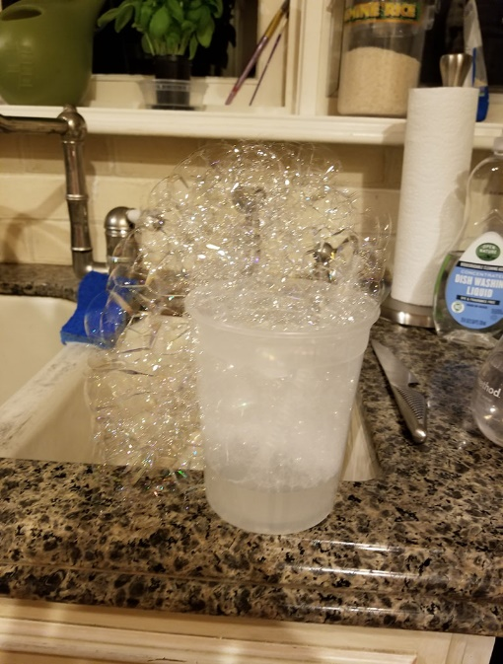
Actual bubbles in Jorge’s kitchen, blown with a straw – it works!

