EWW 124
Senor Tapir Musical Moment:
Mary Anning, Pioneering Female Paleontologist
By Laura Sams

Follows Speedy Swimming: When the kids see Ranger Rabbit swimming speedily in the local lake, they take inspiration from a duck’s webbed feet and learn why fins can help them swim fast.

Curriculum: Mary Anning is one of the first female paleontologists, who found fossils of giant swimming reptiles including a full ichthyosaur (when she was only 12 years old) and the first ever skeleton of a plesiosaur.

LS8. Begin to understand that there are many different kinds of living things and how they may be the same or different: Group different kinds of living things into categories based on basic similarities and differences
- Intro scene in which Sr. Tapir and the kids see a row of turtles sunning themselves on a log in Mossy Lake, and one turtle hops into the water. Elinor giggles as she observes that the turtle uses its flippers to swim. Sr. Tapir says he has a song about a scientist who discovered fossils of other swimming reptiles with flippers that lived during the time of the dinosaurs.
- Senor Tapir sings a song about Mary Anning, a scientist who grew up looking for fossil bones on the cliffs near her house with her dad. When she was only 12 years old, her brother found a strange skull, and she kept digging and digging until she found the whole skeleton of an animal called an ichthyosaurus, which is a swimming reptile that lived during the time of the dinosaurs that had flippers too. Later, Mary kept digging in other places and she found the first full skeleton of a plesiosaur, another kind of swimming reptile with a long neck. The emphasis is on her curiosity to keep looking and keep digging to see what she found buried in the ground.

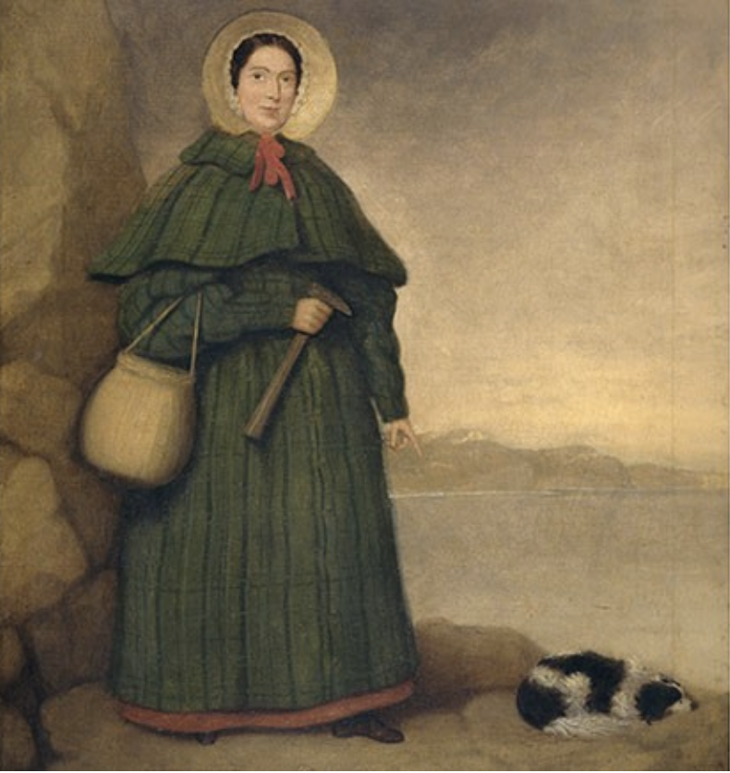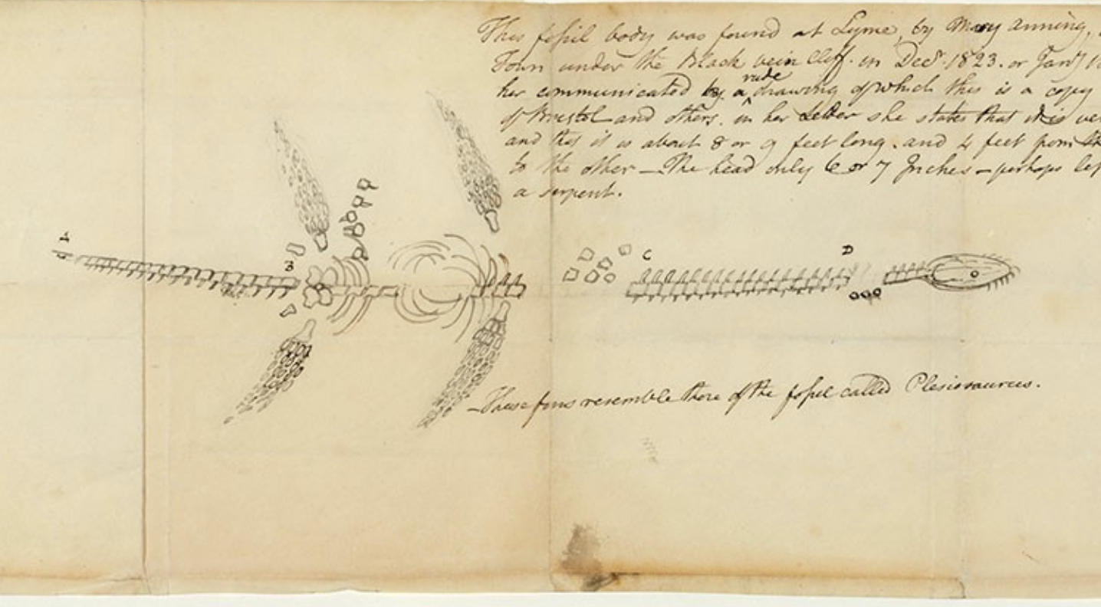
Picture of Mary Anning and her sketch of a plesiosaur skeleton
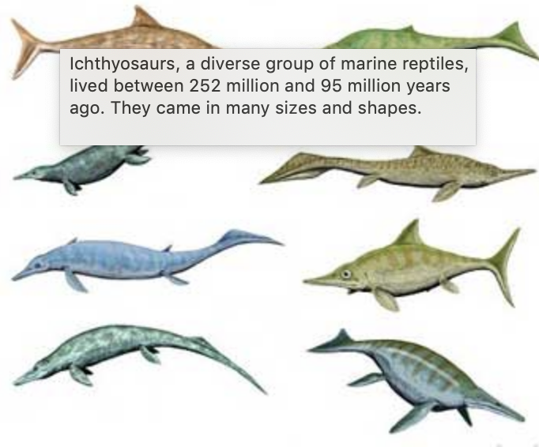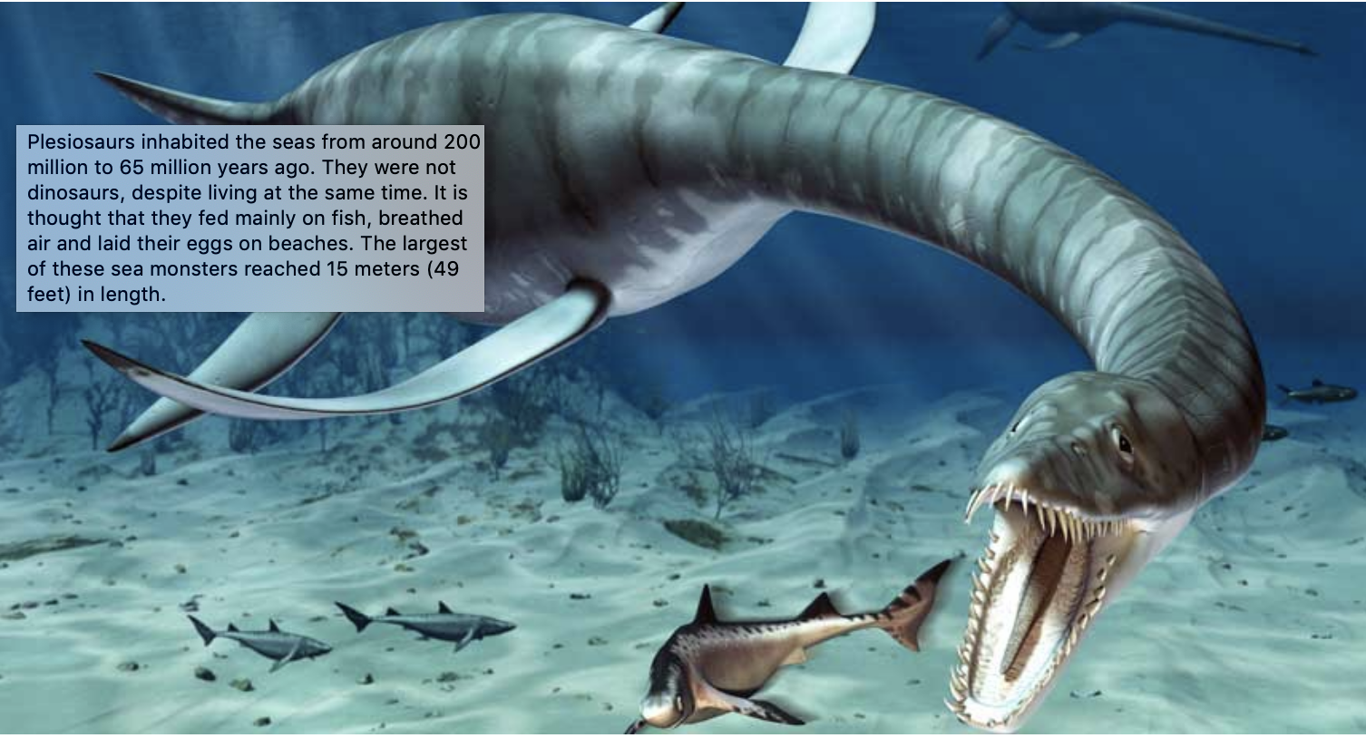
Drawings of ichthyosaurs (on the left) and a plesiosaur (on the right)
- End scene in which Sr. Tapir dramatically plays the last chord of the song, and right afterward, the turtles still on the log in Mossy Lake each hop into the water quickly one after the other. The kids all giggle after the last turtle plops into the lake.

