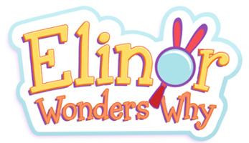

S01 Back Half Questionnaire!

- WHAT ARE YOUR FIVE FAVORITE EPISODES SO FAR, AND WHY (be as specific as possible)?

- WHAT ARE EPISODES YOU THINK WERE NOT AS STRONG AS THE OTHERS (no need to be specific why, unless you want to be)? Also, don’t worry about who authored, it’s all a team effort.

- WHAT KIND OF STORIES DO YOU WANT TO SEE MORE OF AND WHY?

- WHAT KIND OF TOPICS DO YOU WANT TO SEE MORE OF AND WHY?

- WHICH CHARACTER OR CHARACTERS DO YOU WANT TO SEE MORE OF AND WHY?

- PRETEND YOURE A TV CRITIC AND WRITE A CRITIQUE (POSITIVE AND NEGATIVE) OF THE WRITING SO FAR.

