Elinor’s Town
Springboards for Writer

The Tail End of the Problem

Science concept: animals have tails that suit their needs: balance, insects, swimming (adaptation)

Problem solved: they build insect-brushes modeled from horse-tails.

Synopsis: The kids are at out in the forest one day, having a picnic with their families. Unfortunately, there seem to be a lot of bugs flying around and bothering everyone. They wonder how they can shoo the flies away. Meanwhile, Elinor gets really curious examining everyone’s tails. She notices that everyone’s tails are different and that everyone uses their tail for different things. They explore around the clearing, seeing how the different animals use their tails: swat away flies (horses), swim (beavers) balance (squirrels, cats), communicate (dogs), even climb (monkeys). Back in the picnic, the flies are still being annoying to everyone. Elinor remembers that horses use their tail to shoo flies away, so they devise something that looks like a horse’s tail using branches and leaves and they hang it and have it swing in circles from a branch overhead. The kids learn that everyone is different and that we can learn from these differences.

Green Energy

Concept: plants get energy from the sun using a green chemical

Problem solved: mixing colors

Synopsis: Elinor and her friends are painting in the afternoon at a clearing in the forest, led by Mr. Ferret, the town art teacher. They start to paint the scenery and quickly run out of green. The grass is green, the trees are green, the bushes are green. They wonder “Why is nature so green?” Why isn’t it blue like the sky or brown like the ground or clear like the air and water? They look around and notice that flowers are colorful and that it’s the leaves that are green. They wonder: why do plants have leaves and why are they green? Mr. Ferret explains that leaves are green because there’s something in the leaves that takes the light from the sun to help the plants grow. This gives Elinor an idea: maybe they can mix different colors to get green. They experiment mixing different colors until they get the right combination of blue and yellow to make green. The problem is solved and the kids finish their works of art.

In a Pinch

Concept: animals have adapted to their environment by developing different ways of picking up their food.

Problem solved: They use the pincer idea from a crane’s beak to rescue a lost toy

Synopsis: Elinor and her friends are out on the lake with Mr. Rabbit, paddling around on a canoe (everyone is wearing poofy life vests, of course). It’s a gorgeous day and Mr. Rabbit is pointing out all the interesting birds that make their home in the area. Ari, however, is more interested in playing with his new toy plane. He is so engrossed swooping the plane up and down that he loses his balance and falls into the water. As he emerges, he makes a funny comment before he realizes that he dropped his toy plane! Oh no! Ari tries to reach it, but it’s just a little bit two deep for him to get it. Ari gets back on the boat and the kids (and Mr. Rabbit) wonder how they’re going to get the toy back. They try different strategies: Hazel tries sticking her head in and reaching with her trunk; Elinor tries using their fishing pole to hook the toy; Mr. Rabbit tries scooping it up with his oar; none of the things they try work. They take a break to have lunch (or a snack) and Elinor notices how they birds around them all eat differently: She sees a bird pulling bugs out of a tree. She sees a pelican use its beak to scoop up fish. She notices a crane in the water digging worms out of the bottom of the lake, its beak is like a pair of pincers. The kids get an idea, and take two long sticks and use them like pincers to get Ari’s toy.

The Wind in the Web

Concept: Animals use the wind in different ways; some catch it in sails, others have holes to avoid getting blown away by the wind.

Problem solved: Kids make a sign for the fall festival and cut holes to let the wind through

Synopsis: Elinor and her friends are really excited about the town fall festival. They love how the seasons change and all the plants and animals adjust. They volunteered to make a biiig sign advertising the festival. They have a big tarp, but the swirling winds keep blowing it away. On a particularly strong gust, the fliers for the fall festival get blown away and Elinor runs off to catch them. As she’s collecting the fliers, she notices that leaves and birds also catch the wind. She also notices that spider webs don’t get blown away in the wind, because they have holes in them. They realize that something solid will catch the wind and something with holes will not. So they cut some holes in the sign to let the wind through. Problem solved!

The Science of Staying Warm

Concept: Some animals have fur that works like jackets to keep them warm because they are adapted to a cold environment. Other animals don’t, because they are adapted to a warmer environment.

Problem solved: Hazel accepts that she doesn’t have an automatic jacket and has to wear one.

Synopsis: There was a big snow storm the previous night. Hazel wants to play in the snow with her friends, but it’s very cold outside. Her mom tells her she can’t go outside unless she wears her jacket and winter gear. When she puts it all on, however, it’s a massive poofy jacket and scarf and hat that covers her entirely. She can barely move! Hazel sees that Elinor is only wearing a light jacket, and decides to go outside without all her winter gear. Outside, she starts to have fun, but eventually realizes she’s really cold. She looks around and notices that some kids have big thick jackets and others don’t. Finally, she decides to go back inside. Her mom explains to her that her family comes from a really hot place, and asks Hazel if she can tell the difference between the kids that needed thick jackets and the ones that don’t. Hazel makes the connection that the kids with fur don’t need the heavy jackets. Fur and jackets help keep the heat in and keep you warm. Hazel understands that she needs a jacket to go outside and puts one on.

No Need to Shout

Concept: There are many ways to communicate, and Nature uses different ones for different situations

Problem solved: Elinor learns to communicate without her voice

Synopsis: Elinor has lost her voice from yelling too much at a recent soccer game she watched. She and the gang are trying to play together, but Elinor can’t talk, which makes it hard for them to play. This is particularly challenging for Elinor, who usually leads the group and talks a lot; she really wants to say something but can’t! Hazel realizes they have a problem, and wonders what Elinor would normally do. She remembers that Elinor always gets ideas from looking around, and so they start to explore their surroundings. While they look, they notice that birds communicate by singing, and the bees communicate by dancing, dogs communicate a lot using their facial expression, chameleons communicate using color, skunks using scent. Hazel and Ari get the idea that there are other ways to talk. So they make up a little code language for their game that uses gestures and play happily.

The Right Spot

Concepts: flowers are bright and colorful to attract insects

Problem solved: Elinor and her friends get creative and add colorful and fun things to their bake sale table to attract customers

Synopsis: Elinor and her friends have a table at the town bake sale. They are excited about sharing their carrot cake cupcakes that they spent all morning baking. But it’s a busy event and people don’t seem to be stopping to buy their cupcakes. After an hour, they only sold one: to Elinor’s parents. They get distracted following a bee and notice that lots of insects are buzzing the flowers. How do the flowers get the insects to come? They wonder if it’s the smell, but figure out that it’s the color. They dress up their bake sale table with lots more colors and get a lot more customers.

Reuse, Recycle, Re-grow!”

Concept: nature naturally recycles plant and animal matter by composting

Problem solved: cafeteria waste can be recycled using a compost bin

Synopsis: The kids are excited about starting a vegetable garden at their school. They plant the seeds, water the ground and make sure that there’s enough sunlight. A few days later, though, they notice that the garden is not growing very well. At lunch, the kids wonder what else the plants in the garden needs. Watching all the kids eat their lunches, Elinor wonders if plants also need to eat food. She also notices that sometimes the kids don't finish all their fruits and vegetables and it all just gets thrown in the trash. They go for a walk in the forest and they wonder how plants get their food. When Ari trips over a root sticking out, they get the idea that plants get their food through their roots on the ground, but since roots don’t move, the nutrients must be in the soil itself. They tell Ms. Mole of their idea to bury the leftover food in the ground for the garden plants to eat, and Ms. Mole says that’s a great idea, but that they need to compost it first. Just like the leaves and fruit that falls on the ground, nature does its own kind of recycling and nobody has to throw leaves or food in the trash. They propose a food recycling program and make a compost bin. Their composted soil is very rich, and they grow delicious fruits and veggies in their garden a short time later.

Hiding in Plain Sight

Concept: Insects and animals use camouflage to hide themselves

Problem solved: E+friends camo themselves so that they can observe lizards up close

Synopsis: The friends are playing hide and seek. Elinor, Ari and Hazel along with the goat twins. Goats have excellent eyesight, and the rest of the kids have some trouble hiding. Elinor’s ears always stick out, Hazel’s trunk keeps poking out, and Ari’s wings give him away. The kids wonder how they can hide from the goat twins. On the next round, Elinor hides behind a rock, not noticing that some of the leaves on the rocks were actually insects hiding as leaves. They scatter when she sits down. They get interested and go find other examples: lizards looking like trees.; a chameleon that can change colors; an owl that blends into the trees. Owls and lizards use color; insects mimic color and shape. They get the idea, and make costumes covered in leaves and they learn to mimic the shape of things nearby. The next time, they surprise the goats by hiding really well in plain sight. The twins walk right by them without noticing and everyone has fun!

The House That Ants Built

Concept: teams of ants can work together to do something no single ant can

Problem solved: the gang builds a fort together

Synopsis: The gang are hanging out in Elinor’s living room. They are excited to build a fort out of cushions and blankets and furniture. They each draw their idea, but each one is totally different. Hazel wants a big door and lots of bookshelves in her fort. Elinor wants lots of tiny windows for making observations. Ari wants hooks in the ceiling of his fort. They can’t agree on one idea so they try to each build their own fort. They soon find out that it’s a lot of work, and none of them can do it alone. Frustrated, Elinor plops down near the window, and see an ant walking outside. She follows that ant and soon it is joined by more ants. She follows the trail of ants to an ant-pile outside the house, where she sees an ant stick its head up out of the entrance. Hazel and Ari soon join her and Hazel remembers learning about how big ant nests are underground. The kids wonder, how did such a tiny ant make that? Elinor spots a bunch of ants working together to carry a leaf much bigger than they are, and realizes that they did it by working together. They see birds working together by taking turns being in the front of a flock. They see a beaver family working together to take down a big tree. They get the idea to try to work together and design a fort they all like. They build it and play happily.

Saving A Rainy Day

Concept: plants and animals don’t always have access to what they need, so they store it when there is an excess. For example, desert plants are really good at storing water; there are other ways to store water

Problem solved: how to stay hydrated on a hike.

Synopsis: The kids are on a field trip to the desert. They stop at the ranger station where Elinor’s mom, the ranger, reminds them all to fill up their water bottles. Ari doesn’t want to carry a heavy water bottle, so doesn’t fill his up. Elinor and Hazel remind him, but Ari says, “I’m sure we can find water out there. If plants can live in the desert, so can I.” They go for the hike, and soon Ari gets super thirsty. He wonders how he can be so thirsty if plants can survive here. They wonder if someone is watering these plants. One of the kids accidentally breaks a small branch of a succulent and sees drops of water come out. Where did this water come from? They remember it rained a few days ago, but there’s no water to be seen anywhere. (Or it sprinkles a bit and they see the cactus drink it up. Ari tries to drink the rain.) They figure out that the plants have stored the rain for later. Ari is convinced that it’s good to plan ahead. He goes back and fills up his water bottle.

Special Places

Concept: Nature can look like a chaotic mess, but many organisms do a good job in staying organized to protect their valuables.

Problem solved: the kids learn to make specific spots for their special toys to keep them safe and organized

Synopsis: It’s Saturday morning, and Ari is excited to play outside with E+H and their favorite Frisbee. They remember that Ari took it home last time, but he can’t find the Frisbee. It’s not in his room, or under the kitchen table, or in the yard, or hanging from a hook, or (he looks in lots of silly places). E+H notice Ari being kind of careless about the stuff in his room. “Your room is a mess!” “I just look for something and usually find it.” He asks his parents if they know where it is, and they ask him where he usually keeps it. He tells them that he usually forgets to put it away so he always has to look in the last place he used it. The parents exchange a knowing look but don’t say anything. Elinor sympathizes, since she often can’t find her special magnifying glass, which she needs to watch the ants in her backyard. Hazel says that sometimes can’t find her favorite pillow that helps her get comfortable in her reading hammock (some silly visuals of an elephant in a hammock). They all agree it’s a serious problem when you can’t find things. They decide to look in the last spot where they were playing, a little clearing near Ari’s house. While walking, they spot birds building nests for their eggs, squirrel kids stashing nuts in their backyard trees. They understand that Nature keeps itself organized by having a special place to put away important things. So they spend an afternoon building special boxes and organizers for their favorite toys.

Sound Is More Than What You Hear

Concept: Elinor and friends learn how animals use sound in different ways.

Problem: they use different sounds to get the animal’s attention

Synopsis: Elinor and her family stop by her friends’ houses on their way to a concert at the park. At Hazel’s house, everyone is an elephant and they use stompy sounds to communicate with each other. At Ari’s house (cave actually), everyone is a bat (their furniture is bolted to the ceiling) and they use squeaky sounds to talk to each other. When they reach the park, there is a problem: no one can hear Deputy Ranger Joe Mouse trying to start the concert. Elinor tries to help him by waving colorful items or shushing the crowd, but nobody quiets down. Then, Elinor uses different sounds to get the animals’ attention: thumps from the drums to get the larger animals’ attention, squeaky sounds from the flute to get the birds’ attention, etc.

The Tomato Drop

Natural design element: Elinor and friends learn how plants and animals float, and apply it to a contest.

Synopsis: Elinor and her friends are assigned to build something for the school’s tomato-drop contest. Every year, the sheep family wins because their wool, which they use to pad the tomato, is super soft. On a walk, Elinor sees leaves drifting down slowly, dandelion seeds floating by and, of course, Ari floating on his wings. She spots Mrs. Hippo coming down in a parachute (she is an avid skydiver). They experiment to see what falls fast and slow and discover that things that are flat fall more slowly. Elinor connects what they saw with the tomato- drop contest and they build a parachute for their tomato. At the contest, their tomato floats gently to the ground, tying for first place with the goose family.

Why Do Birds Sing

It’s morning in Elinor’s Town. Elinor is happily sleeping in her bed. Suddenly, a bird lands on the tree outside her window and starting singing. This wakes Elinor up, who tries to ignore it and go back to sleep. After a beat, the bird starts to sing again, waking her up again. She walks down to breakfast, looking a little sleepy. Her parents ask her how she slept and she tells them about the bird. She asks her parents why birds sing? They have fun coming up with ideas:
- Maybe birds just like music… but they haven’t ever seen a bird attracted to their music, or dancing to music
- Maybe birds are practicing for a big performance, that's why they do the same song over and over…. But has anyone seen a bird performance?
Her parents aren’t sure what the answer is, which makes Elinor very curious to know. Her dad gives her a pair of binoculars and encourages her to observe them to try to find out.
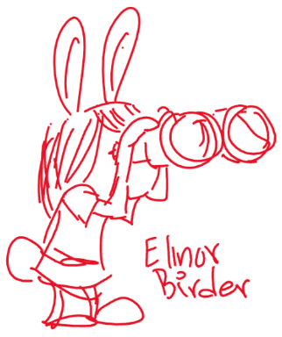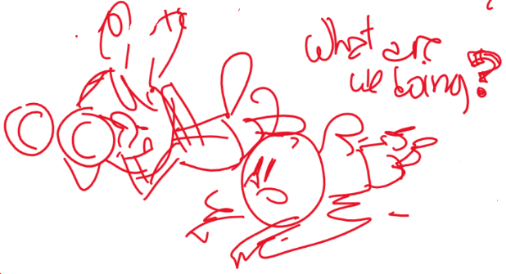

As she’s walking looking for birds, Ari and Hazel join her, and they decide to help Elinor observe birds. They all crouch down in the same spot to listen for birds. When they realize there are lots of birds in the area, they decide to split up.

Now that they are in separate parts of the forest, they have to shout to communicate: to identify themselves (It’s me! Hazel!!), find each other (Where are you!?), warn each other (Watch out for this rock!), claim territory (This is my spot!). Each time, Elinor notices that birds seem to be doing similar things (identifying themselves, finding each other, warning and claiming spots), but that the kids’ shouting scares the birds away. Elinor realizes the birds sing to communicate, and figures out a way to communicate with her friends without shouting: they whistle to each other, like the birds!

The next morning, Elinor is woken up again by the singing bird, but this time she knows the bird is just talking to other birds, so she snugly goes back to sleep.

What Do Plants Need?

It’s Plant Day at Elinor’s school once again, and this time it’s Ari’s turn to take a plant home and take care of it. Ari gets a regular simple plant, and when Elinor and Hazel offer to help him take care of it, Ari tells them not to worry. Ari says he’s an expert at taking care of things because he helps take care of his baby sister all the time.

When he gets home, Ari tries to take care of the plant in the same way he sees his parents taking care of his little sister. He puts diapers on the plant. He lies it down in a basket (which spills some of the soil) and covers it. He tries to feed it milk from a bottle. He reads to it. A few days later, Elinor and Hazel come over to visit, and when Ari shows them the plant, they see that the plant looks kind of sad (a little droopy). Ari doesn’t understand why, since he’s done everything the same way as his parents do for his sister. Elinor suggests that maybe plants and bat babies need different things. They decide to go to the forest to see how plants take care of their baby plants.
As they walk around, they realize that all plants really need is soil, water and sunlight. They go back to Ari’s house and stand the plant up, put the soil back in the pot, add a little bit water and place the plant near the window. Almost immediately, the plant seems to perk up. Ari sighs a big sigh of relief.

Back in School, Ari reports on his experiences, and Ms. Mole says maybe Ari can take Mr. Beeker (the class lizard) home next time. Mr. Beeker looks worried and gulps.

Why Are There So Many Different Kinds of Plants?

Elinor, Hazel and Ari are walking through the forest in their team uniforms on their way to soccer practice. Hazel hurries them up (they’re late!), as Elinor and Ari toss the soccer ball around. Ari kicks the ball into a bush and Elinor goes to get it. As she steps out, she realizes she’s standing next to a small bush, a medium sized tree, and a giant tall tree.

At soccer practice, Ms. Mole has them doing drills. Elinor tries to run fast, but Silas Cheetah is obviously the fastest runner. She tries to be the best ball dribbler, but Huey Mouse can scurry around faster. She tries to be the best kicker, but the goat twins can back kick the ball farther. She’s not even the best water drinker. Camilla Camel doesn’t even need to drink and just sips gracefully out of a teacup!
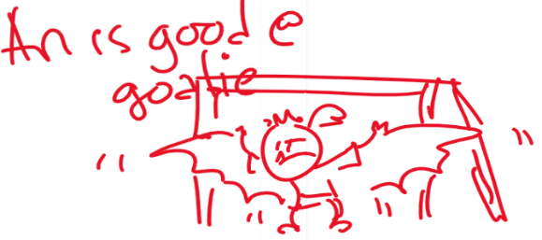
When they start playing games, even her two best friends are really good at something: Ari is the perfect goalie (his wingspan and echo location help stop any balls), and Hazel can do alley oops and tricks with her trunk (some kids cry foul, but Ms. Mole reminds them that you can use your nose to hit the ball).

Elinor is feeling bummed that she’s not as good at soccer as everyone else, and goes to sit on the bench. Ms. Mole notices she’s bummed and goes over to talk to Elinor. After Elinor tells her what’s wrong, Ms. Mole points Elinor to the trees surrounding the field, and asks Elinor if she notices something. Elinor notices there are all kinds of different plants, from little plants, to bushes to vines to giant trees. There are sooo many different kinds of plants. Why are there SO many? Why isn’t there just one kind of plant? They all are green and drink the sun, so why so many different kinds? Ms. Mole asks her what she thinks, and she has some silly ideas:

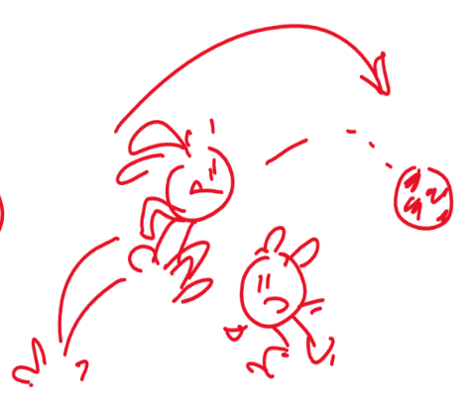- plants are very proud and want to stand out?
- plants can’t agree on what’s best
- plants are too disorganized

Eventually, she realizes that every plant must be good at something different and that’s why they are part of nature.

She understands that there are lots of ways to do the same thing (get water and sun) and that plants have a lot in common with each other, but they don’t have to be identical. In the same way, we find the best way to use our skills to accomplish our goals.

After realizing this, she is energized to play again, and figures out that hopping and jumping is something she’s really good at, and she’s able to toss the ball up and jump up over other players. At the end of the practice, she shows off: I didn’t even get to use my ears (she handles the ball with her ears)! All the other kids go, hey!!

How do plants know which way is up?

Elinor’s class is growing some seedlings to plant around the school. They pack them in dirt and give them water and put them in the sun. A week later, they all sprout, and Elinor, Ari and Hazel take good care of their seedlings. But they come in after a weekend and find that one of the seedlings looks a lot different:
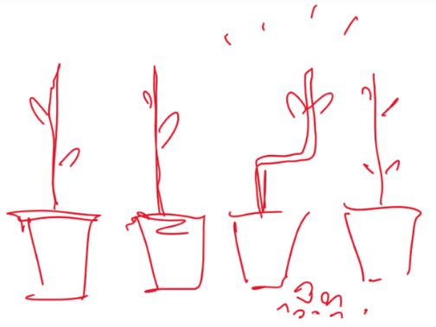
It looks like a zig zag!

The kids are completely puzzled by this. It’s a mystery! Elinor decides they must know the answer and begins an investigation. They consider the possibilities. Maybe this is a different kind of plant? They check and confirm that this is the same type of plant. Maybe it’s in a different kind of pot or soil? Nope, also the same. They start to think about what determines which way plants grow.

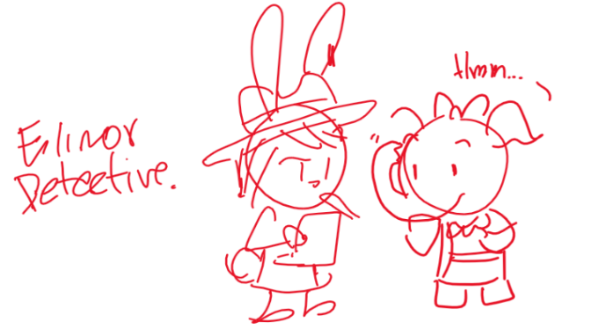Proceeding like a detective story, the kids try different things and interview the rest of the kids in class and Ms. Mole. Slowly the piece together what happened: Ari knocked over the plant right before they left for the weekend (hence the small amount of dirt near the plant), but at some point, in the middle of the weekend, Ms. Mole came into school to tidy up, and put the plant right side up. Since plants always grow up (in the direction away from the ground), the seedling grew into a zig zag shape!

Having solved the mystery of the zig zag plant, the kids try to experiment: they make a whole row of zig zag plants and plant them in the garden.

Why do lizards sit in the sun?

It’s a sunny day in the forest, and Elinor and her mom and her friends are walking around. Ari complains that it’s very hot and takes a rest in the shade where it is cooler. They come upon Mrs. Beaver, who is in the middle of a construction project to a new house for Mr. Antelope. Unfortunately, though, all construction has come to a halt, as there are two lizards sitting on a rock in the middle of the clearing where the house is supposed to be built. The lizards won’t budge, and they can’t shoo them away because they are a protected species. The lizards eventually leave at the end of the day, but they come right back each morning. Mrs. Beaver is afraid they’ll have to cancel the whole project.
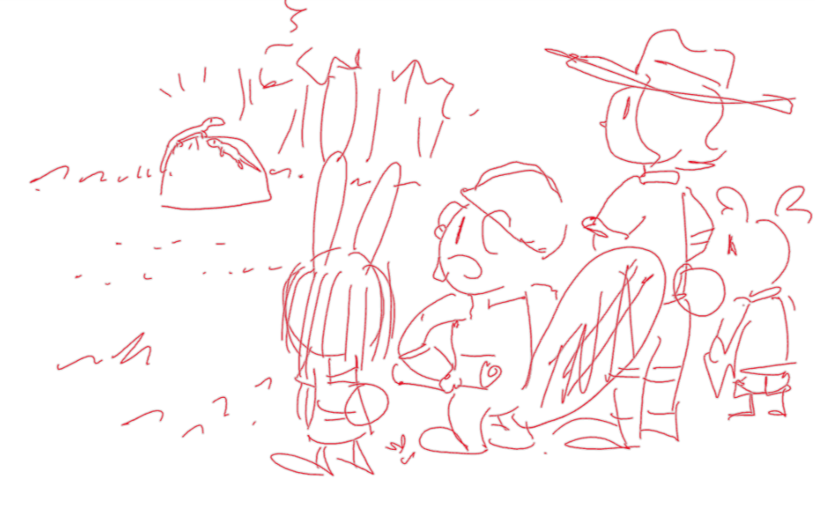
Elinor wonders why the lizards are just sitting on the rock in the sun. Elinor’s mom suggests that if they knew why, maybe they could figure out a way to get them to move to a different rock. The kids come up with different ideas for why the lizards might be sitting on the rock. Hazel looks up lizards on her nature book, and we learn some basic facts about lizards, including the fact that they are cold-blooded (i.e. they can’t get warm by themselves). As Ari says he feels hot again and looks for some shade, Elinor hypothesizes that maybe the lizards are just trying to get warm. Elinor devices a plan: if they can shade the rock in the middle of the clearing, maybe the lizards will want to move to a different rock. They find a different rock and move some branches to make it sunny, and then Ari hovers over the lizards (working up quite a sweat). Soon, the lizards decide to move to the other rock, and everyone cheers. As Mrs. Beaver resumes her work, a tired Ari plops down in a different rock in the shade and wishes he was cool like the lizards, in more ways than one!

Are there plants and animals on the moon?

Elinor and her dad are sitting outside, enjoying the night air. The clouds part and the moon comes out. They look at it through a telescope and comment on how round it is and how bright it looks. Elinor wonders, “are there plants and animals on the moon?” Before her dad can answer, Elinor’s mom calls them for her to go to bed.
The next day, Elinor and her friends are wondering about this question. If there are plants and animals all around them, why can’t there be plants and animals on the moon? They discuss different ways they could find out: they could go to the moon (but none of them know how to get there). They could get a bigger telescope, but none of them know where to get one. Finally, Elinor has an idea: they could ask a lot of different people, and see what they think.

The first animal they talk to doesn’t give them an answer, but fills them in on what the moon is: it’s a big round rock in space that moves around the Earth.

The second animal doesn’t know either, but they guess that there are probably a lot of plants there. This animals guesses that the moon is covered in green plants.

The third animal doesn’t know for sure either, but gets the kids to think about what plants need: air, and water and sunlight and dirt.

The fourth animal is the librarian, and brings out for them pictures of the moon. The kids ask questions and learn that there is no air or liquid water on the moon. The kids put together that there can’t be any plants there because they don’t have the things they need. They also check that against their observation of the moon (it’s not covered in green plants), so *their* best guess is that there are no plants on the moon (and also no animals, because animals need plants to eat).

Why do birds have feathers?

Elinor is walking to school one day. She sees a bunch of birds in a tree, clustered together. One of their feathers blows loose and floats down to her. She picks it up and looks at it closely in awe.

In class, she shows it to her friends, and comments how cool feathers are. But she wonders what they are for? The kids decide to split up and get more observations.

The kids each observe different things about birds and they each come up with a different hypothesis: Elinor watches some birds spread their wings and fly and thinks that feathers help birds fly because they act like a fan and are really light; Hazel sees some birds play around and sing and, and thinks feathers are pretty and colorful and help birds make a fashion statement; and Ari sees birds huddle together in the cold gust of wind and thinks feathers are there to keep birds warm, like fur.

The kids get back together and they each present their hypothesis. There is a little bit of competition because each thinks they are right. At that moment, Ms. Mole comes in and starts asking about their clothes (which seems random to the kids). Slowly, the kids realize that clothes also serve multiple functions: they keep you warm, they make a statement, and they help your body keep from getting dirty. The kids realize feathers are good for a lot of things, and that’s why birds have them. Phew, says Ari, he feels light as a feather now that they solved the mystery!

Do baby plants have parents?

Young animals and young plants are similar but not the same.
The young are the same kind as the parents. Babies are little versions of adults.

Elinor is on her way to school. In a big open field, she sees a tiny little plant pushing its way up. She thinks it’s cute. She has a water bottle with her, so she gives it a few drops. Every day, she stops and checks on the plant and gives it water. One day some trash is stuck on it, so she clears it off. She likes taking care of it, and it begins to grow until she can tell it’s going to be a tree.

She tells Ms Mole all about it during show and tell one day. MM asks her what made her want to take care of that tree, and she says that it just seemed all by itself, and that now she likes taking care of it, since it didn’t have anyone else to help it. That makes her wonder: why didn’t it have anyone else? Do plants have parents anyway?

She feels like a detective, on the case. She and her friend brainstorm how they are going to figure it out.

They go take a more careful look at the little tree and draw the shape of its leaves.

Now they need MORE OBSERVATIONS. They look at the big trees nearby and draw the shape of their leaves. They find a big group of old trees with leaves the same kind of leaf. They tell their parents, but they still don’t know which tree it was and why the little tree was so far away from it. They realize that trees don’t treat their babies the way animals do: they just let them grow up on their own. The kids are glad to be animals, and have parents that take care of them. Elinor says: except for this little tree. It has me to take care of it!

Why do termites make holes in wood? (they are eating it!)

Elinor and her friends are visiting Sally Beaver’s house, which is beautifully carved out of wood. While they are telling Elinor about how they designed it and carved it with their teeth, Elinor spots a small bug climbing out of a hole in the wood. She asks her friend what it is, and her friend turns white. “Oh no!” She goes to get her parents who get alarmed. It’s a termite! Elinor doesn’t know what a termite is, and her friend explains: it’s a little bug that makes holes in wood. Eventually it could make holes all over the house!

The kids go outside. Elinor is amazed. A tiny bug can cut through wood?!

They decide to try to find more of these bugs. After all the forest is filled with wood from trees. But after examining some trees, they can’t find any termites.

The kids wonder: How does it cut through wood and why? They have some ideas. Is it just building a home, like ants making tunnels in dirt? Dirt is so much easier, why would they use wood? [NOTE: it seems most termites live in mounds or “hive” like structures up in trees made out of their poop. Only some termites live in wood]

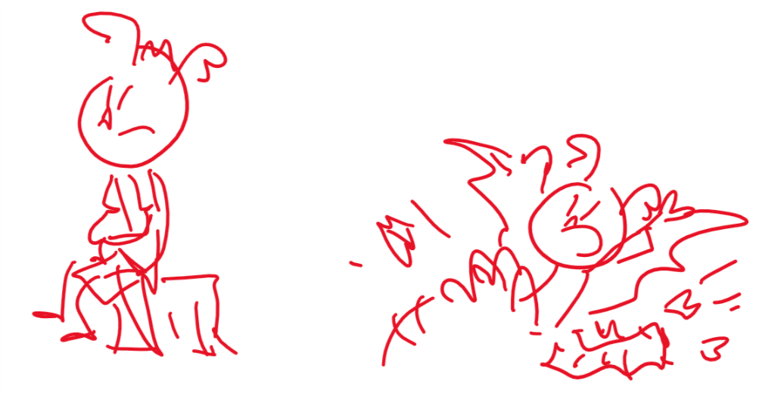
As they are about to give up, Ari sits down on an old log in a clearing. As he sits, the log collapses! It’s full of holes made by termites.

They take a closer look and watch as a termite chomps on the wood. It uses its mouth parts to cut and eat the wood! So they understand that the termite has super sharp jaws that can cut wood AND that it is EATING the wood. That’s amazing to them.

Ari thinks it's a cool idea: what if you lived in a huge block of chocolate cake, and when you wanted to make your room bigger, you could just eat the walls! Hazel points out that everyone else would also want to eat your house, and you’d be worse off than the beavers! Ari says: well, I would cover the outside with something gross, like brussel sprouts.

The kids realize that termites only seem to eat the old wood that is left over in the forest, which helps get rid of the things nobody wants, so they are helpful in that way. (Ari at the same time offers to eat the leftover cookies they were snacking on)

The kids visit the Beavers again. They have put something in the wood of their house that makes it yucky for termites. (Ari thinks this is a copy of his Brussel-sprouts idea). The termites went back into the forest to eat old, dead trees. Ari wonders if there is any old chocolate cake in the forest he could eat.

